ReactJS tutorial provides basic and advanced concepts of ReactJS. Currently, ReactJS is one of the most popular JavaScript front-end libraries which has a strong foundation and a large community.

ReactJS is a **declarative**, **efficient**, and flexible **JavaScript library** for building reusable UI components. It is an open-source, component-based front end library which is responsible only for the view layer of the application. It was initially developed and maintained by Facebook and later used in its products like WhatsApp & Instagram.

Our ReactJS tutorial includes all the topics which help to learn ReactJS. These are ReactJS Introduction, ReactJS Features, ReactJS Installation, Pros and Cons of ReactJS, ReactJS JSX, ReactJS Components, ReactJS State, ReactJS Props, ReactJS Forms, ReactJS Events, ReactJS Animation and many more.

Why we use ReactJS?

The main objective of ReactJS is to develop User Interfaces (UI) that improves the speed of the apps. It uses virtual DOM (JavaScript object), which improves the performance of the app. The JavaScript virtual DOM is faster than the regular DOM. We can use ReactJS on the client and server-side as well as with other frameworks. It uses component and data patterns that improve readability and helps to maintain larger apps.

Prerequisite

Before learning ReactJS in-depth, you must have a good knowledge of JavaScript, HTML5, and CSS. The knowledge of ECMAScript 2015 syntax can also be helpful.

Audience

We have developed this ReactJS tutorial for beginners and professionals both. We will try to introduce every concept with simple code examples that you can be easily understood. After completing all the sections, you can work confidently with ReactJS.

Problems

We assure you that you will not find any problem in our ReactJS tutorial. But, if you find any mistake, you can post it in our comment section.

# **React Introduction**

ReactJS is a declarative, efficient, and flexible JavaScript library for building reusable UI components. It is an open-source, component-based front end library responsible only for the view layer of the application. It was created by **Jordan Walke,** who was a software engineer at **Facebook.** It was initially developed and maintained by Facebook and was later used in its products like **WhatsApp** & **Instagram.** Facebook developed ReactJS in **2011** in its newsfeed section, but it was released to the public in the month of **May 2013.**

Today, most of the websites are built using MVC (model view controller) architecture. In MVC architecture, React is the 'V' which stands for view, whereas the architecture is provided by the Redux or Flux.

A ReactJS application is made up of multiple components, each component responsible for outputting a small, reusable piece of HTML code. The components are the heart of all React applications. These Components can be nested with other components to allow complex applications to be built of simple building blocks. ReactJS uses virtual DOM based mechanism to fill data in HTML DOM. The virtual DOM works fast as it only changes individual DOM elements instead of reloading complete DOM every time.

To create React app, we write React components that correspond to various elements. We organize these components inside higher level components which define the application structure. For example, we take a form that consists of many elements like input fields, labels, or buttons. We can write each element of the form as React components, and then we combine it into a higher-level component, i.e., the form component itself. The form components would specify the structure of the form along with elements inside of it.

## Why learn ReactJS?

Today, many JavaScript frameworks are available in the market(like angular, node), but still, React came into the market and gained popularity amongst them. The previous frameworks follow the traditional data flow structure, which uses the DOM (Document Object Model). DOM is an object which is created by the browser each time a web page is loaded. It dynamically adds or removes the data at the back end and when any modifications were done, then each time a new DOM is created for the same page. This repeated creation of DOM makes unnecessary memory wastage and reduces the performance of the application.

Therefore, a new technology ReactJS framework invented which remove this drawback. ReactJS allows you to divide your entire application into various components. ReactJS still used the same traditional data flow, but it is not directly operating on the browser's Document Object Model (DOM) immediately; instead, it operates on a virtual DOM. It means rather than manipulating the document in a browser after changes to our data, it resolves changes on a DOM built and run entirely in memory. After the virtual DOM has been updated, React determines what changes made to the actual browser's DOM. The React Virtual DOM exists entirely in memory and is a representation of the web browser's DOM. Due to this, when we write a React component, we did not write directly to the DOM; instead, we are writing virtual components that react will turn into the DOM.

# **React Version**

A complete release history for React is given below. You can also see the full documentation for recent releases on GitHub.

|  |  |  |  |
| --- | --- | --- | --- |
| **SN** | **Version** | **Release Date** | **Significant Changes** |
| 1. | 0.3.0 | 29/05/2013 | Initial Public Release |
| 2. | 0.4.0 | 20/07/2013 | Support for comment nodes <div>{/* */}</div>, Improved server-side rendering APIs, Removed React.autoBind, Support for the key prop, Improvements to forms, Fixed bugs. |
| 3. | 0.5.0 | 20/10/2013 | Improve Memory usage, Support for Selection and Composition events, Support for getInitialState and getDefaultProps in mixins, Added React.version and React.isValidClass, Improved compatibility for Windows. |
| 4. | 0.8.0 | 20/12/2013 | Added support for rows & cols, defer & async, loop for <audio> & <video>, autoCorrect attributes. Added onContextMenu events, Upgraded jstransform and esprima-fb tools, Upgraded browserify. |
| 5. | 0.9.0 | 20/02/2014 | Added support for crossOrigin, download and hrefLang, mediaGroup and muted, sandbox, seamless, and srcDoc, scope attributes, Added any, arrayOf, component, oneOfType, renderable, shape to React.PropTypes, Added support for onMouseOver and onMouseOut event, Added support for onLoad and onError on <img> elements. |
| 6. | 0.10.0 | 21-03-2014 | Added support for srcSet and textAnchor attributes, add update function for immutable data, Ensure all void elements don't insert a closing tag. |
| 7. | 0.11.0 | 17/07/2014 | Improved SVG support, Normalized e.view event, Update $apply command, Added support for namespaces, Added new transformWithDetails API, includes pre-built packages under dist/, MyComponent() now returns a descriptor, not an instance. |
| 8. | 0.12.0 | 21/11/2014 | Added new features Spread operator ({...}) introduced to deprecate this.transferPropsTo, Added support for acceptCharset, classID, manifest HTML attributes, React.addons.batchedUpdates added to API, @jsx React.DOM no longer required, Fixed issues with CSS Transitions. |
| 9. | 0.13.0 | 10/03/2015 | Deprecated patterns that warned in 0.12 no longer work, ref resolution order has changed, Removed properties this._pendingState and this._rootNodeID, Support ES6 classes, Added API React.findDOMNode(component), Support for iterators and immutable-js sequences, Added new features React.addons.createFragment, deprecated React.addons.classSet. |
| 10. | 0.14.1 | 29/10/2015 | Added support for srcLang, default, kind attributes, and color attribute, Ensured legacy .props access on DOM nodes, Fixed scryRenderedDOMComponentsWithClass, Added react-dom.js. |
| 11. | 15.0.0 | 07/04/2016 | Initial render now uses document.createElement instead of generating HTML, No more extra <span>s, Improved SVG support, ReactPerf.getLastMeasurements() is opaque, New deprecations introduced with a warning, Fixed multiple small memory leaks, React DOM now supports the cite and profile HTML attributes and cssFloat, gridRow and gridColumn CSS properties. |
| 12. | 15.1.0 | 20/05/2016 | Fix a batching bug, Ensure use of the latest object-assign, Fix regression, Remove use of merge utility, Renamed some modules. |
| 13. | 15.2.0 | 01/07/2016 | Include component stack information, Stop validating props at mount time, Add React.PropTypes.symbol, Add onLoad handling to <link> and onError handling to <source> element, Add isRunning() API, Fix performance regression. |
| 14. | 15.3.0 | 30/07/2016 | Add React.PureComponent, Fix issue with nested server rendering, Add xmlns, xmlnsXlink to support SVG attributes and referrerPolicy to HTML attributes, updates React Perf Add-on, Fixed issue with ref. |
| 15. | 15.3.1 | 19/08/2016 | Improve performance of development builds, Cleanup internal hooks, Upgrade fbjs, Improve startup time of React, Fix memory leak in server rendering, fix React Test Renderer, Change trackedTouchCount invariant into a console.error. |
| 16. | 15.4.0 | 16/11/2016 | React package and browser build no longer includes React DOM, Improved development performance, Fixed occasional test failures, update batchedUpdates API, React Perf, and ReactTestRenderer.create(). |
| 17. | 15.4.1 | 23/11/2016 | Restructure variable assignment, Fixed event handling, Fixed compatibility of browser build with AMD environments. |
| 18. | 15.4.2 | 06/01/2017 | Fixed build issues, Added missing package dependencies, Improved error messages. |
| 19. | 15.5.0 | 07/04/2017 | Added react-dom/test-utils, Removed peerDependencies, Fixed issue with Closure Compiler, Added a deprecation warning for React.createClass and React.PropTypes, Fixed Chrome bug. |
| 20. | 15.5.4 | 11/04/2017 | Fix compatibility with Enzyme by exposing batchedUpdates on shallow renderer, Update version of prop-types, Fix react-addons-create-fragment package to include loose-envify transform. |
| 21. | 15.6.0 | 13/06/2017 | Add support for CSS variables in style attribute and Grid style properties, Fix AMD support for addons depending on react, Remove unnecessary dependency, Add a deprecation warning for React.createClass and React.DOM factory helpers. |
| 22. | 16.0.0 | 26/09/2017 | Improvd error handling with introduction of "error boundaries", React DOM allows passing non-standard attributes, Minor changes to setState behavior, remove react-with-addons.js build, Add React.createClass as create-react-class, React.PropTypes as prop-types, React.DOM as react-dom-factories, changes to the behavior of scheduling and lifecycle methods. |
| 23. | 16.1.0 | 9/11/2017 | Discontinuing Bower Releases, Fix an accidental extra global variable in the UMD builds, Fix onMouseEnter and onMouseLeave firing, Fix <textarea> placeholder, Remove unused code, Add a missing package.json dependency, Add support for React DevTools. |
| 24. | 16.3.0 | 29/03/2018 | Add a new officially supported context API, Add new packagePrevent an infinite loop when attempting to render portals with SSR, Fix an issue with this.state, Fix an IE/Edge issue. |
| 25. | 16.3.1 | 03/04/2018 | Prefix private API, Fix performance regression and error handling bugs in development mode, Add peer dependency, Fix a false positive warning in IE11 when using Fragment. |
| 26. | 16.3.2 | 16/04/2018 | Fix an IE crash, Fix labels in User Timing measurements, Add a UMD build, Improve performance of unstable_observedBits API with nesting. |
| 27. | 16.4.0 | 24/05/2018 | Add support for Pointer Events specification, Add the ability to specify propTypes, Fix reading context, Fix the getDerivedStateFromProps() support, Fix a testInstance.parent crash, Add React.unstable_Profiler component for measuring performance, Change internal event names. |
| 28. | 16.5.0 | 05/09/2018 | Add support for React DevTools Profiler, Handle errors in more edge cases gracefully, Add react-dom/profiling, Add onAuxClick event for browsers, Add movementX and movementY fields to mouse events, Add tangentialPressure and twist fields to pointer event. |
| 29. | 16.6.0 | 23/10/2018 | Add support for contextType, Support priority levels, continuations, and wrapped callbacks, Improve the fallback mechanism, Fix gray overlay on iOS Safari, Add React.lazy() for code splitting components. |
| 30. | 16.7.0 | 20/12/2018 | Fix performance of React.lazy for lazily-loaded components, Clear fields on unmount to avoid memory leaks, Fix bug with SSR, Fix a performance regression. |
| 31. | 16.8.0 | 06/02/2019 | Add Hooks, Add ReactTestRenderer.act() and ReactTestUtils.act() for batching updates, Support synchronous thenables passed to React.lazy(), Improve useReducer Hook lazy initialization API. |
| 32. | 16.8.6 | 27/03/2019 | Fix an incorrect bailout in useReducer(), Fix iframe warnings in Safari DevTools, Warn if contextType is set to Context.Consumer instead of Context, Warn if contextType is set to invalid values. |

# **React Environment Setup**

In this section, we will learn how to set up an environment for the successful development of ReactJS application.

## Pre-requisite for ReactJS

1. NodeJS and NPM
2. React and React DOM
3. Webpack
4. Babel

## Ways to install ReactJS

There are two ways to set up an environment for successful ReactJS application. They are given below.

1. Using the npm command
2. Using the create-react-app command

### **1. Using the npm command**

**Install NodeJS and NPM**

NodeJS and NPM are the platforms need to develop any ReactJS application. You can install NodeJS and NPM package manager by the link given below.

Play Video

<https://www.javatpoint.com/install-nodejs-on-linux-ubuntu-centos>

To verify NodeJS and NPM, use the command shown in the below image.

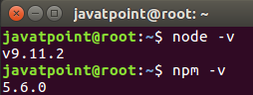

**Install React and React DOM**

Create a **root** folder with the name **reactApp** on the desktop or where you want. Here, we create it on the desktop. You can create the folder directly or using the command given below.

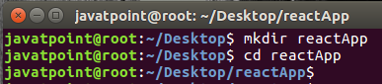

Now, you need to create a **package.json** file. To create any module, it is required to generate a package.json file in the project folder. To do this, you need to run the following command as shown in the below image.

1. javatpoint@root:~/Desktop/reactApp> npm init -y

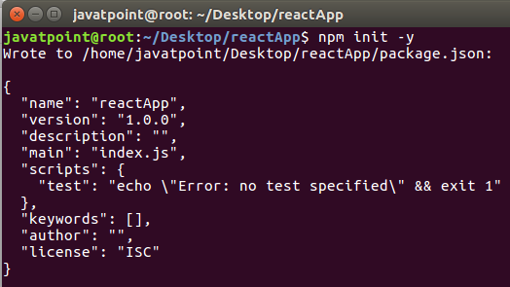

After creating a package.json file, you need to install **react** and its DOM **packages** using the following npm command in the terminal window as shown in the below image.

1. javatpoint@root:~/Desktop/reactApp>npm install react react-dom --save

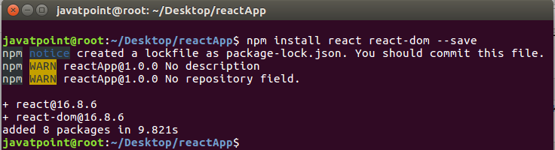

You can also use the above command separately which can be shown as below.

1. javatpoint@root:~/Desktop/reactApp>npm install react --save
2. javatpoint@root:~/Desktop/reactApp>npm install react-dom --save

**Install Webpack**

Webpack is used for module packaging, development, and production pipeline automation. We will use **webpack-dev-server** during development, **webpack** to create production builds, and **webpack CLI** provides a set of commands. Webpack compiles these into a single file(bundle). To install webpack use the command shown in the below image.

1. javatpoint@root:~/Desktop/reactApp>npm install webpack webpack-dev-server webpack-cli --save

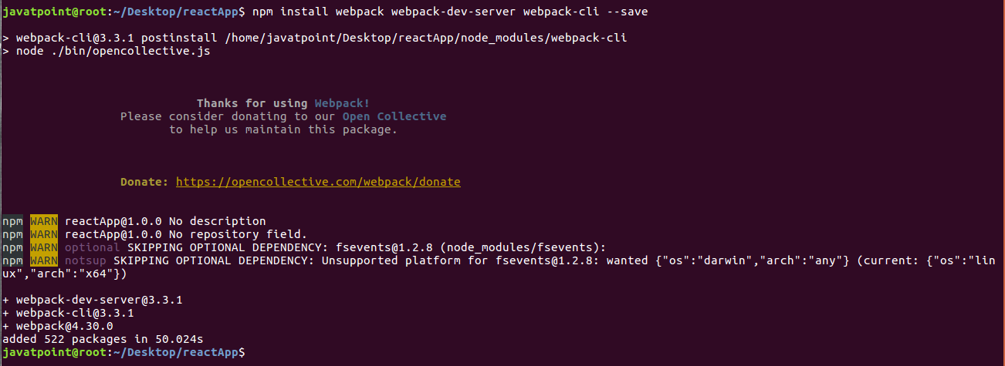

You can also use the above command separately which can be shown as below.

1. javatpoint@root:~/Desktop/reactApp>npm install webpack --save
2. javatpoint@root:~/Desktop/reactApp>npm install webpack-dev-server --save
3. javatpoint@root:~/Desktop/reactApp>npm install webpack-cli --save

**Install Babel**

Babel is a JavaScript compiler and transpiler used to convert one source code to others. It compiles React JSX and ES6 to ES5 JavaScript which can be run on all browsers. We need **babel-loader** for JSX file types, **babel-preset-react** makes your browser update automatically when any changes occur to your code without losing the current state of the app. ES6 support requires **babel-preset-env** Babel preset. To install webpack use the following command shown in the below image.

1. javatpoint@root:~/Desktop/reactApp>npm install babel-core babel-loader babel-preset-env babel-preset-react babel-webpack-plugin --save-dev

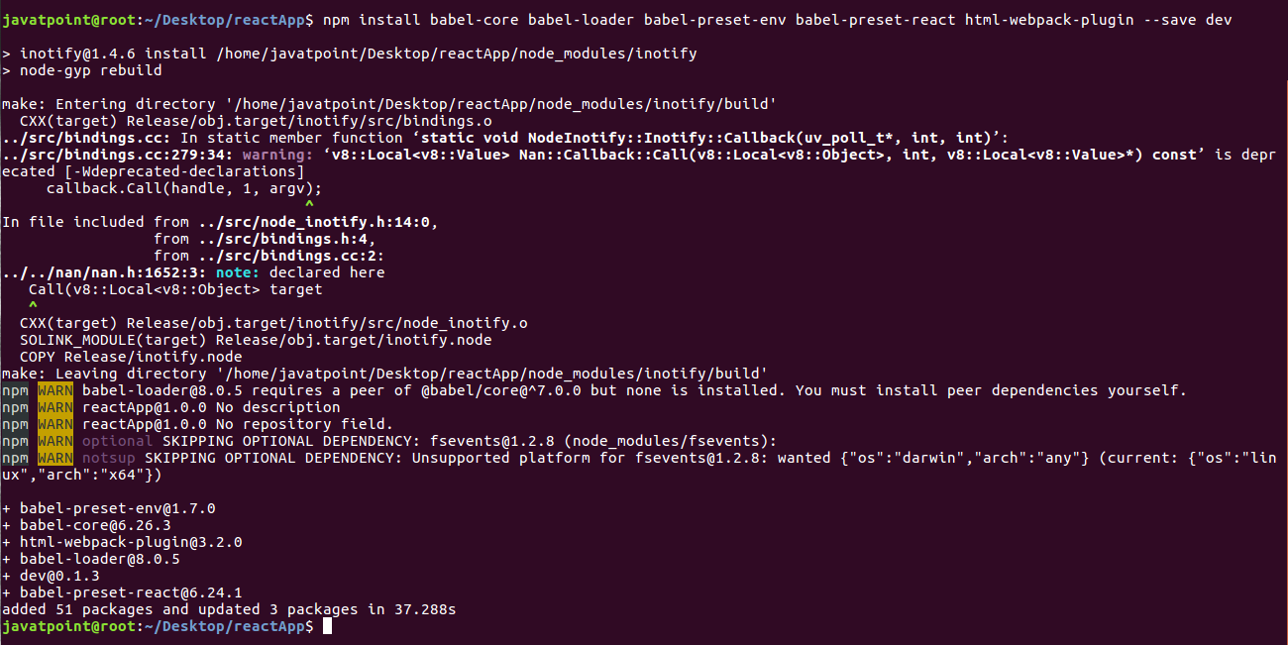

You can also use the above command separately which can be shown as below.

1. javatpoint@root:~/Desktop/reactApp>npm install babel-core --save-dev
2. javatpoint@root:~/Desktop/reactApp>npm install babel-loader --save-dev
3. javatpoint@root:~/Desktop/reactApp>npm install babel-preset-env --save-dev
4. javatpoint@root:~/Desktop/reactApp>npm install babel-preset-react --save-dev
5. javatpoint@root:~/Desktop/reactApp>npm install babel-webpack-plugin --save-dev

**Create Files**

To complete the installation process, you need to add the following files in your project folder. These files are **index.html, App.js, main.js, webpack.config.js** and, **.babelrc.** You can create these files by manually, or by using the command prompt.

1. javatpoint@root:~/Desktop/reactApp>touch index.html
2. javatpoint@root:~/Desktop/reactApp>touch App.js
3. javatpoint@root:~/Desktop/reactApp>touch main.js
4. javatpoint@root:~/Desktop/reactApp>touch webpack.config.js
5. javatpoint@root:~/Desktop/reactApp>touch .babelrc

### **Set Compiler, Loader, and Server for React Application**

**Configure webpack**

You can configure webpack in the **webpack.config.js** file by adding the following code. It defines your app entry point, build output and the extension which will resolve automatically. It also set the development server to **8080** port. It defines the loaders for processing various file types used within your app and wrap up by adding plugins needed during our development.

**webpack.config.json**

1. **const** path = require('path');
2. **const** HtmlWebpackPlugin = require('html-webpack-plugin');
4. module.exports = {
5. entry: './main.js',
6. output: {
7. path: path.join(__dirname, '/bundle'),
8. filename: 'index_bundle.js'
9. },
10. devServer: {
11. inline: **true**,
12. port: 8080
13. },
14. module: {
15. rules: [
16. {
17. test: /\.jsx?$/,
18. exclude: /node_modules/,
19. use: {
20. loader: "babel-loader",
21. }
22. }
23. ]
24. },
25. plugins:[
26. **new** HtmlWebpackPlugin({
27. template: './index.html'
28. })
29. ]
30. }

Now, open the **package.json** file and delete **"test" "echo \" Error: no test specified\" && exit 1"** inside **"scripts"** object, then add the start and build commands instead. It is because we will not perform any testing in this app.

1. {
2. "name": "reactApp",
3. "version": "1.0.0",
4. "description": "",
5. "main": "index.js",
6. "scripts": {
7. "start": "webpack-dev-server --mode development --open --hot",
8. "build": "webpack --mode production"
9. },
10. "keywords": [],
11. "author": "",
12. "license": "ISC",
13. "dependencies": {
14. "react": "^16.8.6",
15. "react-dom": "^16.8.6",
16. "webpack-cli": "^3.3.1",
17. "webpack-dev-server": "^3.3.1"
18. },
19. "devDependencies": {
20. "@babel/core": "^7.4.3",
21. "@babel/preset-env": "^7.4.3",
22. "@babel/preset-react": "^7.0.0",
23. "babel-core": "^6.26.3",
24. "babel-loader": "^8.0.5",
25. "babel-preset-env": "^1.7.0",
26. "babel-preset-react": "^6.24.1",
27. "html-webpack-plugin": "^3.2.0",
28. "webpack": "^4.30.0"
29. }
30. }

**HTML webpack template for index.html**

We can add a custom template to generate **index.html** using the **HtmlWeb-packPlugin** plugin. This enables us to add a viewport tag to support mobile responsive scaling of our app. It also set the **div id = "app"** as a root element for your app and adding the **index_bundle.js** script, which is our bundled app file.

1. <!DOCTYPE html>
2. <html lang = "en">
3. <head>
4. <meta charset = "UTF-8">
5. <title>React App</title>
6. </head>
7. <body>
8. <div id = "app"></div>
9. <script src = 'index_bundle.js'></script>
10. </body>
11. </html>

**App.jsx and main.js**

This is the first React component, i.e. app entry point. It will render Hello World.

**App.js**

1. **import** React, { Component } from 'react';
2. **class** App **extends** Component{
3. render(){
4. **return**(
5. <div>
6. <h1>Hello World</h1>
7. </div>
8. );
9. }
10. }
11. export **default** App;

Now, import this component and render it to your root App element so that you can see it in the browser.

**Main.js**

1. **import** React from 'react';
2. **import** ReactDOM from 'react-dom';
3. **import** App from './App.js';
5. ReactDOM.render(<App />, document.getElementById('app'));

#### **Note: If you want to use something, you need to import it first. To make the component usable in other parts of the app, you need to export it after creation and import it in the file where you want to use it.**

**Create .babelrc file**

Create a file with name **.babelrc** and copy the following code to it.

**.babelrc**

1. {
2. "presets":[
3. "@babel/preset-env", "@babel/preset-react"]
4. }

**Running the Server**

After completing the installation process and setting up the app, you can start the server by running the following command.

1. javatpoint@root:~/Desktop/reactApp>npm start

It will show the port number which we need to open in the browser. After we open it, you will see the following output.

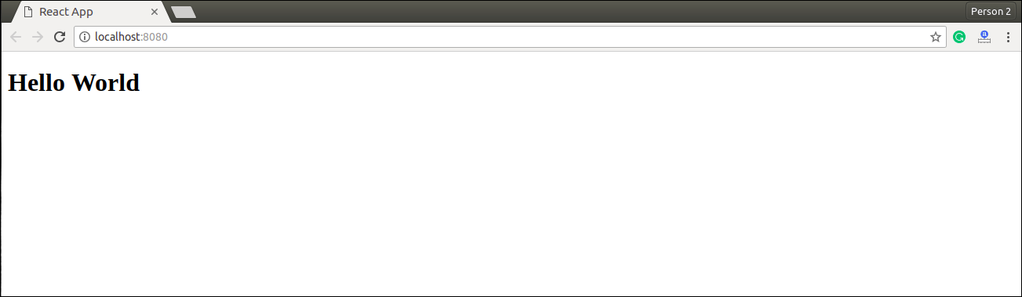

**Generate the Bundle**

Now, generate the bundle for your app. Bundling is the process of following imported files and merging them into a single file: a **"bundle."** This bundle can then be included on a webpage to load an entire app at once. To generate this, you need to run the build command in command prompt which can be shown below.

1. javatpoint@root:~/Desktop/reactApp> npm run build

This command will generate the bundle in the current folder(in which your app belongs) and will be shown as like below image.

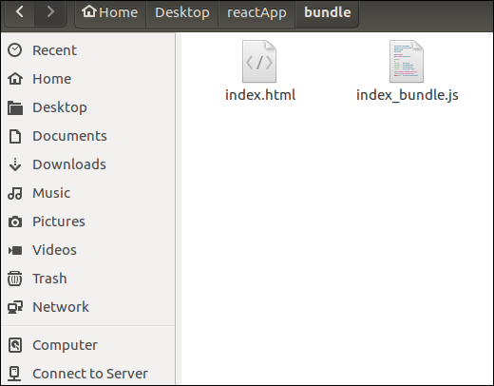

## 2. Using the create-react-app command

If you do not want to install react by using webpack and babel, then you can choose create-react-app to install react. The 'create-react-app' is a tool maintained by Facebook itself. This is suitable for beginners without manually having to deal with transpiling tools like webpack and babel. In this section, I will be showing you how to install React using CRA tool.

**Install NodeJS and NPM**

NodeJS and NPM are the platforms need to develop any ReactJS application. You can install NodeJS and NPM package manager by the link given below.

<https://www.javatpoint.com/install-nodejs-on-linux-ubuntu-centos>

**Install React**

You can install React using npm package manager by using the below command. There is no need to worry about the complexity of React installation. The create-react-app npm package will take care of it.

1. javatpoint@root:~/>npm install -g create-react-app

**Create a new React project**

After the installation of React, you can create a new react project using create-react-app command. Here, I choose **jtp-reactapp** name for my project.

1. javatpoint@root:~/>create-react-app jtp-reactapp

#### **NOTE: You can combine the above two steps in a single command using npx. The npx is a package runner tool that comes with npm 5.2 and above version.**

1. javatpoint@root:~/>npx create-react-app jtp-reactapp

The above command will install the react and create a new project with the name jtp-reactapp. This app contains the following sub-folders and files by default which can be shown in the below image.

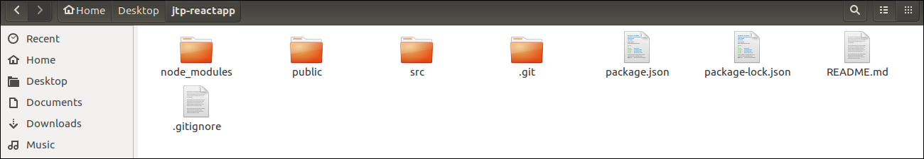

Now, to get started, open the **src** folder and make changes in your desired file. By default, the src folder contain the following files shown in below image.

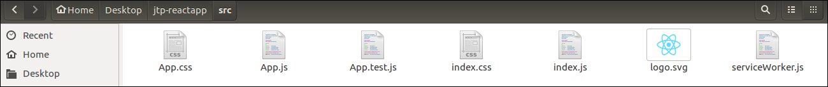

For example, I will open **App.js** and make changes in its code which are shown below.

**App.js**

1. **import** React from 'react';
2. **import** logo from './logo.svg';
3. **import** './App.css';
5. function App() {
6. **return** (
7. <div className="App">
8. <header className="App-header">
9. <img src={logo} className="App-logo" alt="logo" />
10. <p>
11. Welcome To JavaTpoint.
13. <p>To get started, edit src/App.js and save to reload.</p>
14. </p>
15. <a
16. className="App-link"
17. href="https://reactjs.org"
18. target="_blank"
19. rel="noopener noreferrer"
20. >
21. Learn React
22. </a>
23. </header>
24. </div>
25. );
26. }
28. export **default** App;

#### NOTE:**You can also choose your own favorite code editor for editing your project. But in my case, I choose Eclipse. Using the below link, you can download Eclipse for Ubuntu and install.**

[**click Here to download Eclipse for Ubuntu and install**](https://www.javatpoint.com/how-to-install-eclipse-in-ubuntu)

**Running the Server**

After completing the installation process, you can start the server by running the following command.

1. javatpoint@root:~/Desktop>cd jtp-reactapp
2. javatpoint@root:~/Desktop/jtp-reactapp>npm start

It will show the port number which we need to open in the browser. After we open it, you will see the following output.

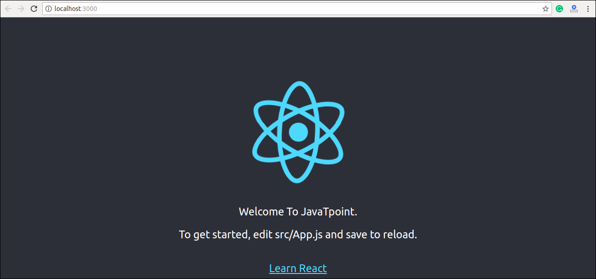

# **React create-react-app**

Starting a new React project is very complicated, with so many build tools. It uses many dependencies, configuration files, and other requirements such as Babel, Webpack, ESLint before writing a single line of React code. Create React App CLI tool removes all that complexities and makes React app simple. For this, you need to install the package using NPM, and then run a few simple commands to get a new React project.

The **create-react-app** is an excellent tool for beginners, which allows you to create and run React project very quickly. It does not take any configuration manually. This tool is wrapping all of the required dependencies like **Webpack**, **Babel** for React project itself and then you need to focus on writing React code only. This tool sets up the development environment, provides an excellent developer experience, and optimizes the app for production.

## Requirements

The Create React App is maintained by **Facebook** and can works on any **platform**, for example, macOS, Windows, Linux, etc. To create a React Project using create-react-app, you need to have installed the following things in your system.

1. Node version >= 8.10
2. NPM version >= 5.6

Let us check the current version of **Node** and **NPM** in the system.

Run the following command to check the Node version in the command prompt.

1. $ node -v

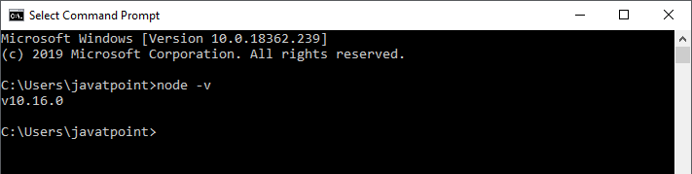

Run the following command to check the NPM version in the command prompt.

1. $ npm -v

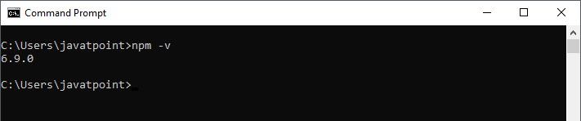

## Installation

Here, we are going to learn how we can install React using **CRA** tool. For this, we need to follow the steps as given below.

### **Install React**

We can install React using npm package manager by using the following command. There is no need to worry about the complexity of React installation. The create-react-app npm package manager will manage everything, which needed for React project.

1. C:\Users\javatpoint> npm install -g create-react-app

### **Create a new React project**

Once the React installation is successful, we can create a new React project using create-react-app command. Here, I choose "reactproject" name for my project.

1. C:\Users\javatpoint> create-react-app reactproject

#### NOTE:**We can combine the above two steps in a single command using**npx**. The npx is a package runner tool which comes with npm 5.2 and above version.**

1. C:\Users\javatpoint> npx create-react-app reactproject

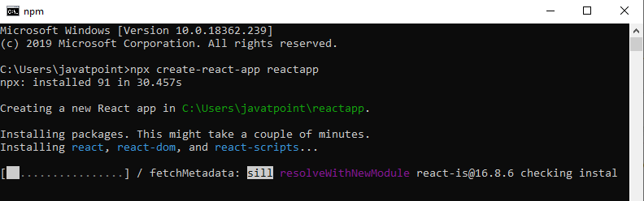

The above command will take some time to install the React and create a new project with the name "reactproject." Now, we can see the terminal as like below.

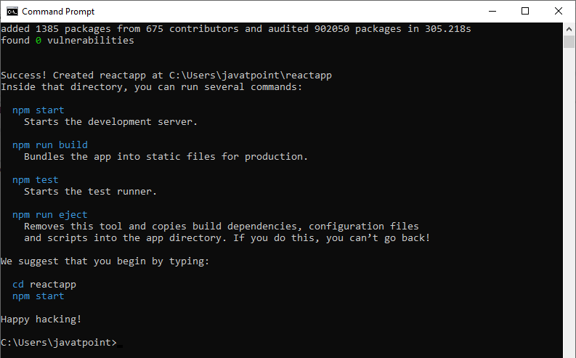

The above screen tells that the React project is created successfully on our system. Now, we need to start the server so that we can access the application on the browser. Type the following command in the terminal window.

1. $ cd Desktop
2. $ npm start

NPM is a package manager which starts the server and access the application at default server [http://localhost:3000](http://localhost:3000/). Now, we will get the following screen.

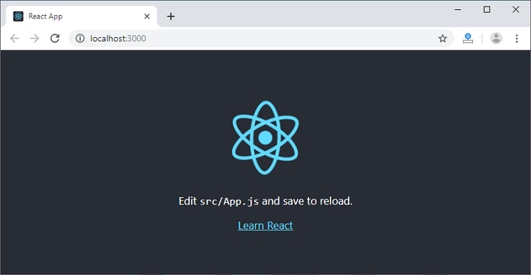

Next, open the project on Code editor. Here, I am using Visual Studio Code. Our project's default structure looks like as below image.

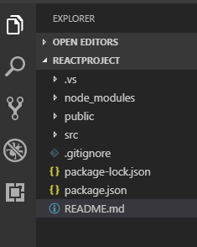

In React application, there are several files and folders in the root directory. Some of them are as follows:

1. **node_modules:** It contains the React library and any other third party libraries needed.
2. **public:** It holds the public assets of the application. It contains the index.html where React will mount the application by default on the <div id="root"></div> element.
3. **src:** It contains the App.css, App.js, App.test.js, index.css, index.js, and serviceWorker.js files. Here, the App.js file always responsible for displaying the output screen in React.
4. **package-lock.json:** It is generated automatically for any operations where npm package modifies either the node_modules tree or package.json. It cannot be published. It will be ignored if it finds any other place rather than the top-level package.
5. **package.json:** It holds various metadata required for the project. It gives information to npm, which allows to identify the project as well as handle the project?s dependencies.
6. **README.md:** It provides the documentation to read about React topics.

### **React Environment Setup**

Now, open the **src >> App.js** file and make changes which you want to display on the screen. After making desired changes, **save** the file. As soon as we save the file, Webpack recompiles the code, and the page will refresh automatically, and changes are reflected on the browser screen. Now, we can create as many components as we want, import the newly created component inside the **App.js** file and that file will be included in our main **index.html** file after compiling by Webpack.

Next, if we want to make the project for the production mode, type the following command. This command will generate the production build, which is best optimized.

1. $ npm build

# **React Features**

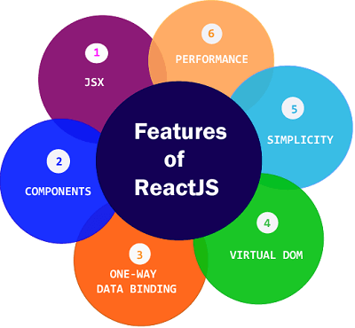

Currently, ReactJS gaining quick popularity as the best JavaScript framework among web developers. It is playing an essential role in the front-end ecosystem. The important features of ReactJS are as following.

* JSX
* Components
* One-way Data Binding
* Virtual DOM
* Simplicity
* Performance

### **JSX**

JSX stands for JavaScript XML. It is a JavaScript syntax extension. Its an XML or HTML like syntax used by ReactJS. This syntax is processed into JavaScript calls of React Framework. It extends the ES6 so that HTML like text can co-exist with JavaScript react code. It is not necessary to use JSX, but it is recommended to use in ReactJS.

### **Components**

ReactJS is all about components. ReactJS application is made up of multiple components, and each component has its own logic and controls. These components can be reusable which help you to maintain the code when working on larger scale projects.

### **One-way Data Binding**

ReactJS is designed in such a manner that follows unidirectional data flow or one-way data binding. The benefits of one-way data binding give you better control throughout the application. If the data flow is in another direction, then it requires additional features. It is because components are supposed to be immutable and the data within them cannot be changed. Flux is a pattern that helps to keep your data unidirectional. This makes the application more flexible that leads to increase efficiency.

### **Virtual DOM**

A virtual DOM object is a representation of the original DOM object. It works like a one-way data binding. Whenever any modifications happen in the web application, the entire UI is re-rendered in virtual DOM representation. Then it checks the difference between the previous DOM representation and new DOM. Once it has done, the real DOM will update only the things that have actually changed. This makes the application faster, and there is no wastage of memory.

### **Simplicity**

ReactJS uses JSX file which makes the application simple and to code as well as understand. We know that ReactJS is a component-based approach which makes the code reusable as your need. This makes it simple to use and learn.

### **Performance**

ReactJS is known to be a great performer. This feature makes it much better than other frameworks out there today. The reason behind this is that it manages a virtual DOM. The DOM is a cross-platform and programming API which deals with HTML, XML or XHTML. The DOM exists entirely in memory. Due to this, when we create a component, we did not write directly to the DOM. Instead, we are writing virtual components that will turn into the DOM leading to smoother and faster performance.

# **Pros and Cons of ReactJS**

Today, ReactJS is the highly used open-source JavaScript Library. It helps in creating impressive web apps that require minimal effort and coding. The main objective of ReactJS is to develop User Interfaces (UI) that improves the speed of the apps. There are important pros and cons of ReactJS given as following:

### **Advantage of ReactJS**

**1. Easy to Learn and USe**

ReactJS is much easier to learn and use. It comes with a good supply of documentation, tutorials, and training resources. Any developer who comes from a JavaScript background can easily understand and start creating web apps using React in a few days. It is the V(view part) in the MVC (Model-View-Controller) model, and referred to as ?one of the JavaScript frameworks.? It is not fully featured but has the advantage of open-source JavaScript User Interface(UI) library, which helps to execute the task in a better manner.

**2. Creating Dynamic Web Applications Becomes Easier**

To create a dynamic web application specifically with HTML strings was tricky because it requires a complex coding, but React JS solved that issue and makes it easier. It provides less coding and gives more functionality. It makes use of the JSX(JavaScript Extension), which is a particular syntax letting HTML quotes and HTML tag syntax to render particular subcomponents. It also supports the building of machine-readable codes.

**3. Reusable Components**

A ReactJS web application is made up of multiple components, and each component has its own logic and controls. These components are responsible for outputting a small, reusable piece of HTML code which can be reused wherever you need them. The reusable code helps to make your apps easier to develop and maintain. These Components can be nested with other components to allow complex applications to be built of simple building blocks. ReactJS uses virtual DOM based mechanism to fill data in HTML DOM. The virtual DOM works fast as it only changes individual DOM elements instead of reloading complete DOM every time.

**4. Performance Enhancement**

ReactJS improves performance due to virtual DOM. The DOM is a cross-platform and programming API which deals with HTML, XML or XHTML. Most of the developers faced the problem when the DOM was updated, which slowed down the performance of the application. ReactJS solved this problem by introducing virtual DOM. The React Virtual DOM exists entirely in memory and is a representation of the web browser's DOM. Due to this, when we write a React component, we did not write directly to the DOM. Instead, we are writing virtual components that react will turn into the DOM, leading to smoother and faster performance.

**5. The Support of Handy Tools**

React JS has also gained popularity due to the presence of a handy set of tools. These tools make the task of the developers understandable and easier. The React Developer Tools have been designed as Chrome and Firefox dev extension and allow you to inspect the React component hierarchies in the virtual DOM. It also allows you to select particular components and examine and edit their current props and state.

**6. Known to be SEO Friendly**

Traditional JavaScript frameworks have an issue in dealing with SEO. The search engines generally having trouble in reading JavaScript-heavy applications. Many web developers have often complained about this problem. ReactJS overcomes this problem that helps developers to be easily navigated on various search engines. It is because React.js applications can run on the server, and the virtual DOM will be rendering and returning to the browser as a regular web page.

**7. The Benefit of Having JavaScript Library**

Today, ReactJS is choosing by most of the web developers. It is because it is offering a very rich JavaScript library. The JavaScript library provides more flexibility to the web developers to choose the way they want.

**8. Scope for Testing the Codes**

ReactJS applications are extremely easy to test. It offers a scope where the developer can test and debug their codes with the help of native tools.

### **Disadvantage of ReactJS**

**1. The high pace of development**

The high pace of development has an advantage and disadvantage both. In case of disadvantage, since the environment continually changes so fast, some of the developers not feeling comfortable to relearn the new ways of doing things regularly. It may be hard for them to adopt all these changes with all the continuous updates. They need to be always updated with their skills and learn new ways of doing things.

**2. Poor Documentation**

It is another cons which are common for constantly updating technologies. React technologies updating and accelerating so fast that there is no time to make proper documentation. To overcome this, developers write instructions on their own with the evolving of new releases and tools in their current projects.

**3. View Part**

ReactJS Covers only the UI Layers of the app and nothing else. So you still need to choose some other technologies to get a complete tooling set for development in the project.

**4. JSX as a barrier**

ReactJS uses JSX. It's a syntax extension that allows HTML with JavaScript mixed together. This approach has its own benefits, but some members of the development community consider JSX as a barrier, especially for new developers. Developers complain about its complexity in the learning curve.

# **Difference Between AngularJS and ReactJS**

## AngularJS

AngularJS is an open-source JavaScript framework used to build a dynamic web application. Misko Hevery and Adam Abrons developed AngularJS in 2009, and now Google maintained it. The latest version of Angular is 1.7.8 on March 11, 2019. It is based on HTML and JavaScript and mostly used for building a Single Page Application. It can be included to an HTML page with a <script> tag. It extends HTML by adding built-in attributes with the directive and binds data to HTML with Expressions.

### **Features of AngularJS**

1. **Data-binding:** AngularJS follows the two-way data binding. It is the automatic synchronization of data between model and view components.
2. **POJO Model:** AngularJS uses POJO (Plain Old JavaScript) model, which provides spontaneous and well-planned objects. The POJO model makes AngularJS self-sufficient and easy to use.
3. **Model View Controller(MVC) Framework:** MVC is a software design pattern used for developing web applications. The working model of AngularJS is based on MVC patterns. The MVC Architecture in AngularJS is easy, versatile, and dynamic. MVC makes it easier to build a separate client-side application.
4. **Services:** AngularJS has several built-in services such as $http to make an XMLHttpRequest.
5. **User interface with HTML:** In AngularJS, User interfaces are built on HTML. It is a declarative language which has shorter tags and easy to comprehend. It provides an organized, smooth, and structured interface.
6. **Dependency Injection:** AngularJS has a built-in dependency injection subsystem that helps the developer to create, understand, and test the applications easily.
7. **Active community on Google:** AngularJS provides excellent community support. It is Because Google maintains AngularJS. So, if you have any maintenance issues, there are many forums available where you can get your queries solved.
8. **Routing:** Routing is the transition from one view to another view. Routing is the key aspect of single page applications where everything comes in a single page. Here, developers do not want to redirect the users to a new page every time they click the menu. The developers want the content load on the same page with the URL changing.

## ReactJS

ReactJS is an open-source JavaScript library used to build a user interface for Single Page Application. It is responsible only for the view layer of the application. It provides developers to compose complex UIs from a small and isolated piece of code called "components." ReactJS made of two parts first is components, that are the pieces that contain HTML code and what you want to see in the user interface, and the second one is HTML document where all your components will be rendered.

Jordan Walke, who was a software engineer at Facebook, develops it. Initially, it was developed and maintained by Facebook and was later used in its products like WhatsApp & Instagram. Facebook developed ReactJS in 2011 for the newsfeed section, but it was released to the public in May 2013.

### **Features of ReactJS**

1. **JSX:** JSX is a JavaScript syntax extension. The JSX syntax is processed into JavaScript calls of React Framework. It extends the ES6 so that HTML like text can co-exist with JavaScript React code.
2. **Components:** ReactJS is all about components. ReactJS application is made up of multiple components, and each component has its logic and controls. These components can be reusable, which help you to maintain the code when working on larger scale projects.
3. **One-way Data Binding:** ReactJS follows unidirectional data flow or one-way data binding. The one-way data binding gives you better control throughout the application. If the data flow is in another direction, then it requires additional features. It is because components are supposed to be immutable, and the data within them cannot be changed.
4. **Virtual DOM:** A virtual DOM object is a representation of the real DOM object. Whenever any modifications happen in the web application, the entire UI is re-rendered in virtual DOM representation. Then, it checks the difference between the previous DOM representation and new DOM. Once it has done, the real DOM will update only the things that are changed. It makes the application faster, and there is no wastage of memory.
5. **Simplicity:** ReactJS uses the JSX file, which makes the application simple and to code as well as understand. Also, ReactJS is a component-based approach which makes the code reusable as your need. It makes it simple to use and learn.
6. **Performance:** ReactJS is known to be a great performer. The reason behind this is that it manages a virtual DOM. The DOM exists entirely in memory. Due to this, when we create a component, we did not write directly to the DOM. Instead, we are writing virtual Components that will turn into the DOM, leading to smoother and faster performance.

## AngularJS Vs. ReactJS

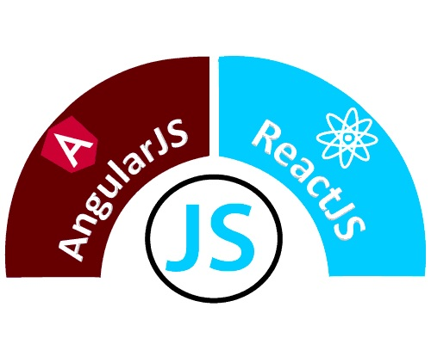

|  |  |  |
| --- | --- | --- |
|  | **AngularJS** | **ReactJS** |
| **Author** | Google | Facebook Community |
| **Developer** | Misko Hevery | Jordan Walke |
| **Initial Release** | October 2010 | March 2013 |
| **Latest Version** | Angular 1.7.8 on 11 March 2019. | React 16.8.6 on 27 March 2019 |
| **Language** | JavaScript, HTML | JSX |
| **Type** | Open Source MVC Framework | Open Source JS Framework |
| **Rendering** | Client-Side | Server-Side |
| **Packaging** | Weak | Strong |
| **Data-Binding** | Bi-directional | Uni-directional |
| **DOM** | Regular DOM | Virtual DOM |
| **Testing** | Unit and Integration Testing | Unit Testing |
| **App Architecture** | MVC | Flux |
| **Dependencies** | It manages dependencies automatically. | It requires additional tools to manage dependencies. |
| **Routing** | It requires a template or controller to its router configuration, which has to be managed manually. | It doesn't handle routing but has a lot of modules for routing, eg., react-router. |
| **Performance** | Slow | Fast, due to virtual DOM. |
| **Best For** | It is best for single page applications that update a single view at a time. | It is best for single page applications that update multiple views at a time. |

# **Difference between ReactJS and React Native**

## ReactJS

ReactJS is an open-source JavaScript library used to build the user interface for Web Applications. It is responsible only for the view layer of the application. It provides developers to compose complex UIs from a small and isolated piece of code called "components." ReactJS made of two parts first is components, that are the pieces that contain HTML code and what you want to see in the user interface, and the second one is HTML document where all your components will be rendered.

Jordan Walke, who was a software engineer at Facebook, develops it. Initially, it was developed and maintained by Facebook and was later used in its products like WhatsApp & Instagram. Facebook developed ReactJS in 2011 for the newsfeed section, but it was released to the public in May 2013.

### **Advantage of ReactJS**

1. **Easy to Learn and Use:** ReactJS is much easier to learn and use. Any developer who comes from a JavaScript background can easily understand and start creating web apps using React.
2. **Creating Dynamic Web Applications Becomes Easier:** To create a dynamic web application specifically with HTML was tricky, which requires complex coding, but React JS solved that issue and makes it easier. It provides less coding and gives more functionality.
3. **Reusable Components:** A ReactJS web application is made up of multiple components, and each component has its logic and controls. These components can be reused wherever you need them. The reusable code helps to make your apps easier to develop and maintain.
4. **Performance Enhancement:** ReactJS improves performance due to virtual DOM. The React Virtual DOM exists entirely in memory and is a representation of the web browser's DOM. Due to this, when we write a React component, we did not write directly to the DOM. Instead, we are writing virtual components that react will turn into the DOM, leading to smoother and faster performance.
5. **The Support of Handy Tools:** ReactJS support a handy set of tools which make the task of the developers understandable and easier. It also allows you to select particular components and examine and edit their current Props and State.

### **Disadvantage of ReactJS**

1. **The high pace of development:** As we know, the frameworks continually changes so fast. The developers are not feeling comfortable to re-learn the new ways of doing things regularly. It may be hard for them to adopt all these changes with all the continuous updates.
2. **Poor Documentation:** React technologies updating and accelerating so fast that there is no time to make proper documentation. To overcome this, developers write instructions on their own with the evolving of new releases and tools in their current projects.
3. **View Part:** ReactJS covers only the UI Layers of the app and nothing else. So you still need to choose some other technologies to get a complete tooling set for development in the project.
4. **Known to be SEO Friendly:** Traditional JavaScript frameworks have an issue in dealing with SEO. ReactJS overcomes this problem, which helps developers to be easily navigated on various search engines. It is because ReactJS applications can run on the server, and the virtual DOM will be rendering and returning to the browser as a regular web page.
5. **The Benefit of Having JavaScript Library:** Today, ReactJS gaining popularity among web developers. It is offering a very rich JavaScript library which provides more flexibility to the web developers to choose the way they want.
6. **Scope for Testing the Codes:** ReactJS applications are easy to test. It offers a scope where the developer can test and debug their codes with the help of native tools.

## React Native

React Native is an open-source JavaScript framework used for developing a mobile application for iOS Android, and Windows. It uses only JavaScript to build a cross-platform mobile app. React Native is same as React, but it uses native components instead of using web components as building blocks. It targets mobile platforms rather than the browser.

Facebook develops the React Native in 2013 for its internal project Hackathon. In March 2015, Facebook announced that React Native is open and available on GitHub.

React Native was initially developed for the iOS application. However, recently, it also supports the Android operating system.

### **Advantages of React Native**

There are several advantages of React Native for building mobile applications. Some of them are given below:

1. **Cross-Platform Usage:** It provides the facility of "Learn once write everywhere." It works for both platform Android as well as iOS devices.
2. **Class Performance:** The code written in React Native are compiled into native code, which enables it for both operating systems as well as it functions in the same way on both the platforms.
3. **JavaScript:** JavaScript knowledge is used to build native mobile apps.
4. **Community:** The large community of ReactJS and React Native helps us to find any answer we require.
5. **Hot Reloading:** Making a few changes in the code of your app will be immediately visible during development. If the business logic is changed, its reflection is live reloaded on screen.
6. **Improving with Time:** Some features of iOS and Android are still not supported, and the community is always inventing the best practices.
7. **Native Components:** We will need to write some platform specific code if we want to create native functionality, which is not designed yet.
8. **Existence is Uncertain:** As Facebook develop this framework, its presence is uncertain since it keeps all the rights to kill off the project anytime. As the popularity of React Native rises, it is unlikely to happen.

### **Disadvantage of React Native**

1. **React Native is Still New and Immature:** React Native is a newbie in Android and iOS programming languages and is still in its improvement stage, which can have a negative impact on the apps.
2. **Learning is Tough:** React Native is not easy to learn, especially for a fresher in the app development field.
3. **It Lacks the Security Robustness:** React Native is a JavaScript library and open-source framework, which creates a gap in the security robustness. When you are creating banking and financial apps where data is highly confidential, experts advice not to choose React Native.
4. **It Takes More Time to Initialize:** React Native takes a lot of time for initializing the runtime even for the hi-tech gadgets and devices.

## ReactJS Vs React Native

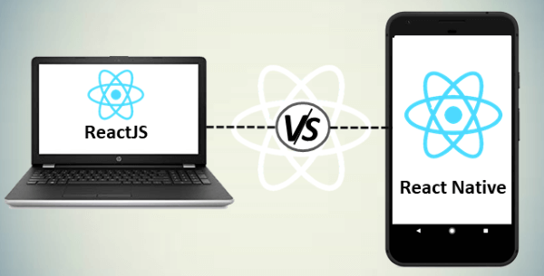

|  |  |  |
| --- | --- | --- |
| **SN** | **ReactJS** | **React Native** |
| 1. | The ReactJS initial release was in 2013. | The React Native initial release was in 2015. |
| 2. | It is used for developing web applications. | It is used for developing mobile applications. |
| 3. | It can be executed on all platforms. | It is not platform independent. It takes more effort to be executed on all platforms. |
| 4. | It uses a JavaScript library and CSS for animations. | It comes with built-in animation libraries. |
| 5. | It uses React-router for navigating web pages. | It has built-in Navigator library for navigating mobile applications. |
| 6. | It uses HTML tags. | It does not use HTML tags. |
| 7. | It can use code components, which saves a lot of valuable time. | It can reuse React Native UI components & modules which allow hybrid apps to render natively. |
| 8. | It provides high security. | It provides low security in comparison to ReactJS. |
| 9. | In this, the Virtual DOM renders the browser code. | In this, Native uses its API to render code for mobile applications. |

# **React vs. Vue**

React and Vue is the two most popular JavaScript libraries which are used to build thousands of websites today. Both React and Vue are very powerful frameworks with their own set of pros and cons. Which one you have to pick, depends on the business needs and use cases.

Both React and Vue have a lot of common things like the component-based architecture, usage of virtual DOM, usage of props, chrome Dev tools for debugging, and many more. But, both have some significant differences, which are given below.



|  |  |  |
| --- | --- | --- |
|  | **React** | **Vue** |
| **Definition** | React is a declarative, efficient, flexible, open-source JavaScript library for building reusable UI components. | Vue is an open-source JavaScript library for building reusable user interfaces and single-page applications. |
| **History** | It was created by Jordan Walke, a software engineer at Facebook. It was initially developed and maintained by Facebook and later used in its products like WhatsApp & Instagram. Facebook developed React in 2011 for the newsfeed section, but it was released to the public on May 2013. | Vue was created by Evan You, a former employee of Google worked on many Angular projects. He wanted to make a better version of Angular, just extracting the part which he liked about Angular and making it lighter. The first release of Vue was introduced in February 2014. |
| **Learning Curve** | React is not a complete framework, and the more advanced framework must be looked for the use of third-party libraries. It makes the learning of the core framework not so easy. It adds some complexity to the learning curve as it differs based on the choices you take with additional functionality. | Vue provides higher customizability, which makes it easier to learn than Angular or React. Vue shares some concepts with Angular and React in their functionality. Hence, the transition to Vue from Angular and React is an easy option. Also, the official documentation is well written and covers everything the developer needs to build a Vue app. |
| **Preferred Language** | JavaScript/JavaScript XML | HTML/JavaScript |
| **Size** | The size of the React library is 100 kilobytes (approx.). | The size of the Vue library is 60 kilobytes (approx.). |
| **Performance** | Its performance is slow as compared to Vue. | Its performance is fast as compared to React. |
| **Flexibility** | React provides great flexibility to support third-party libraries. | Vue provides limited flexibility as compared to React. |
| **Coding Style** | React uses JSX for writing JavaScript Expression instead of regular JavaScript. JSX is similar to HTML code within the JavaScript expressions. React takes everything as Component, and each component has its own lifecycle methods. | Vue coding style is little similar to Angular. It separates HTML, JS, and CSS as like web developers have been used to the web development scenario for years. But, it also allows using JSX if you prefer. Vue's take of the component lifecycle more intuitive than React's. |
| **Data Binding** | React supports one-way data binding. The one-way data binding refers to a single source of truth. React flows in a single direction, and only the model can change the app's state. | Vue supports both one-way and two-way data binding. The two-way data binding is a mechanism where UI fields are bound to model dynamically. If the UI components change, model data is also changed accordingly. |
| **Tooling** | React has great tooling support. It uses third-party CLI tool (create-react-app), which helps to create new apps and components in React Project. It has excellent support for the major IDEs. | Vue provides limited tooling support as compared to React. It has a Vue CLI tool, which is similar to the create-react-app tool. It gives supports for major IDEs but not as good as React. |
| **Current Version** | React 16.8.6 on March 27, 2019 | Vue 2.6.10 on March 20, 2019. |
| **Long Term Support** | It is suitable for long term supports. | It is not suitable for long term support. |

# **React JSX**

As we have already seen that, all of the React components have a **render** function. The render function specifies the HTML output of a React component. JSX(JavaScript Extension), is a React extension which allows writing JavaScript code that looks like HTML. In other words, JSX is an HTML-like syntax used by React that extends ECMAScript so that **HTML-like** syntax can co-exist with JavaScript/React code. The syntax is used by **preprocessors** (i.e., transpilers like babel) to transform HTML-like syntax into standard JavaScript objects that a JavaScript engine will parse.

JSX provides you to write HTML/XML-like structures (e.g., DOM-like tree structures) in the same file where you write JavaScript code, then preprocessor will transform these expressions into actual JavaScript code. Just like XML/HTML, JSX tags have a tag name, attributes, and children.

### **Example**

Here, we will write JSX syntax in JSX file and see the corresponding JavaScript code which transforms by preprocessor(babel).

**JSX File**

1. <div>Hello JavaTpoint</div>

**Corresponding Output**

1. React.createElement("div", **null**, "Hello JavaTpoint");

The above line creates a **react element** and passing **three arguments** inside where the first is the name of the element which is div, second is the **attributes** passed in the div tag, and last is the **content** you pass which is the "Hello JavaTpoint."

## Why use JSX?

* It is faster than regular JavaScript because it performs optimization while translating the code to JavaScript.
* Instead of separating technologies by putting markup and logic in separate files, React uses components that contain both. We will learn components in a further section.
* It is type-safe, and most of the errors can be found at compilation time.
* It makes easier to create templates.

## Nested Elements in JSX

To use more than one element, you need to wrap it with one container element. Here, we use **div** as a container element which has **three** nested elements inside it.

**App.JSX**

1. **import** React, { Component } from 'react';
2. **class** App **extends** Component{
3. render(){
4. **return**(
5. <div>
6. <h1>JavaTpoint</h1>
7. <h2>Training Institutes</h2>
8. <p>This website contains the best CS tutorials.</p>
9. </div>
10. );
11. }
12. }
13. export **default** App;

**Output:**

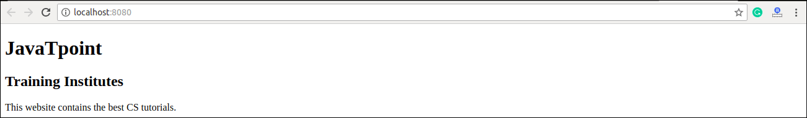

## JSX Attributes

JSX use attributes with the HTML elements same as regular HTML. JSX uses **camelcase** naming convention for attributes rather than standard naming convention of HTML such as a class in HTML becomes **className** in JSX because the class is the reserved keyword in JavaScript. We can also use our own custom attributes in JSX. For custom attributes, we need to use **data- prefix**. In the below example, we have used a custom attribute **data-demoAttribute** as an attribute for the **<p>** tag.

### **Example**

1. **import** React, { Component } from 'react';
2. **class** App **extends** Component{
3. render(){
4. **return**(
5. <div>
6. <h1>JavaTpoint</h1>
7. <h2>Training Institutes</h2>
8. <p data-demoAttribute = "demo">This website contains the best CS tutorials.</p>
9. </div>
10. );
11. }
12. }
13. export **default** App;

In JSX, we can specify attribute values in two ways:

**1. As String Literals:** We can specify the values of attributes in double quotes:

1. var element = <h2 className = "firstAttribute">Hello JavaTpoint</h2>;

**Example**

1. **import** React, { Component } from 'react';
2. **class** App **extends** Component{
3. render(){
4. **return**(
5. <div>
6. <h1 className = "hello" >JavaTpoint</h1>
7. <p data-demoAttribute = "demo">This website contains the best CS tutorials.</p>
8. </div>
9. );
10. }
11. }
12. export **default** App;

**Output:**

JavaTpoint

This website contains the best CS tutorials.

**2. As Expressions:** We can specify the values of attributes as expressions using curly braces {}:

1. var element = <h2 className = {varName}>Hello JavaTpoint</h2>;

**Example**

1. **import** React, { Component } from 'react';
2. **class** App **extends** Component{
3. render(){
4. **return**(
5. <div>
6. <h1 className = "hello" >{25+20}</h1>
7. </div>
8. );
9. }
10. }
11. export **default** App;

**Output:**

45

## JSX Comments

JSX allows us to use comments that begin with /* and ends with */ and wrapping them in curly braces {} just like in the case of JSX expressions. Below example shows how to use comments in JSX.

### **Example**

1. **import** React, { Component } from 'react';
2. **class** App **extends** Component{
3. render(){
4. **return**(
5. <div>
6. <h1 className = "hello" >Hello JavaTpoint</h1>
7. {/* This is a comment in JSX */}
8. </div>
9. );
10. }
11. }
12. export **default** App;

## JSX Styling

React always recommends to use **inline** styles. To set inline styles, you need to use **camelCase** syntax. React automatically allows appending **px** after the number value on specific elements. The following example shows how to use styling in the element.

### **Example**

1. **import** React, { Component } from 'react';
2. **class** App **extends** Component{
3. render(){
4. var myStyle = {
5. fontSize: 80,
6. fontFamily: 'Courier',
7. color: '#003300'
8. }
9. **return** (
10. <div>
11. <h1 style = {myStyle}>www.javatpoint.com</h1>
12. </div>
13. );
14. }
15. }
16. export **default** App;

**Output:**

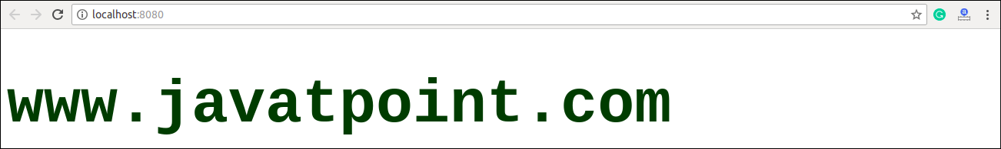

#### **NOTE: JSX cannot allow to use if-else statements. Instead of it, you can use conditional (ternary) expressions. It can be seen in the following example.**

### **Example**

1. **import** React, { Component } from 'react';
2. **class** App **extends** Component{
3. render(){
4. var i = 5;
5. **return** (
6. <div>
7. <h1>{i == 1 ? 'True!' : 'False!'}</h1>
8. </div>
9. );
10. }
11. }
12. export **default** App;

**Output:**

False!

# **React Components**

Earlier, the developers write more than thousands of lines of code for developing a single page application. These applications follow the traditional DOM structure, and making changes in them was a very challenging task. If any mistake found, it manually searches the entire application and update accordingly. The component-based approach was introduced to overcome an issue. In this approach, the entire application is divided into a small logical group of code, which is known as components.

A Component is considered as the core building blocks of a React application. It makes the task of building UIs much easier. Each component exists in the same space, but they work independently from one another and merge all in a parent component, which will be the final UI of your application.

Every React component have their own structure, methods as well as APIs. They can be reusable as per your need. For better understanding, consider the entire UI as a tree. Here, the root is the starting component, and each of the other pieces becomes branches, which are further divided into sub-branches.

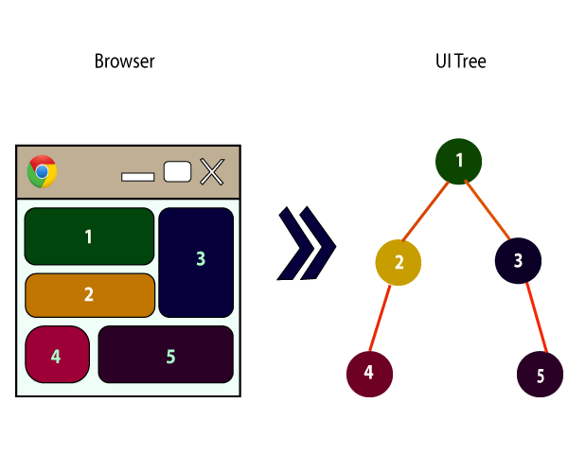

In ReactJS, we have mainly two types of components. They are

1. Functional Components
2. Class Components

## Functional Components

In React, function components are a way to write components that only contain a render method and don't have their own state. They are simply JavaScript functions that may or may not receive data as parameters. We can create a function that takes props(properties) as input and returns what should be rendered. A valid functional component can be shown in the below example.

1. function WelcomeMessage(props) {
2. **return** <h1>Welcome to the , {props.name}</h1>;
3. }

The functional component is also known as a stateless component because they do not hold or manage state. It can be explained in the below example.

### **Example**

1. **import** React, { Component } from 'react';
2. **class** App **extends** React.Component {
3. render() {
4. **return** (
5. <div>
6. <First/>
7. <Second/>
8. </div>
9. );
10. }
11. }
12. **class** First **extends** React.Component {
13. render() {
14. **return** (
15. <div>
16. <h1>JavaTpoint</h1>
17. </div>
18. );
19. }
20. }
21. **class** Second **extends** React.Component {
22. render() {
23. **return** (
24. <div>
25. <h2>www.javatpoint.com</h2>
26. <p>This websites contains the great CS tutorial.</p>
27. </div>
28. );
29. }
30. }
31. export **default** App;

**Output:**

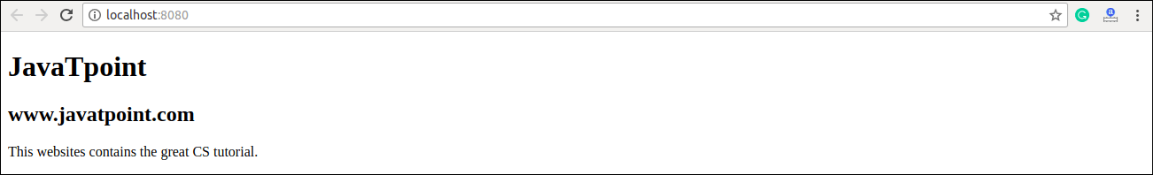

## Class Components

Class components are more complex than functional components. It requires you to extend from React. Component and create a render function which returns a React element. You can pass data from one class to other class components. You can create a class by defining a class that extends Component and has a render function. Valid class component is shown in the below example.

1. **class** MyComponent **extends** React.Component {
2. render() {
3. **return** (
4. <div>This is main component.</div>
5. );
6. }
7. }

The class component is also known as a stateful component because they can hold or manage local state. It can be explained in the below example.

### **Example**

In this example, we are creating the list of unordered elements, where we will dynamically insert StudentName for every object from the data array. Here, we are using ES6 arrow syntax (=>) which looks much cleaner than the old JavaScript syntax. It helps us to create our elements with fewer lines of code. It is especially useful when we need to create a list with a lot of items.

1. **import** React, { Component } from 'react';
2. **class** App **extends** React.Component {
3. constructor() {
4. **super**();
5. **this**.state = {
6. data:
7. [
8. {
9. "name":"Abhishek"
10. },
11. {
12. "name":"Saharsh"
13. },
14. {
15. "name":"Ajay"
16. }
17. ]
18. }
19. }
20. render() {
21. **return** (
22. <div>
23. <StudentName/>
24. <ul>
25. {**this**.state.data.map((item) => <List data = {item} />)}
26. </ul>
27. </div>
28. );
29. }
30. }
31. **class** StudentName **extends** React.Component {
32. render() {
33. **return** (
34. <div>
35. <h1>Student Name Detail</h1>
36. </div>
37. );
38. }
39. }
40. **class** List **extends** React.Component {
41. render() {
42. **return** (
43. <ul>
44. <li>{**this**.props.data.name}</li>
45. </ul>
46. );
47. }
48. }
49. export **default** App;

**Output:**

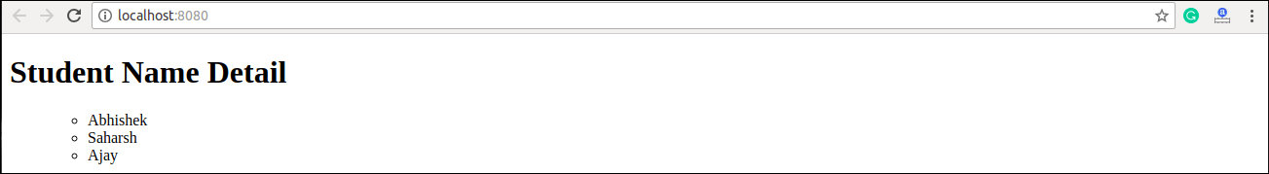

# **React State**

The state is an updatable structure that is used to contain data or information about the component. The state in a component can change over time. The change in state over time can happen as a response to user action or system event. A component with the state is known as stateful components. It is the heart of the react component which determines the behavior of the component and how it will render. They are also responsible for making a component dynamic and interactive.

A state must be kept as simple as possible. It can be set by using the **setState()** method and calling setState() method triggers UI updates. A state represents the component's local state or information. It can only be accessed or modified inside the component or by the component directly. To set an initial state before any interaction occurs, we need to use the **getInitialState()** method.

**For example**, if we have five components that need data or information from the state, then we need to create one container component that will keep the state for all of them.

## Defining State

To define a state, you have to first declare a default set of values for defining the component's initial state. To do this, add a class constructor which assigns an initial state using this.state. The '**this.state**' property can be rendered inside **render()** method.

[](https://campaign.adpushup.com/get-started/?utm_source=banner&utm_campaign=growth_hack)

### **Example**

The below sample code shows how we can create a stateful component using ES6 syntax.

1. **import** React, { Component } from 'react';
2. **class** App **extends** React.Component {
3. constructor() {
4. **super**();
5. **this**.state = { displayBio: **true** };
6. }
7. render() {
8. **const** bio = **this**.state.displayBio ? (
9. <div>
10. <p><h3>Javatpoint is one of the best Java training institute in Noida, Delhi, Gurugram, Ghaziabad and Faridabad. We have a team of experienced Java developers and trainers from multinational companies to teach our campus students.</h3></p>
11. </div>
12. ) : **null**;
13. **return** (
14. <div>
15. <h1> Welcome to JavaTpoint!! </h1>
16. { bio }
17. </div>
18. );
19. }
20. }
21. export **default** App;

To set the state, it is required to call the super() method in the constructor. It is because this.state is uninitialized before the super() method has been called.

**Output**

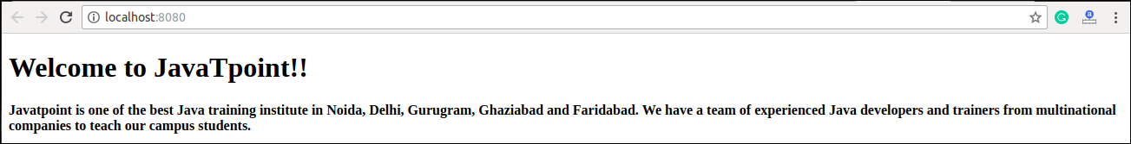

## Changing the State

We can change the component state by using the setState() method and passing a new state object as the argument. Now, create a new method toggleDisplayBio() in the above example and bind this keyword to the toggleDisplayBio() method otherwise we can't access this inside toggleDisplayBio() method.

1. **this**.toggleDisplayBio = **this**.toggleDisplayBio.bind(**this**);

### **Example**

In this example, we are going to add a **button** to the **render**() method. Clicking on this button triggers the toggleDisplayBio() method which displays the desired output.

1. **import** React, { Component } from 'react';
2. **class** App **extends** React.Component {
3. constructor() {
4. **super**();
5. **this**.state = { displayBio: **false** };
6. console.log('Component this', **this**);
7. **this**.toggleDisplayBio = **this**.toggleDisplayBio.bind(**this**);
8. }
9. toggleDisplayBio(){
10. **this**.setState({displayBio: !**this**.state.displayBio});
11. }
12. render() {
13. **return** (
14. <div>
15. <h1>Welcome to JavaTpoint!!</h1>
16. {
17. **this**.state.displayBio ? (
18. <div>
19. <p><h4>Javatpoint is one of the best Java training institute in Noida, Delhi, Gurugram, Ghaziabad and Faridabad. We have a team of experienced Java developers and trainers from multinational companies to teach our campus students.</h4></p>
20. <button onClick={**this**.toggleDisplayBio}> Show Less </button>
21. </div>
22. ) : (
23. <div>
24. <button onClick={**this**.toggleDisplayBio}> Read More </button>
25. </div>
26. )
27. }
28. </div>
29. )
30. }
31. }
32. export **default** App;

**Output:**

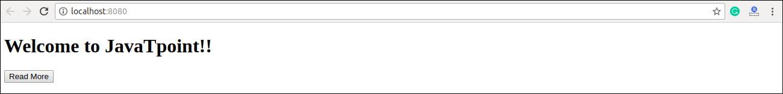

When you click the **Read More** button, you will get the below output, and when you click the **Show Less** button, you will get the output as shown in the above image.

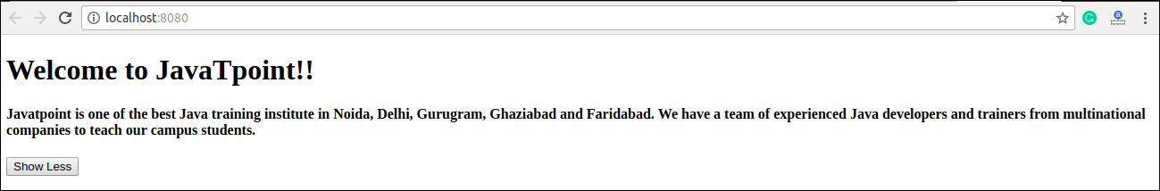

# **React Props**

Props stand for "**Properties**." They are **read-only** components. It is an object which stores the value of attributes of a tag and work similar to the HTML attributes. It gives a way to pass data from one component to other components. It is similar to function arguments. Props are passed to the component in the same way as arguments passed in a function.

Props are **immutable** so we cannot modify the props from inside the component. Inside the components, we can add attributes called props. These attributes are available in the component as **this.props** and can be used to render dynamic data in our render method.

When you need immutable data in the component, you have to add props to **reactDom.render()** method in the **main.js** file of your ReactJS project and used it inside the component in which you need. It can be explained in the below example.

### **Example**

**App.js**

1. **import** React, { Component } from 'react';
2. **class** App **extends** React.Component {
3. render() {
4. **return** (
5. <div>
6. <h1> Welcome to { **this**.props.name } </h1>
7. <p> <h4> Javatpoint is one of the best Java training institute in Noida, Delhi, Gurugram, Ghaziabad and Faridabad. </h4> </p>
8. </div>
9. );
10. }
11. }
12. export **default** App;

**Main.js**

1. **import** React from 'react';
2. **import** ReactDOM from 'react-dom';
3. **import** App from './App.js';
5. ReactDOM.render(<App name = "JavaTpoint!!" />, document.getElementById('app'));

**Output**

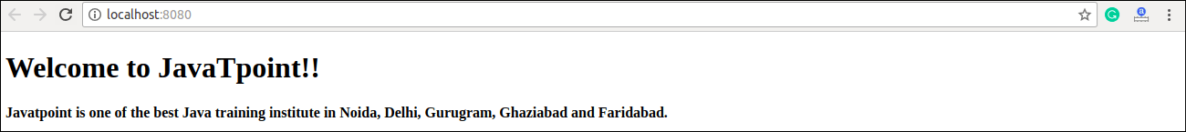

## Default Props

It is not necessary to always add props in the reactDom.render() element. You can also set **default** props directly on the component constructor. It can be explained in the below example.

### **Example**

**App.js**

1. **import** React, { Component } from 'react';
2. **class** App **extends** React.Component {
3. render() {
4. **return** (
5. <div>
6. <h1>Default Props Example</h1>
7. <h3>Welcome to {**this**.props.name}</h3>
8. <p>Javatpoint is one of the best Java training institute in Noida, Delhi, Gurugram, Ghaziabad and Faridabad.</p>
9. </div>
10. );
11. }
12. }
13. App.defaultProps = {
14. name: "JavaTpoint"
15. }
16. export **default** App;

**Main.js**

1. **import** React from 'react';
2. **import** ReactDOM from 'react-dom';
3. **import** App from './App.js';
5. ReactDOM.render(<App/>, document.getElementById('app'));

**Output**

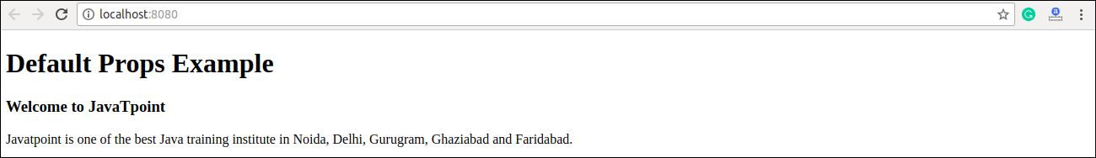

## State and Props

It is possible to combine both state and props in your app. You can set the state in the parent component and pass it in the child component using props. It can be shown in the below example.

### **Example**

**App.js**

1. **import** React, { Component } from 'react';
2. **class** App **extends** React.Component {
3. constructor(props) {
4. **super**(props);
5. **this**.state = {
6. name: "JavaTpoint",
7. }
8. }
9. render() {
10. **return** (
11. <div>
12. <JTP jtpProp = {**this**.state.name}/>
13. </div>
14. );
15. }
16. }
17. **class** JTP **extends** React.Component {
18. render() {
19. **return** (
20. <div>
21. <h1>State & Props Example</h1>
22. <h3>Welcome to {**this**.props.jtpProp}</h3>
23. <p>Javatpoint is one of the best Java training institute in Noida, Delhi, Gurugram, Ghaziabad and Faridabad.</p>
24. </div>
25. );
26. }
27. }
28. export **default** App;

**Main.js**

1. **import** React from 'react';
2. **import** ReactDOM from 'react-dom';
3. **import** App from './App.js';
5. ReactDOM.render(<App/>, document.getElementById('app'));

**Output:**

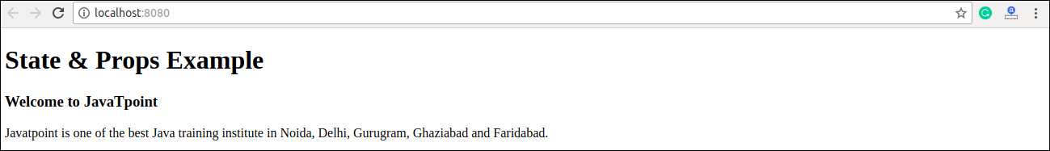

# **React Props Validation**

Props are an important mechanism for passing the **read-only** attributes to React components. The props are usually required to use correctly in the component. If it is not used correctly, the components may not behave as expected. Hence, it is required to use **props validation** in improving react components.

Props validation is a tool that will help the developers to avoid future bugs and problems. It is a useful way to force the correct usage of your components. It makes your code more readable. React components used special property **PropTypes** that help you to catch bugs by validating data types of values passed through props, although it is not necessary to define components with propTypes. However, if you use propTypes with your components, it helps you to avoid unexpected bugs.

## Validating Props

**App.propTypes** is used for props validation in react component. When some of the props are passed with an invalid type, you will get the warnings on JavaScript console. After specifying the validation patterns, you will set the App.defaultProps.

### **Syntax:**

1. **class** App **extends** React.Component {
2. render() {}
3. }
4. Component.propTypes = { /*Definition */};

## ReactJS Props Validator

ReactJS props validator contains the following list of validators.

Play Video

|  |  |  |
| --- | --- | --- |
| **SN** | **PropsType** | **Description** |
| **1.** | PropTypes.any | The props can be of any data type. |
| **2.** | PropTypes.array | The props should be an array. |
| **3.** | PropTypes.bool | The props should be a boolean. |
| **4.** | PropTypes.func | The props should be a function. |
| **5.** | PropTypes.number | The props should be a number. |
| **6.** | PropTypes.object | The props should be an object. |
| **7.** | PropTypes.string | The props should be a string. |
| **8.** | PropTypes.symbol | The props should be a symbol. |
| **9.** | PropTypes.instanceOf | The props should be an instance of a particular JavaScript class. |
| **10.** | PropTypes.isRequired | The props must be provided. |
| **11.** | PropTypes.element | The props must be an element. |
| **12.** | PropTypes.node | The props can render anything: numbers, strings, elements or an array (or fragment) containing these types. |
| **13.** | PropTypes.oneOf() | The props should be one of several types of specific values. |
| **14.** | PropTypes.oneOfType([PropTypes.string,PropTypes.number]) | The props should be an object that could be one of many types. |

### **Example**

Here, we are creating an App component which contains all the props that we need. In this example, **App.propTypes** is used for props validation. For props validation, you must have to add this line: **import PropTypes from 'prop-types'** in **App.js file**.

**App.js**

1. **import** React, { Component } from 'react';
2. **import** PropTypes from 'prop-types';
3. **class** App **extends** React.Component {
4. render() {
5. **return** (
6. <div>
7. <h1>ReactJS Props validation example</h1>
8. <table>
9. <tr>
10. <th>Type</th>
11. <th>Value</th>
12. <th>Valid</th>
13. </tr>
14. <tr>
15. <td>Array</td>
16. <td>{**this**.props.propArray}</td>
17. <td>{**this**.props.propArray ? "true" : "False"}</td>
18. </tr>
19. <tr>
20. <td>Boolean</td>
21. <td>{**this**.props.propBool ? "true" : "False"}</td>
22. <td>{**this**.props.propBool ? "true" : "False"}</td>
23. </tr>
24. <tr>
25. <td>Function</td>
26. <td>{**this**.props.propFunc(5)}</td>
27. <td>{**this**.props.propFunc(5) ? "true" : "False"}</td>
28. </tr>
29. <tr>
30. <td>String</td>
31. <td>{**this**.props.propString}</td>
32. <td>{**this**.props.propString ? "true" : "False"}</td>
33. </tr>
34. <tr>
35. <td>Number</td>
36. <td>{**this**.props.propNumber}</td>
37. <td>{**this**.props.propNumber ? "true" : "False"}</td>
38. </tr>
39. </table>
40. </div>
41. );
42. }
43. }
44. App.propTypes = {
45. propArray: PropTypes.array.isRequired,
46. propBool: PropTypes.bool.isRequired,
47. propFunc: PropTypes.func,
48. propNumber: PropTypes.number,
49. propString: PropTypes.string,
50. }
51. App.defaultProps = {
52. propArray: [1,2,3,4,5],
53. propBool: **true**,
54. propFunc: function(x){**return** x+5},
55. propNumber: 1,
56. propString: "JavaTpoint",
57. }
58. export **default** App;

**Main.js**

1. **import** React from 'react';
2. **import** ReactDOM from 'react-dom';
3. **import** App from './App.js';
5. ReactDOM.render(<App/>, document.getElementById('app'));

**Output:**

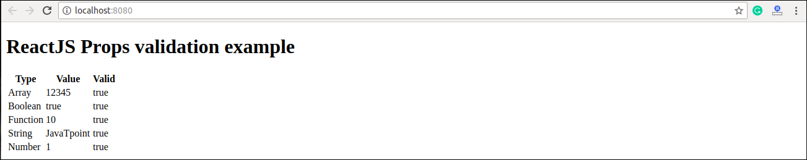

## ReactJS Custom Validators

ReactJS allows creating a custom validation function to perform custom validation. The following argument is used to create a custom validation function.

* **props:** It should be the first argument in the component.
* **propName:** It is the propName that is going to validate.
* **componentName:** It is the componentName that are going to validated again.

### **Example**

1. var Component = React.createClass({
2. App.propTypes = {
3. customProp: function(props, propName, componentName) {
4. **if** (!item.isValid(props[propName])) {
5. **return** **new** Error('Validation failed!');
6. }
7. }
8. }
9. })

# **State Vs. Props**

## State

The state is an updatable structure that is used to contain data or information about the component and can change over time. The change in state can happen as a response to user action or system event. It is the heart of the react component which determines the behavior of the component and how it will render. A state must be kept as simple as possible. It represents the component's local state or information. It can only be accessed or modified inside the component or by the component directly.

## Props

Props are read-only components. It is an object which stores the value of attributes of a tag and work similar to the HTML attributes. It allows passing data from one component to other components. It is similar to function arguments and can be passed to the component the same way as arguments passed in a function. Props are immutable so we cannot modify the props from inside the component.

## Difference between State and Props

|  |  |  |
| --- | --- | --- |
| **SN** | **Props** | **State** |
| **1.** | Props are read-only. | State changes can be asynchronous. |
| **2.** | Props are immutable. | State is mutable. |
| **3.** | Props allow you to pass data from one component to other components as an argument. | State holds information about the components. |
| **4.** | Props can be accessed by the child component. | State cannot be accessed by child components. |
| **5.** | Props are used to communicate between components. | States can be used for rendering dynamic changes with the component. |
| **6.** | Stateless component can have Props. | Stateless components cannot have State. |
| **7.** | Props make components reusable. | State cannot make components reusable. |
| **8.** | Props are external and controlled by whatever renders the component. | The State is internal and controlled by the React Component itself. |

The below table will guide you about the changing in props and state.

|  |  |  |  |
| --- | --- | --- | --- |
| **SN** | **Condition** | **Props** | **State** |
| **1.** | Can get initial value from parent Component? | Yes | Yes |
| **2.** | Can be changed by parent Component? | Yes | No |
| **3.** | Can set default values inside Component? | Yes | Yes |
| **4.** | Can change inside Component? | No | Yes |
| **5.** | Can set initial value for child Components? | Yes | Yes |
| **6.** | Can change in child Components? | Yes | No |

#### **Note: The component State and Props share some common similarities. They are given in the below table.**

|  |  |
| --- | --- |
| **SN** | **State and Props** |
| **1.** | Both are plain JS object. |
| **2.** | Both can contain default values. |
| **3.** | Both are read-only when they are using by this. |

# **What is Constructor?**

The constructor is a method used to initialize an object's state in a class. It automatically called during the creation of an object in a class.

The concept of a constructor is the same in React. The constructor in a React component is called before the component is mounted. When you implement the constructor for a React component, you need to call **super(props)** method before any other statement. If you do not call super(props) method, **this.props** will be undefined in the constructor and can lead to bugs.

### **Syntax**

1. Constructor(props){
2. **super**(props);
3. }

In React, constructors are mainly used for two purposes:

1. It used for initializing the local state of the component by assigning an object to this.state.
2. It used for binding event handler methods that occur in your component.

#### **Note: If you neither initialize state nor bind methods for your React component, there is no need to implement a constructor for React component.**

You cannot call **setState()** method directly in the **constructor()**. If the component needs to use local state, you need directly to use '**this.state**' to assign the initial state in the constructor. The constructor only uses this.state to assign initial state, and all other methods need to use set.state() method.

Play Video

### **Example**

The concept of the constructor can understand from the below example.

**App.js**

1. **import** React, { Component } from 'react';
3. **class** App **extends** Component {
4. constructor(props){
5. **super**(props);
6. **this**.state = {
7. data: 'www.javatpoint.com'
8. }
9. **this**.handleEvent = **this**.handleEvent.bind(**this**);
10. }
11. handleEvent(){
12. console.log(**this**.props);
13. }
14. render() {
15. **return** (
16. <div className="App">
17. <h2>React Constructor Example</h2>
18. <input type ="text" value={**this**.state.data} />
19. <button onClick={**this**.handleEvent}>Please Click</button>
20. </div>
21. );
22. }
23. }
24. export **default** App;

**Main.js**

1. **import** React from 'react';
2. **import** ReactDOM from 'react-dom';
3. **import** App from './App.js';
5. ReactDOM.render(<App />, document.getElementById('app'));

**Output**

When you execute the above code, you get the following output.

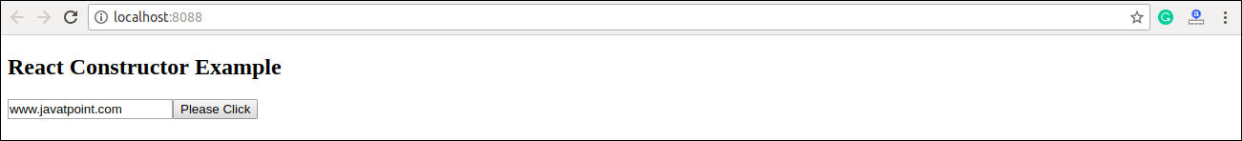

The most common question related to the constructor are:

**1. Is it necessary to have a constructor in every component?**

No, it is not necessary to have a constructor in every component. If the component is not complex, it simply returns a node.

1. **class** App **extends** Component {
2. render () {
3. **return** (
4. <p> Name: { **this**.props.name }</p>
5. );
6. }
7. }

**2. Is it necessary to call super() inside a constructor?**

Yes, it is necessary to call super() inside a constructor. If you need to set a property or access 'this' inside the constructor in your component, you need to call super().

1. **class** App **extends** Component {
2. constructor(props){
3. **this**.fName = "Jhon"; // 'this' is not allowed before super()
4. }
5. render () {
6. **return** (
7. <p> Name: { **this**.props.name }</p>
8. );
9. }
10. }

When you run the above code, you get an error saying **'this' is not allowed before super()**. So if you need to access the props inside the constructor, you need to call super(props).

## Arrow Functions

The Arrow function is the new feature of the ES6 standard. If you need to use arrow functions, it is not necessary to bind any event to 'this.' Here, the scope of 'this' is global and not limited to any calling function. So If you are using Arrow Function, there is no need to bind 'this' inside the constructor.

1. **import** React, { Component } from 'react';
3. **class** App **extends** Component {
4. constructor(props){
5. **super**(props);
6. **this**.state = {
7. data: 'www.javatpoint.com'
8. }
9. }
10. handleEvent = () => {
11. console.log(**this**.props);
12. }
13. render() {
14. **return** (
15. <div className="App">
16. <h2>React Constructor Example</h2>
17. <input type ="text" value={**this**.state.data} />
18. <button onClick={**this**.handleEvent}>Please Click</button>
19. </div>
20. );
21. }
22. }
23. export **default** App;

We can use a constructor in the following ways:

**1) The constructor is used to initialize state.**

1. **class** App **extends** Component {
2. constructor(props){
3. // here, it is setting initial value for 'inputTextValue'
4. **this**.state = {
5. inputTextValue: 'initial value',
6. };
7. }
8. }

**2) Using 'this' inside constructor**

1. **class** App **extends** Component {
2. constructor(props) {
3. // when you use 'this' in constructor, super() needs to be called first
4. **super**();
5. // it means, when you want to use 'this.props' in constructor, call it as below
6. **super**(props);
7. }
8. }

**3) Initializing third-party libraries**

1. **class** App **extends** Component {
2. constructor(props) {
4. **this**.myBook = **new** MyBookLibrary();
6. //Here, you can access props without using 'this'
7. **this**.Book2 = **new** MyBookLibrary(props.environment);
8. }
9. }

**4) Binding some context(this) when you need a class method to be passed in props to children.**

1. **class** App **extends** Component {
2. constructor(props) {
4. // when you need to 'bind' context to a function
5. **this**.handleFunction = **this**.handleFunction.bind(**this**);
6. }
7. }

# **React Component API**

ReactJS component is a top-level API. It makes the code completely individual and reusable in the application. It includes various methods for:

* Creating elements
* Transforming elements
* Fragments

Here, we are going to explain the three most important methods available in the React component API.

1. setState()
2. forceUpdate()
3. findDOMNode()

## setState()

This method is used to update the state of the component. This method does not always replace the state immediately. Instead, it only adds changes to the original state. It is a primary method that is used to update the user interface(UI) in response to event handlers and server responses.

#### **Note: In the ES6 classes, this.method.bind(this) is used to manually bind the setState() method.**

### **Syntax**

1. **this**.stateState(object newState[, function callback]);

In the above syntax, there is an optional **callback** function which is executed once setState() is completed and the component is re-rendered.

Play Video

### **Example**

1. **import** React, { Component } from 'react';
2. **import** PropTypes from 'prop-types';
3. **class** App **extends** React.Component {
4. constructor() {
5. **super**();
6. **this**.state = {
7. msg: "Welcome to JavaTpoint"
8. };
9. **this**.updateSetState = **this**.updateSetState.bind(**this**);
10. }
11. updateSetState() {
12. **this**.setState({
13. msg:"Its a best ReactJS tutorial"
14. });
15. }
16. render() {
17. **return** (
18. <div>
19. <h1>{**this**.state.msg}</h1>
20. <button onClick = {**this**.updateSetState}>SET STATE</button>
21. </div>
22. );
23. }
24. }
25. export **default** App;

**Main.js**

1. **import** React from 'react';
2. **import** ReactDOM from 'react-dom';
3. **import** App from './App.js';
5. ReactDOM.render(<App/>, document.getElementById('app'));

**Output:**

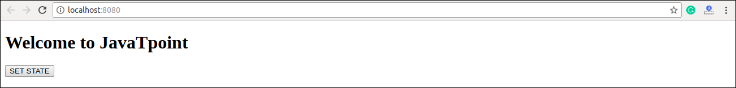

When you click on the **SET STATE** button, you will see the following screen with the updated message.

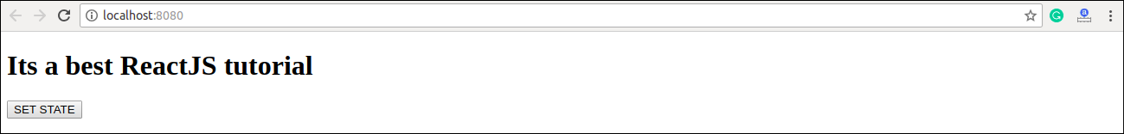

## forceUpdate()

This method allows us to update the component manually.

### **Syntax**

1. Component.forceUpdate(callback);

### **Example**

**App.js**

1. **import** React, { Component } from 'react';
2. **class** App **extends** React.Component {
3. constructor() {
4. **super**();
5. **this**.forceUpdateState = **this**.forceUpdateState.bind(**this**);
6. }
7. forceUpdateState() {
8. **this**.forceUpdate();
9. };
10. render() {
11. **return** (
12. <div>
13. <h1>Example to generate random number</h1>
14. <h3>Random number: {Math.random()}</h3>
15. <button onClick = {**this**.forceUpdateState}>ForceUpdate</button>
16. </div>
17. );
18. }
19. }
20. export **default** App;

**Output:**

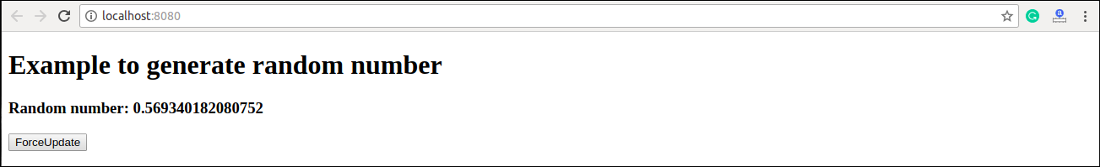

Each time when you click on **ForceUpdate** button, it will generate the **random** number. It can be shown in the below image.

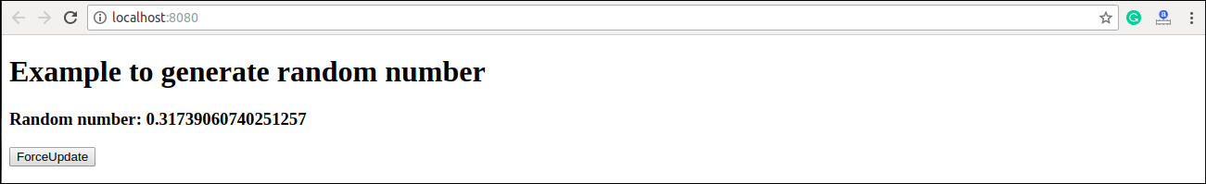

## findDOMNode()

For DOM manipulation, you need to use **ReactDOM.findDOMNode()** method. This method allows us to find or access the underlying DOM node.

### **Syntax**

1. ReactDOM.findDOMNode(component);

### **Example**

For DOM manipulation, first, you need to import this line: **import ReactDOM** from '**react-dom**' in your **App.js** file.

**App.js**

1. **import** React, { Component } from 'react';
2. **import** ReactDOM from 'react-dom';
3. **class** App **extends** React.Component {
4. constructor() {
5. **super**();
6. **this**.findDomNodeHandler1 = **this**.findDomNodeHandler1.bind(**this**);
7. **this**.findDomNodeHandler2 = **this**.findDomNodeHandler2.bind(**this**);
8. };
9. findDomNodeHandler1() {
10. var myDiv = document.getElementById('myDivOne');
11. ReactDOM.findDOMNode(myDivOne).style.color = 'red';
12. }
13. findDomNodeHandler2() {
14. var myDiv = document.getElementById('myDivTwo');
15. ReactDOM.findDOMNode(myDivTwo).style.color = 'blue';
16. }
17. render() {
18. **return** (
19. <div>
20. <h1>ReactJS Find DOM Node Example</h1>
21. <button onClick = {**this**.findDomNodeHandler1}>FIND_DOM_NODE1</button>
22. <button onClick = {**this**.findDomNodeHandler2}>FIND_DOM_NODE2</button>
23. <h3 id = "myDivOne">JTP-NODE1</h3>
24. <h3 id = "myDivTwo">JTP-NODE2</h3>
25. </div>
26. );
27. }
28. }
29. export **default** App;

**Output:**

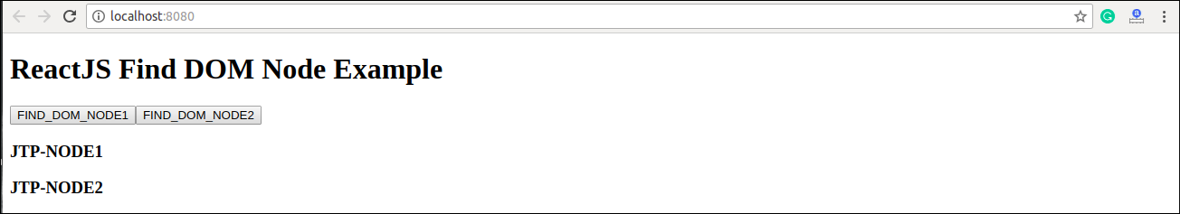

Once you click on the **button**, the color of the node gets changed. It can be shown in the below screen.

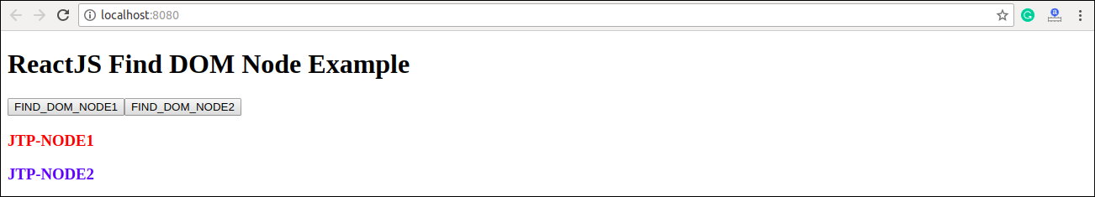

# **React Component Life-Cycle**

In ReactJS, every component creation process involves various lifecycle methods. These lifecycle methods are termed as component's lifecycle. These lifecycle methods are not very complicated and called at various points during a component's life. The lifecycle of the component is divided into **four phases**. They are:

1. Initial Phase
2. Mounting Phase
3. Updating Phase
4. Unmounting Phase

Each phase contains some lifecycle methods that are specific to the particular phase. Let us discuss each of these phases one by one.

## 1. Initial Phase

It is the **birth** phase of the lifecycle of a ReactJS component. Here, the component starts its journey on a way to the DOM. In this phase, a component contains the default Props and initial State. These default properties are done in the constructor of a component. The initial phase only occurs once and consists of the following methods.

* **getDefaultProps()**  
  It is used to specify the default value of this.props. It is invoked before the creation of the component or any props from the parent is passed into it.
* **getInitialState()**  
  It is used to specify the default value of this.state. It is invoked before the creation of the component.

## 2. Mounting Phase

In this phase, the instance of a component is created and inserted into the DOM. It consists of the following methods.

* **componentWillMount()**  
  This is invoked immediately before a component gets rendered into the DOM. In the case, when you call **setState()** inside this method, the component will not **re-render**.
* **componentDidMount()**  
  This is invoked immediately after a component gets rendered and placed on the DOM. Now, you can do any DOM querying operations.
* **render()**  
  This method is defined in each and every component. It is responsible for returning a single root **HTML node** element. If you don't want to render anything, you can return a **null** or **false** value.

## 3. Updating Phase

It is the next phase of the lifecycle of a react component. Here, we get new **Props** and change **State**. This phase also allows to handle user interaction and provide communication with the components hierarchy. The main aim of this phase is to ensure that the component is displaying the latest version of itself. Unlike the Birth or Death phase, this phase repeats again and again. This phase consists of the following methods.

* **componentWillRecieveProps()**  
  It is invoked when a component receives new props. If you want to update the state in response to prop changes, you should compare this.props and nextProps to perform state transition by using **this.setState()** method.
* **shouldComponentUpdate()**  
  It is invoked when a component decides any changes/updation to the DOM. It allows you to control the component's behavior of updating itself. If this method returns true, the component will update. Otherwise, the component will skip the updating.
* **componentWillUpdate()**  
  It is invoked just before the component updating occurs. Here, you can't change the component state by invoking **this.setState()** method. It will not be called, if **shouldComponentUpdate()** returns false.
* **render()**  
  It is invoked to examine **this.props** and **this.state** and return one of the following types: React elements, Arrays and fragments, Booleans or null, String and Number. If shouldComponentUpdate() returns false, the code inside render() will be invoked again to ensure that the component displays itself properly.
* **componentDidUpdate()**  
  It is invoked immediately after the component updating occurs. In this method, you can put any code inside this which you want to execute once the updating occurs. This method is not invoked for the initial render.

## 4. Unmounting Phase

It is the final phase of the react component lifecycle. It is called when a component instance is **destroyed** and **unmounted** from the DOM. This phase contains only one method and is given below.

* **componentWillUnmount()**  
  This method is invoked immediately before a component is destroyed and unmounted permanently. It performs any necessary **cleanup** related task such as invalidating timers, event listener, canceling network requests, or cleaning up DOM elements. If a component instance is unmounted, you cannot mount it again.

### **Example**

1. **import** React, { Component } from 'react';
3. **class** App **extends** React.Component {
4. constructor(props) {
5. **super**(props);
6. **this**.state = {hello: "JavaTpoint"};
7. **this**.changeState = **this**.changeState.bind(**this**)
8. }
9. render() {
10. **return** (
11. <div>
12. <h1>ReactJS component's Lifecycle</h1>
13. <h3>Hello {**this**.state.hello}</h3>
14. <button onClick = {**this**.changeState}>Click Here!</button>
15. </div>
16. );
17. }
18. componentWillMount() {
19. console.log('Component Will MOUNT!')
20. }
21. componentDidMount() {
22. console.log('Component Did MOUNT!')
23. }
24. changeState(){
25. **this**.setState({hello:"All!!- Its a great reactjs tutorial."});
26. }
27. componentWillReceiveProps(newProps) {
28. console.log('Component Will Recieve Props!')
29. }
30. shouldComponentUpdate(newProps, newState) {
31. **return** **true**;
32. }
33. componentWillUpdate(nextProps, nextState) {
34. console.log('Component Will UPDATE!');
35. }
36. componentDidUpdate(prevProps, prevState) {
37. console.log('Component Did UPDATE!')
38. }
39. componentWillUnmount() {
40. console.log('Component Will UNMOUNT!')
41. }
42. }
43. export **default** App;

**Output:**

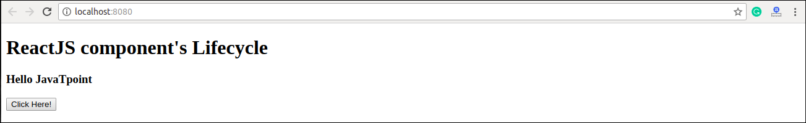

When you click on the **Click Here** Button, you get the updated result which is shown in the below screen.

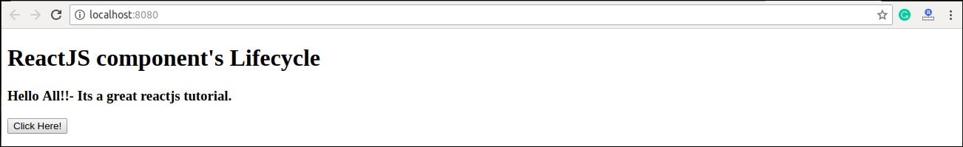

# **React Forms**

Forms are an integral part of any modern web application. It allows the users to interact with the application as well as gather information from the users. Forms can perform many tasks that depend on the nature of your business requirements and logic such as authentication of the user, adding user, searching, filtering, booking, ordering, etc. A form can contain text fields, buttons, checkbox, radio button, etc.

## Creating Form

React offers a stateful, reactive approach to build a form. The component rather than the DOM usually handles the React form. In React, the form is usually implemented by using controlled components.

There are mainly two types of form input in React.

1. Uncontrolled component
2. Controlled component

### **Uncontrolled component**

The uncontrolled input is similar to the traditional HTML form inputs. The DOM itself handles the form data. Here, the HTML elements maintain their own state that will be updated when the input value changes. To write an uncontrolled component, you need to use a ref to get form values from the DOM. In other words, there is no need to write an event handler for every state update. You can use a ref to access the input field value of the form from the DOM.

**Example**

In this example, the code accepts a field **username** and **company name** in an uncontrolled component.

1. **import** React, { Component } from 'react';
2. **class** App **extends** React.Component {
3. constructor(props) {
4. **super**(props);
5. **this**.updateSubmit = **this**.updateSubmit.bind(**this**);
6. **this**.input = React.createRef();
7. }
8. updateSubmit(event) {
9. alert('You have entered the UserName and CompanyName successfully.');
10. event.preventDefault();
11. }
12. render() {
13. **return** (
14. <form onSubmit={**this**.updateSubmit}>
15. <h1>Uncontrolled Form Example</h1>
16. <label>Name:
17. <input type="text" ref={**this**.input} />
18. </label>
19. <label>
20. CompanyName:
21. <input type="text" ref={**this**.input} />
22. </label>
23. <input type="submit" value="Submit" />
24. </form>
25. );
26. }
27. }
28. export **default** App;

**Output**

When you execute the above code, you will see the following screen.

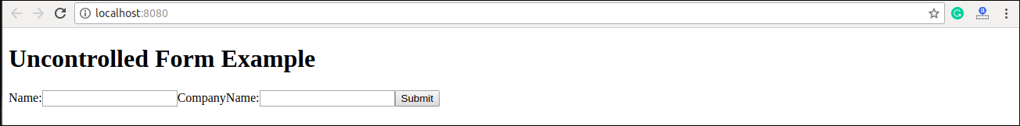

After filling the data in the field, you get the message that can be seen in the below screen.

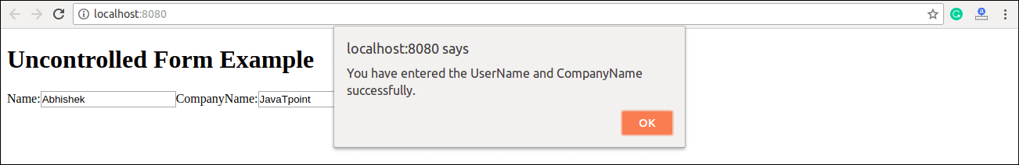

### **Controlled Component**

In HTML, form elements typically maintain their own state and update it according to the user input. In the controlled component, the input form element is handled by the component rather than the DOM. Here, the mutable state is kept in the state property and will be updated only with **setState()** method.

Controlled components have functions that govern the data passing into them on every **onChange event**, rather than grabbing the data only once, e.g., when you click a **submit button**. This data is then saved to state and updated with setState() method. This makes component have better control over the form elements and data.

A controlled component takes its current value through **props** and notifies the changes through **callbacks** like an onChange event. A parent component "controls" this changes by handling the callback and managing its own state and then passing the new values as props to the controlled component. It is also called as a "dumb component."

**Example**

1. **import** React, { Component } from 'react';
2. **class** App **extends** React.Component {
3. constructor(props) {
4. **super**(props);
5. **this**.state = {value: ''};
6. **this**.handleChange = **this**.handleChange.bind(**this**);
7. **this**.handleSubmit = **this**.handleSubmit.bind(**this**);
8. }
9. handleChange(event) {
10. **this**.setState({value: event.target.value});
11. }
12. handleSubmit(event) {
13. alert('You have submitted the input successfully: ' + **this**.state.value);
14. event.preventDefault();
15. }
16. render() {
17. **return** (
18. <form onSubmit={**this**.handleSubmit}>
19. <h1>Controlled Form Example</h1>
20. <label>
21. Name:
22. <input type="text" value={**this**.state.value} onChange={**this**.handleChange} />
23. </label>
24. <input type="submit" value="Submit" />
25. </form>
26. );
27. }
28. }
29. export **default** App;

**Output**

When you execute the above code, you will see the following screen.

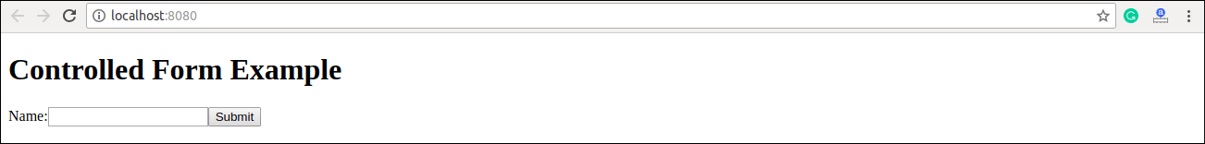

After filling the data in the field, you get the message that can be seen in the below screen.

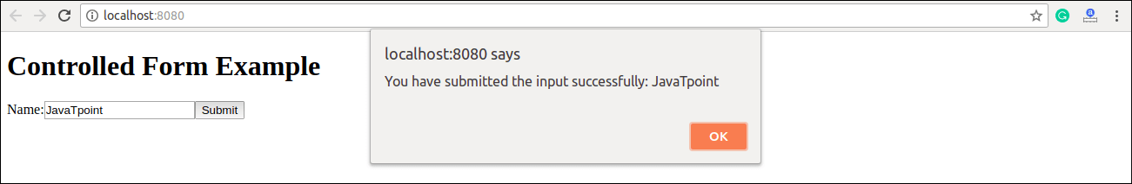

## Handling Multiple Inputs in Controlled Component

If you want to handle multiple controlled input elements, add a **name** attribute to each element, and then the handler function decided what to do based on the value of **event.target.name**.

### **Example**

1. **import** React, { Component } from 'react';
2. **class** App **extends** React.Component {
3. constructor(props) {
4. **super**(props);
5. **this**.state = {
6. personGoing: **true**,
7. numberOfPersons: 5
8. };
9. **this**.handleInputChange = **this**.handleInputChange.bind(**this**);
10. }
11. handleInputChange(event) {
12. **const** target = event.target;
13. **const** value = target.type === 'checkbox' ? target.checked : target.value;
14. **const** name = target.name;
15. **this**.setState({
16. [name]: value
17. });
18. }
19. render() {
20. **return** (
21. <form>
22. <h1>Multiple Input Controlled Form Example</h1>
23. <label>
24. Is Person going:
25. <input
26. name="personGoing"
27. type="checkbox"
28. checked={**this**.state.personGoing}
29. onChange={**this**.handleInputChange} />
30. </label>
31. <br />
32. <label>
33. Number of persons:
34. <input
35. name="numberOfPersons"
36. type="number"
37. value={**this**.state.numberOfPersons}
38. onChange={**this**.handleInputChange} />
39. </label>
40. </form>
41. );
42. }
43. }
44. export **default** App;

**Output**

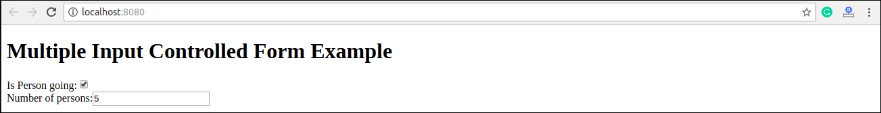

# **React Controlled Vs. Uncontrolled Component**

## Controlled Component

A controlled component is bound to a value, and its changes will be handled in code by using **event-based callbacks**. Here, the input form element is handled by the react itself rather than the DOM. In this, the mutable state is kept in the state property and will be updated only with setState() method.

Controlled components have functions that govern the data passing into them on every **onChange** event occurs. This data is then saved to state and updated with setState() method. It makes component have better control over the form elements and data.

## Uncontrolled Component

It is similar to the traditional HTML form inputs. Here, the form data is handled by the DOM itself. It maintains their own state and will be updated when the input value changes. To write an uncontrolled component, there is no need to write an event handler for every state update, and you can use a ref to access the value of the form from the DOM.

## Difference table between controlled and uncontrolled component

|  |  |  |
| --- | --- | --- |
| **SN** | **Controlled** | **Uncontrolled** |
| **1.** | It does not maintain its internal state. | It maintains its internal states. |
| **2.** | Here, data is controlled by the parent component. | Here, data is controlled by the DOM itself. |
| **3.** | It accepts its current value as a prop. | It uses a ref for their current values. |
| **4.** | It allows validation control. | It does not allow validation control. |
| **5.** | It has better control over the form elements and data. | It has limited control over the form elements and data. |

# **React Events**

An event is an action that could be triggered as a result of the user action or system generated event. For example, a mouse click, loading of a web page, pressing a key, window resizes, and other interactions are called events.

React has its own event handling system which is very similar to handling events on DOM elements. The react event handling system is known as Synthetic Events. The synthetic event is a cross-browser wrapper of the browser's native event.

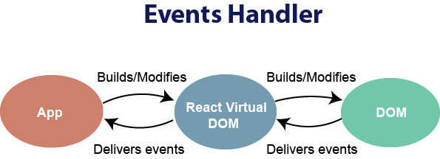

Handling events with react have some syntactic differences from handling events on DOM. These are:

1. React events are named as **camelCase** instead of **lowercase**.
2. With JSX, a function is passed as the **event handler** instead of a **string**. For example:

**Event declaration in plain HTML:**

1. <button onclick="showMessage()">
2. Hello JavaTpoint
3. </button>

**Event declaration in React:**

1. <button onClick={showMessage}>
2. Hello JavaTpoint
3. </button>

3. In react, we cannot return **false** to prevent the **default** behavior. We must call **preventDefault** event explicitly to prevent the default behavior. For example:

In plain HTML, to prevent the default link behavior of opening a new page, we can write:

1. <a href="#" onclick="console.log('You had clicked a Link.'); return false">
2. Click_Me
3. </a>

In React, we can write it as:

1. function ActionLink() {
2. function handleClick(e) {
3. e.preventDefault();
4. console.log('You had clicked a Link.');
5. }
6. **return** (
7. <a href="#" onClick={handleClick}>
8. Click_Me
9. </a>
10. );
11. }

In the above example, e is a **Synthetic Event** which defines according to the **W3C** spec.

Now let us see how to use Event in React.

### **Example**

In the below example, we have used only one component and adding an onChange event. This event will trigger the **changeText** function, which returns the company name.

1. **import** React, { Component } from 'react';
2. **class** App **extends** React.Component {
3. constructor(props) {
4. **super**(props);
5. **this**.state = {
6. companyName: ''
7. };
8. }
9. changeText(event) {
10. **this**.setState({
11. companyName: event.target.value
12. });
13. }
14. render() {
15. **return** (
16. <div>
17. <h2>Simple Event Example</h2>
18. <label htmlFor="name">Enter company name: </label>
19. <input type="text" id="companyName" onChange={**this**.changeText.bind(**this**)}/>
20. <h4>You entered: { **this**.state.companyName }</h4>
21. </div>
22. );
23. }
24. }
25. export **default** App;

**Output**

When you execute the above code, you will get the following output.

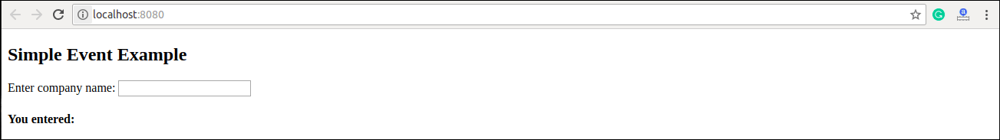

After entering the name in the textbox, you will get the output as like below screen.

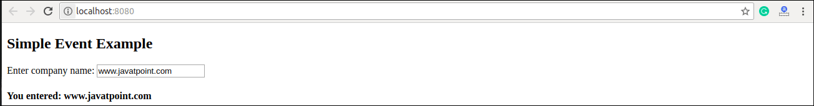

# **React Conditional Rendering**

In React, we can create multiple components which encapsulate behavior that we need. After that, we can render them depending on some conditions or the state of our application. In other words, based on one or several conditions, a component decides which elements it will return. In React, conditional rendering works the same way as the conditions work in JavaScript. We use JavaScript operators to create elements representing the current state, and then React Component update the UI to match them.

From the given scenario, we can understand how conditional rendering works. Consider an example of handling a **login/logout** button. The login and logout buttons will be separate components. If a user logged in, render the **logout component** to display the logout button. If a user not logged in, render the **login component** to display the login button. In React, this situation is called as **conditional rendering**.

There is more than one way to do conditional rendering in React. They are given below.

* if
* ternary operator
* logical && operator
* switch case operator
* Conditional Rendering with enums

## if

It is the easiest way to have a conditional rendering in React in the render method. It is restricted to the total block of the component. IF the condition is **true**, it will return the element to be rendered. It can be understood in the below example.

### **Example**

1. function UserLoggin(props) {
2. **return** <h1>Welcome back!</h1>;
3. }
4. function GuestLoggin(props) {
5. **return** <h1>Please sign up.</h1>;
6. }
7. function SignUp(props) {
8. **const** isLoggedIn = props.isLoggedIn;
9. **if** (isLoggedIn) {
10. **return** <UserLogin />;
11. }
12. **return** <GuestLogin />;
13. }
15. ReactDOM.render(
16. <SignUp isLoggedIn={**false**} />,
17. document.getElementById('root')
18. );

## Logical && operator

This operator is used for checking the condition. If the condition is **true**, it will return the element **right** after **&&**, and if it is **false**, React will **ignore** and skip it.

### **Syntax**

1. {
2. condition &&
3. // whatever written after && will be a part of output.
4. }

We can understand the behavior of this concept from the below example.

If you run the below code, you will not see the **alert** message because the condition is not matching.

1. ('javatpoint' == 'JavaTpoint') && alert('This alert will never be shown!')

If you run the below code, you will see the **alert** message because the condition is matching.

1. (10 > 5) && alert('This alert will be shown!')

### **Example**

1. **import** React from 'react';
2. **import** ReactDOM from 'react-dom';
3. // Example Component
4. function Example()
5. {
6. **return**(<div>
7. {
8. (10 > 5) && alert('This alert will be shown!')
9. }
10. </div>
11. );
12. }

You can see in the above output that as the condition **(10 > 5)** evaluates to true, the alert message is successfully rendered on the screen.

## Ternary operator

The ternary operator is used in cases where two blocks alternate given a certain condition. This operator makes your if-else statement more concise. It takes **three** operands and used as a shortcut for the if statement.

### **Syntax**

1. condition ?  **true** : **false**

If the condition is **true**, **statement1** will be rendered. Otherwise, **false** will be rendered.

### **Example**

1. render() {
2. **const** isLoggedIn = **this**.state.isLoggedIn;
3. **return** (
4. <div>
5. Welcome {isLoggedIn ? 'Back' : 'Please login first'}.
6. </div>
7. );
8. }

## Switch case operator

Sometimes it is possible to have multiple conditional renderings. In the switch case, conditional rendering is applied based on a different state.

### **Example**

1. function NotificationMsg({ text}) {
2. **switch**(text) {
3. **case** 'Hi All':
4. **return** <Message: text={text} />;
5. **case** 'Hello JavaTpoint':
6. **return** <Message text={text} />;
7. **default**:
8. **return** **null**;
9. }
10. }

## Conditional Rendering with enums

An **enum** is a great way to have a multiple conditional rendering. It is more **readable** as compared to switch case operator. It is perfect for **mapping** between different **state**. It is also perfect for mapping in more than one condition. It can be understood in the below example.

### **Example**

1. function NotificationMsg({ text, state }) {
2. **return** (
3. <div>
4. {{
5. info: <Message text={text} />,
6. warning: <Message text={text} />,
7. }[state]}
8. </div>
9. );
10. }

## Conditional Rendering Example

In the below example, we have created a **stateful** component called **App** which maintains the login control. Here, we create three components representing Logout, Login, and Message component. The stateful component App will render either or depending on its current **state**.

1. **import** React, { Component } from 'react';
2. // Message Component
3. function Message(props)
4. {
5. **if** (props.isLoggedIn)
6. **return** <h1>Welcome Back!!!</h1>;
7. **else**
8. **return** <h1>Please Login First!!!</h1>;
9. }
10. // Login Component
11. function Login(props)
12. {
13. **return**(
14. <button onClick = {props.clickInfo}> Login </button>
15. );
16. }
17. // Logout Component
18. function Logout(props)
19. {
20. **return**(
21. <button onClick = {props.clickInfo}> Logout </button>
22. );
23. }
24. **class** App **extends** Component{
25. constructor(props)
26. {
27. **super**(props);
28. **this**.handleLogin = **this**.handleLogin.bind(**this**);
29. **this**.handleLogout = **this**.handleLogout.bind(**this**);
30. **this**.state = {isLoggedIn : **false**};
31. }
32. handleLogin()
33. {
34. **this**.setState({isLoggedIn : **true**});
35. }
36. handleLogout()
37. {
38. **this**.setState({isLoggedIn : **false**});
39. }
40. render(){
41. **return**(
42. <div>
43. <h1> Conditional Rendering Example </h1>
44. <Message isLoggedIn = {**this**.state.isLoggedIn}/>
45. {
46. (**this**.state.isLoggedIn)?(
47. <Logout clickInfo = {**this**.handleLogout} />
48. ) : (
49. <Login clickInfo = {**this**.handleLogin} />
50. )
51. }
52. </div>
53. );
54. }
55. }
56. export **default** App;

**Output:**

When you execute the above code, you will get the following screen.

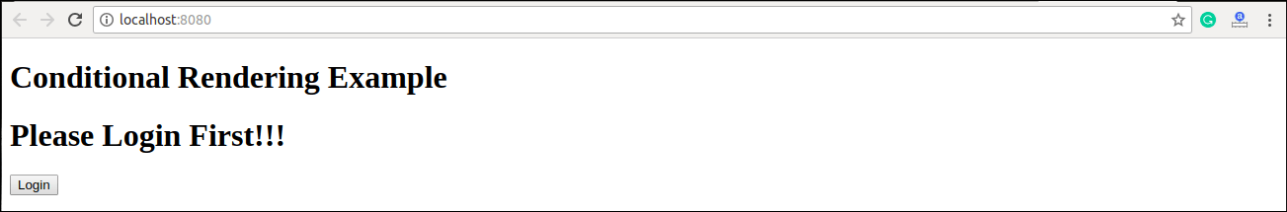

After clicking the logout button, you will get the below screen.

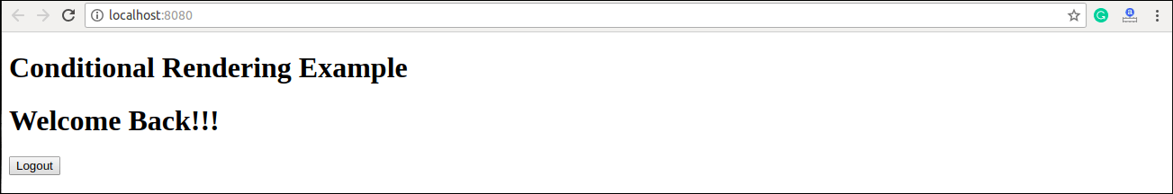

## Preventing Component form Rendering

Sometimes it might happen that a component hides itself even though another component rendered it. To do this (prevent a component from rendering), we will have to return **null** instead of its render output. It can be understood in the below example:

### **Example**

In this example, the is rendered based on the value of the prop called **displayMessage**. If the prop value is false, then the component does not render.

1. **import** React from 'react';
2. **import** ReactDOM from 'react-dom';
3. function Show(props)
4. {
5. **if**(!props.displayMessage)
6. **return** **null**;
7. **else**
8. **return** <h3>Component is rendered</h3>;
9. }
10. ReactDOM.render(
11. <div>
12. <h1>Message</h1>
13. <Show displayMessage = {**true**} />
14. </div>,
15. document.getElementById('app')
16. );

**Output:**

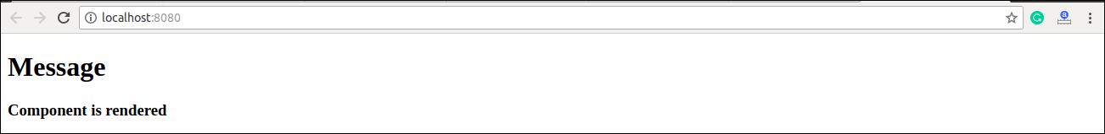

# **React Lists**

Lists are used to display data in an ordered format and mainly used to display menus on websites. In React, Lists can be created in a similar way as we create lists in JavaScript. Let us see how we transform Lists in regular JavaScript.

The map() function is used for traversing the lists. In the below example, the map() function takes an array of numbers and multiply their values with 5. We assign the new array returned by map() to the variable multiplyNums and log it.

### **Example**

1. var numbers = [1, 2, 3, 4, 5];
2. **const** multiplyNums = numbers.map((number)=>{
3. **return** (number * 5);
4. });
5. console.log(multiplyNums);

**Output**

The above JavaScript code will log the output on the console. The output of the code is given below.

[5, 10, 15, 20, 25]

Now, let us see how we create a list in React. To do this, we will use the map() function for traversing the list element, and for updates, we enclosed them between **curly braces {}**. Finally, we assign the array elements to listItems. Now, include this new list inside **<ul> </ul>** elements and render it to the DOM.

### **Example**

1. **import** React from 'react';
2. **import** ReactDOM from 'react-dom';
4. **const** myList = ['Peter', 'Sachin', 'Kevin', 'Dhoni', 'Alisa'];
5. **const** listItems = myList.map((myList)=>{
6. **return** <li>{myList}</li>;
7. });
8. ReactDOM.render(
9. <ul> {listItems} </ul>,
10. document.getElementById('app')
11. );
12. export **default** App;

**Output**

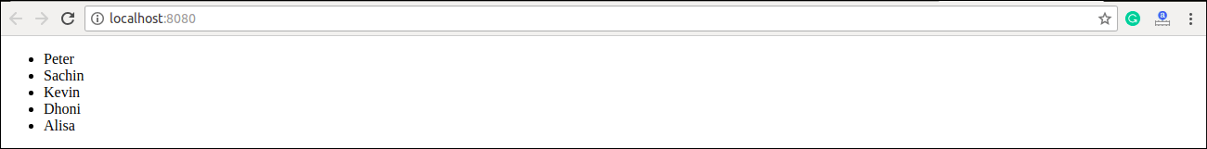

## Rendering Lists inside components

In the previous example, we had directly rendered the list to the DOM. But it is not a good practice to render lists in React. In React, we had already seen that everything is built as individual components. Hence, we would need to render lists inside a component. We can understand it in the following code.

### **Example**

1. **import** React from 'react';
2. **import** ReactDOM from 'react-dom';
4. function NameList(props) {
5. **const** myLists = props.myLists;
6. **const** listItems = myLists.map((myList) =>
7. <li>{myList}</li>
8. );
9. **return** (
10. <div>
11. <h2>Rendering Lists inside component</h2>
12. <ul>{listItems}</ul>
13. </div>
14. );
15. }
16. **const** myLists = ['Peter', 'Sachin', 'Kevin', 'Dhoni', 'Alisa'];
17. ReactDOM.render(
18. <NameList myLists={myLists} />,
19. document.getElementById('app')
20. );
21. export **default** App;

**Output**

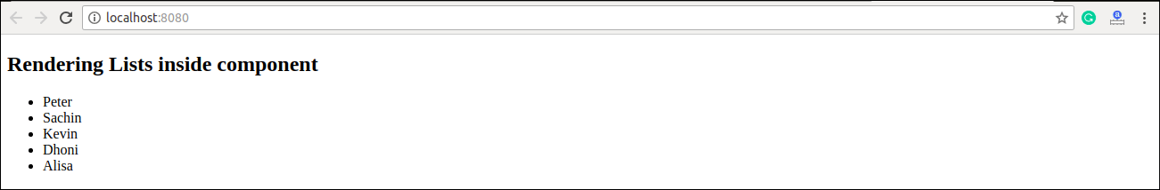

# **React Keys**

A key is a unique identifier. In React, it is used to identify which items have changed, updated, or deleted from the Lists. It is useful when we dynamically created components or when the users alter the lists. It also helps to determine which components in a collection needs to be re-rendered instead of re-rendering the entire set of components every time.

Keys should be given inside the array to give the elements a stable identity. The best way to pick a key as a string that uniquely identifies the items in the list. It can be understood with the below example.

### **Example**

1. **const** stringLists = [ 'Peter', 'Sachin', 'Kevin', 'Dhoni', 'Alisa' ];
3. **const** updatedLists = stringLists.map((strList)=>{
4. <li key={strList.id}> {strList} </li>;
5. });

If there are no stable IDs for rendered items, you can assign the item **index** as a key to the lists. It can be shown in the below example.

### **Example**

1. **const** stringLists = [ 'Peter', 'Sachin', 'Kevin', 'Dhoni', 'Alisa' ];
3. **const** updatedLists = stringLists.map((strList, index)=>{
4. <li key={index}> {strList} </li>;
5. });

#### **Note: It is not recommended to use indexes for keys if the order of the item may change in future. It creates confusion for the developer and may cause issues with the component state.**

## Using Keys with component

Consider you have created a separate component for **ListItem** and extracting ListItem from that component. In this case, you should have to assign keys on the **<ListItem />** elements in the array, not to the **<li>** elements in the ListItem itself. To avoid mistakes, you have to keep in mind that keys only make sense in the context of the surrounding array. So, anything you are returning from map() function is recommended to be assigned a key.

### **Example: Incorrect Key usage**

1. **import** React from 'react';
2. **import** ReactDOM from 'react-dom';
4. function ListItem(props) {
5. **const** item = props.item;
6. **return** (
7. // Wrong! No need to specify the key here.
8. <li key={item.toString()}>
9. {item}
10. </li>
11. );
12. }
13. function NameList(props) {
14. **const** myLists = props.myLists;
15. **const** listItems = myLists.map((strLists) =>
16. // The key should have been specified here.
17. <ListItem item={strLists} />
18. );
19. **return** (
20. <div>
21. <h2>Incorrect Key Usage Example</h2>
22. <ol>{listItems}</ol>
23. </div>
24. );
25. }
26. **const** myLists = ['Peter', 'Sachin', 'Kevin', 'Dhoni', 'Alisa'];
27. ReactDOM.render(
28. <NameList myLists={myLists}/>,
29. document.getElementById('app')
30. );
31. export **default** App;

In the given example, the list is rendered successfully. But it is not a good practice that we had not assigned a key to the map() iterator.

**Output**

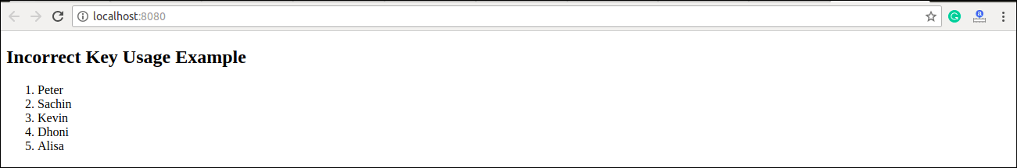

### **Example: Correct Key usage**

To correct the above example, we should have to assign key to the map() iterator.

1. **import** React from 'react';
2. **import** ReactDOM from 'react-dom';
4. function ListItem(props) {
5. **const** item = props.item;
6. **return** (
7. // No need to specify the key here.
8. <li> {item} </li>
9. );
10. }
11. function NameList(props) {
12. **const** myLists = props.myLists;
13. **const** listItems = myLists.map((strLists) =>
14. // The key should have been specified here.
15. <ListItem key={myLists.toString()} item={strLists} />
16. );
17. **return** (
18. <div>
19. <h2>Correct Key Usage Example</h2>
20. <ol>{listItems}</ol>
21. </div>
22. );
23. }
24. **const** myLists = ['Peter', 'Sachin', 'Kevin', 'Dhoni', 'Alisa'];
25. ReactDOM.render(
26. <NameList myLists={myLists}/>,
27. document.getElementById('app')
28. );
29. export **default** App;

**Output**

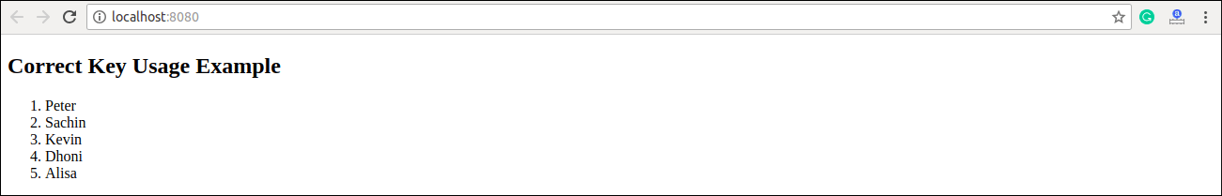

## Uniqueness of Keys among Siblings

We had discussed that keys assignment in arrays must be unique among their **siblings**. However, it doesn't mean that the keys should be **globally** unique. We can use the same set of keys in producing two different arrays. It can be understood in the below example.

### **Example**

1. **import** React from 'react';
2. **import** ReactDOM from 'react-dom';
3. function MenuBlog(props) {
4. **const** titlebar = (
5. <ol>
6. {props.data.map((show) =>
7. <li key={show.id}>
8. {show.title}
9. </li>
10. )}
11. </ol>
12. );
13. **const** content = props.data.map((show) =>
14. <div key={show.id}>
15. <h3>{show.title}: {show.content}</h3>
16. </div>
17. );
18. **return** (
19. <div>
20. {titlebar}
21. <hr />
22. {content}
23. </div>
24. );
25. }
26. **const** data = [
27. {id: 1, title: 'First', content: 'Welcome to JavaTpoint!!'},
28. {id: 2, title: 'Second', content: 'It is the best ReactJS Tutorial!!'},
29. {id: 3, title: 'Third', content: 'Here, you can learn all the ReactJS topics!!'}
30. ];
31. ReactDOM.render(
32. <MenuBlog data={data} />,
33. document.getElementById('app')
34. );
35. export **default** App;

**Output**

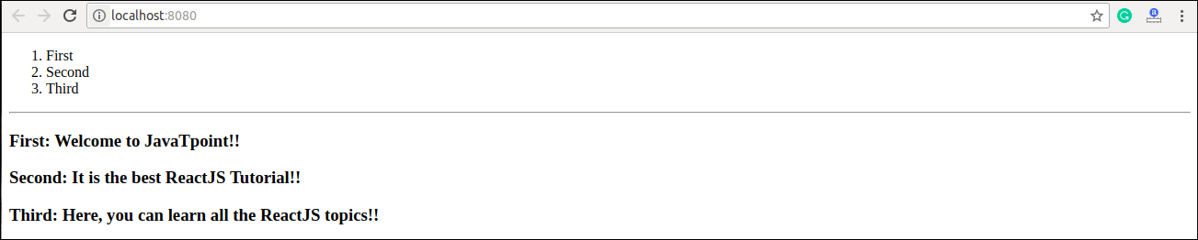

# **React Refs**

Refs is the shorthand used for **references** in React. It is similar to **keys** in React. It is an attribute which makes it possible to store a reference to particular DOM nodes or React elements. It provides a way to access React DOM nodes or React elements and how to interact with it. It is used when we want to change the value of a child component, without making the use of props.

## When to Use Refs

Refs can be used in the following cases:

* When we need DOM measurements such as managing focus, text selection, or media playback.
* It is used in triggering imperative animations.
* When integrating with third-party DOM libraries.
* It can also use as in callbacks.

## When to not use Refs

* Its use should be avoided for anything that can be done **declaratively**. For example, instead of using **open()** and **close()** methods on a Dialog component, you need to pass an **isOpen** prop to it.
* You should have to avoid overuse of the Refs.

## How to create Refs

In React, Refs can be created by using **React.createRef()**. It can be assigned to React elements via the **ref** attribute. It is commonly assigned to an instance property when a component is created, and then can be referenced throughout the component.

1. **class** MyComponent **extends** React.Component {
2. constructor(props) {
3. **super**(props);
4. **this**.callRef = React.createRef();
5. }
6. render() {
7. **return** <div ref={**this**.callRef} />;
8. }
9. }

## How to access Refs

In React, when a ref is passed to an element inside render method, a reference to the node can be accessed via the current attribute of the ref.

1. **const** node = **this**.callRef.current;

## Refs current Properties

The ref value differs depending on the type of the node:

* When the ref attribute is used in HTML element, the ref created with **React.createRef()** receives the underlying DOM element as its **current** property.
* If the ref attribute is used on a custom class component, then ref object receives the **mounted** instance of the component as its current property.
* The ref attribute cannot be used on **function components** because they don't have instances.

## Add Ref to DOM elements

In the below example, we are adding a ref to store the reference to a DOM node or element.

1. **import** React, { Component } from 'react';
2. **import** { render } from 'react-dom';
4. **class** App **extends** React.Component {
5. constructor(props) {
6. **super**(props);
7. **this**.callRef = React.createRef();
8. **this**.addingRefInput = **this**.addingRefInput.bind(**this**);
9. }
11. addingRefInput() {
12. **this**.callRef.current.focus();
13. }
15. render() {
16. **return** (
17. <div>
18. <h2>Adding Ref to DOM element</h2>
19. <input
20. type="text"
21. ref={**this**.callRef} />
22. <input
23. type="button"
24. value="Add text input"
25. onClick={**this**.addingRefInput}
26. />
27. </div>
28. );
29. }
30. }
31. export **default** App;

**Output**

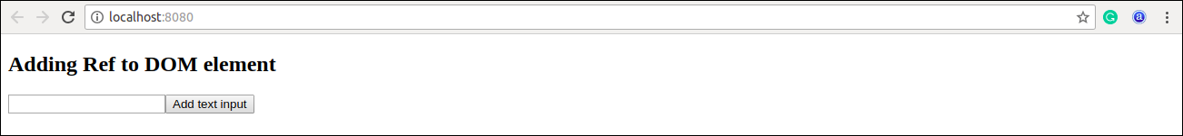

## Add Ref to Class components

In the below example, we are adding a ref to store the reference to a class component.

### **Example**

1. **import** React, { Component } from 'react';
2. **import** { render } from 'react-dom';
4. function CustomInput(props) {
5. let callRefInput = React.createRef();
7. function handleClick() {
8. callRefInput.current.focus();
9. }
11. **return** (
12. <div>
13. <h2>Adding Ref to Class Component</h2>
14. <input
15. type="text"
16. ref={callRefInput} />
17. <input
18. type="button"
19. value="Focus input"
20. onClick={handleClick}
21. />
22. </div>
23. );
24. }
25. **class** App **extends** React.Component {
26. constructor(props) {
27. **super**(props);
28. **this**.callRefInput = React.createRef();
29. }
31. focusRefInput() {
32. **this**.callRefInput.current.focus();
33. }
35. render() {
36. **return** (
37. <CustomInput ref={**this**.callRefInput} />
38. );
39. }
40. }
41. export **default** App;

**Output**

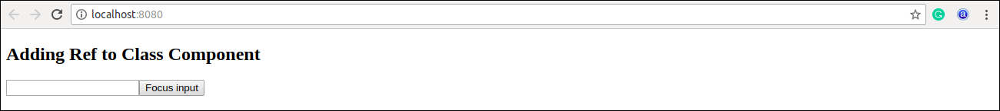

## Callback refs

In react, there is another way to use refs that is called "**callback refs**" and it gives more control when the refs are **set** and **unset**. Instead of creating refs by createRef() method, React allows a way to create refs by passing a callback function to the ref attribute of a component. It looks like the below code.

1. <input type="text" ref={element => **this**.callRefInput = element} />

The callback function is used to store a reference to the DOM node in an instance property and can be accessed elsewhere. It can be accessed as below:

1. **this**.callRefInput.value

The example below helps to understand the working of callback refs.

1. **import** React, { Component } from 'react';
2. **import** { render } from 'react-dom';
4. **class** App **extends** React.Component {
5. constructor(props) {
6. **super**(props);
8. **this**.callRefInput = **null**;
10. **this**.setInputRef = element => {
11. **this**.callRefInput = element;
12. };
14. **this**.focusRefInput = () => {
15. //Focus the input using the raw DOM API
16. **if** (**this**.callRefInput) **this**.callRefInput.focus();
17. };
18. }
20. componentDidMount() {
21. //autofocus of the input on mount
22. **this**.focusRefInput();
23. }
25. render() {
26. **return** (
27. <div>
28. <h2>Callback Refs Example</h2>
29. <input
30. type="text"
31. ref={**this**.setInputRef}
32. />
33. <input
34. type="button"
35. value="Focus input text"
36. onClick={**this**.focusRefInput}
37. />
38. </div>
39. );
40. }
41. }
42. export **default** App;

In the above example, React will call the "ref" callback to store the reference to the input DOM element when the component **mounts**, and when the component **unmounts**, call it with **null**. Refs are always **up-to-date** before the **componentDidMount** or **componentDidUpdate** fires. The callback refs pass between components is the same as you can work with object refs, which is created with React.createRef().

**Output**

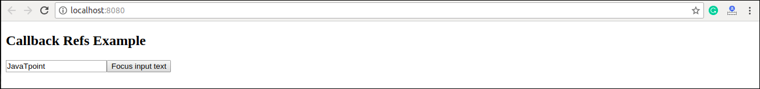

## Forwarding Ref from one component to another component

Ref forwarding is a technique that is used for passing a **ref** through a component to one of its child components. It can be performed by making use of the **React.forwardRef()** method. This technique is particularly useful with **higher-order components** and specially used in reusable component libraries. The most common example is given below.

### **Example**

1. **import** React, { Component } from 'react';
2. **import** { render } from 'react-dom';
4. **const** TextInput = React.forwardRef((props, ref) => (
5. <input type="text" placeholder="Hello World" ref={ref} />
6. ));
8. **const** inputRef = React.createRef();
10. **class** CustomTextInput **extends** React.Component {
11. handleSubmit = e => {
12. e.preventDefault();
13. console.log(inputRef.current.value);
14. };
15. render() {
16. **return** (
17. <div>
18. <form onSubmit={e => **this**.handleSubmit(e)}>
19. <TextInput ref={inputRef} />
20. <button>Submit</button>
21. </form>
22. </div>
23. );
24. }
25. }
26. export **default** App;

In the above example, there is a component **TextInput** that has a child as an input field. Now, to pass or forward the **ref** down to the input, first, create a ref and then pass your ref down to **<TextInput ref={inputRef}>**. After that, React forwards the ref to the **forwardRef** function as a second argument. Next, we forward this ref argument down to **<input ref={ref}>**. Now, the value of the DOM node can be accessed at **inputRef.current**.

## React with useRef()

It is introduced in **React 16.7** and above version. It helps to get access the DOM node or element, and then we can interact with that DOM node or element such as focussing the input element or accessing the input element value. It returns the ref object whose **.current** property initialized to the passed argument. The returned object persist for the lifetime of the component.

### **Syntax**

1. **const** refContainer = useRef(initialValue);

### **Example**

In the below code, **useRef** is a function that gets assigned to a variable, **inputRef**, and then attached to an attribute called ref inside the HTML element in which you want to reference.

1. function useRefExample() {
2. **const** inputRef= useRef(**null**);
3. **const** onButtonClick = () => {
4. inputRef.current.focus();
5. };
6. **return** (
7. <>
8. <input ref={inputRef} type="text" />
9. <button onClick={onButtonClick}>Submit</button>
10. </>
11. );
12. }

# **React Fragments**

In React, whenever you want to render something on the screen, you need to use a render method inside the component. This render method can return **single** elements or **multiple** elements. The render method will only render a single root node inside it at a time. However, if you want to return multiple elements, the render method will require a '**div**' tag and put the entire content or elements inside it. This extra node to the DOM sometimes results in the wrong formatting of your HTML output and also not loved by the many developers.

### **Example**

1. // Rendering with div tag
2. **class** App **extends** React.Component {
3. render() {
4. **return** (
5. //Extraneous div element
6. <div>
7. <h2> Hello World! </h2>
8. <p> Welcome to the JavaTpoint. </p>
9. </div>
10. );
11. }
12. }

To solve this problem, React introduced **Fragments** from the **16.2** and above version. Fragments allow you to group a list of children without adding extra nodes to the DOM.

### **Syntax**

1. <React.Fragment>
2. <h2> child1 </h2>
3. <p> child2 </p>
4. .. ..... .... ...
5. </React.Fragment>

### **Example**

1. // Rendering with fragments tag
2. **class** App **extends** React.Component {
3. render() {
4. **return** (
5. <React.Fragment>
6. <h2> Hello World! </h2>
7. <p> Welcome to the JavaTpoint. </p>
8. </React.Fragment>
9. );
10. }
11. }

## Why we use Fragments?

The main reason to use Fragments tag is:

1. It makes the execution of code faster as compared to the div tag.
2. It takes less memory.

## Fragments Short Syntax

There is also another shorthand exists for declaring fragments for the above method. It looks like **empty** tag in which we can use of '<>' and '' instead of the '**React.Fragment**'.

### **Example**

1. //Rendering with short syntax
2. **class** Columns **extends** React.Component {
3. render() {
4. **return** (
5. <>
6. <h2> Hello World! </h2>
7. <p> Welcome to the JavaTpoint </p>
8. </>
9. );
10. }
11. }

## Keyed Fragments

The shorthand syntax does not accept key attributes. You need a key for mapping a collection to an array of fragments such as to create a description list. If you need to provide keys, you have to declare the fragments with the explicit <**React.Fragment**> syntax.

#### **Note: Key is the only attributes that can be passed with the Fragments.**

### **Example**

1. Function  = (props) {
2. **return** (
3. <Fragment>
4. {props.items.data.map(item => (
5. // Without the 'key', React will give a key warning
6. <React.Fragment key={item.id}>
7. <h2>{item.name}</h2>
8. <p>{item.url}</p>
9. <p>{item.description}</p>
10. </React.Fragment>
11. ))}
12. </Fragment>
13. )
14. }

# **React Router**

Routing is a process in which a user is directed to different pages based on their action or request. ReactJS Router is mainly used for developing Single Page Web Applications. React Router is used to define multiple routes in the application. When a user types a specific URL into the browser, and if this URL path matches any 'route' inside the router file, the user will be redirected to that particular route.

React Router is a standard library system built on top of the React and used to create routing in the React application using React Router Package. It provides the synchronous URL on the browser with data that will be displayed on the web page. It maintains the standard structure and behavior of the application and mainly used for developing single page web applications.

## Need of React Router

React Router plays an important role to display multiple views in a single page application. Without React Router, it is not possible to display multiple views in React applications. Most of the social media websites like Facebook, Instagram uses React Router for rendering multiple views.

## React Router Installation

React contains three different packages for routing. These are:

Play Video

1. **react-router:** It provides the core routing components and functions for the React Router applications.
2. **react-router-native:** It is used for mobile applications.
3. **react-router-dom:** It is used for web applications design.

It is not possible to install react-router directly in your application. To use react routing, first, you need to install react-router-dom modules in your application. The below command is used to install react router dom.

1. $ npm install react-router-dom --save

## Components in React Router

There are two types of router components:

* **<BrowserRouter>:** It is used for handling the dynamic URL.
* **<HashRouter>:** It is used for handling the static request.

### **Example**

**Step-1:** In our project, we will create two more components along with **App.js**, which is already present.

**About.js**

1. **import** React from 'react'
2. **class** About **extends** React.Component {
3. render() {
4. **return** <h1>About</h1>
5. }
6. }
7. export **default** About

**Contact.js**

1. **import** React from 'react'
2. **class** Contact **extends** React.Component {
3. render() {
4. **return** <h1>Contact</h1>
5. }
6. }
7. export **default** Contact

**App.js**

1. **import** React from 'react'
2. **class** App **extends** React.Component {
3. render() {
4. **return** (
5. <div>
6. <h1>Home</h1>
7. </div>
8. )
9. }
10. }
11. export **default** App

**Step-2:** For Routing, open the index.js file and import all the three component files in it. Here, you need to import line: **import { Route, Link, BrowserRouter as Router } from 'react-router-dom'** which helps us to implement the Routing. Now, our index.js file looks like below.

## What is Route?

It is used to define and render component based on the specified path. It will accept components and render to define what should be rendered.

**Index.js**

1. **import** React from 'react';
2. **import** ReactDOM from 'react-dom';
3. **import** { Route, Link, BrowserRouter as Router } from 'react-router-dom'
4. **import** './index.css';
5. **import** App from './App';
6. **import** About from './about'
7. **import** Contact from './contact'
9. **const** routing = (
10. <Router>
11. <div>
12. <h1>React Router Example</h1>
13. <Route path="/" component={App} />
14. <Route path="/about" component={About} />
15. <Route path="/contact" component={Contact} />
16. </div>
17. </Router>
18. )
19. ReactDOM.render(routing, document.getElementById('root'));

**Step-3:** Open **command prompt**, go to your project location, and then type **npm start**. You will get the following screen.

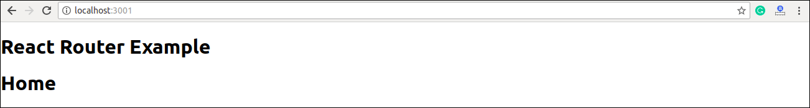

Now, if you enter **manually** in the browser: **localhost:3000/about**, you will see **About** component is rendered on the screen.

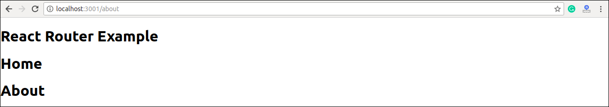

**Step-4:** In the above screen, you can see that **Home** component is still rendered. It is because the home path is '**/**' and about path is '**/about**', so you can observe that **slash** is common in both paths which render both components. To stop this behavior, you need to use the **exact** prop. It can be seen in the below example.

**Index.js**

1. **import** React from 'react';
2. **import** ReactDOM from 'react-dom';
3. **import** { Route, Link, BrowserRouter as Router } from 'react-router-dom'
4. **import** './index.css';
5. **import** App from './App';
6. **import** About from './about'
7. **import** Contact from './contact'
9. **const** routing = (
10. <Router>
11. <div>
12. <h1>React Router Example</h1>
13. <Route exact path="/" component={App} />
14. <Route path="/about" component={About} />
15. <Route path="/contact" component={Contact} />
16. </div>
17. </Router>
18. )
19. ReactDOM.render(routing, document.getElementById('root'));

**Output**

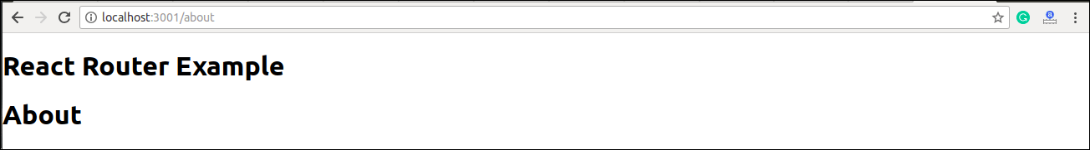

## Adding Navigation using Link component

Sometimes, we want to need **multiple** links on a single page. When we click on any of that particular **Link**, it should load that page which is associated with that path without **reloading** the web page. To do this, we need to import **<Link>** component in the **index.js** file.

### **What is < Link> component?**

This component is used to create links which allow to **navigate** on different **URLs** and render its content without reloading the webpage.

**Example**

**Index.js**

1. **import** React from 'react';
2. **import** ReactDOM from 'react-dom';
3. **import** { Route, Link, BrowserRouter as Router } from 'react-router-dom'
4. **import** './index.css';
5. **import** App from './App';
6. **import** About from './about'
7. **import** Contact from './contact'
9. **const** routing = (
10. <Router>
11. <div>
12. <h1>React Router Example</h1>
13. <ul>
14. <li>
15. <Link to="/">Home</Link>
16. </li>
17. <li>
18. <Link to="/about">About</Link>
19. </li>
20. <li>
21. <Link to="/contact">Contact</Link>
22. </li>
23. </ul>
24. <Route exact path="/" component={App} />
25. <Route path="/about" component={About} />
26. <Route path="/contact" component={Contact} />
27. </div>
28. </Router>
29. )
30. ReactDOM.render(routing, document.getElementById('root'));

**Output**

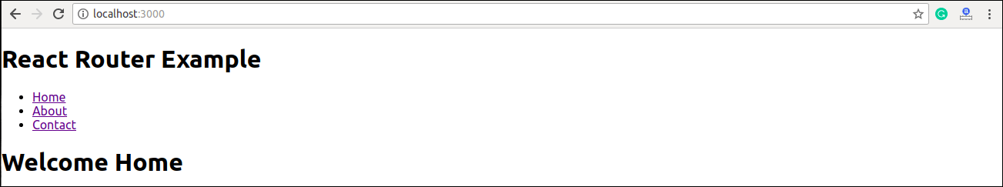

After adding Link, you can see that the routes are rendered on the screen. Now, if you click on the **About**, you will see URL is changing and About component is rendered.

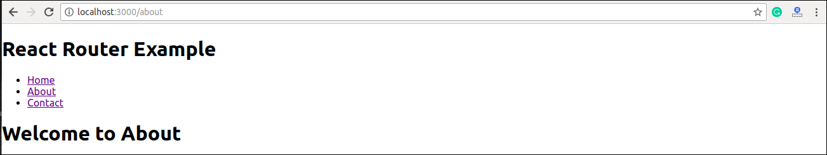

Now, we need to add some **styles** to the Link. So that when we click on any particular link, it can be easily **identified** which Link is **active**. To do this react router provides a new trick **NavLink** instead of **Link**. Now, in the index.js file, replace Link from Navlink and add properties **activeStyle**. The activeStyle properties mean when we click on the Link, it should have a specific style so that we can differentiate which one is currently active.

1. **import** React from 'react';
2. **import** ReactDOM from 'react-dom';
3. **import** { BrowserRouter as Router, Route, Link, NavLink } from 'react-router-dom'
4. **import** './index.css';
5. **import** App from './App';
6. **import** About from './about'
7. **import** Contact from './contact'
9. **const** routing = (
10. <Router>
11. <div>
12. <h1>React Router Example</h1>
13. <ul>
14. <li>
15. <NavLink to="/" exact activeStyle={
16. {color:'red'}
17. }>Home</NavLink>
18. </li>
19. <li>
20. <NavLink to="/about" exact activeStyle={
21. {color:'green'}
22. }>About</NavLink>
23. </li>
24. <li>
25. <NavLink to="/contact" exact activeStyle={
26. {color:'magenta'}
27. }>Contact</NavLink>
28. </li>
29. </ul>
30. <Route exact path="/" component={App} />
31. <Route path="/about" component={About} />
32. <Route path="/contact" component={Contact} />
33. </div>
34. </Router>
35. )
36. ReactDOM.render(routing, document.getElementById('root'));

**Output**

When we execute the above program, we will get the following screen in which we can see that **Home** link is of color **Red** and is the only currently **active** link.

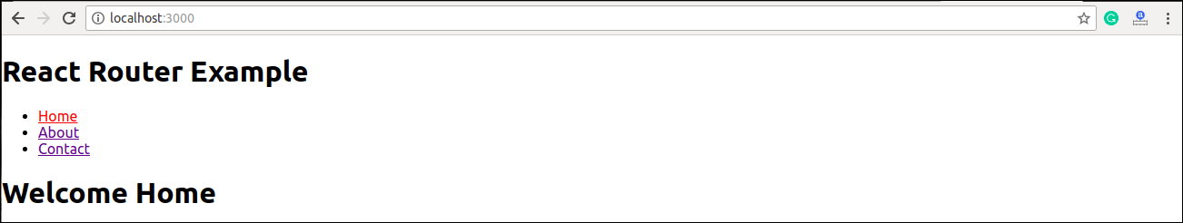

Now, when we click on **About** link, its color shown **green** that is the currently **active** link.

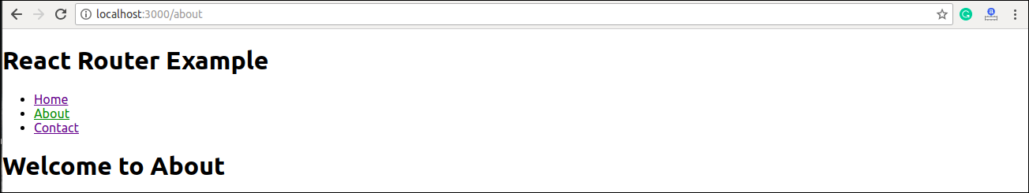

### **<Link> vs <NavLink>**

The Link component allows navigating the different routes on the websites, whereas NavLink component is used to add styles to the active routes.

## React Router Switch

The <**Switch**> component is used to render components only when the path will be **matched**. Otherwise, it returns to the **not found** component.

To understand this, first, we need to create a **notfound** component.

**notfound.js**

1. **import** React from 'react'
2. **const** Notfound = () => <h1>Not found</h1>
3. export **default** Notfound

Now, import component in the index.js file. It can be seen in the below code.

**Index.js**

1. **import** React from 'react';
2. **import** ReactDOM from 'react-dom';
3. **import** { BrowserRouter as Router, Route, Link, NavLink, Switch } from 'react-router-dom'
4. **import** './index.css';
5. **import** App from './App';
6. **import** About from './about'
7. **import** Contact from './contact'
8. **import** Notfound from './notfound'
10. **const** routing = (
11. <Router>
12. <div>
13. <h1>React Router Example</h1>
14. <ul>
15. <li>
16. <NavLink to="/" exact activeStyle={
17. {color:'red'}
18. }>Home</NavLink>
19. </li>
20. <li>
21. <NavLink to="/about" exact activeStyle={
22. {color:'green'}
23. }>About</NavLink>
24. </li>
25. <li>
26. <NavLink to="/contact" exact activeStyle={
27. {color:'magenta'}
28. }>Contact</NavLink>
29. </li>
30. </ul>
31. <Switch>
32. <Route exact path="/" component={App} />
33. <Route path="/about" component={About} />
34. <Route path="/contact" component={Contact} />
35. <Route component={Notfound} />
36. </Switch>
37. </div>
38. </Router>
39. )
40. ReactDOM.render(routing, document.getElementById('root'));

**Output**

If we manually enter the **wrong** path, it will give the not found error.

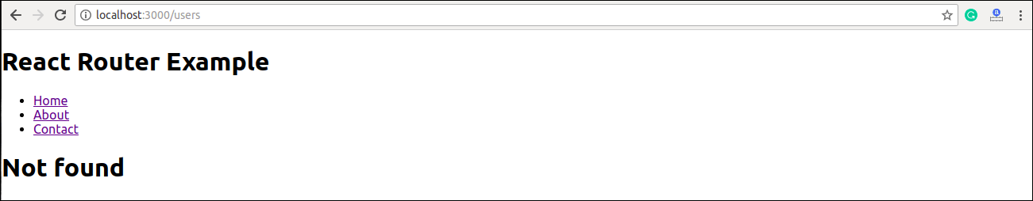

## React Router <Redirect>

A <Redirect> component is used to redirect to another route in our application to maintain the old URLs. It can be placed anywhere in the route hierarchy.

### **Nested Routing in React**

Nested routing allows you to render **sub-routes** in your application. It can be understood in the below example.

**Example**

**index.js**

1. **import** React from 'react';
2. **import** ReactDOM from 'react-dom';
3. **import** { BrowserRouter as Router, Route, Link, NavLink, Switch } from 'react-router-dom'
4. **import** './index.css';
5. **import** App from './App';
6. **import** About from './about'
7. **import** Contact from './contact'
8. **import** Notfound from './notfound'
10. **const** routing = (
11. <Router>
12. <div>
13. <h1>React Router Example</h1>
14. <ul>
15. <li>
16. <NavLink to="/" exact activeStyle={
17. {color:'red'}
18. }>Home</NavLink>
19. </li>
20. <li>
21. <NavLink to="/about" exact activeStyle={
22. {color:'green'}
23. }>About</NavLink>
24. </li>
25. <li>
26. <NavLink to="/contact" exact activeStyle={
27. {color:'magenta'}
28. }>Contact</NavLink>
29. </li>
30. </ul>
31. <Switch>
32. <Route exact path="/" component={App} />
33. <Route path="/about" component={About} />
34. <Route path="/contact" component={Contact} />
35. <Route component={Notfound} />
36. </Switch>
37. </div>
38. </Router>
39. )
40. ReactDOM.render(routing, document.getElementById('root'));

In the **contact.js** file, we need to import the **React Router** component to implement the **subroutes**.

**contact.js**

1. **import** React from 'react'
2. **import** { Route, Link } from 'react-router-dom'
4. **const** Contacts = ({ match }) => <p>{match.params.id}</p>
6. **class** Contact **extends** React.Component {
7. render() {
8. **const** { url } = **this**.props.match
9. **return** (
10. <div>
11. <h1>Welcome to Contact Page</h1>
12. <strong>Select contact Id</strong>
13. <ul>
14. <li>
15. <Link to="/contact/1">Contacts 1 </Link>
16. </li>
17. <li>
18. <Link to="/contact/2">Contacts 2 </Link>
19. </li>
20. <li>
21. <Link to="/contact/3">Contacts 3 </Link>
22. </li>
23. <li>
24. <Link to="/contact/4">Contacts 4 </Link>
25. </li>
26. </ul>
27. <Route path="/contact/:id" component={Contacts} />
28. </div>
29. )
30. }
31. }
32. export **default** Contact

**Output**

When we execute the above program, we will get the following output.

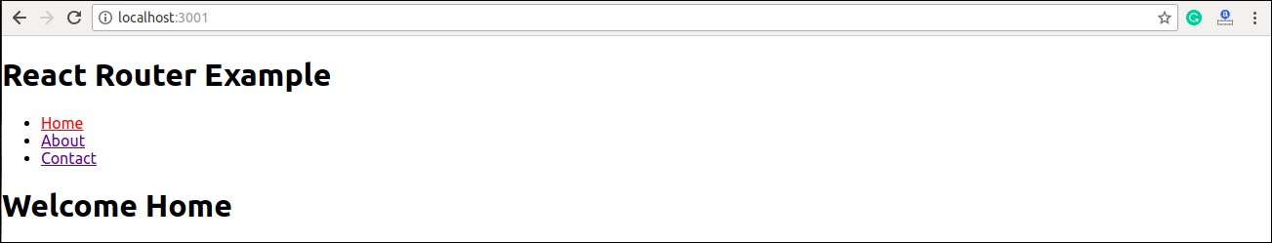

After clicking the **Contact** link, we will get the contact list. Now, selecting any contact, we will get the corresponding output. It can be shown in the below example.

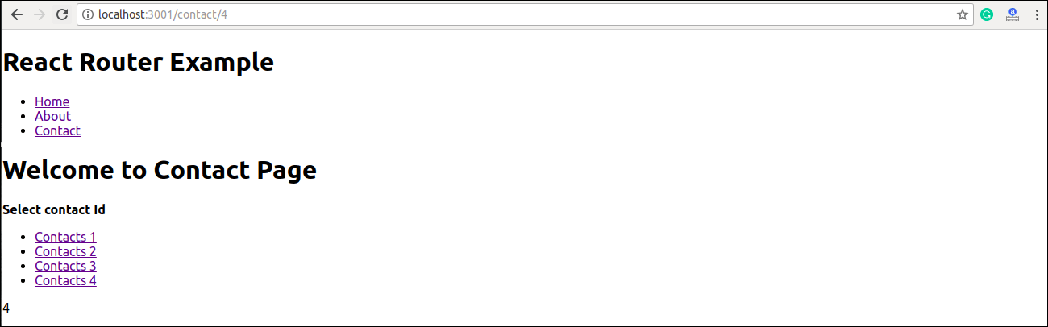

## Benefits Of React Router

The benefits of React Router is given below:

* In this, it is not necessary to set the browser history manually.
* Link uses to navigate the internal links in the application. It is similar to the anchor tag.
* It uses Switch feature for rendering.
* The Router needs only a Single Child element.
* In this, every component is specified in .

# **React CSS**

CSS in React is used to style the React App or Component. The **style** attribute is the most used attribute for styling in React applications, which adds dynamically-computed styles at render time. It accepts a JavaScript object in **camelCased** properties rather than a CSS string. There are many ways available to add styling to your React App or Component with CSS. Here, we are going to discuss mainly **four** ways to style React Components, which are given below:

1. Inline Styling
2. CSS Stylesheet
3. CSS Module
4. Styled Components

## 1. Inline Styling

The inline styles are specified with a JavaScript object in camelCase version of the style name. Its value is the style?s value, which we usually take in a string.

### **Example**

**App.js**

1. **import** React from 'react';
2. **import** ReactDOM from 'react-dom';
4. **class** App **extends** React.Component {
5. render() {
6. **return** (
7. <div>
8. <h1 style={{color: "Green"}}>Hello JavaTpoint!</h1>
9. <p>Here, you can find all CS tutorials.</p>
10. </div>
11. );
12. }
13. }
14. export **default** App;

#### Note:**You can see in the above example, we have used two curly braces in:** <h1 style={{color: "Green"}}>Hello JavaTpoint!</h1>**. It is because, in JSX, JavaScript expressions are written inside curly braces, and JavaScript objects also use curly braces, so the above styling is written inside two sets of curly braces {{}}.**

**Output**

Play Video[](https://campaign.adpushup.com/get-started/?utm_source=banner&utm_campaign=growth_hack)

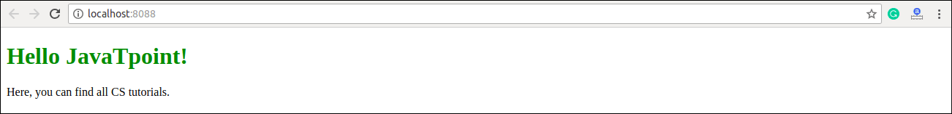

### **camelCase Property Name**

If the properties have two names, like **background-color**, it must be written in camel case syntax.

**Example**

**App.js**

1. **import** React from 'react';
2. **import** ReactDOM from 'react-dom';
4. **class** App **extends** React.Component {
5. render() {
6. **return** (
7. <div>
8. <h1 style={{color: "Red"}}>Hello JavaTpoint!</h1>
9. <p style={{backgroundColor: "lightgreen"}}>Here, you can find all CS tutorials.</p>
10. </div>
11. );
12. }
13. }
14. export **default** App;

**Output**

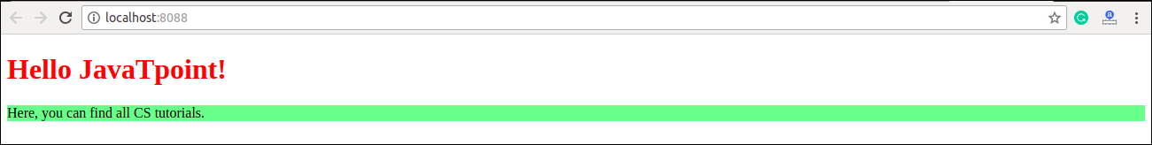

### **Using JavaScript Object**

The inline styling also allows us to create an object with styling information and refer it in the style attribute.

**Example**

**App.js**

1. **import** React from 'react';
2. **import** ReactDOM from 'react-dom';
4. **class** App **extends** React.Component {
5. render() {
6. **const** mystyle = {
7. color: "Green",
8. backgroundColor: "lightBlue",
9. padding: "10px",
10. fontFamily: "Arial"
11. };
12. **return** (
13. <div>
14. <h1 style={mystyle}>Hello JavaTpoint</h1>
15. <p>Here, you can find all CS tutorials.</p>
16. </div>
17. );
18. }
19. }
20. export **default** App;

**Output**

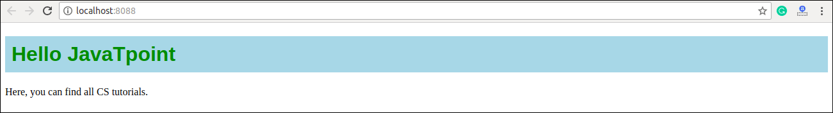

## 2. CSS Stylesheet

You can write styling in a separate file for your React application, and save the file with a .css extension. Now, you can **import** this file in your application.

### **Example**

**App.js**

1. **import** React from 'react';
2. **import** ReactDOM from 'react-dom';
3. **import** './App.css';
5. **class** App **extends** React.Component {
6. render() {
7. **return** (
8. <div>
9. <h1>Hello JavaTpoint</h1>
10. <p>Here, you can find all CS tutorials.</p>
11. </div>
12. );
13. }
14. }
15. export **default** App;

**App.css**

1. body {
2. background-color: #008080;
3. color: yellow;
4. padding: 40px;
5. font-family: Arial;
6. text-align: center;
7. }

**Index.html**

1. <!DOCTYPE html>
2. <html lang="en">
3. <head>
4. <meta charset="utf-8" />
5. <meta name="viewport"
6. content="width=device-width, initial-scale=1" />
7. <title>React App</title>
8. </head>
9. <body>
10. <div id="app"></div>
11. </body>
12. </html>

**Output**

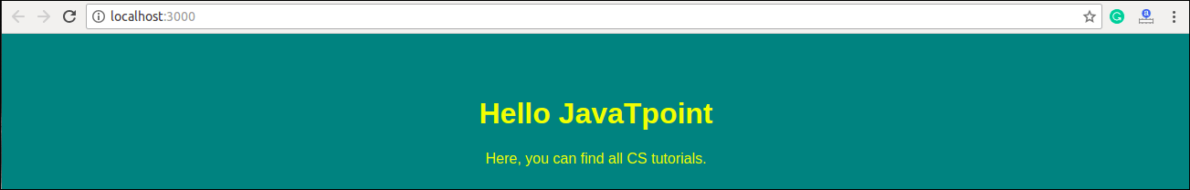

## 3. CSS Module

CSS Module is another way of adding styles to your application. It is a **CSS file** where all class names and **animation** names are scoped locally by default. It is available only for the component which imports it, means any styling you add can never be applied to other components without your permission, and you never need to worry about name conflicts. You can create CSS Module with the **.module.css** extension like a **myStyles.module.css** name.

### **Example**

**App.js**

1. **import** React from 'react';
2. **import** ReactDOM from 'react-dom';
3. **import** styles from './myStyles.module.css';
5. **class** App **extends** React.Component {
6. render() {
7. **return** (
8. <div>
9. <h1 className={styles.mystyle}>Hello JavaTpoint</h1>
10. <p className={styles.parastyle}>It provides great CS tutorials.</p>
11. </div>
12. );
13. }
14. }
15. export **default** App;

**myStyles.module.css**

1. .mystyle {
2. background-color: #cdc0b0;
3. color: Red;
4. padding: 10px;
5. font-family: Arial;
6. text-align: center;
7. }
9. .parastyle{
10. color: Green;
11. font-family: Arial;
12. font-size: 35px;
13. text-align: center;
14. }

**Output**

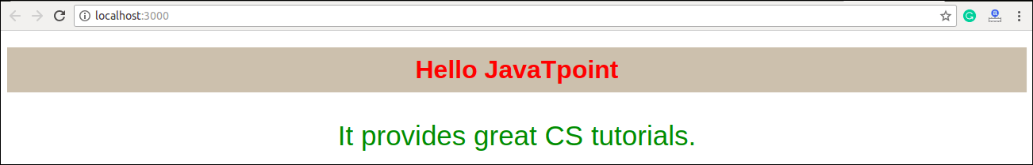

## 4. Styled Components

Styled-components is a **library** for React. It uses enhance CSS for styling React component systems in your application, which is written with a mixture of JavaScript and CSS.

**The styled-components provides:**

* Automatic critical CSS
* No class name bugs
* Easier deletion of CSS
* Simple dynamic styling
* Painless maintenance

### **Installation**

The styled-components library takes a single command to install in your React application. which is:

1. $ npm install styled-components --save

**Example**

Here, we create a variable by selecting a particular HTML element such as **<div>**, **<Title>**, and **<paragraph>** where we store our style attributes. Now we can use the name of our variable as a wrapper **<Div></Div>** kind of React component.

**App.js**

1. **import** React from 'react';
2. **import** ReactDOM from 'react-dom';
3. **import** styled from 'styled-components';
5. **class** App **extends** React.Component {
6. render() {
7. **const** Div:any = styled.div`
8. margin: 20px;
9. border: 5px dashed green;
10. &:hover {
11. background-color: ${(props:any) => props.hoverColor};
12. }
13. `;
14. **const** Title = styled.h1`
15. font-family: Arial;
16. font-size: 35px;
17. text-align: center;
18. color: palevioletred;
19. `;
20. **const** Paragraph = styled.p`
21. font-size: 25px;
22. text-align: center;
23. background-Color: lightgreen;
24. `;
25. **return** (
26. <div>
27. <Title>Styled Components Example</Title>
28. <p></p>
29. <Div hoverColor="Orange">
30. <Paragraph>Hello JavaTpoint!!</Paragraph>
31. </Div>
32. </div>
33. );
34. }
35. }
36. export **default** App;

**Output**

Now, execute the App.js file, we will get the output as shown below.

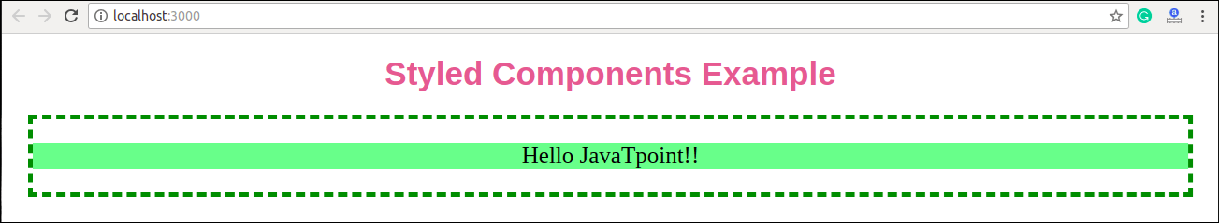

When we move the mouse pointer over the image, its color will be changed, as shown in the below image.

* 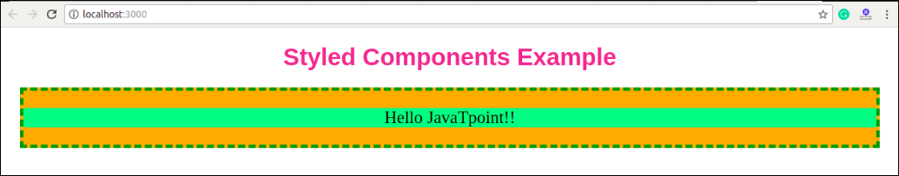

# **React Animation**

The animation is a technique in which images are manipulated to appear as moving images. It is one of the most used technique to make an interactive web application. In React, we can add animation using an explicit group of components known as the **React Transition Group**.

React Transition Group is an add-on component for managing component states and useful for defining **entering** and **exiting** transitions. It is not able to animate styles by itself. Instead, it exposes transition states, manages classes and group elements, and manipulates the DOM in useful ways. It makes the implementation of visual transitions much easier.

React Transition group has mainly **two APIs** to create transitions. These are:

1. **ReactTransitionGroup:** It uses as a low-level API for animation.
2. **ReactCSSTransitionGroup:** It uses as a high-level API for implementing basic CSS transitions and animations.

## Installation

We need to install **react-transition-group** for creating animation in React Web application. You can use the below command.

1. $ npm install react-transition-group --save

## React Transition Group Components

React Transition Group API provides **three** main components. These are:

1. Transition
2. CSSTransition
3. Transition Group

### **Transition**

It has a simple component API to describe a transition from one component state to another over time. It is mainly used to animate the **mounting** and **unmounting** of a component. It can also be used for in-place transition states as well.

We can access the Transition component into four states:

* entering
* entered
* exiting
* exited

### **CSSTransition**

The CSSTransition component uses CSS stylesheet classes to write the transition and create animations. It is inspired by the **ng-animate** library. It can also inherit all the props of the transition component. We can divide the "CSSTransition" into **three** states. These are:

* Appear
* Enter
* Exit

CSSTransition component must be applied in a pair of class names to the child components. The first class is in the form of **name-stage** and the second class is in the **name-stage-active**. For example, you provide the name fade, and when it applies to the 'enter' stage, the two classes will be **fade-enter** and **fade-enter-active**. It may also take a prop as Timeout which defines the maximum time to animate.

### **TransitionGroup**

This component is used to manage a set of transition components (Transition and CSSTransition) in a list. It is a state machine that controls the **mounting** and **unmounting** of components over time. The Transition component does not define any animation directly. Here, how 'list' item animates is based on the individual transition component. It means, the "TransitionGroup" component can have different animation within a component.

Let us see the example below, which clearly help to understand the React Animation.

**Example**

**App.js**

In the App.js file, import react-transition-group component, and create the CSSTransition component that uses as a wrapper of the component you want to animate. We are going to use **transitionEnterTimeout** and **transitionLeaveTimeout** for CSS Transition. The Enter and Leave animations used when we want to insert or delete elements from the list.

1. **import** React, { Component } from 'react';
2. **import** { CSSTransitionGroup } from 'react-transition-group';
4. **class** App **extends** React.Component {
5. constructor(props) {
6. **super**(props);
7. **this**.state = {items: ['Blockchain', 'ReactJS', 'TypeScript', 'JavaTpoint']};
8. **this**.handleAdd = **this**.handleAdd.bind(**this**);
9. }
11. handleAdd() {
12. **const** newItems = **this**.state.items.concat([
13. prompt('Enter Item Name')
14. ]);
15. **this**.setState({items: newItems});
16. }
18. handleRemove(i) {
19. let newItems = **this**.state.items.slice();
20. newItems.splice(i, 1);
21. **this**.setState({items: newItems});
22. }
24. render() {
25. **const** items = **this**.state.items.map((item, i) => (
26. <div key={item} onClick={() => **this**.handleRemove(i)}>
27. {item}
28. </div>
29. ));
31. **return** (
32. <div>
33. <h1>Animation Example</h1>
34. <button onClick={**this**.handleAdd}>Insert Item</button>
35. <CSSTransitionGroup
36. transitionName="example"
37. transitionEnterTimeout={800}
38. transitionLeaveTimeout={600}>
39. {items}
40. </CSSTransitionGroup>
41. </div>
42. );
43. }
44. }
45. export **default** App;

**Main.js**

1. **import** React from 'react';
2. **import** ReactDOM from 'react-dom';
3. **import** App from './App.js';
5. ReactDOM.render(<App />, document.getElementById('app'));

**style.css**

Add style.css file in your application, and add the following CSS styles. Now, to use this CSS file, you need to add the **link** of this file in your HTML file.

1. .example-enter {
2. opacity: 0.01;
3. }
5. .example-enter.example-enter-active {
6. opacity: 1;
7. transition: opacity 500ms ease-in;
8. }
10. .example-leave {
11. opacity: 1;
12. }
14. .example-leave.example-leave-active {
15. opacity: 0.01;
16. transition: opacity 300ms ease-in;
17. }

In the above example, the animation durations are specified in both the **CSS** and **render** method. It tells React component when to remove the animation classes from the list and if it is leaving when to remove the element from the DOM.

**Output**

When we execute the above program, it gives the below output.

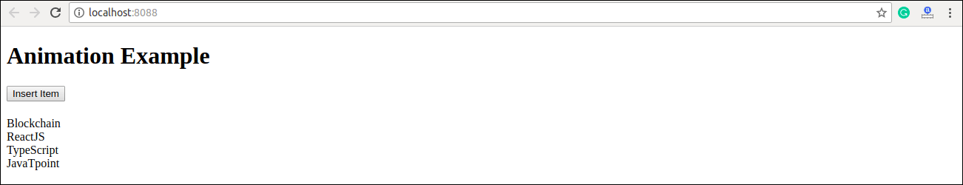

Click on '**Insert Item**' button, the following screen appears.

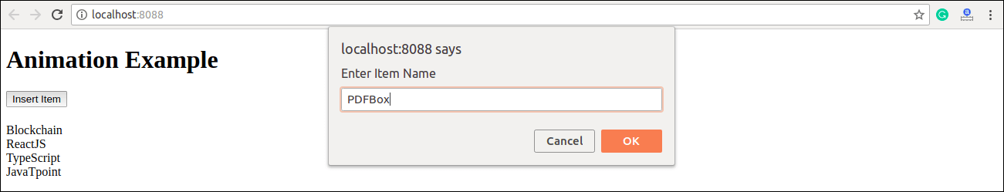

Once we insert the item and press **Ok**, the new item can be added in the list with fade in style. Here, we can also delete any item from the list by clicking on the particular link.

* 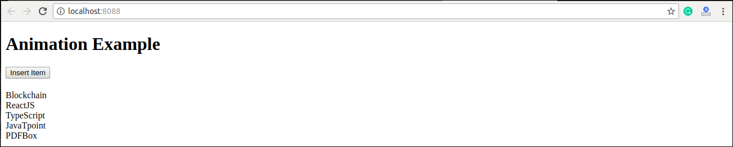

# **React Bootstrap**

Single-page applications gaining popularity over the last few years, so many front-end frameworks have introduced such as Angular, React, Vue.js, Ember, etc. As a result, jQuery is not a necessary requirement for building web apps. Today, React has the most used JavaScript framework for building web applications, and Bootstrap become the most popular CSS framework. So, it is necessary to learn various ways in which Bootstrap can be used in React apps, which is the main aim of this section.

## Adding Bootstrap for React

We can add Bootstrap to the React app in several ways. The **three** most common ways are given below:

1. Using the Bootstrap CDN
2. Bootstrap as Dependency
3. React Bootstrap Package

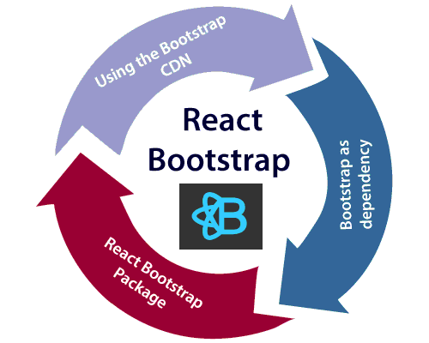

## Using the Bootstrap CDN

It is the easiest way of adding Bootstrap to the React app. There is no need to install or download Bootstrap. We can simply put an **<link>** into the **<head>** section of the **index.html** file of the React app as shown in the following snippet.

1. <link rel="stylesheet" href="https://stackpath.bootstrapcdn.com/bootstrap/4.3.1/css/bootstrap.min.css" integrity="sha384-ggOyR0iXCbMQv3Xipma34MD+dH/1fQ784/j6cY/iJTQUOhcWr7x9JvoRxT2MZw1T" crossorigin="anonymous">

If there is a need to use Bootstrap components which depend on JavaScript/jQuery in the React application, we need to include **jQuery**, **Popper.js**, and **Bootstrap.js** in the document. Add the following imports in the **<script>** tags near the end of the closing **</body>** tag of the **index.html** file.

Play Video[](https://campaign.adpushup.com/get-started/?utm_source=banner&utm_campaign=growth_hack)

1. <script src="https://code.jquery.com/jquery-3.3.1.slim.min.js" integrity="sha384-q8i/X+965DzO0rT7abK41JStQIAqVgRVzpbzo5smXKp4YfRvH+8abtTE1Pi6jizo" crossorigin="anonymous"></script>
3. <script src="https://cdnjs.cloudflare.com/ajax/libs/popper.js/1.14.7/umd/popper.min.js" integrity="sha384-UO2eT0CpHqdSJQ6hJty5KVphtPhzWj9WO1clHTMGa3JDZwrnQq4sF86dIHNDz0W1" crossorigin="anonymous"></script>
5. <script src="https://stackpath.bootstrapcdn.com/bootstrap/4.3.1/js/bootstrap.min.js" integrity="sha384-JjSmVgyd0p3pXB1rRibZUAYoIIy6OrQ6VrjIEaFf/nJGzIxFDsf4x0xIM+B07jRM" crossorigin="anonymous"></script>

In the above snippet, we have used jQuery's slim version, although we can also use the full version as well. Now, Bootstrap is successfully added in the React application, and we can use all the CSS utilities and UI components available from Bootstrap in the React application.

## Bootstrap as Dependency

If we are using a build tool or a module bundler such as Webpack, then importing Bootstrap as dependency is the preferred option for adding Bootstrap to the React application. We can install Bootstrap as a dependency for the React app. To install the Bootstrap, run the following commands in the terminal window.

1. $ npm install bootstrap --save

Once Bootstrap is installed, we can import it in the React application entry file. If the React project created using the **create-react-app** tool, open the **src/index.js** file, and add the following code:

1. **import** 'bootstrap/dist/css/bootstrap.min.css';

Now, we can use the CSS classes and utilities in the React application. Also, if we want to use the JavaScript components, we need to install the **jquery** and **popper.js** packages from **npm**. To install the following packages, run the following command in the terminal window.

1. $ npm install jquery popper.js

Next, go to the **src/index.js** file and add the following imports.

1. **import** $ from 'jquery';
2. **import** Popper from 'popper.js';
3. **import** 'bootstrap/dist/js/bootstrap.bundle.min';

Now, we can use Bootstrap JavaScript Components in the React application.

## React Bootstrap Package

The React Bootstrap package is the most popular way to add bootstrap in the React application. There are many Bootstrap packages built by the community, which aim to rebuild Bootstrap components as React components. The **two** most popular Bootstrap packages are:

1. **react-bootstrap:** It is a complete re-implementation of the Bootstrap components as React components. It does not need any dependencies like bootstrap.js or jQuery. If the React setup and React-Bootstrap installed, we have everything which we need.
2. **reactstrap:** It is a library which contains React Bootstrap 4 components that favor composition and control. It does not depend on jQuery or Bootstrap JavaScript. However, react-popper is needed for advanced positioning of content such as Tooltips, Popovers, and auto-flipping Dropdowns.

## React Bootstrap Installation

Let us create a new React app using the **create-react-app** command as follows.

1. $ npx create-react-app react-bootstrap-app

After creating the React app, the best way to install Bootstrap is via the npm package. To install Bootstrap, navigate to the React app folder, and run the following command.

1. $ npm install react-bootstrap bootstrap --save

### **Importing Bootstrap**

Now, open the **src/index.js** file and add the following code to import the Bootstrap file.

1. **import** 'bootstrap/dist/css/bootstrap.min.css';

We can also import individual components **like import { SplitButton, Dropdown } from 'react-bootstrap';** instead of the entire library. It provides the specific components which we need to use, and can significantly reduce the amount of code.

In the React app, create a new file named **ThemeSwitcher.js** in the **src** directory and put the following code.

1. **import** React, { Component } from 'react';
2. **import** { SplitButton, Dropdown } from 'react-bootstrap';
4. **class** ThemeSwitcher **extends** Component {
6. state = { theme: **null** }
8. chooseTheme = (theme, evt) => {
9. evt.preventDefault();
10. **if** (theme.toLowerCase() === 'reset') { theme = **null** }
11. **this**.setState({ theme });
12. }
14. render() {
15. **const** { theme } = **this**.state;
16. **const** themeClass = theme ? theme.toLowerCase() : 'default';
18. **const** parentContainerStyles = {
19. position: 'absolute',
20. height: '100%',
21. width: '100%',
22. display: 'table'
23. };
25. **const** subContainerStyles = {
26. position: 'relative',
27. height: '100%',
28. width: '100%',
29. display: 'table-cell',
30. };
32. **return** (
33. <div style={parentContainerStyles}>
34. <div style={subContainerStyles}>
36. <span className={`h1 center-block text-center text-${theme ? themeClass : 'muted'}`} style={{ marginBottom: 25 }}>{theme || 'Default'}</span>
38. <div className="center-block text-center">
39. <SplitButton bsSize="large" bsStyle={themeClass} title={`${theme || 'Default Block'} Theme`}>
40. <Dropdown.Item eventKey="Primary Block" onSelect={**this**.chooseTheme}>Primary Theme</Dropdown.Item>
41. <Dropdown.Item eventKey="Danger Block" onSelect={**this**.chooseTheme}>Danger Theme</Dropdown.Item>
42. <Dropdown.Item eventKey="Success Block" onSelect={**this**.chooseTheme}>Success Theme</Dropdown.Item>
43. <Dropdown.Item divider />
44. <Dropdown.Item eventKey="Reset Block" onSelect={**this**.chooseTheme}>Default Theme</Dropdown.Item>
45. </SplitButton>
46. </div>
47. </div>
48. </div>
49. );
50. }
51. }
52. export **default** ThemeSwitcher;

Now, update the **src/index.js** file with the following snippet.

**Index.js**

1. **import** 'bootstrap/dist/css/bootstrap.min.css';
2. **import** React from 'react';
3. **import** ReactDOM from 'react-dom';
4. **import** App from './App.js';
5. **import** './index.css';
6. **import** ThemeSwitcher from './ThemeSwitcher';
8. ReactDOM.render(<ThemeSwitcher />, document.getElementById('root'));

**Output**

When we execute the React app, we should get the output as below.

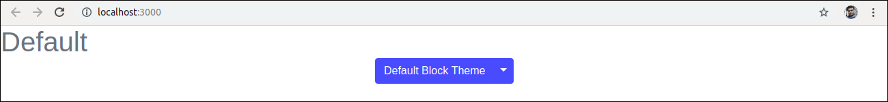

Click on the dropdown menu. We will get the following screen.

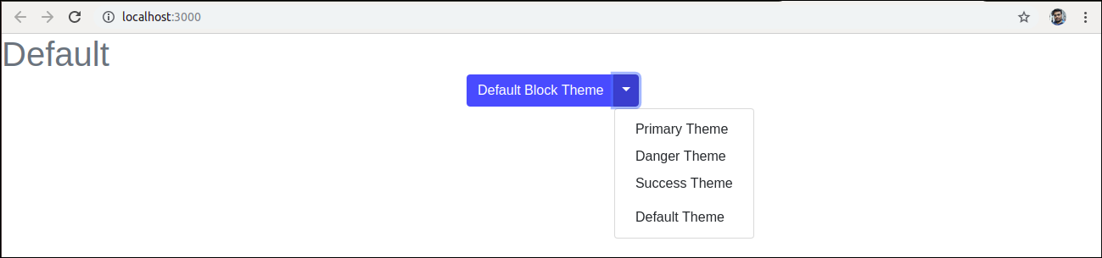

Now, if we choose the **Success Theme**, we will get the below screen.

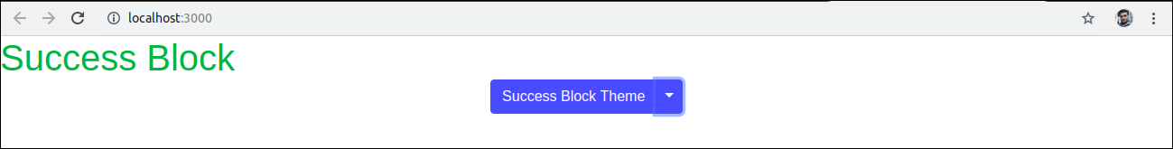

## Using reactstrap

Let us create a new React app using the create-react-app command as follows.

1. $ npx create-react-app reactstrap-app

Next, install the **reactstrap** via the npm package. To install reactstrap, navigate to the React app folder, and run the following command.

1. $ npm install bootstrap reactstrap --save

### **Importing Bootstrap**

Now, open the **src/index.js** file and add the following code to import the Bootstrap file.

1. **import** 'bootstrap/dist/css/bootstrap.min.css';

We can also import individual components **like import { Button, Dropdown } from 'reactstrap';** instead of the entire library. It provides the specific components which we need to use, and can significantly reduce the amount of code.

In the React app, create a new file named **ThemeSwitcher.js** in the **src** directory and put the following code.

1. **import** React, { Component } from 'react';
2. **import** { Button, ButtonDropdown, DropdownToggle, DropdownMenu, DropdownItem } from 'reactstrap';
4. **class** ThemeSwitcher **extends** Component {
6. state = { theme: **null**, dropdownOpen: **false** }
8. toggleDropdown = () => {
9. **this**.setState({ dropdownOpen: !**this**.state.dropdownOpen });
10. }
12. resetTheme = evt => {
13. evt.preventDefault();
14. **this**.setState({ theme: **null** });
15. }
17. chooseTheme = (theme, evt) => {
18. evt.preventDefault();
19. **this**.setState({ theme });
20. }
21. render() {
22. **const** { theme, dropdownOpen } = **this**.state;
23. **const** themeClass = theme ? theme.toLowerCase() : 'secondary';
25. **return** (
26. <div className="d-flex flex-wrap justify-content-center align-items-center">
28. <span className={`h1 mb-4 w-100 text-center text-${themeClass}`}>{theme || 'Default'}</span>
30. <ButtonDropdown isOpen={dropdownOpen} toggle={**this**.toggleDropdown}>
31. <Button id="caret" color={themeClass}>{theme || 'Custom'} Theme</Button>
32. <DropdownToggle caret size="lg" color={themeClass} />
33. <DropdownMenu>
34. <DropdownItem onClick={e => **this**.chooseTheme('Primary', e)}>Primary Theme</DropdownItem>
35. <DropdownItem onClick={e => **this**.chooseTheme('Danger', e)}>Danger Theme</DropdownItem>
36. <DropdownItem onClick={e => **this**.chooseTheme('Success', e)}>Success Theme</DropdownItem>
37. <DropdownItem divider />
38. <DropdownItem onClick={**this**.resetTheme}>Default Theme</DropdownItem>
39. </DropdownMenu>
40. </ButtonDropdown>
42. </div>
43. );
44. }
45. }
46. export **default** ThemeSwitcher;

Now, update the **src/index.js** file with the following snippet.

**Index.js**

1. **import** 'bootstrap/dist/css/bootstrap.min.css';
2. **import** React from 'react';
3. **import** ReactDOM from 'react-dom';
4. **import** App from './App.js';
5. **import** './index.css';
6. **import** ThemeSwitcher from './ThemeSwitcher';
8. ReactDOM.render(<ThemeSwitcher />, document.getElementById('root'));

**Output**

When we execute the React app, we should get the output as below.

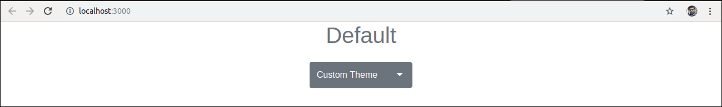

Click on the dropdown menu. We will get the following screen.

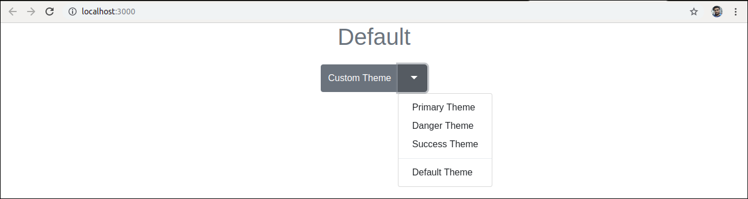

Now, if we choose the **Danger Theme**, we will get the below screen.

* 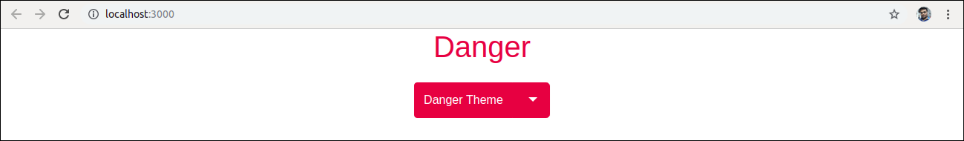

# **React Map**

A map is a data collection type where data is stored in the form of pairs. It contains a unique key. The value stored in the map must be mapped to the key. We cannot store a duplicate pair in the map(). It is because of the uniqueness of each stored key. It is mainly used for fast searching and looking up data.

In React, the ?map? method used to traverse and display a list of similar objects of a component. A map is not the feature of React. Instead, it is the standard JavaScript function that could be called on any array. The map() method creates a new array by calling a provided function on every element in the calling array.

### **Example**

In the given example, the map() function takes an array of numbers and double their values. We assign the new array returned by map() to the variable doubleValue and log it.

1. var numbers = [1, 2, 3, 4, 5];
2. **const** doubleValue = numbers.map((number)=>{
3. **return** (number * 2);
4. });
5. console.log(doubleValue);

## In React, the map() method used for:

1. Traversing the list element.

**Example**

1. **import** React from 'react';
2. **import** ReactDOM from 'react-dom';
4. function NameList(props) {
5. **const** myLists = props.myLists;
6. **const** listItems = myLists.map((myList) =>
7. <li>{myList}</li>
8. );
9. **return** (
10. <div>
11. <h2>React Map Example</h2>
12. <ul>{listItems}</ul>
13. </div>
14. );
15. }
16. **const** myLists = ['A', 'B', 'C', 'D', 'D'];
17. ReactDOM.render(
18. <NameList myLists={myLists} />,
19. document.getElementById('app')
20. );
21. export **default** App;

**Output**

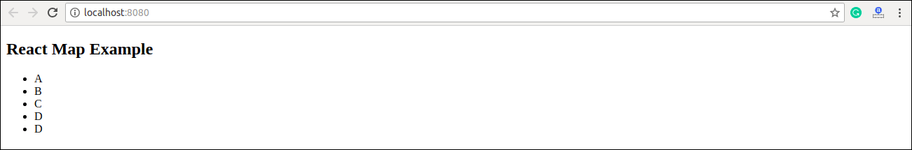

2. Traversing the list element with keys.

**Example**

1. **import** React from 'react';
2. **import** ReactDOM from 'react-dom';
4. function ListItem(props) {
5. **return** <li>{props.value}</li>;
6. }
8. function NumberList(props) {
9. **const** numbers = props.numbers;
10. **const** listItems = numbers.map((number) =>
11. <ListItem key={number.toString()}
12. value={number} />
13. );
14. **return** (
15. <div>
16. <h2>React Map Example</h2>
17. <ul> {listItems} </ul>
18. </div>
19. );
20. }
22. **const** numbers = [1, 2, 3, 4, 5];
23. ReactDOM.render(
24. <NumberList numbers={numbers} />,
25. document.getElementById('app')
26. );
27. export **default** App;

**Output**

* 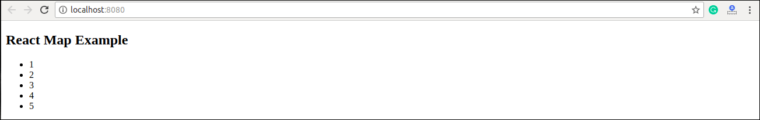

# **React Table**

A table is an arrangement which organizes information into rows and columns. It is used to store and display data in a structured format.

The react-table is a lightweight, fast, fully customizable (JSX, templates, state, styles, callbacks), and extendable Datagrid built for React. It is fully controllable via optional props and callbacks.

## Features

1. It is lightweight at 11kb (and only need 2kb more for styles).
2. It is fully customizable (JSX, templates, state, styles, callbacks).
3. It is fully controllable via optional props and callbacks.
4. It has client-side & Server-side pagination.
5. It has filters.
6. Pivoting & Aggregation
7. Minimal design & easily themeable

## Installation

Let us create a **React app** using the following command.

1. $ npx create-react-app myreactapp

Next, we need to install **react-table**. We can install react-table via npm command, which is given below.

Play Video

1. $ npm install react-table

Once, we have installed react-table, we need to **import** the react-table into the react component. To do this, open the **src/App.js** file and add the following snippet.

1. **import** ReactTable from "react-table";

Let us assume we have data which needs to be rendered using react-table.

1. **const** data = [{
2. name: 'Ayaan',
3. age: 26
4. },{
5. name: 'Ahana',
6. age: 22
7. },{
8. name: 'Peter',
9. age: 40
10. },{
11. name: 'Virat',
12. age: 30
13. },{
14. name: 'Rohit',
15. age: 32
16. },{
17. name: 'Dhoni',
18. age: 37
19. }]

Along with data, we also need to specify the **column info** with **column attributes**.

1. **const** columns = [{
2. Header: 'Name',
3. accessor: 'name'
4. },{
5. Header: 'Age',
6. accessor: 'age'
7. }]

Inside the render method, we need to bind this data with react-table and then returns the react-table.

1. **return** (
2. <div>
3. <ReactTable
4. data={data}
5. columns={columns}
6. defaultPageSize = {2}
7. pageSizeOptions = {[2,4, 6]}
8. />
9. </div>
10. )

Now, our **src/App.js** file looks like as below.

1. **import** React, { Component } from 'react';
2. **import** ReactTable from "react-table";
3. **import** "react-table/react-table.css";
5. **class** App **extends** Component {
6. render() {
7. **const** data = [{
8. name: 'Ayaan',
9. age: 26
10. },{
11. name: 'Ahana',
12. age: 22
13. },{
14. name: 'Peter',
15. age: 40
16. },{
17. name: 'Virat',
18. age: 30
19. },{
20. name: 'Rohit',
21. age: 32
22. },{
23. name: 'Dhoni',
24. age: 37
25. }]
26. **const** columns = [{
27. Header: 'Name',
28. accessor: 'name'
29. },{
30. Header: 'Age',
31. accessor: 'age'
32. }]
33. **return** (
34. <div>
35. <ReactTable
36. data={data}
37. columns={columns}
38. defaultPageSize = {2}
39. pageSizeOptions = {[2,4, 6]}
40. />
41. </div>
42. )
43. }
44. }
45. export **default** App;

**Output**

When we execute the React app, we will get the output as below.

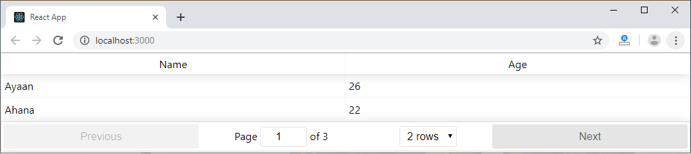

Now, change the rows dropdown menu, we will get the output as below.

* 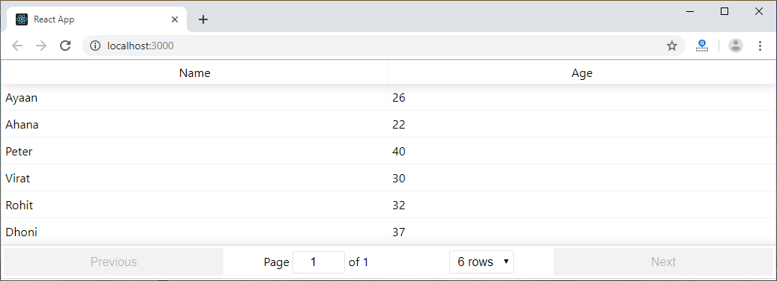

# **React Higher-Order Components**

It is also known as HOC. In React, HOC is an advanced technique for reusing component logic. It is a function that takes a component and returns a new component. According to the official website, it is not the feature(part) in React API, but a pattern that emerges from React compositional nature. They are similar to JavaScript functions used for adding additional functionalities to the existing component.

A higher order component function accepts another function as an argument. The **map** function is the best example to understand this. The main goal of this is to decompose the component logic into simpler and smaller functions that can be reused as you need.

### **Syntax**

1. **const** NewComponent = higherOrderComponent(WrappedComponent);

We know that component transforms props into UI, and a higher-order component converts a component another component and allows to add additional data or functionality into this. **Hocs** are common in **third-party** libraries. The examples of HOCs are **Redux's connect** and **Relay's createFragmentContainer**.

Now, we can understand the **working of HOCs** from the below example.

[](https://campaign.adpushup.com/get-started/?utm_source=banner&utm_campaign=growth_hack)

1. //Function Creation
2. function add (a, b) {
3. **return** a + b
4. }
5. function higherOrder(a, addReference) {
6. **return** addReference(a, 20)
7. }
8. //Function call
9. higherOrder(30, add) // 50

In the above example, we have created two functions **add()** and **higherOrder()**. Now, we provide the add() function as an **argument** to the higherOrder() function. For invoking, rename it **addReference** in the higherOrder() function, and then **invoke it**.

Here, the function you are passing is called a callback function, and the function where you are passing the callback function is called a **higher-order(HOCs)** function.

### **Example**

Create a new file with the name HOC.js. In this file, we have made one function HOC. It accepts one **argument** as a component. Here, that component is **App**.

**HOC.js**

1. **import** React, {Component} from 'react';
3. export **default** function Hoc(HocComponent){
4. **return** **class** **extends** Component{
5. render(){
6. **return** (
7. <div>
8. <HocComponent></HocComponent>
9. </div>
11. );
12. }
13. }
14. }

Now, include **HOC.js** file into the **App.js** file. In this file, we need to **call** the HOC function.

1. App = Hoc(App);

The App component wrapped inside another React component so that we can modify it. Thus, it becomes the primary application of the Higher-Order Components.

**App.js**

1. **import** React, { Component } from 'react';
2. **import** Hoc from './HOC';
4. **class** App **extends** Component {
5. render() {
6. **return** (
7. <div>
8. <h2>HOC Example</h2>
9. JavaTpoint provides best CS tutorials.
10. </div>
11. )
12. }
13. }
14. App = Hoc(App);
15. export **default** App;

**Output**

When we execute the above file, it will give the output as below screen.

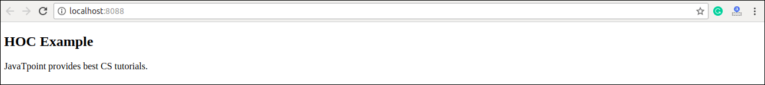

## Higher-Order Component Conventions

* Do not use HOCs inside the render method of a component.
* The static methods must be copied over to have access to them. You can do this using hoist-non-react-statics package to automatically copy all non-React static methods.
* HOCs does not work for refs as 'Refs' does not pass through as a parameter or argument. If you add a ref to an element in the HOC component, the ref refers to an instance of the outermost container component, not the wrapped component.

# **React Code Splitting**

The React app bundled their files using tools like **Webpack** or **Browserfy**. Bundling is a process which takes multiple files and merges them into a single file, which is called a **bundle**. The bundle is responsible for loading an entire app at once on the webpage. We can understand it from the below example.

**App.js**

1. **import** { add } from './math.js';
3. console.log(add(16, 26)); // 42

**math.js**

1. export function add(a, b) {
2. **return** a + b;
3. }

**Bundle file as like below:**

Play Video[](https://campaign.adpushup.com/get-started/?utm_source=banner&utm_campaign=growth_hack)

1. function add(a, b) {
2. **return** a + b;
3. }
5. console.log(add(16, 26)); // 42

As our app grows, our bundle will grow too, especially when we are using large third-party libraries. If the bundle size gets large, it takes a long time to load on a webpage. For avoiding the large bundling, it?s good to start ?splitting? your bundle.

**React 16.6.0**, released in **October 2018**, and introduced a way of performing code splitting. Code-Splitting is a feature supported by Webpack and Browserify, which can create multiple bundles that can be dynamically loaded at runtime.

Code splitting uses **React.lazy** and **Suspense** tool/library, which helps you to load a dependency lazily and only load it when needed by the user.

The code splitting improves:

* The performance of the app
* The impact on memory
* The downloaded Kilobytes (or Megabytes) size

### **React.lazy**

The best way for code splitting into the app is through the dynamic **import()** syntax. The React.lazy function allows us to render a dynamic import as a regular component.

**Before**

1. **import** ExampleComponent from './ExampleComponent';
3. function MyComponent() {
4. **return** (
5. <div>
6. <ExampleComponent />
7. </div>
8. );
9. }

**After**

1. **const** ExampleComponent = React.lazy(() => **import**('./ExampleComponent'));
3. function MyComponent() {
4. **return** (
5. <div>
6. <ExampleComponent />
7. </div>
8. );
9. }

The above code snippet automatically loads the bundle which contains the ExampleComponent when the ExampleComponent gets rendered.

### **Suspense**

If the module which contains the ExampleComponent is not yet loaded by the function component(MyComponent), then we need to show some **fallback** content while we are waiting for it to load. We can do this using the suspense component. In other words, the suspense component is responsible for handling the output when the lazy component is fetched and rendered.

1. **const** ExampleComponent = React.lazy(() => **import**('./ ExampleComponent'));
3. function MyComponent() {
4. **return** (
5. <div>
6. <Suspense fallback={<div>Loading...</div>}>
7. <ExampleComponent />
8. </Suspense>
9. </div>
10. );
11. }

The **fallback** prop accepts the React elements which you want to render while waiting for the component to load. We can combine multiple lazy components with a single Suspense component. It can be seen in the below example.

1. **const** ExampleComponent = React.lazy(() => **import**('./ ExampleComponent'));
2. **const** ExamComponent = React.lazy(() => **import**('./ ExamComponent'));
4. function MyComponent() {
5. **return** (
6. <div>
7. <Suspense fallback={<div>Loading...</div>}>
8. <section>
9. <ExampleComponent />
10. <ExamComponent />
11. </section>
12. </Suspense>
13. </div>
14. );
15. }

#### Note:**React.lazy and Suspense components are not yet available for server-side rendering. For code-splitting in a server-rendered app, it is recommended to use Loadable Components.**

## Error boundaries

If any module fails to load, for example, due to network failure, we will get an error. We can handle these errors with Error Boundaries. Once we have created the Error Boundary, we can use it anywhere above our lazy components to display an error state.

1. **import** MyErrorBoundary from './MyErrorBoundary';
2. **const** ExampleComponent = React.lazy(() => **import**('./ ExampleComponent'));
3. **const** ExamComponent = React.lazy(() => **import**('./ ExamComponent'));
5. **const** MyComponent = () => (
6. <div>
7. <MyErrorBoundary>
8. <Suspense fallback={<div>Loading...</div>}>
9. <section>
10. <ExampleComponent />
11. <ExamComponent />
12. </section>
13. </Suspense>
14. </MyErrorBoundary>
15. </div>
16. );

## Route-based code splitting

It is very tricky to decide where we introduce code splitting in the app. For this, we have to make sure that we choose the place which will split the bundles evenly without disrupting the user experience.

The route is the best place to start the code splitting. Route based code splitting is essential during the page transitions on the web, which takes some amount of time to load. Here is an example of how to setup route-based code splitting into the app using React Router with React.lazy.

1. **import** { Switch, BrowserRouter as Router, Route} from 'react-router-dom';
2. **import** React, { Suspense, lazy } from 'react';
4. **const** Home = lazy(() => **import**('./routes/Home'));
5. **const** About = lazy(() => **import**('./routes/About'));
6. **const** Contact = lazy(() => **import**('./routes/Contact'));
8. **const** App = () => (
9. <Router>
10. <Suspense fallback={<div>Loading...</div>}>
11. <Switch>
12. <Route exact path="/" component={Home}/>
13. <Route path="/about" component={About}/>
14. <Route path="/contact" component={Contact}/>
15. </Switch>
16. </Suspense>
17. </Router>
18. );

## Named Export

Currently, React.lazy supports default exports only. If any module you want to import using named exports, you need to create an intermediate module that re-exports it as the default. We can understand it from the below example.

**ExampleComponents.js**

1. export **const** MyFirstComponent = /* ... */;
2. export **const** MySecondComponent = /* ... */;

**MyFirstComponent.js**

1. export { MyFirstComponent as **default** } from "./ExampleComponents.js";

**MyApp.js**

1. **import** React, { lazy } from 'react';
2. **const** MyFirstComponent = lazy(() => **import**("./MyFirstComponent.js"));

# **React Context**

Context allows passing data through the component tree without passing props down manually at every level.

In React application, we passed data in a top-down approach via props. Sometimes it is inconvenient for certain types of props that are required by many components in the React application. Context provides a way to pass values between components without explicitly passing a prop through every level of the component tree.

### **How to use Context**

There are two main steps to use the React context into the React application:

1. Setup a context provider and define the data which you want to store.
2. Use a context consumer whenever you need the data from the store

### **When to use Context**

Context is used to share data which can be considered "global" for React components tree and use that data where needed, such as the current authenticated user, theme, etc. For example, in the below code snippet, we manually thread through a "theme" prop to style the Button component.

Play Video[](https://campaign.adpushup.com/get-started/?utm_source=banner&utm_campaign=growth_hack)

1. **class** App **extends** React.Component {
2. render() {
3. **return** <Toolbar theme="dark" />;
4. }
5. }
7. function Toolbar(props) {
8. **return** (
9. <div>
10. <ThemedButton theme={props.theme} />
11. </div>
12. );
13. }
15. **class** ThemedButton **extends** React.Component {
16. render() {
17. **return** <Button theme={**this**.props.theme} />;
18. }
19. }

In the above code, the Toolbar function component takes an extra "theme" prop and pass it to the ThemedButton. It can become inconvenient if every single button in the app needs to know the theme because it would be required to pass through all components. But using context, we can avoid passing props for every component through intermediate elements.

We can understand it from the below example. Here, context passes a value into the component tree without explicitly threading it through every single component.

1. // Create a context for the current theme which is "light" as the default.
2. **const** ThemeContext = React.createContext('light');
4. **class** App **extends** React.Component {
5. render() {
6. /* Use a ContextProvider to pass the current theme, which allows every component to read it, no matter how deep it is. Here, we are passing the "dark" theme as the current value.*/
8. **return** (
9. <ThemeContext.Provider value="dark">
10. <Toolbar />
11. </ThemeContext.Provider>
12. );
13. }
14. }
16. // Now, it is not required to pass the theme down explicitly for every component.
17. function Toolbar(props) {
18. **return** (
19. <div>
20. <ThemedButton />
21. </div>
22. );
23. }
25. **class** ThemedButton **extends** React.Component {
26. **static** contextType = ThemeContext;
27. render() {
28. **return** <Button theme={**this**.context} />;
29. }
30. }

## React Context API

The React Context API is a component structure, which allows us to share data across all levels of the application. The main aim of Context API is to solve the problem of prop drilling (also called "Threading"). The Context API in React are given below.

1. React.createContext
2. Context.provider
3. Context.Consumer
4. Class.contextType

### **React.createContext**

It creates a context object. When React renders a component which subscribes to this context object, then it will read the current context value from the matching provider in the component tree.

**Syntax**

1. **const** MyContext = React.createContext(defaultValue);

When a component does not have a matching Provider in the component tree, it returns the defaultValue argument. It is very helpful for testing components isolation (separately) without wrapping them.

### **Context.Provider**

Every Context object has a Provider React component which allows consuming components to subscribe to context changes. It acts as a delivery service. When a consumer component asks for something, it finds it in the context and provides it to where it is needed.

**Syntax**

1. <MyContext.Provider value={/* some value */}>

It accepts the value prop and passes to consuming components which are descendants of this Provider. We can connect one Provider with many consumers. Context Providers can be nested to override values deeper within the component tree. All consumers that are descendants of a Provider always re-render whenever the Provider's value prop is changed. The changes are determined by comparing the old and new values using the same algorithm as **Object.is** algorithm.

### **Context.Consumer**

It is the React component which subscribes to the context changes. It allows us to subscribe to the context within the function component. It requires the function as a component. A consumer is used to request data through the provider and manipulate the central data store when the provider allows it.

**Syntax**

1. <MyContext.Consumer>
2. {value => /* render something which is based on the context value */}
3. </MyContext.Consumer>

The function component receives the current context value and then returns a React node. The value argument which passed to the function will be equal to the value prop of the closest Provider for this context in the component tree. If there is no Provider for this context, the value argument will be equal to the defaultValue which was passed to createContext().

### **Class.contextType**

The contextType property on a class used to assign a Context object which is created by React.createContext(). It allows you to consume the closest current value of that Context type using this.context. We can reference this in any of the component life-cycle methods, including the render function.

#### Note:**We can only subscribe to a single context using this API. If we want to use the experimental public class field's syntax, we can use a static class field to initialize the contextType.**

**React Context API Example**

**Step1** Create a new React app using the following command.

1. $ npx create-react-app mycontextapi

**Step2** Install bootstrap CSS framework using the following command.

1. $ npm install react-bootstrap bootstrap --save

**Step3** Add the following code snippet in the src/APP.js file.

1. **import** React, { Component } from 'react';
2. **import** 'bootstrap/dist/css/bootstrap.min.css';
4. **const** BtnColorContext = React.createContext('btn btn-darkyellow');
6. **class** App **extends** Component {
7. render() {
8. **return** (
9. <BtnColorContext.Provider value="btn btn-info">
10. <Button />
11. </BtnColorContext.Provider>
12. );
13. }
14. }
16. function Button(props) {
17. **return** (
18. <div className="container">
19. <ThemedButton />
20. </div>
21. );
22. }
24. **class** ThemedButton **extends** Component {
26. **static** contextType = BtnColorContext;
27. render() {
28. **return** <button className={**this**.context} >
29. welcome to javatpoint
30. </button>;
31. }
32. }
33. export **default** App;

In the above code snippet, we have created the context using React.createContext(), which returns the Context object. After that, we have created the wrapper component which returns the Provider component, and then add all the elements as children from which we want to access the context.

**output:**

When we run the React app, we will get the following screen.

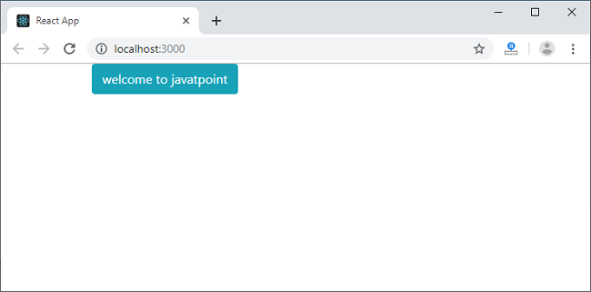

# **React Hooks**

Hooks are the new feature introduced in the React 16.8 version. It allows you to use state and other React features without writing a class. Hooks are the functions which "hook into" React state and lifecycle features from function components. It does not work inside classes.

Hooks are backward-compatible, which means it does not contain any breaking changes. Also, it does not replace your knowledge of React concepts.

## When to use a Hooks

If you write a function component, and then you want to add some state to it, previously you do this by converting it to a class. But, now you can do it by using a Hook inside the existing function component.

## Rules of Hooks

Hooks are similar to JavaScript functions, but you need to follow these two rules when using them. Hooks rule ensures that all the stateful logic in a component is visible in its source code. These rules are:

Play Video[](https://campaign.adpushup.com/get-started/?utm_source=banner&utm_campaign=growth_hack)

### **1. Only call Hooks at the top level**

Do not call Hooks inside loops, conditions, or nested functions. Hooks should always be used at the top level of the React functions. This rule ensures that Hooks are called in the same order each time a components renders.

### **2. Only call Hooks from React functions**

You cannot call Hooks from regular JavaScript functions. Instead, you can call Hooks from React function components. Hooks can also be called from custom Hooks.

## Pre-requisites for React Hooks

1. Node version 6 or above
2. NPM version 5.2 or above
3. Create-react-app tool for running the React App

## React Hooks Installation

To use React Hooks, we need to run the following commands:

1. $ npm install react@16.8.0-alpha.1 --save
2. $ npm install react-dom@16.8.0-alpha.1 --save

The above command will install the latest React and React-DOM alpha versions which support React Hooks. Make sure the **package.json** file lists the React and React-DOM dependencies as given below.

1. "react": "^16.8.0-alpha.1",
2. "react-dom": "^16.8.0-alpha.1",

## Hooks State

Hook state is the new way of declaring a state in React app. Hook uses useState() functional component for setting and retrieving state. Let us understand Hook state with the following example.

**App.js**

1. **import** React, { useState } from 'react';
3. function CountApp() {
4. // Declare a new state variable, which we'll call "count"
5. **const** [count, setCount] = useState(0);
7. **return** (
8. <div>
9. <p>You clicked {count} times</p>
10. <button onClick={() => setCount(count + 1)}>
11. Click me
12. </button>
13. </div>
14. );
15. }
16. export **default** CountApp;

**output:**

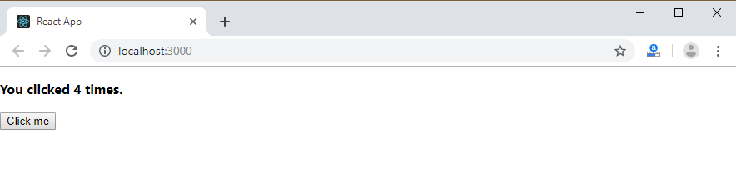

In the above example, useState is the Hook which needs to call inside a function component to add some local state to it. The useState returns a pair where the first element is the current state value/initial value, and the second one is a function which allows us to update it. After that, we will call this function from an event handler or somewhere else. The useState is similar to this.setState in class. The equivalent code without Hooks looks like as below.

**App.js**

1. **import** React, { useState } from 'react';
3. **class** CountApp **extends** React.Component {
4. constructor(props) {
5. **super**(props);
6. **this**.state = {
7. count: 0
8. };
9. }
10. render() {
11. **return** (
12. <div>
13. <p><b>You clicked {**this**.state.count} times</b></p>
14. <button onClick={() => **this**.setState({ count: **this**.state.count + 1 })}>
15. Click me
16. </button>
17. </div>
18. );
19. }
20. }
21. export **default** CountApp;

## Hooks Effect

The Effect Hook allows us to perform side effects (an action) in the function components. It does not use components lifecycle methods which are available in class components. In other words, Effects Hooks are equivalent to componentDidMount(), componentDidUpdate(), and componentWillUnmount() lifecycle methods.

Side effects have common features which the most web applications need to perform, such as:

* Updating the DOM,
* Fetching and consuming data from a server API,
* Setting up a subscription, etc.

Let us understand Hook Effect with the following example.

1. **import** React, { useState, useEffect } from 'react';
3. function CounterExample() {
4. **const** [count, setCount] = useState(0);
6. // Similar to componentDidMount and componentDidUpdate:
7. useEffect(() => {
8. // Update the document title using the browser API
9. document.title = `You clicked ${count} times`;
10. });
12. **return** (
13. <div>
14. <p>You clicked {count} times</p>
15. <button onClick={() => setCount(count + 1)}>
16. Click me
17. </button>
18. </div>
19. );
20. }
21. export **default** CounterExample;

The above code is based on the previous example with a new feature which we set the document title to a custom message, including the number of clicks.

**Output:**

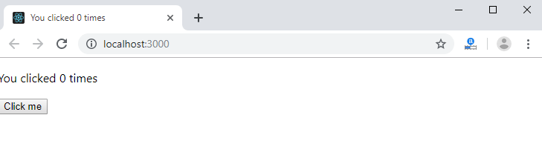

In React component, there are two types of side effects:

1. Effects Without Cleanup
2. Effects With Cleanup

### **Effects without Cleanup**

It is used in useEffect which does not block the browser from updating the screen. It makes the app more responsive. The most common example of effects which don't require a cleanup are manual DOM mutations, Network requests, Logging, etc.

### **Effects with Cleanup**

Some effects require cleanup after DOM updation. For example, if we want to set up a subscription to some external data source, it is important to clean up memory so that we don't introduce a memory leak. React performs the cleanup of memory when the component unmounts. However, as we know that, effects run for every render method and not just once. Therefore, React also cleans up effects from the previous render before running the effects next time.

## Custom Hooks

A custom Hook is a JavaScript function. The name of custom Hook starts with "use" which can call other Hooks. A custom Hook is just like a regular function, and the word "use" in the beginning tells that this function follows the rules of Hooks. Building custom Hooks allows you to extract component logic into reusable functions.

Let us understand how custom Hooks works in the following example.

1. **import** React, { useState, useEffect } from 'react';
3. **const** useDocumentTitle = title => {
4. useEffect(() => {
5. document.title = title;
6. }, [title])
7. }
9. function CustomCounter() {
10. **const** [count, setCount] = useState(0);
11. **const** incrementCount = () => setCount(count + 1);
12. useDocumentTitle(`You clicked ${count} times`);
13. // useEffect(() => {
14. //   document.title = `You clicked ${count} times`
15. // });
17. **return** (
18. <div>
19. <p>You clicked {count} times</p>
20. <button onClick={incrementCount}>Click me</button>
21. </div>
22. )
23. }
24. export **default** CustomCounter;

In the above snippet, useDocumentTitle is a custom Hook which takes an argument as a string of text which is a title. Inside this Hook, we call useEffect Hook and set the title as long as the title has changed. The second argument will perform that check and update the title only when its local state is different than what we are passing in.

#### **Note: A custom Hook is a convention which naturally follows from the design of Hooks, instead of a React feature.**

## Built-in Hooks

Here, we describe the APIs for the built-in Hooks in React. The built-in Hooks can be divided into two parts, which are given below.

**Basic Hooks**

* useState
* useEffect
* useContext

**Additional Hooks**

* useReducer
* useCallback
* useMemo
* useRef
* useImperativeHandle
* useLayoutEffect
* useDebugValue

# **React Flux Concept**

Flux is an application architecture that Facebook uses internally for building the client-side web application with React. It is not a library nor a framework. It is neither a library nor a framework. It is a kind of architecture that complements React as view and follows the concept of Unidirectional Data Flow model. It is useful when the project has dynamic data, and we need to keep the data updated in an effective manner. It reduces the runtime errors.

Flux applications have three major roles in dealing with data:

1. Dispatcher
2. Stores
3. Views (React components)

Here, you should not be confused with the Model-View-Controller (MVC) model. Although, Controllers exists in both, but Flux controller-views (views) found at the top of the hierarchy. It retrieves data from the stores and then passes this data down to their children. Additionally, action creators - dispatcher helper methods used to describe all changes that are possible in the application. It can be useful as a fourth part of the Flux update cycle.

## Structure and Data Flow

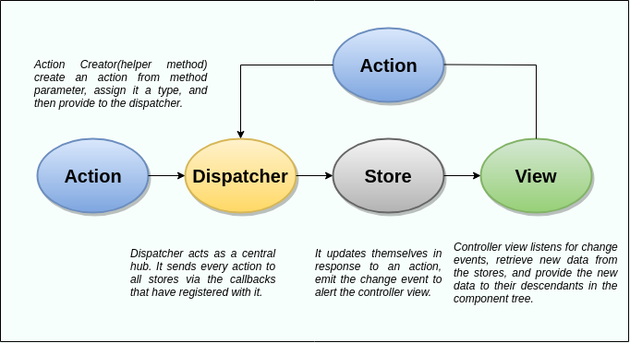

In Flux application, data flows in a single direction(unidirectional). This data flow is central to the flux pattern. The dispatcher, stores, and views are independent nodes with inputs and outputs. The actions are simple objects that contain new data and type property. Now, let us look at the various components of flux architecture one by one.

### **Dispatcher**

It is a central hub for the React Flux application and manages all data flow of your Flux application. It is a registry of callbacks into the stores. It has no real intelligence of its own, and simply acts as a mechanism for distributing the actions to the stores. All stores register itself and provide a callback. It is a place which handled all events that modify the store. When an action creator provides a new action to the dispatcher, all stores receive that action via the callbacks in the registry.

The dispatcher's API has five methods. These are:

|  |  |  |
| --- | --- | --- |
| **SN** | **Methods** | **Descriptions** |
| 1. | register() | It is used to register a store's action handler callback. |
| 2. | unregister() | It is used to unregisters a store's callback. |
| 3. | waitFor() | It is used to wait for the specified callback to run first. |
| 4. | dispatch() | It is used to dispatches an action. |
| 5. | isDispatching() | It is used to checks if the dispatcher is currently dispatching an action. |

### **Stores**

It primarily contains the application state and logic. It is similar to the model in a traditional MVC. It is used for maintaining a particular state within the application, updates themselves in response to an action, and emit the change event to alert the controller view.

### **Views**

It is also called as controller-views. It is located at the top of the chain to store the logic to generate actions and receive new data from the store. It is a React component listen to change events and receives the data from the stores and re-render the application.

### **Actions**

The dispatcher method allows us to trigger a dispatch to the store and include a payload of data, which we call an action. It is an action creator or helper methods that pass the data to the dispatcher.

### **Advantage of Flux**

* It is a unidirectional data flow model which is easy to understand.
* It is open source and more of a design pattern than a formal framework like MVC architecture.
* The flux application is easier to maintain.
* The flux application parts are decoupled.

# **React Flux Vs. MVC**

## MVC

MVC stands for Model View Controller. It is an architectural pattern used for developing the user interface. It divides the application into three different logical components: the Model, the View, and the Controller. It is first introduced in 1976 in the Smalltalk programming language. In MVC, each component is built to handle specific development aspect of an application. It is one of the most used web development frameworks to create scalable projects.

### **MVC Architecture**

The MVC architecture contains the three components. These are:

* **Model:** It is responsible for maintaining the behavior and data of an application.
* **View:** It is used to display the model in the user interface.
* **Controller:** It acts as an interface between the Model and the View components. It takes user input, manipulates the data(model) and causes the view to update.

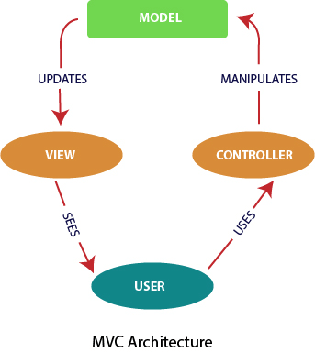

## Flux

According to the official site, Flux is the application architecture that Facebook uses for building client-side web applications. It is an alternative to MVC architecture and other software design patterns for managing how data flows in the react application. It is the backbone of all React application. It is not a library nor a framework. It complements React as view and follows the concept of Unidirectional Data Flow model.

Flux Architecture has three major roles in dealing with data:

1. Dispatcher
2. Stores
3. Views (React components)

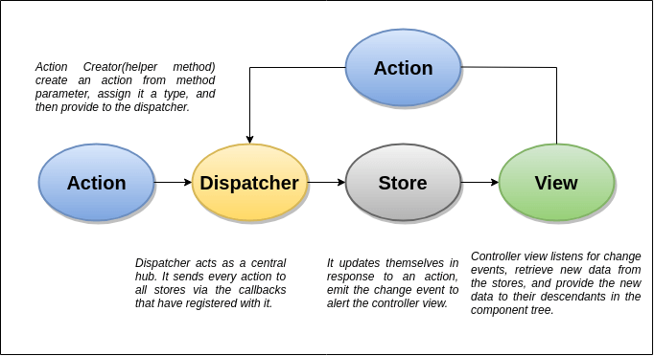

## MVC Vs. Flux

|  |  |  |
| --- | --- | --- |
| **SN** | **MVC** | **FLUX** |
| **1.** | It was introduced in 1976. | It was introduced just a few years ago. |
| **2.** | It supports Bi-directional data Flow model. | It supports Uni-directional data flow model. |
| **3.** | In this, data binding is the key. | In this, events or actions are the keys. |
| **4.** | It is synchronous. | It is asynchronous. |
| **5.** | Here, controllers handle everything(logic). | Here, stores handle all logic. |
| **6.** | It is hard to debug. | It is easy to debug because it has common initiating point: Dispatcher. |
| **7.** | It is difficult to understand as the project size increases. | It is easy to understand. |
| **8.** | Its maintainability is difficult as the project scope goes huge. | Its maintainability is easy and reduces runtime errors. |
| **9.** | Testing of application is difficult. | Testing of application is easy. |
| **10.** | Scalability is complex. | It can be easily scalable. |

# **React Redux**

Redux is an open-source JavaScript library used to manage application state. React uses Redux for building the user interface. It was first introduced by **Dan Abramov** and **Andrew Clark** in **2015**.

React Redux is the official React binding for Redux. It allows React components to read data from a Redux Store, and dispatch **Actions** to the **Store** to update data. Redux helps apps to scale by providing a sensible way to manage state through a unidirectional data flow model. React Redux is conceptually simple. It subscribes to the Redux store, checks to see if the data which your component wants have changed, and re-renders your component.

Redux was inspired by Flux. Redux studied the Flux architecture and omitted unnecessary complexity.

* Redux does not have Dispatcher concept.
* Redux has an only Store whereas Flux has many Stores.
* The Action objects will be received and handled directly by Store.

## Why use React Redux?

The main reason to use React Redux are:

* React Redux is the official **UI bindings** for react Application. It is kept up-to-date with any API changes to ensure that your React components behave as expected.
* It encourages good 'React' architecture.
* It implements many performance optimizations internally, which allows to components re-render only when it actually needs.

## Redux Architecture

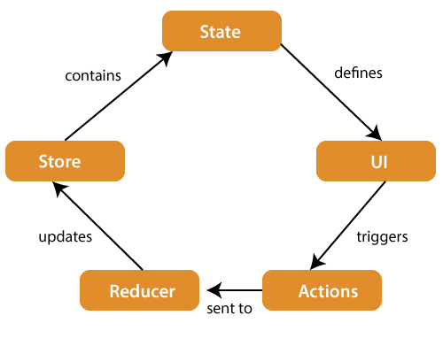

The components of Redux architecture are explained below.

**STORE:** A Store is a place where the entire state of your application lists. It manages the status of the application and has a dispatch(action) function. It is like a brain responsible for all moving parts in Redux.

**ACTION:** Action is sent or dispatched from the view which are payloads that can be read by Reducers. It is a pure object created to store the information of the user's event. It includes information such as type of action, time of occurrence, location of occurrence, its coordinates, and which state it aims to change.

**REDUCER:** Reducer read the payloads from the actions and then updates the store via the state accordingly. It is a pure function to return a new state from the initial state.

## Redux Installation

**Requirements:** React Redux requires React 16.8.3 or later version.

To use React Redux with React application, you need to install the below command.

1. $ npm install redux react-redux --save

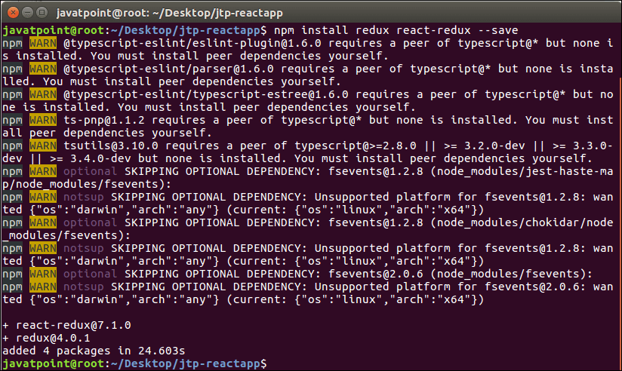

# **React Redux Example**

In this section, we will learn how to implements Redux in React application. Here, we provide a simple example to connect Redux and React.

**Step-1** Create a new react project using **create-react-app** command. I choose the project name: "**reactproject**." Now, install **Redux** and **React-Redux**.

1. javatpoint@root:~/Desktop$ npx create-react-app reactproject
2. javatpoint@root:~/Desktop/reactproject$ npm install redux react-redux --save

**Step-2 Create Files and Folders**

In this step, we need to create folders and files for actions, reducers, components, and containers. After creating folders and files, our project looks like as below image.

Play Video

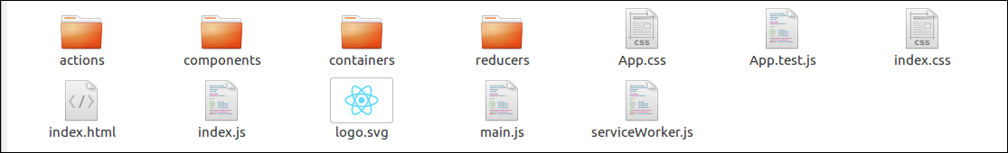

**Step-3 Actions**

It uses '**type**' property to inform about data that should be sent to the **Store**. In this folder, we will create two files: **index.js** and **index.spec.js**. Here, we have created an **action creator** that returns our action and sets an **id** for every created item.

**Index.js**

1. let nextTodoId = 0
2. export **const** addTodo = text => ({
3. type: 'ADD_TODO',
4. id: nextTodoId++,
5. text
6. })
8. export **const** setVisibilityFilter = filter => ({
9. type: 'SET_VISIBILITY_FILTER',
10. filter
11. })
13. export **const** toggleTodo = id => ({
14. type: 'TOGGLE_TODO',
15. id
16. })
18. export **const** VisibilityFilters = {
19. SHOW_ALL: 'SHOW_ALL',
20. SHOW_COMPLETED: 'SHOW_COMPLETED',
21. SHOW_ACTIVE: 'SHOW_ACTIVE'
22. }

**Index.spec.js**

1. **import** * as actions from './index'
3. describe('todo actions', () => {
4. it('addTodo should create ADD_TODO action', () => {
5. expect(actions.addTodo('Use Redux')).toEqual({
6. type: 'ADD_TODO',
7. id: 0,
8. text: 'Use Redux'
9. })
10. })
12. it('setVisibilityFilter should create SET_VISIBILITY_FILTER action', () => {
13. expect(actions.setVisibilityFilter('active')).toEqual({
14. type: 'SET_VISIBILITY_FILTER',
15. filter: 'active'
16. })
17. })
19. it('toggleTodo should create TOGGLE_TODO action', () => {
20. expect(actions.toggleTodo(1)).toEqual({
21. type: 'TOGGLE_TODO',
22. id: 1
23. })
24. })
25. })

**Step-4 Reducers**

As we know, Actions only trigger changes in the app, and the Reducers specify those changes. The Reducer is a function which takes two parameters 'Action' and 'State' to calculate and return an updated State. It read the payloads from the 'Actions' and then updates the 'Store' via the State accordingly.

In the given files, each Reducer managing its own part of the global State. The State parameter is different for every Reducer and corresponds to the part of the 'State' it manages. When the app becomes larger, we can split the Reducers into separate files and keep them completely independent and managing different data domains.

Here, we are using 'combineReducers' helper function to add any new Reducers we might use in the future.

**index.js**

1. **import** { combineReducers } from 'redux'
2. **import** todos from './todos'
3. **import** visibilityFilter from './visibilityFilter'
5. export **default** combineReducers({
6. todos,
7. visibilityFilter
8. })

**Todos.js**

1. **const** todos = (state = [], action) => {
2. **switch** (action.type) {
3. **case** 'ADD_TODO':
4. **return** [
5. ...state,
6. {
7. id: action.id,
8. text: action.text,
9. completed: **false**
10. }
11. ]
12. **case** 'TOGGLE_TODO':
13. **return** state.map(todo =>
14. (todo.id === action.id)
15. ? {...todo, completed: !todo.completed}
16. : todo
17. )
18. **default**:
19. **return** state
20. }
21. }
22. export **default** todos

**Todos.spec.js**

1. **import** todos from './todos'
3. describe('todos reducer', () => {
4. it('should handle initial state', () => {
5. expect(
6. todos(undefined, {})
7. ).toEqual([])
8. })
10. it('should handle ADD_TODO', () => {
11. expect(
12. todos([], {
13. type: 'ADD_TODO',
14. text: 'Run the tests',
15. id: 0
16. })
17. ).toEqual([
18. {
19. text: 'Run the tests',
20. completed: **false**,
21. id: 0
22. }
23. ])
25. expect(
26. todos([
27. {
28. text: 'Run the tests',
29. completed: **false**,
30. id: 0
31. }
32. ], {
33. type: 'ADD_TODO',
34. text: 'Use Redux',
35. id: 1
36. })
37. ).toEqual([
38. {
39. text: 'Run the tests',
40. completed: **false**,
41. id: 0
42. }, {
43. text: 'Use Redux',
44. completed: **false**,
45. id: 1
46. }
47. ])
49. expect(
50. todos([
51. {
52. text: 'Run the tests',
53. completed: **false**,
54. id: 0
55. }, {
56. text: 'Use Redux',
57. completed: **false**,
58. id: 1
59. }
60. ], {
61. type: 'ADD_TODO',
62. text: 'Fix the tests',
63. id: 2
64. })
65. ).toEqual([
66. {
67. text: 'Run the tests',
68. completed: **false**,
69. id: 0
70. }, {
71. text: 'Use Redux',
72. completed: **false**,
73. id: 1
74. }, {
75. text: 'Fix the tests',
76. completed: **false**,
77. id: 2
78. }
79. ])
80. })
82. it('should handle TOGGLE_TODO', () => {
83. expect(
84. todos([
85. {
86. text: 'Run the tests',
87. completed: **false**,
88. id: 1
89. }, {
90. text: 'Use Redux',
91. completed: **false**,
92. id: 0
93. }
94. ], {
95. type: 'TOGGLE_TODO',
96. id: 1
97. })
98. ).toEqual([
99. {
100. text: 'Run the tests',
101. completed: **true**,
102. id: 1
103. }, {
104. text: 'Use Redux',
105. completed: **false**,
106. id: 0
107. }
108. ])
109. })
110. })

**VisibilityFilter.js**

1. **import** { VisibilityFilters } from '../actions'
3. **const** visibilityFilter = (state = VisibilityFilters.SHOW_ALL, action) => {
4. **switch** (action.type) {
5. **case** 'SET_VISIBILITY_FILTER':
6. **return** action.filter
7. **default**:
8. **return** state
9. }
10. }
11. export **default** visibilityFilter

**Step-5 Components**

It is a Presentational Component, which concerned with how things look such as markup, styles. It receives data and invokes callbacks exclusively via props. It does not know where the data comes from or how to change it. It only renders what is given to them.

**App.js**

It is the root component which renders everything in the UI.

1. **import** React from 'react'
2. **import** Footer from './Footer'
3. **import** AddTodo from '../containers/AddTodo'
4. **import** VisibleTodoList from '../containers/VisibleTodoList'
6. **const** App = () => (
7. <div>
8. <AddTodo />
9. <VisibleTodoList />
10. <Footer />
11. </div>
12. )
13. export **default** App

**Footer.js**

It tells where the user changes currently visible **todos**.

1. **import** React from 'react'
2. **import** FilterLink from '../containers/FilterLink'
3. **import** { VisibilityFilters } from '../actions'
5. **const** Footer = () => (
6. <p>
7. Show: <FilterLink filter={VisibilityFilters.SHOW_ALL}>All</FilterLink>
8. {', '}
9. <FilterLink filter={VisibilityFilters.SHOW_ACTIVE}>Active</FilterLink>
10. {', '}
11. <FilterLink filter={VisibilityFilters.SHOW_COMPLETED}>Completed</FilterLink>
12. </p>
13. )
14. export **default** Footer

**Link.js**

It is a link with a callback.

1. **import** React from 'react'
2. **import** PropTypes from 'prop-types'
4. **const** Link = ({ active, children, onClick }) => {
5. **if** (active) {
6. **return** <span>{children}</span>
7. }
9. **return** (
10. <a
11. href=""
12. onClick={e => {
13. e.preventDefault()
14. onClick()
15. }}
16. >
17. {children}
18. </a>
19. )
20. }
22. Link.propTypes = {
23. active: PropTypes.bool.isRequired,
24. children: PropTypes.node.isRequired,
25. onClick: PropTypes.func.isRequired
26. }
28. export **default** Link

**Todo.js**

It represents a single todo item which shows **text**.

1. **import** React from 'react'
2. **import** PropTypes from 'prop-types'
4. **const** Todo = ({ onClick, completed, text }) => (
5. <li
6. onClick={onClick}
7. style={{
8. textDecoration: completed ? 'line-through' : 'none'
9. }}
10. >
11. {text}
12. </li>
13. )
15. Todo.propTypes = {
16. onClick: PropTypes.func.isRequired,
17. completed: PropTypes.bool.isRequired,
18. text: PropTypes.string.isRequired
19. }
21. export **default** Todo

**TodoList.js**

It is a list to show visible todos{ id, text, completed }.

1. **import** React from 'react'
2. **import** PropTypes from 'prop-types'
3. **import** Todo from './Todo'
5. **const** TodoList = ({ todos, onTodoClick }) => (
6. <ul>
7. {todos.map((todo, index) => (
8. <Todo key={index} {...todo} onClick={() => onTodoClick(index)} />
9. ))}
10. </ul>
11. )
13. TodoList.propTypes = {
14. todos: PropTypes.arrayOf(
15. PropTypes.shape({
16. id: PropTypes.number.isRequired,
17. completed: PropTypes.bool.isRequired,
18. text: PropTypes.string.isRequired
19. }).isRequired
20. ).isRequired,
21. onTodoClick: PropTypes.func.isRequired
22. }
23. export **default** TodoList

**Step-6 Containers**

It is a Container Component which concerned with how things work such as data fetching, updates State. It provides data and behavior to presentational components or other container components. It uses Redux State to read data and dispatch Redux Action for updating data.

**AddTodo.js**

It contains the input field with an ADD (submit) button.

1. **import** React from 'react'
2. **import** { connect } from 'react-redux'
3. **import** { addTodo } from '../actions'
5. **const** AddTodo = ({ dispatch }) => {
6. let input
8. **return** (
9. <div>
10. <form onSubmit={e => {
11. e.preventDefault()
12. **if** (!input.value.trim()) {
13. **return**
14. }
15. dispatch(addTodo(input.value))
16. input.value = ''
17. }}>
18. <input ref={node => input = node} />
19. <button type="submit">
20. Add Todo
21. </button>
22. </form>
23. </div>
24. )
25. }
26. export **default** connect()(AddTodo)

**FilterLink.js**

It represents the current visibility filter and renders a link.

1. **import** { connect } from 'react-redux'
2. **import** { setVisibilityFilter } from '../actions'
3. **import** Link from '../components/Link'
5. **const** mapStateToProps = (state, ownProps) => ({
6. active: ownProps.filter === state.visibilityFilter
7. })
9. **const** mapDispatchToProps = (dispatch, ownProps) => ({
10. onClick: () => dispatch(setVisibilityFilter(ownProps.filter))
11. })
13. export **default** connect(
14. mapStateToProps,
15. mapDispatchToProps
16. )(Link)

**VisibleTodoList.js**

It filters the todos and renders a TodoList.

1. **import** { connect } from 'react-redux'
2. **import** { toggleTodo } from '../actions'
3. **import** TodoList from '../components/TodoList'
4. **import** { VisibilityFilters } from '../actions'
6. **const** getVisibleTodos = (todos, filter) => {
7. **switch** (filter) {
8. **case** VisibilityFilters.SHOW_ALL:
9. **return** todos
10. **case** VisibilityFilters.SHOW_COMPLETED:
11. **return** todos.filter(t => t.completed)
12. **case** VisibilityFilters.SHOW_ACTIVE:
13. **return** todos.filter(t => !t.completed)
14. **default**:
15. **throw** **new** Error('Unknown filter: ' + filter)
16. }
17. }
19. **const** mapStateToProps = state => ({
20. todos: getVisibleTodos(state.todos, state.visibilityFilter)
21. })
23. **const** mapDispatchToProps = dispatch => ({
24. toggleTodo: id => dispatch(toggleTodo(id))
25. })
27. export **default** connect(
28. mapStateToProps,
29. mapDispatchToProps
30. )(TodoList)

**Step-7 Store**

All container components need access to the Redux Store to subscribe to it. For this, we need to pass it(store) as a prop to every container component. However, it gets tedious. So we recommend using special React Redux component called which make the store available to all container components without passing it explicitly. It used once when you render the root component.

**index.js**

1. **import** React from 'react'
2. **import** { render } from 'react-dom'
3. **import** { createStore } from 'redux'
4. **import** { Provider } from 'react-redux'
5. **import** App from './components/App'
6. **import** rootReducer from './reducers'
8. **const** store = createStore(rootReducer)
10. render(
11. <Provider store={store}>
12. <App />
13. </Provider>,
14. document.getElementById('root')
15. )

**Output**

When we execute the application, it gives the output as below screen.



Now, we will be able to add items in the list.

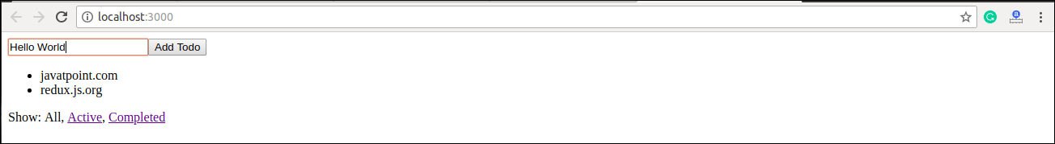

The detailed explanation of React-Redux example can be shown here: <https://redux.js.org/basics/usage-with-react>.

# **React Portals**

The **React 16.0** version introduced React portals in **September 2017**. A React portal provides a way to render an element outside of its component hierarchy, i.e., in a separate component.

Before React 16.0 version, it is very tricky to render the child component outside of its parent component hierarchy. If we do this, it breaks the convention where a component needs to render as a new element and follow a **parent-child** hierarchy. In React, the parent component always wants to go where its child component goes. That's why React portal concept comes in.

### **Syntax**

1. ReactDOM.createPortal(child, container)

Here, the first argument (child) is the component, which can be an element, string, or fragment, and the second argument (container) is a DOM element.

### **Example before React v16**

Generally, when you want to return an element from a component's render method, it is mounted as a new div into the DOM and render the children of the closest parent component.

Play Video

1. render() {
2. // React mounts a new div into the DOM and renders the children into it
3. **return** (
4. <div>
5. {**this**.props.children}
6. </div>
7. );
8. }

### **Example using portal**

But, sometimes we want to insert a child component into a different location in the DOM. It means React does not want to create a new div. We can do this by creating React portal.

1. render() {
2. **return** ReactDOM.createPortal(
3. **this**.props.children,
4. myNode,
5. );
6. }

## Features

* It uses React version 16 and its official API for creating portals.
* It has a fallback for React version 15.
* It transports its children component into a new React portal which is appended by default to document.body.
* It can also target user specified DOM element.
* It supports server-side rendering
* It supports returning arrays (no wrapper div's needed)
* It uses <Portal /> and <PortalWithState /> so there is no compromise between flexibility and convenience.
* It doesn't produce any DOM mess.
* It has no dependencies, minimalistic.

## When to use?

The common use-cases of React portal include:

* Modals
* Tooltips
* Floating menus
* Widgets

## Installation

We can install React portal using the following command.

1. $ npm install react-portal --save

## Explanation of React Portal

Create a new React project using the following command.

1. $ npx create-react-app reactapp

Open the App.js file and insert the following code snippet.

**App.js**

1. **import** React, {Component} from 'react';
2. **import** './App.css'
3. **import** PortalDemo from './PortalDemo.js';
5. **class** App **extends** Component {
6. render () {
7. **return** (
8. <div className='App'>
9. <PortalDemo />
10. </div>
11. );
12. }
13. }
14. export **default** App;

The next step is to create a **portal** component and import it in the App.js file.

**PortalDemo.js**

1. **import** React from 'react'
2. **import** ReactDOM from 'react-dom'
4. function PortalDemo(){
5. **return** ReactDOM.createPortal(
6. <h1>Portals Demo</h1>,
7. document.getElementById('portal-root')
8. )
9. }
10. export **default** PortalDemo

Now, open the Index.html file and add a <div id="portal-root"></div> element to access the child component outside the root node.

**Index.html**

1. <!DOCTYPE html>
2. <html lang="en">
3. <head>
4. <meta charset="utf-8" />
5. <link rel="shortcut icon" href="%PUBLIC_URL%/favicon.ico" />
6. <meta name="viewport" content="width=device-width, initial-scale=1" />
7. <meta name="theme-color" content="#000000" />
8. <link rel="manifest" href="%PUBLIC_URL%/manifest.json" />
9. <title>React App</title>
10. </head>
11. <body>
12. <noscript>It is required to enable JavaScript to run **this** app.</noscript>
13. <div id="root"></div>
14. <div id="portal-root"></div>
15. </body>
16. </html>

**Output:**

When we execute the React app, we will get the following screen.

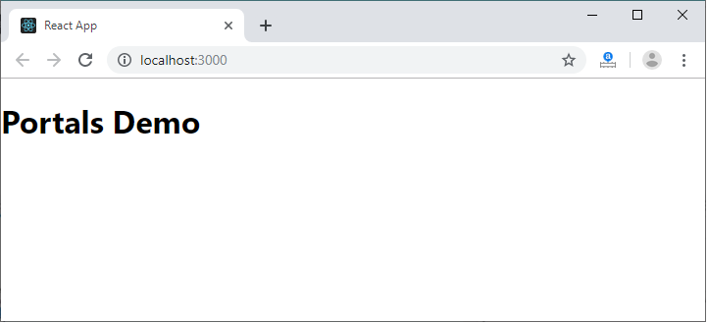

Now, open the **Inspect** (ctrl + shift + I). In this window, select the **Elements** section and then click on the <div id="portal-root"></div> component. Here, we can see that each tag is under the "portal-root" DOM node, not the "root" DOM node. Hence, we can see that how React Portal provides the ability to break out of root DOM tree.

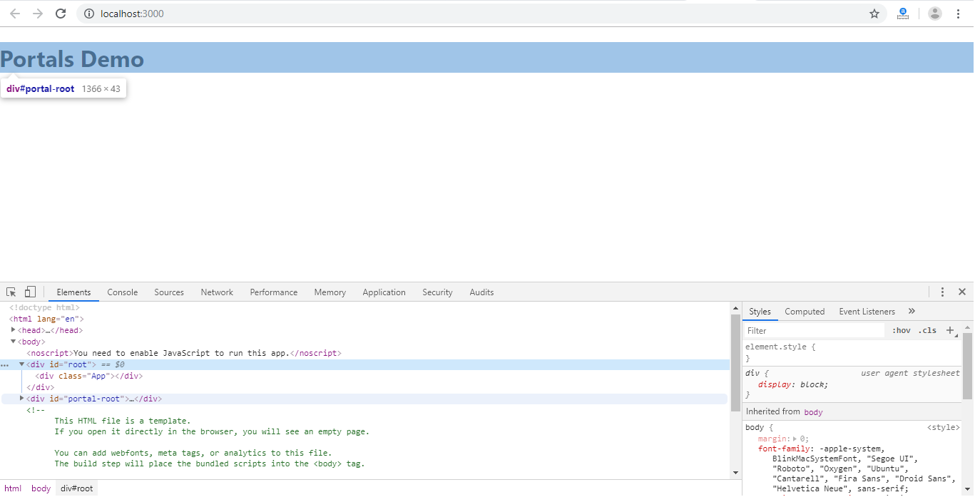

# **React Error Boundaries**

In the past, if we get any JavaScript errors inside components, it corrupts the React?s internal state and put React in a broken state on next renders. There are no ways to handle these errors in React components, nor it provides any methods to recover from them. But, **React 16** introduces a new concept to handle the errors by using the **error boundaries**. Now, if any JavaScript error found in a part of the UI, it does not break the whole app.

Error boundaries are React components which catch JavaScript errors anywhere in our app, log those errors, and display a fallback UI. It does not break the whole app component tree and only renders the fallback UI whenever an error occurred in a component. Error boundaries catch errors during rendering in component lifecycle methods, and constructors of the whole tree below them.

Note:

Sometimes, it is not possible to catch Error boundaries in React application. These are:

* Event handlers
* Asynchronous code (e.g. setTimeout or requestAnimationFrame callbacks)
* Server-side rendering
* Errors are thrown in the error boundary itself rather than its children.

For simple React app, we can declare an error boundary once and can use it for the whole application. For a complex application which have multiple components, we can declare multiple error boundaries to recover each part of the entire application.

We can also report the error to an error monitoring service like **Rollbar**. This monitoring service provides the ability to track how many users are affected by errors, find causes of them, and improve the user experience.

## Error boundary in class

A class component can becomes an error boundary if it defines a new lifecycle methods either static getDerivedStateFromError() or componentDidCatch(error, info). We can use static getDerivedStateFromError() to render a fallback UI when an error has been thrown, and can use componentDidCatch() to log error information.

An error boundary can?t catch the error within itself. If the error boundary fails to render the error message, the error will go to the closest error boundary above it. It is similar to the catch {} block in JavaScript.

## How to implement error boundaries

**Step-1** Create a class which extends React component and passes the props inside it.

**Step-2** Now, add componentDidCatch() method which allows you to catch error in the components below them in the tree.

**Step-3** Next add render() method, which is responsible for how the component should be rendered. For example, it will display the error message like "Something is wrong."

### **Example**

1. **class** ErrorBoundary **extends** React.Component {
2. constructor(props) {
3. **super**(props);
4. **this**.state = { hasError: **false** };
5. }
6. **static** getDerivedStateFromError(error) {
7. // It will update the state so the next render shows the fallback UI.
8. **return** { hasError: **true** };
9. }
10. componentDidCatch(error, info) {
11. // It will catch error in any component below. We can also log the error to an error reporting service.
12. logErrorToMyService(error, info);
13. }
14. render() {
15. **if** (**this**.state.hasError) {
16. **return** (
17. <div>Something is wrong.</div>;
18. );
19. }
20. **return** **this**.props.children;
21. }
22. }

**Step-4** Now, we can use it as a regular component. Add the new component in HTML, which you want to include in the error boundary. In this example, we are adding an error boundary around a MyWidgetCounter component.

1. <ErrorBoundary>
2. <MyWidgetCounter/>
3. </ErrorBoundary>

## Where to Place Error Boundaries

An error boundary entirely depends on you. You can use error boundaries on the top-level of the app components or wrap it on the individual components to protect them from breaking the other parts of the app.

Let us see an example.

1. **import** React from 'react';
2. **import** './App.css'
4. **class** ErrorBoundary **extends** React.Component {
5. constructor(props) {
6. **super**(props);
7. **this**.state = { error: **false**, errorInfo: **null** };
8. }
10. componentDidCatch(error, errorInfo) {
11. // Catch errors in any components below and re-render with error message
12. **this**.setState({
13. error: error,
14. errorInfo: errorInfo
15. })
16. }
18. render() {
19. **if** (**this**.state.errorInfo) {
20. **return** (
21. <div>
22. <h2>Something went wrong.</h2>
23. <details style={{ whiteSpace: 'pre-wrap' }}>
24. {**this**.state.error && **this**.state.error.toString()}
25. <br />
26. {**this**.state.errorInfo.componentStack}
27. </details>
28. </div>
29. );
30. }
31. **return** **this**.props.children;
32. }
33. }
35. **class** BuggyCounter **extends** React.Component {
36. constructor(props) {
37. **super**(props);
38. **this**.state = { counter: 0 };
39. **this**.handleClick = **this**.handleClick.bind(**this**);
40. }
42. handleClick() {
43. **this**.setState(({counter}) => ({
44. counter: counter + 1
45. }));
46. }
48. render() {
49. **if** (**this**.state.counter === 3) {
50. **throw** **new** Error('I crashed!');
51. }
52. **return** <h1 onClick={**this**.handleClick}>{**this**.state.counter}</h1>;
53. }
54. }
56. function App() {
57. **return** (
58. <div>
59. <p><b>Example of Error Boundaries</b></p>
60. <hr />
61. <ErrorBoundary>
62. <p>These two counters are inside the same error boundary.</p>
63. <BuggyCounter />
64. <BuggyCounter />
65. </ErrorBoundary>
66. <hr />
67. <p>These two counters are inside of their individual error boundary.</p>
68. <ErrorBoundary><BuggyCounter /></ErrorBoundary>
69. <ErrorBoundary><BuggyCounter /></ErrorBoundary>
70. </div>
71. );
72. }
73. export **default** App

In the above code snippet, when we click on the **numbers**, it increases the **counters**. The counter is programmed to **throw** an error when it reaches **3**. It simulates a JavaScript error in a component. Here, we used an error boundary in **two ways**, which are given below.

**First**, these two counters are inside the same error boundary. If anyone crashes, the error boundary will replace both of them.

1. <ErrorBoundary>
2. <BuggyCounter />
3. <BuggyCounter />
4. </ErrorBoundary>

**Second**, these two counters are inside of their individual error boundary. So if anyone crashes, the other is not affected.

1. <ErrorBoundary><BuggyCounter /></ErrorBoundary>
2. <ErrorBoundary><BuggyCounter /></ErrorBoundary>

**Output:**

When we execute the above code, we will get the following output.

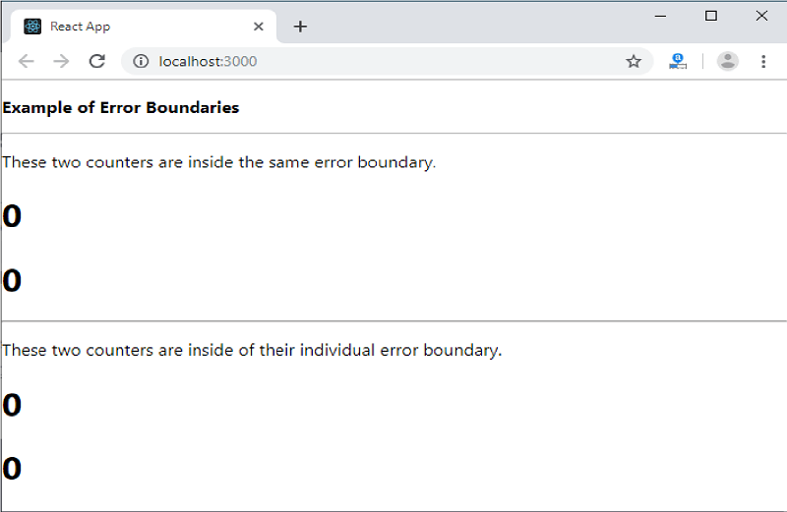

When the counter has reached at 3, it gives the following output.

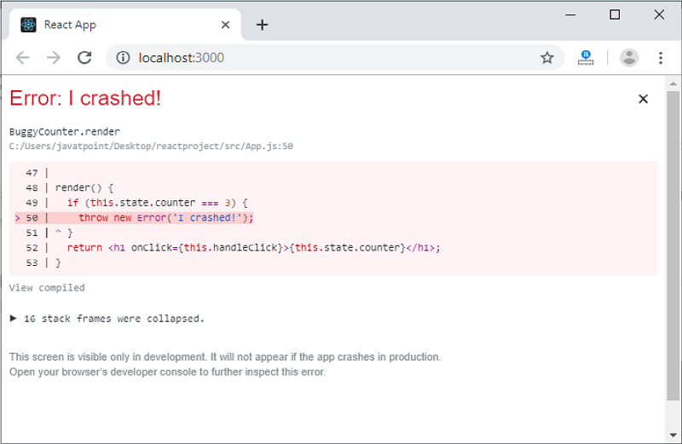

## New Behavior for Uncaught error

It is an important implication related to error boundaries. If the error does not catch by any error boundary, it will result in **unmounting** of the whole React application.

## Error Boundary in Event Handler

Error boundaries do not allow catching errors inside event handlers. React does not need any error boundary to recover from errors in the event handler. If there is a need to catch errors in the event handler, you can use JavaScript **try-catch** statement.

In the below example, you can see how an event handler will handle the errors.

1. **class** MyComponent **extends** React.Component {
2. constructor(props) {
3. **super**(props);
4. **this**.state = { error: **null** };
5. **this**.handleClick = **this**.handleClick.bind(**this**);
6. }
8. handleClick() {
9. **try** {
10. // Do something which can throw error
11. } **catch** (error) {
12. **this**.setState({ error });
13. }
14. }
16. render() {
17. **if** (**this**.state.error) {
18. **return**
19. <h2>It caught an error.</h2>
20. }
21. **return** <div onClick={**this**.handleClick}>Click Me</div>
22. }
23. }

# **Loop Array in React JS | React Foreach Loop Example**

In this section, we are going to use an array to explain the reach native loop in the render. For this, we have described a react loop array example in the render. When we want to build any web application, it is very important to have the knowledge of handling an array of data. In this example, we will see the use of loop in [react js](https://www.javatpoint.com/reactjs-tutorial). In our given example, we are going to use for loop in react js. To perform this, we have to follow some steps.

In this section, we will use react app. When we require a map, foreach loop, and for loop in react, we can look at the following example to learn the use of loop array n react js. In array, we always want for loop and foreach loop. When we want to loop our array in reach, it will require a map to do this. So we are going to explain the example of a map in react native. A new array is created by the map() method. In the calling array, it provides the result of calling a function on each and every element. The looping process can be simplified by this. When we use the map, we don't require the use of forEach function and for loop. Map, forEach loop, for loop has many differences. Instead of overwriting the existing data, the map function uses the data and creates a new array. Due to all the features and the simplicity of the map function, React docs strongly encourage us to use the map function.

We will provide two examples in react app to explain this easy concept. In the first example, we are going to describe the react loop, which has a single-dimensional array. In the second example, we will describe a loop that has a multidimensional array. Both examples are as follows:

**Example 1:**

**rc/App.js**

1. **import** React from 'react';
3. function App() {
5. **const** myArray = ['Jack', 'Mary', 'John', 'Krish', 'Navin'];
7. **return** (
8. <div className="container">
9. <h1> Example of React Map Loop </h1>
11. {myArray.map(name => (
12. <li>
13. {name}
14. </li>
15. ))}
17. </div>
18. );
19. }
21. export **default** App;

**Example 2:**

**src/App.js**

1. **import** React from 'react';
3. function App() {
5. **const** students = [
6. {
7. 'id': 1,
8. 'name': Jack,
9. 'email': 'jack@gmail.com'
10. },
11. {
12. 'id': 2,
13. 'name': 'Mary',
14. 'email': ?mary@gmail.com'
15. },
16. {
17. 'id': 3,
18. 'name': 'John',
19. 'email': 'john@gmail.com'
20. },
21. ];
23. **return** (
24. <div className="container">
25. <h1> Example of React Map Loop </h1>
27. <table className="table table-bordered">
28. <tr>
29. <th>ID</th>
30. <th>Name</th>
31. <th>Email</th>
32. </tr>
34. {students.map((student, index) => (
35. <tr data-index={index}>
36. <td>{student.id}</td>
37. <td>{student.name}</td>
38. <td>{student.email}</td>
39. </tr>
40. ))}
42. </table>
44. </div>
45. );
46. }
48. export **default** App;

After running this example, we will get the following preview:

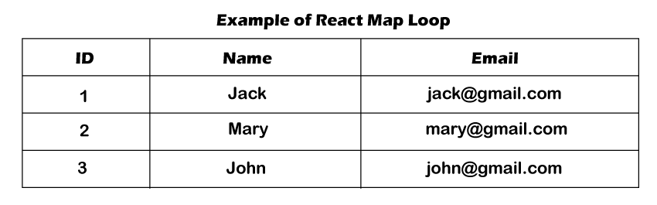

# **React Axios Delete Request Example**

In this section, we are going to see the delete request of react axios. We will use the react js to learn the http delete request. Suppose we want to use axios react to send the http delete request. In this case, we have to follow the step-by-step process to send and delete requests in react, which will be described in the given example.

[React](https://www.javatpoint.com/reactjs-tutorial) is a [JavaScript](https://www.javatpoint.com/javascript-tutorial) library. It can build the interface. Sometimes the data need to be revalidated by the reactive JavaScript frameworks such as Angular and React when a page renders. After this, many requests will be lead between various external services and the front end and back end. Using the axios, we can keep things D.R.Y with default, interceptors, and instances. The complex applications use axios, which are frequently making API requests. Different APIs can be created the separate instances. In order to handle the global error, we can set interceptors. For common headers, the default can be unset or set. A little more functionality is provided by axios. The functionality will be useful for those applications that use React.

Axios is a kind of nmp package which is used to send the http request from our application. The api of "jsonplaceholder" uses the axios package to delete the data, and we will use this api in our example. When we use the web to access resources, this process is not instantaneous. The promise API is contained by JavaScript. When we want to perform asynchronous tasks, these promises will be useful. Asynchronous tasks are very useful to perform things in sequence. That means it does not change any things from happening.

**Example:**

Play Video

1. **import** React from 'react';
3. **import** axios from 'axios';
5. export **default** **class** PostList **extends** React.Component {
6. state = {
7. posts: []
8. }
10. componentDidMount() {
11. axios.get(`https://jsonplaceholder.typicode.com/posts`)
12. .then(res => {
13. **const** posts = res.data;
14. **this**.setState({ posts });
15. })
16. }
18. deleteRow(id, e){
19. axios.delete(`https://jsonplaceholder.typicode.com/posts/${id}`)
20. .then(res => {
21. console.log(res);
22. console.log(res.data);
24. **const** posts = **this**.state.posts.filter(item => item.id !== id);
25. **this**.setState({ posts });
26. })
28. }
30. render() {
31. **return** (
32. <div>
33. <h1> Example of React Axios Delete Request </h1>
35. <table className="table table-bordered">
36. <thead>
37. <tr>
38. <th>ID</th>
39. <th>Title</th>
40. <th>Body</th>
41. <th>Action</th>
42. </tr>
43. </thead>
45. <tbody>
46. {**this**.state.posts.map((post) => (
47. <tr>
48. <td>{post.id}</td>
49. <td>{post.title}</td>
50. <td>{post.body}</td>
51. <td>
52. <button className="btn btn-danger" onClick={(e) => **this**.deleteRow(post.id, e)}>Delete</button>
53. </td>
54. </tr>
55. ))}
56. </tbody>
58. </table>
59. </div>
60. )
61. }
62. }

After executing the above code, we will see the following output:

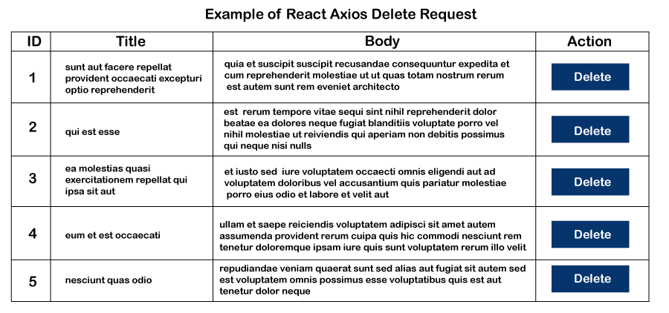

1. In some instances, one library might not contain all the essential icons for usage. Thus, there arises a problem of installing some other libraries to import them into your project directory. React Icons saves developers from having to install different types of packages for such icons.
2. ES6 imports are greatly utilized by React Icons that allow us to include only those necessary icons for the current project. Hence, it removes space-related confusion.
3. React Icons are designed solely for React. This means that it is tailored only to React, and there exist no issues using it in our react project.
4. It is straightforward to implement.

## Getting Started

To get started with the practical visualization of React Icons, all we need to do is add a node package and import the component we want. To do that, we need to install the package using npm through the below-given command.

### **Installation (for standard projects)**

1. $ npm i react-icons--save    // NPM
3. $ yarn add react-icons  // Yarn

### **Usage**

1. **import** { FaBeer } from 'react-icons/fa';
2. **class** Question **extends** React.Component {
3. render() {
4. **return** <h3> Lets go **for** a <FaBeer />? </h3>
5. }
6. }

### **Installation(for meteorjs, gatsbyjs, etc)**

1. $ npm install @react-icons/all-files --save

### **Usage**

1. **import** { FaBeer } from "@react-icons/all-files/fa/FaBeer";
2. **class** Question **extends** React.Component {
3. render() {
4. **return** <h3> Lets go **for** a <FaBeer />? </h3>
5. }
6. }

### **Importing React Icons**

Importing React icons is very simple. It follows this rule or syntax.

1. **import** { IconName } from "react-icons/<library-initials>";

For instance, consider that we are importing more than one icon from the library. We can do that in just one line of code using the ES6 destructing feature. See the code below for reference.

1. **import** { IconName1, IconName2, ..., IconNameN } from "react-
2. icons/<library-initials>";

Now, to take this forward, add the below code in the App.js file and import all the necessary icons. The method of importing multiple icons is shown below.

1. **import** { AiFillTwitterCircle } from "react-icons/ai";
2. **import** { DiGithubBadge } from "react-icons/di";
3. **import** { FaCodepen } from "react-icons/fa";
4. **import** { IoLogoLinkedin } from "react-icons/io";

### **Entering icon tags**

After importing the icons from React Icons in the App.js file, we can use it anywhere in the file, like any HTML tag we know. Consider the below code, for instance, where we would be working only in the nav section within the div tag of the navbar-header. Enter two icons before the h1 tag and two after it, as shown below.

1. <div className="navbar-header">
2. <AiFillTwitterCircle />
3. <FaCodepen />
5. <h1>Navigation</h1>
7. <IoLogoLinkedin />
8. <DiGithubBadge />
9. </div>

The icons would appear something like this.

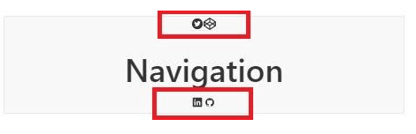

Just like this, we can add multiple icons across different sections of our application. It is simple as that.

### **Icon Styling**

There are usually various ways to style the icons. In this case, we would be using only two ways to style React icons to keep them neat and easy to understand.

1. React Context API.
2. Styled component.

**Using React Context API**

We can either choose to style an icon or more than one icon in React. We need to wrap up all the icons in the tag and style the desired icon residing in the tag.

To understand how it is done, import the Context API and add it to the top of the file, as shown below.

1. **import** { IconContext } from "react-icons";
2. Styling more than one Let's wrap the first 2 icons and assign a
3. className to it like so:
4. <div className="navbar-header">
5. <IconContext.Provider value={{ className: "top-react-icons" }}>
6. <AiFillTwitterCircle />
7. <FaCodepen />
8. </IconContext.Provider>
9. <h1>Navigation</h1>
10. <IoLogoLinkedin />
11. <DiGithubBadge />
12. </div>

Let's style the added react icons in the App.js file as shown below.

1. .top-react-icons{
2. font-size: 5rem;
3. }

The above CSS code would increase the font size. To visualize this, open the browser and the results should look something like this.

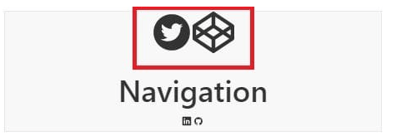

Let's move ahead by styling individual elements. To do that, first, change the color of each icon present on the other side. The overall code snippet is given below to help us out.

1. <div className="navbar-header">
2. {/* styling multiple icons */}
3. <IconContext.Provider value={{ className: "top-react-icons" }}>
5. <AiFillTwitterCircle />
6. <FaCodepen />
7. </IconContext.Provider>
8. <h1>Navigation</h1>
10. {/* styling individual icons */}
11. <IconContext.Provider value={{ color: "blue" }}>
12. <IoLogoLinkedin />
13. </IconContext.Provider>
14. <IconContext.Provider value={{ color: "green" }}>
15. <DiGithubBadge />
16. </IconContext.Provider>
17. </div>

### **Styled Components in React Icons**

Assuming that we are familiar with Styled components, let's install this component through the command line as shown below.

1. $ npm install --save styled-components --save

**Importing Styled Components**

1. **import** styled from from 'styled-components

**Usage**

1. <div className="jumbotron">
2. <BsFillAlarmFill />
3. <h1>Header</h1>
4. <BsFillArchiveFill />
5. </div>

Now, move down to the last line in App.js and add the styles as shown below.

1. **const** Archive  = styled(BsFillArchiveFill)`
2. color: purple;
3. transform: scale(2);
4. margin: 5%;
5. `;

Adding another styled component like an **alarm,** as given below.

1. **const** Alarm = styled(BsFillAlarmFill)`
2. color: red;
3. transform: scale(2);
5. margin: 5%;
6. `;

To apply these styled components to the icons used in the App.js file, use the below method as shown.

1. <div className="jumbotron">
2. <Alarm />
3. <h1>Header</h1>
4. <Archive />
5. </div>

It is important to note that all we did was rename the components to the styled-components and save the changes. It is simple as that. The final output might look something like this.

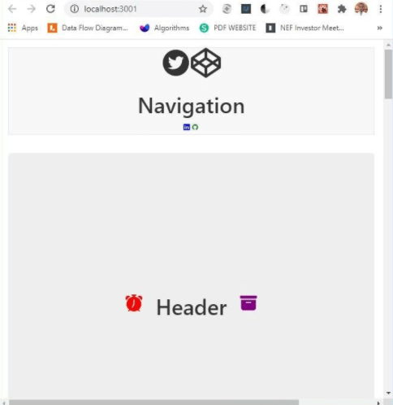

This was one of the examples to make us familiar with React Icons and how different components of React Icons can be used for adding different types of icons on a website or web application.

Let's look at some of the advantages and disadvantages of using React Icons.

### **Advantages**

The advantages are as follows:

1. React Icons have the feature of importing only required icons one at a time or more than one depending on the requirement.
2. Icons in React are easy to use. With React Icons, one library serves all the icons in one place. Other icon generators or directories are required to add or install dependencies on the existing projects, but it is not the case with React Icons.
3. React is easy to learn for JavaScript developers, and with the feature of React Icons, they need not write any extra CSS for generating icons on the application they are working on.
4. CSS needs precision, but with React Icons, we don't need to care much about CSS. Although size and color can be easily modified, it is relatively easy than React Icons.

### **Disadvantages**

1. React Icons need multiple imports. Even for one or more than one icon that needs to be imported in the App.js file, the number of imports is directly proportional to the number of icons.
2. Apart from imports, React Icons are confined only to React. Although they can be used without libraries and frameworks, they suit React best, which can be another disadvantage for other frameworks.

### **Conclusion**

Icons are an integral part that needs no explanations at all. They play a crucial role in separating software's UI and make them unique in their class. It also appeals to the users about some of the important features that users see and how they use them. Many icons remain disposed in React Icons, and users can use it anytime with just simple import.

Beyond this, it is interesting to note that we can get all the required icons for our react project in just a single package. Another reason that makes React Icons unique is that they are very easy to use. In this tutorial, we saw how different types of other components apart from React Icons could be used to design and develop our project. We also came across how to get started with React icons and install them for standard projects and other frameworks. We later learned about the advantages and disadvantages of React Icons. React is easy to learn and implement, provided one needs to have good command over JavaScript and add a bit more. The react Icons also help the ideas get clear.

# **React Date Picker**



## Introduction

We often come across various forums and websites where we need to enter our date of birth or select a date for an appointment of any cause, and a calendar-like icon appears right in front of our eyes. How and where does that pop up from? It must be some specific and dynamically powered calendar that smartly recognizes and presents to us to select dates of our desire. This is where React Date Picker hops in. In this tutorial, we would be learning all such methods from scratch to advanced level on how it is implemented in React and how it can be customized. Let's proceed with the discussion.

The [React](https://www.javatpoint.com/reactjs-tutorial) Date Picker is a helpful and abundant Component used to display dates using the calendar dialog format. There are usually a lot a Date picker options available these days. All of them can have different technical aspects and applications. In this tutorial, we are specifically going to deal with React Date Picker. For that, we need to have a package for it that displays time and date. For better understanding, we will make an application that would help us understand React Date Picker better. But, before that, let's install it as shown in the below steps.

## Installation

To install Date Picker for our React application, we need to have [Node.js](https://www.javatpoint.com/nodejs-tutorial) pre-installed on our system. Although it is not important to always have node modules, it is highly recommended to download them so that all the dependencies are served efficiently. Therefore, the command to install React Date Picker is given below.

The package can be installed via **npm:**

Play Video

1. npm install react-datepicker --save

Or via **Yarn:**

1. yarn add react-datepicker

There might arise a need to install React and its Proptypes individually because, without these dependencies, it is impossible to build a React Date Picker. Also, we may need to use [CSS](https://www.javatpoint.com/css-tutorial) from the external packages so that the Date Picker looks visually great. To get started with our application, we need to import the React Date picker in our main file, and we need to keep checking it through React view.

1. **import** React, { useState } from "react";
2. **import** DatePicker from "react-datepicker";
4. **import** "react-datepicker/dist/react-datepicker.css";
6. // CSS Modules, react-datepicker-cssmodules.css
7. // import 'react-datepicker/dist/react-datepicker-cssmodules.css';
9. **const** Example = () => {
10. **const** [startDate, setStartDate] = useState(**new** Date());
11. **return** (
12. <DatePicker selected={startDate} onChange={(date) =>
13. setStartDate(date)} />
14. );
15. };

## React Datepicker example

Assuming that our system is configured with all the installation requirements and dependencies, we will learn how to create a React application from scratch. This implementation is completely based on the application of React datepicker.

In the discussion above, we assume that we have installed React and PropTypes independently since these dependencies are not incorporated in the package itself. To proceed with the methods of building our application, we need to follow the below-given steps.

1. npx create-react-app react-datepicker-app

Move inside the project folder with the command.

1. cd react-datepicker-app

Start the React app.

1. npm start

After the Node engine is started, we can check our application through port number 3000 of the localhost. Also, we need to include the code snippet given below in our app.js file so that important components for React Date Picker are imported into our file.

1. // app.js
3. **import** React, { Component } from 'react';
4. **import** DatePicker from 'react-datepicker';
6. **import** "react-datepicker/dist/react-datepicker.css";
7. **import** 'bootstrap/dist/css/bootstrap.min.css';
9. **class** App **extends** Component {
11. constructor (props) {
12. **super**(props)
13. **this**.state = {
14. startDate: **new** Date()
15. };
16. **this**.handleChange = **this**.handleChange.bind(**this**);
17. **this**.onFormSubmit = **this**.onFormSubmit.bind(**this**);
18. }
20. handleChange(date) {
21. **this**.setState({
22. startDate: date
23. })
24. }
26. onFormSubmit(e) {
27. e.preventDefault();
28. console.log(**this**.state.startDate)
29. }
31. render() {
32. **return** (
33. <form onSubmit={ **this**.onFormSubmit }>
34. <div className="form-group">
35. <DatePicker
36. selected={ **this**.state.startDate }
37. onChange={ **this**.handleChange }
38. name="startDate"
39. dateFormat="MM/dd/yyyy"
40. />
41. <button className="btn btn-primary">Show Date</button>
42. </div>
43. </form>
44. );
45. }
47. }
49. export **default** App;

Our application would now look something like this.

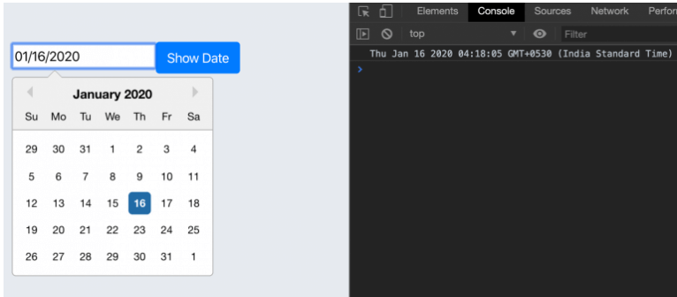

In the above sample coded, we first imported the packages of **Datepicker** and [**Bootstrap**](https://www.javatpoint.com/bootstrap-tutorial) in the React template. Then, we defined it to bind the **handle change** and submit the Component in the event calendar. These events will automatically be triggered when a user submits or changes the Datepicker's input value values. Later, we initialized the Datepicker form state with a new **Date()** object inside the constructor. Lastly, we initiated the Datepicker with the below directive to add some properties to it.

1. **<DatePicker**
2. selected={ this.state.startDate }
3. onChange={ this.handleChange }
4. name="startDate"
5. dateFormat="MM/dd/yyyy"
6. **/>**

We can visualize the output in the form of a calendar-centric datepicker format. The above-given Datepicker adds customized properties to the React application components shown above. It allows us to pick the dates in the form of **months, days,** and **years**.

Furthermore, to customize the datepicker, we have various other methods, be it coloring the components or smartly applying the functions to pick up the dates. We can also customize them easily if we have HTML and CSS components related to the app.js file.

AD

## Localizing the Datepicker

Another instance we are going to learn about is to localize the Datepicker. The Date Picker we are going to make highly depends on date-fns internationalization. This is because it is used to localize the elements that will be on display. If we need to use a locale except for the default en-US, we may need to import it to the project from the date-fns.

Moreover, English is the default locale which consists of 3 methods to set the locale.

AD

**register local** (string, object): loads an imported locale object from date-fns.

**Set default locale** (string): sets a registered locale as the default for all datepicker instances.

**getDefaultLocale:** returns a string showing the currently set default locale.

We can import these services to the locale of the calendar view using the below code snippet.

1. **import** { registerLocale, setDefaultLocale } from  "react-datepicker";
2. **import** es from 'date-fns/locale/es';
3. registerLocale('es', es)
4. <DatePicker
5. locale="es"
6. />

On importing and saving these locale services into our app.js file, our application will look like this.

AD

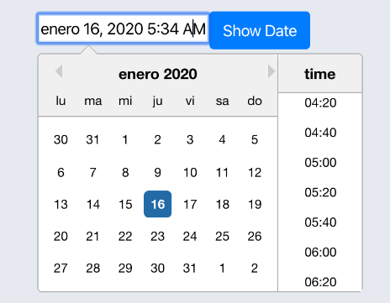

In another instance, to change the locales, we need to primarily change the locale code or by using the internationalization of the date-fns so the code review can be supported.

1. setDefaultLocale('es')

## Setting Calendar date range in Datepicker.

We will learn how to implement the range functionality using **the minDate** and **maxDate property** in this step. To do so, we import the **addDays AP**I from the **date-fns** library to the top of our React component. It will add the specific number of days to the assigned date to set the range.

1. **import** addDays from 'date-fns/addDays'

The **addDays()** method usually takes two parameters:

**Date:** The date that needs to be updated.

**Amount:** The significant amount of days needed to be included.

We can easily set the date range from the current to the next seven days in the React calendar. This can be understood when we implement the **minDate** and **maxDate** methods in the example code shown below.

1. render() {
2. return (
3. **<form** onSubmit={ this.onFormSubmit }**>**
4. **<div** className="form-group"**>**
5. **<DatePicker**
6. selected={ this.state.startDate }
7. onChange={ this.handleChange }
8. showTimeSelect
9. timeFormat="HH:mm"
10. timeIntervals={20}
11. timeCaption="time"
12. dateFormat="MMMM d, yyyy h:mm aa"
13. minDate={new Date()}
14. maxDate={addDays(new Date(), 7)}
15. **/>**
16. **<button** className="btn btn-primary"**>**Show Date**</button>**
17. **</div>**
18. **</form>**
19. );
20. }

The full code snippet for our application after implementing all the steps given above is shown below.

1. **import** React, { Component } from 'react';
2. **import** DatePicker from 'react-datepicker';
3. **import** addDays from 'date-fns/addDays'
4. **import** "react-datepicker/dist/react-datepicker.css";
5. **import** 'bootstrap/dist/css/bootstrap.min.css';

8. **class** App **extends** Component {
10. constructor (props) {
11. **super**(props)
12. **this**.state = {
13. startDate: **new** Date()
14. };
15. **this**.handleChange = **this**.handleChange.bind(**this**);
16. **this**.onFormSubmit = **this**.onFormSubmit.bind(**this**);
17. }
19. handleChange(date) {
20. **this**.setState({
21. startDate: date
22. })
23. }
25. onFormSubmit(e) {
26. e.preventDefault();
27. console.log(**this**.state.startDate)
28. }
30. render() {
31. **return** (
32. <form onSubmit={ **this**.onFormSubmit }>
33. <div className="form-group">
34. <DatePicker
35. selected={ **this**.state.startDate }
36. onChange={ **this**.handleChange }
37. showTimeSelect
38. timeFormat="HH:mm"
39. timeIntervals={20}
40. timeCaption="time"
41. dateFormat="MMMM d, yyyy h:mm aa"
42. minDate={**new** Date()}
43. maxDate={addDays(**new** Date(), 7)}
44. />
45. <button className="btn btn-primary">Show Date</button>
46. </div>
47. </form>
48. );
49. }
51. }
52. export **default** App;

In the above example snippet, we have made **minDate** as a check-in component, and the user can only pick the date before today. We have used the date value for the check-out Component, which means that the user cannot pick a date before the check-in date.

In the next step, we will save the value of our state and define how each handle works. The main idea is to implement it by simply creating a state for each **check-in** and **check-out** date with the defined values and saving the data there. The only difference lies in the **minDate** method of the check-out component, as it is solely dependent on the check-in component. Thus, ensuring that everything is set in terms of values not before and not after, we can now easily select the dates and define the check-out.

## Conclusion

In this tutorial, we have been able to follow through a simple step-by-step guide on building a custom React Datepicker component that can be easily used as a replacement for the native [**HTML5**](https://www.javatpoint.com/html5-tutorial)**datepicker** input elements. We have learned how to set up the React application on priority because rendering the React components might seem complex for beginners, so setting up dependencies would always be preferred by a beginner. We also came across various examples to establish a crystal clear concept of using the components of Datepicker in our application. We also learned about the process of localizing the datepicker so that the date selection process doesn't cause a problem if they are selected for a specif duration on the calendar.

Although the custom datepicker created in this tutorial works as expected, it doesn't comply with all the advanced requirements for a datepicker element. Further improvements can be made, such as implementing the max and min via props, switching the input type from text to date, and establishing better accessibility improvement. We can also develop design methods for the datepicker that we implemented in this tutorial by importing Bootstrap packages and adding custom styling and properties of hovering to make it look more good.

# **React Helmet**



Every developer aspires that his website should appear at the top of the search results pages in a browser. Unfortunately, there are certain instances where the search engine crawler cannot prove to be reliable. This problem occurs because of the inability of the browser to render JavaScript. This means that SPA build on the **React** or **Angular platform** cannot favor the search engine crawlers. This is one of the most significant issues the developers face to bring their pages to the top of the webpage. So, to solve the problem, Server Side Rendering may be used, but it generally has limitations to adapt. This is where React Helmet comes to the rescue.

## What is React Helmet?

React Helmet can be termed as the document **head manager** for React-based applications. Using it, it becomes very easy for developers to update meta tags present on the server-side and the client-side. This library can be termed perfect for applications where SEO plays a crucial role. It is also a media-friendly library with different dependencies and features that make its usage easy in any React app. We will study all the aspects in this tutorial and see how you can add React Helmet into your project.

### **Setup**

Before moving any further, we need to install React Helmet using the traditional and most effective npm approach. We will first initialize a new React project using some commands and start the development process when the server is ready.

To install and initialize React Helmet, follow the below command.

1. npx create-react-app react-helmet-tutorial
2. cd react-helmet-tutorial
3. npm start

Ensure that the system port 3000 is occupied, and then you can get straightforward head over to **http://localhost:3000** and see your app.

## Newly Created React App

We might have known that, like most SPAs available, our application will have a default <head> element. This can be easily verified if we move to the browser for inspection and press F12 in Chrome or use Ctrl+Shift+C in the Firefox browser. Analyzing the content on Chrome, we might see what the <head> element looks like.

1. **<head>**
2. **<meta** charset="utf-8"**>**
3. **<link** rel="icon" href="/favicon.ico"**>**
4. **<meta** name="viewport" content="width=device-width, initial-scale=1"**>**
5. **<meta** name="theme-color" content="#000000"**>**
6. **<meta** name="description" content="Web site created using create-react-app"**>**
7. **<link** rel="apple-touch-icon" href="/logo192.png"**>**
9. **<link** rel="manifest" href="/manifest.json"**>**
11. **<title>**React App**</title>**
12. **<style** type="text/css"**>**
13. <!-- CSS -->
14. **</style>**
15. **</head>**

There's another way to manage the <head>. This is done by updating the public/index.html directory but should not always be an alternative since it is a bad practice. After this step, we need to install and make use of React Helmet in our project.

## Installation and Setup

React Helmet can be installed into your React project through Yarn or npm using the command given below.

1. npm install react-helmet
3. # OR, using Yarn:
5. yarn add react-helmet

The next is to follow the process of importing the Helmet component. Once done, we can easily add elements to the <head> of the document. See how the following step is implemented in the below code snippet.

1. // src/App.js
3. import React from "react";
4. import "./App.css";
5. import { Helmet } from "react-helmet";
7. function App() {
8. return (
9. **<div** className="App"**>**
11. **<Helmet>**
12. **<html** lang="en" **/>**
13. **<title>**React Helmet Tutorial**</title>**
14. **<meta** name="description" content="Tutorial for React Helmet" **/>**
15. **<meta** name="theme-color" content="#E6E6FA" **/>**
16. **</Helmet>**
18. **<header** className="App-header"**>**Title will be React Helmet
19. Tutorial**</header>**
20. **</div>**
21. );
22. }
23. export default App;

As soon as the above code snippet is updated to the directory src/App.js file, we will notice the changes in our React application.

In this code snippet, to keep the understanding level easy, we have used only <title>, <html> and <meta> tag elements for description and some amount of theme color is also used for the other elements like **base, meta, link, script,** etc. These elements are generally treated as the children of Helmet. Below is the example where we can see the attributes that have been defined for the body tag and html tag.

1. **<Helmet>**
2. {/* html attributes */}
3. **<html** lang="en" **/>**
5. {/* body attributes */}
6. **<body** className="dark" **/>**
8. {/* title element */}
9. **<title>**React Helmet Tutorial**</title>**
11. {/* base element */}
12. **<base** target="_blank" href="https://blog.logrocket.com/" **/>**
14. {/* meta elements */}
15. **<meta** name="description" content="Tutorial for React Helmet" **/>**
17. **<meta** name="theme-color" content="#E6E6FA" **/>**
19. {/* link elements */}
20. **<link** rel="canonical" href="https://blog.logrocket.com/" **/>**
21. **</Helmet>**
23. // src/Child.js
25. import React from "react";
26. import { Helmet } from "react-helmet";
27. function Child() {
28. return (
29. **<div>**
30. **<Helmet>**
31. **<title>**Child Component Rocks!**</title>**
32. **</Helmet>**
33. {"  "}  This time title will be  Child Component Rocks!
34. **</div>**
35. );
36. }
37. export default Child;

#### **Note: There is ambiguity in the above example because we may not know whether the preference would be given to the Child or Parent.**

To clarify this, the preference is given to the child component. Consider the below code:

1. // src/Child.js
3. import React from "react";
4. import { Helmet } from "react-helmet";
5. function Child() {
6. return (
7. **<div>**
8. **<Helmet>**
9. **<title>**Child Component Rocks!**</title>**
10. **</Helmet>**
11. {"  "}  This time title will be  Child Component Rocks!
12. **</div>**
13. );
14. }
15. export default Child;

Now, to import the child component, i.e. the Child.js file, to the parent component, i.e. App.js file, we must not forget to change the document's title according to the child component. But, it is also important to understand that the metadata and the theme color cannot be overwritten. The demonstration for the same is shown in the code snippet given below.

1. // src/App.js
3. **import** React from "react";
4. **import** "./App.css";
5. **import** { Helmet } from "react-helmet";
6. **import** Child from "./Child";
7. function App() {
8. **return** (
9. <div className="App">
10. <Helmet>
11. <title>React Helmet Tutorial</title>
12. <meta name="description" content="Tutorial for React Helmet" />
13. <meta name="theme-color" content="#E6E6FA" />
14. </Helmet>
16. <header className="App-header">
17. Title will not be React Helmet Tutorial <Child />
18. </header>
19. </div>
20. );
21. }
22. export **default** App;

Another instance to consider here is that the one occurring later will always be given the utmost preference between two child components. For instance, consider two child components <Child1> and <Child2>, then the <Child2> will be given the preference and vice-versa. The demonstration to support this statement is given below.

1. // src/App.js
2. **import** React from "react";
3. **import** "./App.css";
4. **import** { Helmet } from "react-helmet";
5. **import** Child1 from "./Child1";
6. **import** Child2 from "./Child2";
7. function App() {
8. **return** (
9. <div className="App">
10. <Helmet>
11. <title>React Helmet Tutorial</title>
12. <meta name="description" content="Tutorial for React Helmet" />
13. <meta name="theme-color" content="#E6E6FA" />
14. </Helmet>
15. <header className="App-header">
16. Title will not be React Helmet Tutorial
18. <Child1 />
19. <Child2 />
20. </header>
21. </div>
22. );
23. }
24. export **default** App;

It is evident from the above code that the title will be set according to the <Child2> component. If the order is reversed, then the <Child1> will be set to the preference. This can be shown using the code snippet shown below.

1. <header className="App-header">
2. Title will not be React Helmet Tutorial
3. <Child2 />
4. <Child1 />
5. </header>

## React Helmet with SSR integration

As we previously discussed, React Helmet is mostly nominated to be the best partner for app rendering residing in the server-side of the application; you can easily refer to the terms by setting up a sample React SSR application. Thus, in the application's server-side code, just after the ReactDOMServerr's renderToString or renderToStaticMarkup, we need to apply the method of render static in the Helmet. To illustrate how it is done, consider the below code snippet.

1. // server/index.js
2. **import** React from "react";
3. **import** { renderToString } from "react-dom/server";
4. **import** express from "express";
5. **import** App from "./src/App";
6. **import** { Helmet } from "react-helmet";
7. **const** app = express();
9. app.get("/*", (req, res) => {
10. **const** app = renderToString(<App />);
11. **const** helmet = Helmet.renderStatic();
13. **const** html = `
14. <!DOCTYPE html>
15. <html ${helmet.htmlAttributes.toString()}>
16. <head>
17. ${helmet.title.toString()}
18. ${helmet.meta.toString()}
19. ${helmet.link.toString()}
20. </head>
21. <body ${helmet.bodyAttributes.toString()}>
22. <div id="root">
23. ${app}
24. </div>
25. </body>
26. </html>
27. `;
28. res.send(html);
29. });
30. app.listen(8000);

It is important to understand that in every Helmet property, there is a method of toString(). This method is mainly used inside the HTML string. It is also an instance of Helmet's render static that generally returns with all the properties covered like the **script, link, title,** etc., and all of these properties have default toString() method contained in them.

It might not always be a good option to work synchronously to proceed with the React Helmet's SSR implementation. If we are open or bound to make asynchronous requests like streaming, the React Helmet would lead to potential threats and errors. Hence, to cope up with this issue, we use the react-helmet-async method. This method solves this problem by forking React Helmet explicitly. To install it, we need to run the following terminal command in the node environment.

1. npm i react-helmet-async

After running this command, we need to be assured to keep everything except just using HelmetProvider so that the React tree gets encapsulated on both the server-side and the client-side. The simple demonstration for this is shown below.

1. // src/App.js
2. **import** React from "react";
3. **import** "./App.css";
4. **import**  {Helmet, HelmetProvider } from 'react-helmet-async';
5. function App() {
6. **return** (
7. <HelmetProvider>
8. <div className="App">
9. <Helmet>
10. <title>React Helmet Tutorial</title>
11. <meta name="description" content="Tutorial for React Helmet" />
12. <meta name="theme-color" content="#E6E6FA" />
13. </Helmet>
14. <header className="App-header">
15. Title will be React Helmet Tutorial
16. </header>
17. </div>
18. </HelmetProvider>
19. );
20. }
21. export **default** App;

## React Helmet & React Router

React Helmet works great if the application being build uses React Router for routing. One hook associate with it is that we need to use React Helmet with every Router, so the routes remain intact, and this can be demonstrated using the below code snippet.

1. // src/App.js
2. **import** React from "react";
3. **import** { Helmet } from "react-helmet";
4. **import** { BrowserRouter, Switch, Route, Link } from "react-router-dom";
5. **import** Home from './Home'
6. **import** About from './About'
7. export **default** function App() {
8. **return** (
9. <div>
10. <BrowserRouter>
11. <Switch>
12. <Route exact path="/">
13. <Home />
14. </Route>
15. <Route path="/about">
16. <About />
17. </Route>
18. </Switch>
19. </BrowserRouter>
20. </div>
21. );
22. }
23. Where Home.js is:
25. // src/Home.js
26. **import** React from "react";
27. **import** { Helmet } from "react-helmet";
28. **import** {  Link } from "react-router-dom";
30. **const** Home = () => (
31. <div>
32. <Helmet>
33. <title>Home</title>
34. </Helmet>
35. <h2>Home.</h2>
36. <Link to="/about">About</Link>
37. </div>
38. );
40. export **default** Home
41. And About.js is:
43. // src/About.js
44. **import** React from "react";
45. **import** { Helmet } from "react-helmet";
46. **import** {  Link } from "react-router-dom";
48. **const** About = () => (
49. <div>
50. <Helmet>
51. <title>About</title>
52. </Helmet>
53. <h2>About.</h2>
54. <Link to="/">Home</Link>
55. </div>
56. );
57. export **default** About;

This is how routing is done using React Helmet and React Router, and also, the method can be used as many routes as possible.

## Conclusion

In this tutorial, we learned how to install, set up and use React Helmet. React Helmet is a powerful library mainly used as the document head manager that brings our SEO to the top of the web page. It is small and convenient to use, and if the application is built with the intent to remain at the top charts, it outlasts better than any library in its class.

# **Inline Style in React**

### **Introduction**

In frontend projects that rarely require a single-page app, inline styles of DOM elements are often placed in the target element's **style="property: value**" attribute.

But in React, things are quite different regarding styling inline. This guide focuses on achieving this using a real-world example of creating a User Profile Card component.

### **Styling Components in React**

You may already be aware of the regular way to style React components using the classname attribute in conjunction with an external stylesheet:

1. **import** React from "react"
2. **import** './style.css'
3. function myComponent(){
4. **return**(
5. **return** <p className="paragraph-text">ClassName Styled Text</p>
6. )
7. }

**jsx**

Play Video[](https://campaign.adpushup.com/get-started/?utm_source=banner&utm_campaign=growth_hack)

1. paragraph-text{
2. font-weight: bold;
3. color: beige;
4. }

### **CSS**

**Inline Styles**

Getting the same result with inline styles works quite differently. To use inline styles in React, use the style attribute, which accepts a JavaScript object with camel properties. Example:

1. function MyComponent(){
2. return **<div** style={{ color: 'blue', lineHeight : 10, padding: 20 }}**>** Inline Styled Component**</div>**
3. }

Note that padding value does not have a unit because React adds a **'px**' suffix to some numeric inline style properties. In cases where you need to use other units, such as 'em' or 'rem', explicitly specify the unit with the value as a string. Applying this to the padding property should be padding: **'1.5em'**.

Also, these styles are not automatically vendor-prefixed, so you have to add vendor prefixes manually.

### **Improve Readability**

The readability of MyComponent drops dramatically if the styles become too many and everything gets clunky. As shown below, since styles are just objects, they can be removed from the component.

1. const myComponentStyle = {
2. color: 'blue',
3. lineHeight: 10,
4. padding: '1.5em',
5. }
6. function MyComponent(){
8. return **<div** style={myComponentStyle}**>** Inline Styled Component**</div>**
9. }

### **jsx**

**Building a Card Component**

Let's build the user card component.

1. const cardStyles = {
2. container: {
3. display: "flex",
4. height: 100,
5. width: 400,
6. boxShadow: "0 0 3px 2px #cec7c759",
7. alignItems: "center",
8. padding: 20,
9. borderRadius: 20,
10. },
11. profilePicture: {
12. display: "flex",
13. justifyContent: "center",
14. alignItems: "center",
15. backgroundColor: "orange",
16. color: "white",
17. height: 20,
18. width: 20,
19. borderRadius: "50%",
20. padding: 10,
21. fontWeight: "bold",
22. },
23. bio: {
24. marginLeft: 10,
25. },
26. userName: {
27. fontWeight: "bold",
28. },
29. };
30. function userCardComponent(){
31. **<div** style={cardStyles.container}**>**
32. **<span** style={cardStyles.profilePicture}**>**D**</span>**
33. **<div** style={cardStyles.bio}**>**
34. **<p** style={cardStyles.userName}**>**Desmond Nyamador**</p>**
35. **<p>**I just learned an easy way to style React Components**</p>**
36. **</div>**
37. **</div>**
39. }

### **Rule of Thumb**

The official React documentation barks at using inline styling as the primary means of styling projects and recommends using the className attribute instead.

Note Some examples in the documentation use a style for convenience, but it is generally not recommended to use the style attribute as the primary means of styling elements.

In most cases, [class name](https://reactjs.org/docs/dom-elements.html#classname)s should refer to classes defined in an external CSS stylesheet. Styles are often used in React apps to add dynamically computed styles at render time.

# **jQuery vs. React**

### **Introduction**

jQuery and React are JavaScript libraries that provide comparable results using different technologies. Each has different advantages and disadvantages. In this guide, we'll compare jQuery and React.

jQuery joined the show in 2006. At that time, JavaScript was not as common and trendy as it is now. JQuery changed the fate of web user interfaces as it enabled developers to deliver interactive experiences easily and painlessly.

In other words, jQuery revolutionized the industry by shifting developers from building primitive websites to developing web apps.

React was born in 2013 and was originally written by **Jordan Walke**. By **2016**, React had acquired a wide fan base among web developers, who quickly adopted it as it was capable of embedding HTML within JavaScript.

It allowed seamless HTML manipulation upon a change in state or data. Instead of developing web apps, developers can now build sophisticated, large-scale, single-page apps using React.

For this reason, many new developers are joining the React landscape.

### **Library Size in KB**

The first factor in this comparison is the size of the library, due to its impact on the end user experience. If the end user repeatedly sits and waits for pages to load, their experience of using the web app will not be pleasant. They may get frustrated and choose another, faster web app.

React developers are often opposed to the oversized React library. After minification, the size of the React library is about 95 KB, while the jQuery library is about 75 KB. Thus, jQuery's file size is an astonishing 18% smaller than React's. To get an idea of how low 18% is, think about 20% less load on a 3G network when using a smartphone or tablet. not good, is it?

So when it comes to size, jQuery has a great advantage over React.

### **Opportunities**

Over the years, web app developers have shifted from using jQuery to Angular or React. The impact that React has had on the industry is, and still is, unprecedented.

For a direct understanding, just install the React Developer Tools browser extension; This differentiates websites that employ React. You might be surprised by the number of well-known and even popular web apps that use React: Airbnb, TripAdvisor, Netflix, Facebook (Facebook is maintained by React), and Instagram.

Many other companies are upping their game and switching to React to develop their web apps, which translates to a sky-high demand for React developers.

### **Third Party Libraries**

Developers try to avoid reinventing the wheel at all costs. Web development work may demand that you deploy some functionalities or features that another practical developer had previously done, packaged, and released as a library to developers.

Launched in 2019, the largest available source for JavaScript libraries, although it is not comprehensive, is the Node Package Manager (NPM).

jQuery is seven years older than React, so you might think that the number of libraries offered for jQuery would exceed the number of libraries for React. However, when you search this reservoir for packages for jQuery and React, you will see that React has a huge number of NPM packages.

Thus, React will score higher than jQuery based on the number of third-party libraries available.

### **Ease of Use**

The debate between jQuery and React gets a bit tricky when it comes to ease of use. Both are similar, but the purpose is different when implementing them.

If you are building a simple website to which you want to add some style, you can go with jQuery. jQuery works like magic, whether it's an animated navigation menu, powering a simple contact form, or a basic trigger event in a button.

However, jQuery falls short when it comes to building a web app with sophisticated functionalities and various views. This is where React comes in handy.

React is more capable of handling these apps due to the nature of its design and the mechanism that deploys its components.

### **For which project is React a better choice than jQuery?**

ReactJS is a smart choice when building large applications and complex user interfaces. The library allows you to display multiple dynamic content changes as the user views it. Its decoration simplifies and accelerates the process of product development and release.

With this development tool, you can build a site, application, or specific function from flexible, reusable components (tab bars, lists, etc.) without rewriting code. Thus, it allows developers to build quality applications with a flexible architecture that can be adapted to any further changes.

There is a trend among developers to opt for React. According to JS State, this library has the highest level of satisfaction, and more than 70% of developers use it in their work. Now, most of the large projects are built using this same JS library. We also use it in development.

Yoji experts have developed many web and mobile applications and can easily build supported component systems on projects. Each specialist has unique expertise and their own experience in different projects. We will help you choose the most suitable approach specifically for your project based on your request.

**jQuery** and **React** are both popular JavaScript libraries. These libraries greatly aid and streamline the process of front-end web development. They have advantages over one another based on the use-case and specific requirements.

**Let's take a look at the step-by-step comparison between both libraries.**



* **jQuery** is a "write less, do more" JavaScript library. It simplifies complex JavaScript tasks by wrapping them into straightforward methods. **React** is a JavaScript library for building user interfaces (UI). It is a tool for developing different UI elements and components.
* jQuery was initially released in 2006 by The jQuery Team, but React was initially released in 2013 by Facebook.
* The size of the jQuery library is approximately 18% less than React. While this difference may seem insignificant, it can have a substantial impact on page load times
* jQuery makes use of the traditional DOM. In the case of a traditional DOM update, the tree is updated from the root down. Thus, DOM updates can take more time, especially for large and complex applications.
* As opposed to jQuery, React makes use of a Virtual DOM. The use of a virtual DOM speeds up the DOM update process. It makes React substantially fasterthan jQuery.
* During web development, developers often use third-partyJavaScript libraries written in jQuery or React. These third-party libraries can be really helpful and are usually present as NPM (Node Package Manager) packages. There are significantly more NPM packages available in React compared to jQuery. It makes React more favorable when third-party libraries are required.

**jQuery is a utility library that wraps different browser APIs. It is not specifically designed for building large applications**.

* JQuery can lead developers to create "Spaghetti Code" for large applications, i.e., the code grows bigger and more complex with time and becomes significantly harder to maintain. If we use jQuery for large applications, we might run into the following problems:
* Large applications consist of a huge, complex DOM tree --traditional DOM updates get slower with time.

As opposed to jQuery, React is a component management library. **It is favorable for developing large-sized applications because:**

* The component-oriented structureof React requires developers to use recommended methodologies. While this takes away some flexibility, it helps maintain the code as the application gets larger.
* The use of a virtual DOM incurs a lesser time overhead for DOM updates. It makes the DOM update process faster for large applications.

### **Conclusion**

In this guide, you get a glimpse of some fascinating facts about jQuery and React and compare the two in a different light.

Technically, there is no clear winner in the jQuery vs React debate from a developer's point of view as they solve completely different problems.

However, if you look at them in relation to job opportunities or longevity, then React is a better option. React is an amazing JavaScript library backed by a powerful development team at Facebook and is likely to stand the test of time.

# **ReactJS Architecture**

The React library is built on a solid foundation. It is simple, flexible and extensible. As we learned earlier, React is a library for creating user interfaces in a web application. The primary objective of React is to enable the developer to create user interfaces using pure JavaScript.

Typically, each user interface library introduces a new template language (which we need to learn) for designing user interfaces and provides the option to write logic inside the template or separately.

Instead of introducing a new template language, React introduces three simple concepts as below -

### **React elements**

JavaScript representation of HTML DOM. React provides an API, **React.createElement** to create React Element.

Play Video[](https://campaign.adpushup.com/get-started/?utm_source=banner&utm_campaign=growth_hack)

### **JSX**

A JavaScript extension for designing user interfaces. JSX is an XML based, extensible language that supports HTML syntax with slight modifications. JSX can be compiled for React Elements and used to build user interfaces.

### **React Component**

React components are the primary building block of React applications. It uses React Elements and JSX to design its user interface.

React Component is a JavaScript class (extends the React Component class) or a pure JavaScript function. React components have properties, state management, lifecycle and event handlers. React components can be able to do simple as well as advanced logic.

**Let us learn more about components in the React Component chapter.**

### **Workflow of a React application**

Let us understand the workflow of a React application in this chapter by creating and analyzing a simple React application.

Open a command prompt and go to your workspace.

1. cd /go/to/your/workspace

Next, create a folder, static_site, and change the directory to the newly created folder.

1. mkdir static_site
2. cd static_site

### **Example**

Next, create a file, hello.html and write a simple React application.

1. <!DOCTYPE html**>**
2. **<html>**
3. **<head>**
4. **<meta** charset="UTF-8" **/>**
5. **<title>**React Application**</title>**
6. **</head>**
7. **<body>**
8. **<div** id="react-app"**></div>**
9. **<script** src="https://unpkg.com/react@17/umd/react.development.js" crossorigin**></script>**
10. **<script** src="https://unpkg.com/react-dom@17/umd/react-dom.development.js" crossorigin**></script>**
11. **<script** language="JavaScript"**>**
12. element = React.createElement('h1', {}, 'Hello React!')
13. ReactDOM.render(element, document.getElementById('react-app'));
14. **</script>**
15. **</body>**
16. **</html>**

Next, serve the application using the service web server.

1. serve ./hello.html

**Output**

Next, open your favorite browser. Enter **http://localhost:5000** in the address bar and then press enter.

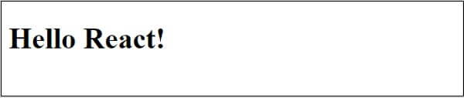

Let us analyze the code and do a little modification to understand the React application better.

Here, we are using two APIs provided by the React library.

**React.createElement**

Used to create React elements. **It expects three parameters** -

* Element tag
* Element attributes as object
* Element content - It can contain nested React elements as well

**ReactDOM.render**

Used to render the element into the container. **It expects two parameters** -

* React Element OR JSX
* Root element of the webpage

**Nested React element**

As **React.createElement** allows nested React element, let us add nested element as shown below -

**Example**

1. **<script** language="JavaScript"**>**
2. element = React.createElement('div', {}, React.createElement('h1', {}, 'Hello React!'));
3. ReactDOM.render(element, document.getElementById('react-app'));
4. **</script>**

**Output**

It will generate the below content -

<div><h1> Hello React!</h1></div>

### **Use JSX**

Next, let us remove the React element entirely and introduce JSX syntax as shown below:

1. <!DOCTYPE html**>**
2. **<html>**
3. **<head>**
4. **<meta** charset="UTF-8" **/>**
5. **<title>**React Application**</title>**
6. **</head>**
7. **<body>**
8. **<div** id="react-app"**></div>**
9. **<script** src="https://unpkg.com/react@17/umd/react.development.js" crossorigin**></script>**
10. **<script** src="https://unpkg.com/react-dom@17/umd/react-dom.development.js" crossorigin**></script>**
11. **<script** src="https://unpkg.com/@babel/standalone/babel.min.js"**></script>**
12. **<script** type="text/babel"**>**
13. ReactDOM.render(
14. **<div><h1>**Hello React!**</h1></div>**,
15. document.getElementById('react-app')
16. );
17. **</script>**
18. **</body>**
19. **</html>**

Here, we have included babel to convert JSX into JavaScript and added type="**text/babel**" in the script tag.

1. **<script** src="https://unpkg.com/@babel/standalone/babel.min.js"**></script>**
2. **<script** type="text/babel"**>**
3. ...
4. ...
5. **</script>**

Next, run the application and open the browser. The output of the application is as follows -

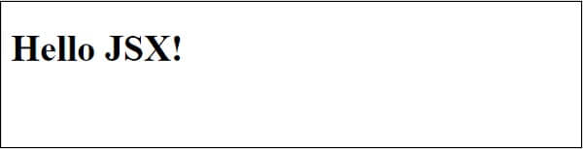

Next, let us create a new React component, Greeting and then try to use it in the webpage.

1. **<script** type="text/babel"**>**
2. function Greeting() {
3. return **<div><h1>**Hello JSX!**</h1></div>**
4. }
5. ReactDOM.render(**<Greeting** **/>**, document.getElementById('react-app') );
6. **</script>**

The result is same and as shown below -



By analyzing the application, we can visualize the workflow of the React application, as shown in the below **diagram**.

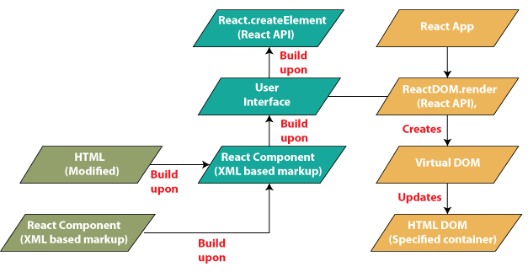

The React app calls the **reactdom.render** method, bypassing the user interface created using the React component (**coded in JSX or React Elementor format**) and the container to render the user interface.

**ReactDOM.render** processes JSX or React Elements and emits virtual DOM.

The virtual DOM will be merged and rendered in the container.

### **React Application Architecture**

The React library is just a UI library, and it doesn't implement any special patterns for writing a complex application. Developers are free to choose the design pattern of their choice. The React community advocates certain design patterns.

One of the patterns is the flux pattern. React library also provides many concepts like higher order components, **context, render props, refs** etc. to write better code. React Hooks is developing concept to do state management in large projects. Let's try to understand the high-level architecture of a React application.

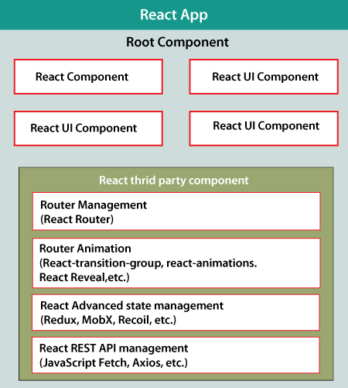

* React app starts with a single root component.
* The core component is created by using one or more components.
* Each component can be nested with any other component at any level.
* Composition is one of the core concepts of the React library. Therefore, each component is built by composing smaller components rather than inheriting one component from another.
* Most of the components are user interface components.
* React apps may include third-party components for a specific purpose, such as **routing, animation, state management**, etc.

# **ReactJS PropTypes**

React props, which stand for "properties", pass data from one component to another. If a component receives the wrong type of props, it can lead to bugs and unexpected errors in your app.

Since JavaScript does not have a built-in type-checking solution, many developers use extensions such as TypeScript and Flow. However, React has an internal mechanism for props validation called prop types.

We pass different types of information, such as integers, strings, arrays, etc., as props to the components. We can either create default props or pass the props directly as attributes of the components. So, let's recall how we passed these props to a component.

We passed props from outside a component and used them inside that component. But did we have to check what kind of values we are getting inside our component via props.

Play Video

It is entirely up to us whether or not we validate the data we receive by using props inside a component. But it is always a good practice for large apps to validate the data we get through props. It will help in debugging and also help in avoiding bugs in the future.

**Let us see how to do this.**

## PropTypes in React

Before React 15.5.0, proptypes are available in the React package, but in later versions of React, you need to add a dependency to your project. You can add a dependency to your project using the below command:

1. npm install prop-types --save

We can use propType to validate any data we get from the prop. But before using it, we have to import it. Add the following line to the top of your index.js file:

1. import PropTypes from 'prop-types';

Once we have imported propTypes, we are ready to work with them. Like default props, propTypes are also objects where keys are the prop names and values are their types.

Below syntax shows how to use **propTypes**:

1. ComponentClassName.propTypes{
2. propName1 : PropTypes.string,
3. propName2 : PropTypes.bool,
4. propName3 : PropTypes.array,
5. .
6. .
7. .
8. .
9. propNamen : PropTypes.anyOtherType
10. }

In the above syntax, componentClassName is the name of the component class; Any other type can be any type we are allowed to pass as prop.

A warning will appear on the console for props that do not validate the type of data specified by propTypes. Let's look at a complete program that uses proptypes for validation for a better understanding:

### **Javascript**

1. import PropTypes from 'prop-types';
2. import React from 'react';
3. import ReactDOM from 'react-dom';
4. // Component
5. class ComponentExample extends React.Component{
6. render(){
7. return(
8. **<div>**
9. {/* printing all props */}
10. **<h1>**
11. {this.props.arrayProp}
12. **<br** **/>**
14. {this.props.stringProp}
15. **<br** **/>**
17. {this.props.numberProp}
18. **<br** **/>**
20. {this.props.boolProp}
21. **<br** **/>**
22. **</h1>**
23. **</div>**
24. );
25. }
26. }
27. // Validating prop types
28. ComponentExample.propTypes = {
29. arrayProp: PropTypes.array,
30. stringProp: PropTypes.string,
31. numberProp: PropTypes.number,
32. boolProp: PropTypes.bool,
33. }
34. // Creating default props
35. ComponentExample.defaultProps = {
36. arrayProp: ['Denail', 'Sairin', 'Rompol'],
37. stringProp: "JavaTpoint",
38. numberProp: "10",
39. boolProp: true,
40. }
41. ReactDOM.render(
42. **<ComponentExample**  **/>**,
43. document.getElementById("root")
44. );

**Output:**

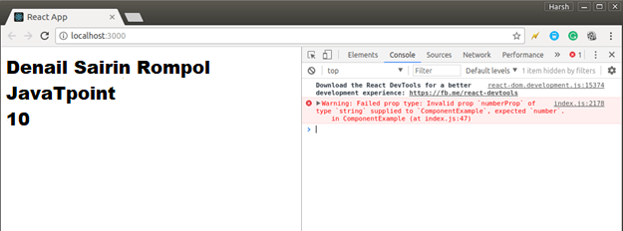

You can see in the above program that we are passing the prop named NumberProp as a string but validating it as a number. You can visit the official documentation of ReactJS to see all the valid types that can take a prop.

Still, everything is rendered perfectly on the browser, but there is a warning message in our browser console. This message tells us that the prop named NumberProp was expected to contain a numeric value, but instead, a string value is passed.

### **Do React props work?**

When you call that component, react props allow you to send data - including numbers, strings, functions, objects, arrays, etc. If you have multiple components, you can pass data from one component to another.

To pass props between components, you would add them when you call the component, just as you would pass arguments when calling a regular JavaScript function.

### **Why validate props in React?**

While developing a React application, you may face the need to structure and define a prop to avoid bugs and errors. Like a function can have mandatory arguments, a react component can require a prop to be defined. Otherwise, it will not render properly.

If you forget to pass a required prop to a component that needs it, it can cause your app to behave unexpectedly.

**Consider the following code.**

1. import React from 'react';
2. import ReactDOM from 'react-dom';
4. function PercentageStat({ label, score = 0, total = Math.max(1, score) }) {
5. return (
6. **<div>**
7. **<h6>**{ label }**</h6>**
8. **<span>**{ Math.round(score / total * 100) }%**</span>**
9. **</div>**
10. )
11. }
13. function App() {
14. return (
15. **<div>**
16. **<h1>**Male Population**</h1>**
17. **<div>**
18. **<PercentageStat** label="Class 1" total={360} score={203} **/>**
19. **<PercentageStat** label="Class 2" total={206} **/>**
20. **<PercentageStat** label="Class 3" score={107} **/>**
21. **<PercentageStat** label="Class 4" **/>**
22. **</div>**
23. **</div>**
24. )
25. }
27. const rootElement = document.getElementById('root');
28. ReactDOM.render(**<App** **/>**, rootElement);

In the above snippet, the component named PercentageStat requires three props for proper rendering: label, score, and total. Default values are set for Score and Total props if they are not provided. The app component renders the percentage position four times, each with different props.

Below is what the app would look like (with some Bootstrap styling):

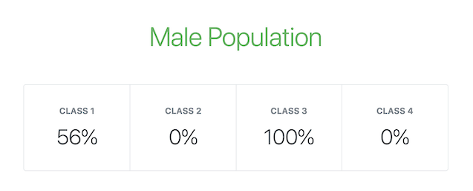

Note that, depending on usage, the label prop is expected to be a string. In the same way, marks and total need to be numerical values as they are used to calculate the percentage. Also, the total is never expected to be 0 because it is being used as the divisor.Below is another code snippet showing a modified app that renders the PercentState components with invalid props.

1. function App() {
2. return (
3. **<div>**
4. **<h1>**Male Population**</h1>**
5. **<div>**
6. **<PercentageStat** label="Class 1" total="0" score={203} **/>**
7. **<PercentageStat** label="Class 2" total={0} **/>**
8. **<PercentageStat** label="Class 3" score={f =**>** f} **/>**
9. **<PercentageStat** label="Class 4" total={{}} score="0" **/>**
10. **</div>**
11. **</div>**
12. )
13. }

The app view now looks like this:

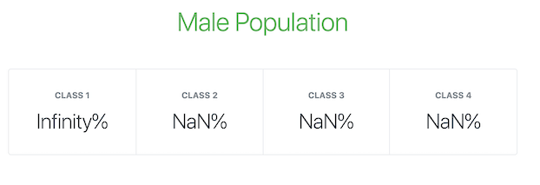

### **Using PropTypes in React**

PropTypes is React's internal mechanism for adding type checking to components.

React components use a special property named prop Types to set up type checking.

1. /**
2. * FUNCTIONAL COMPONENTS
3. */
4. function ReactComponent(props) {
5. // ...implement render logic here
6. }
8. ReactComponent.propTypes = {
9. // ...prop type definitions here
10. }

13. /**
14. * CLASS COMPONENTS: METHOD 1
15. */
16. class ReactComponent extends React.Component {
17. // ...component class body here
18. }
20. ReactComponent.propTypes = {
21. // ...prop type definitions here
22. }

25. /**
26. * CLASS COMPONENTS: METHOD 2
27. * Using the `static` class properties syntax
28. */
29. class ReactComponent extends React.Component {
30. // ...component class body here
32. static propTypes = {
33. // ...prop type definitions here
34. }
35. }

When props are passed to a React component, they are checked against the type definition configured in the propTypes property. When an invalid value is passed to a prop, a warning is displayed on the JavaScript console.

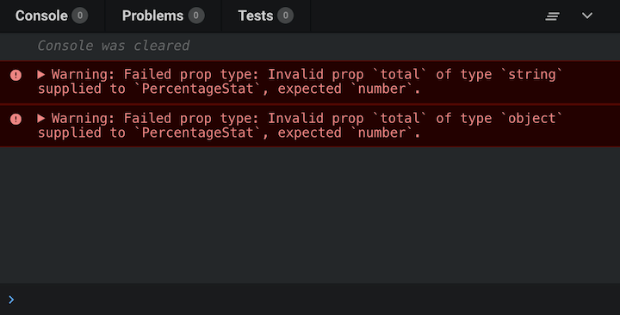

If default props are set for the React component, the value is resolved first before checking against prop types. Therefore, default values are also subject to prop type definitions.

Note that PropTypes type checking happens in development mode, so you can catch bugs in your React application while you're developing. For performance reasons, it is not triggered in a production environment.

### **Using the prop-types library in React**

Before React 15.5.0, a utility called proptypes was available as part of the React package, which provided several validators for configuring type definitions for component props. It can be accessed with React.PropTypes.

However, in later versions of React, this utility has been moved to a separate package called prop-types, so you will need to add it as a dependency to your project to access the proptypes utility.

1. npm install prop-types --save

It can be imported into your project files as follows:

import propType from 'prop-type';

### **React PropTypes validator**

The PropTypes utility exports a wide range of validators for configuring type definitions. Below we'll list the validators available for basic, renderable, instance, multiple, collection, and required prop types.

### **Basic types**

Below are the validators for the basic data types.

* PropTypes.any: Prop can be of any data type
* PropTypes.bool: prop must be a boolean
* PropTypes.number: prop must be a number
* PropTypes.string: prop must be a string
* PropTypes.func: prop must be a function
* PropTypes.array: prop must be an array
* PropTypes.object: prop must be an object
* PropTypes.symbol: prop must be a symbol

1. Component.propTypes = {
2. anyProp: PropTypes.any,
3. booleanProp: PropTypes.bool,
4. numberProp: PropTypes.number,
5. stringProp: PropTypes.string,
6. functionProp: PropTypes.func
7. }

### **Renderable types**

PropTypes also exports the following validators to ensure that a value passed to a prop can be provided by React.

* node: prop must be anything that can be represented by React - a number, string, element, or array (or slice) that contains thesetypes
* element: prop must be a response element.

1. Component.propTypes = {
2. nodeProp: PropTypes.node,
3. elementProp: PropTypes.element
4. }

A common use of the PropTypes.element validator ensures that a component has only one child. If the component has no children or multiple children, an alert is displayed on the JavaScript console.

1. Component.propTypes = {
2. children: PropTypes.element.isRequired
3. }

### **Instance types**

In cases where you need a prop to be an instance of a particular JavaScript class, you can use the PropTypes.instanceOf validator. It takes advantage of the built-in JavaScript instance of the operator.

1. Component.propTypes = {
2. personProp: PropTypes.instanceOf(Person)
3. }

### **Multiple types**

PropTypes also exports validators that can allow a limited number of values or multiple sets of data types for a prop. They are here:

* oneOf: The prop is limited to a specified set of values, treating it likean enum
* oneOfType: prop must be one of a set of specified types, which behaves like a union of types.

1. Component.propTypes = {
2. enumProp: PropTypes.oneOf([true, false, 0, 'Unknown']),
3. unionProp: PropTypes.oneOfType([
4. PropType.bool,
5. PropType.number,
6. PropType.string,
7. PropType.instanceOf(Person)
8. ])
10. }

## Collection types

In addition to the PropTypes.array and PropTypes.object validators, PropTypes also provides validators for more sophisticated validation of arrays and objects.

### **PropTypes.arrayOf**

PropTypes.arrayOf ensures that prop is an array with all items matching the specified type.

1. Component.propTypes = {
3. peopleArrayProp: PropTypes.arrayOf(
4. PropTypes.instanceOf(Person)
5. ),
7. multipleArrayProp: PropTypes.arrayOf(
8. PropTypes.oneOfType([
9. PropType.number,
10. PropType.string
11. ])
12. )
14. }

### **PropTypes.objectOf**

PropTypes.objectOf ensures that a prop is an object where all property values match the specified type.

1. Component.propTypes = {
3. booleanObjectProp: PropTypes.objectOf(
4. PropTypes.bool
5. ),
7. multipleObjectProp: PropTypes.objectOf(
8. PropTypes.oneOfType([
9. PropType.func,
10. PropType.number,
11. PropType.string,
12. PropType.instanceOf(Person)
13. ])
14. )
16. }

### **PropTypes.shape**

When more detailed validation of an object prop is needed, you can use PropTypes.shape. It ensures that a prop is an object containing a set of specified keys with values of the specified type.

1. Component.propTypes = {
2. profileProp: PropTypes.shape({
3. id: PropTypes.number,
4. fullname: PropTypes.string,
5. gender: PropTypes.oneOf(['M', 'F']),
6. birthdate: PropTypes.instanceOf(Date),
7. isAuthor: PropTypes.bool
8. })
9. }

### **PropTypes.exact**

For strict (or exact) object matching, you can use PropTypes.exact as follows:

1. Component.propTypes = {
2. subjectScoreProp: PropTypes.exact({
3. subject: PropTypes.oneOf(['Maths', 'Arts', 'Science']),
4. score: PropTypes.number
5. })
6. }

### **Required types**

The PropTypes validators we've explored allow the prop to be optional. However, you can chain isRequired to any prop validator to ensure a warning is shown whenever the prop is not provided.

1. Component.propTypes = {
2. requiredAnyProp: PropTypes.any.isRequired,
3. requiredFunctionProp: PropTypes.func.isRequired,
4. requiredSingleElementProp: PropTypes.element.isRequired,
5. requiredPersonProp: PropTypes.instanceOf(Person).isRequired,
6. requiredEnumProp: PropTypes.oneOf(['Read', 'Write']).isRequired,
8. requiredShapeObjectProp: PropTypes.shape({
9. title: PropTypes.string.isRequired,
10. date: PropTypes.instanceOf(Date).isRequired,
11. isRecent: PropTypes.bool
12. }).isRequired
13. }

### **Custom validators for type-checking React props.**

Usually, it will help if you define some custom validation logic for component props - for example, ensuring that a prop is passed a valid email address. Prop-type allows you to define custom validation functions for type checking props.

### **Native custom validator**

The custom validation function takes three arguments:

* props, an object containing all props passed to the component
* propname, the name of the prop to be validated
* Component name, Component name

If the validation fails, it should return an error object. Shouldn't throw error. Also, console.warn should not be used inside a custom validation function.

1. const isEmail = function(props, propName, componentName) {
2. const regex = /^((([^**<>**()[]\.,;:s@"]+(.[^**<>**()[]\.,;:s@"]+)*)|(".+"))@(([[0-9]{1,3}.[0-9]{1,3}.[0-9]{1,3}.[0-9]{1,3}])|(([a-zA-Z-0-9]+.)+[a-zA-Z]{2,})))?$/;
4. if (!regex.test(props[propName])) {
5. return new Error(`Invalid prop `${propName}` passed to `${componentName}`. Expected a valid email address.`);
6. }
7. }
9. Component.propTypes = {
10. email: isEmail,
11. fullname: PropTypes.string,
12. date: PropTypes.instanceOf(Date)
13. }

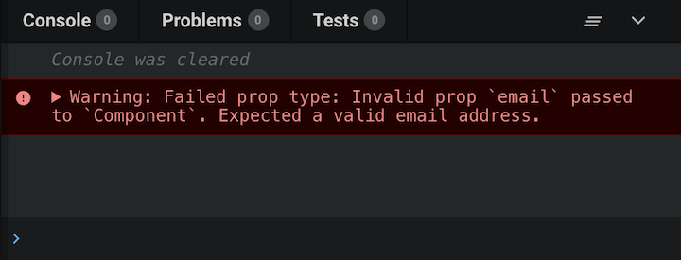

Custom validation functions can also be used with PropTypes.oneOfType. Here's a simple example using the isEmail custom validation function in the previous code snippet:

1. Component.propTypes = {
2. email: PropTypes.oneOfType([
3. isEmail,
4. PropTypes.shape({
5. address: isEmail
6. })
7. ])
8. }

Component will be valid in both of these scenarios:

1. **<Component** email="glad@me.com" **/>**
2. **<Component** email={{ address: 'glad@me.com' }} **/>**

### **Custom validators and collections**

Custom validation functions can also be used with PropTypes.arrayOf and PropTypes.objectOf. When used this way, the custom validation function is called for each key in the array or object.

However, the custom validation function takes five arguments instead of three:

* prop value, array, or object itself
* the key, the key of the current item in the iteration
* component name component name
* location, location of valid data (usually "prop")
* propFullName, the fully resolved name of the current item being validated. It will be an array [index]; It would be an object to anything. key.

**Below is a modified version of the isEmail custom validation function for use with archive types.**

1. const isEmail = function(propValue, key, componentName, location, propFullName) {
2. const regex = /^((([^**<>**()[]\.,;:s@"]+(.[^**<>**()[]\.,;:s@"]+)*)|(".+"))@(([[0-9]{1,3}.[0-9]{1,3}.[0-9]{1,3}.[0-9]{1,3}])|(([a-zA-Z-0-9]+.)+[a-zA-Z]{2,})))?$/;
4. if (!regex.test(propValue[key])) {
5. return new Error(`Invalid prop `${propFullName}` passed to `${componentName}`. Expected a valid email address.`);
6. }
7. }
8. Component.propTypes = {
9. emails: PropTypes.arrayOf(isEmail)
10. }

### **All-purpose custom validators**

Considering what we learned about custom validation functions, let's go ahead and create an all-purpose custom validator that can be used as a standalone validator and with collection types.

A slight modification to the isEmail custom validation function will make it an all-purpose validator, as shown below.

1. const isEmail = function(propValue, key, componentName, location, propFullName) {
2. // Get the resolved prop name based on the validator usage
3. const prop = (location && propFullName) ? propFullName : key;
5. const regex = /^((([^**<>**()[]\.,;:s@"]+(.[^**<>**()[]\.,;:s@"]+)*)|(".+"))@(([[0-9]{1,3}.[0-9]{1,3}.[0-9]{1,3}.[0-9]{1,3}])|(([a-zA-Z-0-9]+.)+[a-zA-Z]{2,})))?$/;
7. if (!regex.test(propValue[key])) {
8. return new Error(`Invalid prop `${prop}` passed to `${componentName}`. Expected a valid email address.`);
9. }
10. }
12. Component.propTypes = {
13. email: PropTypes.oneOfType([
14. isEmail,
15. PropTypes.shape({
16. address: isEmail
17. })
18. ]),
19. emails: PropTypes.arrayOf(isEmail)
20. }

### **Validating Percentage Stat in React**

The following code snippet adds prop types to the **Percentage Stat** component we reviewed at the beginning of this tutorial.

1. import React from 'react';
2. import PropTypes from 'prop-types';
4. // The PercentageStat component
5. function PercentageStat({ label, score = 0, total = Math.max(1, score) }) {
6. return (
7. **<div>**
8. **<h6>**{ label }**</h6>**
9. **<span>**{ Math.round(score / total * 100) }%**</span>**
10. **</div>**
11. )
12. }
14. // Checks if a value is numeric
15. // Either a finite number or a numeric string
16. function isNumeric(value) {
17. const regex = /^(\+|-)?((\d*\.?\d+)|(\d+\.?\d*))$/;
18. return Number.isFinite(value) || ((typeof value === "string") && regex.test(value));
19. }

22. // Checks if value is non-zero
23. // Value is first converted to a number
24. function isNonZero(value) {
25. return +value !== 0;
26. }
27. // Takes test functions as arguments and returns a custom validation function.
28. // Each function passed as argument is expected to take a value argument
29. // Expected to accept a value and return a boolean if it passes validation.
30. // All tests must pass for the custom validator to be marked as passed.
31. function validatedType(...validators) {
32. return function(props, propName, componentName) {
34. const value = props[propName];
36. const valid = validators.every(validator =**>** {
37. if (typeof validator === "function") {
38. const result = validator(value);
39. return (typeof result === "boolean") && result;
40. }
42. return false;
43. });
45. if (!valid) {
46. return new Error(`Invalid prop \`${propName}\` passed to \`${componentName}\`. Validation failed.`);
47. }
49. }
50. }
52. // Set the propTypes for the component
53. PercentageStat.propTypes = {
54. label: PropTypes.string.isRequired,
55. score: validatedType(isNumeric),
56. total: validatedType(isNumeric, isNonZero)
57. }

### **Validate React component props in a production**

Debugging a React application can be difficult, especially in a complex situation, if you are interested in monitoring and tracking redux status for all your users in production.

  
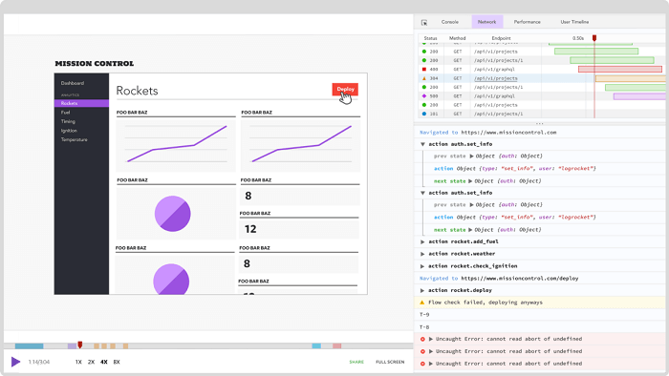

LogRocket is like a DVR for web apps, recording everything that happens on your site. Instead of guessing why problems occur, you can consolidate and report the status of your application when problems occur.

The LogRocket Redux middleware package adds an extra layer of visibility to your user sessions. LogRocket logs all actions and states from your Redux store.

### **Type checking with PropTypes**

**React.PropTypes** has moved into a separate package since React v15.5. Please use the prop-type library instead.

We provide a Codemod script to automate the conversion.

As your app grows, you can catch many bugs with type checking. You can use a JavaScript extension such as Flow or TypeScript to test certain applications to test your entire application.

But even if you don't use them, React has some built-in type checking capabilities. To type check on props for a component, you can assign special propTypes properties:

1. import PropTypes from 'prop-types';
3. class Greeting extends React.Component {
4. render() {
5. return (
6. **<h1>**Hello, {this.props.name}**</h1>**
7. );
8. }
9. }
11. Greeting.propTypes = {
12. name: PropTypes.string
13. };

We're using a class component in this example, but the same functionality can also be applied to function components or components created by React. PropTypes exports a series of validators that can be used to ensure that the data you receive is valid.

We're using a class component in this example, but the same functionality can also be applied to function components or components created by React. Memo or response. forwarded.

PropTypes exports a series of validators that can be used to ensure that the data you receive is valid. In this example, we are using PropTypes.string. When an invalid value is supplied for a prop, a warning will be shown in the JavaScript console. For performance reasons, propTypes are only checked in development mode.

### **PropTypes**

Here's an example documenting the various validators provided:

1. import PropTypes from 'prop-types';
2. MyComponent.propTypes = {
3. // You can declare that a prop is a specific JS type. By default, these
4. // are all optional.
5. optionalArray: PropTypes.array,
6. optionalBool: PropTypes.bool,
7. optionalFunc: PropTypes.func,
8. optionalNumber: PropTypes.number,
9. optionalObject: PropTypes.object,
10. optionalString: PropTypes.string,
11. optionalSymbol: PropTypes.symbol,
13. // Anything that can be rendered: numbers, strings, elements or an array
14. // (or fragment) containing these types.
15. optionalNode: PropTypes.node,
17. // A React element.
18. optionalElement: PropTypes.element,
20. // A React element type (ie. MyComponent).
21. optionalElementType: PropTypes.elementType,
23. // You can also declare that a prop is an instance of a class. This uses
24. // JS's instanceof operator.
25. optionalMessage: PropTypes.instanceOf(Message),
27. // You can ensure that your prop is limited to specific values by treating
28. // it as an enum.
29. optionalEnum: PropTypes.oneOf(['News', 'Photos']),
31. // An object that could be one of many types
32. optionalUnion: PropTypes.oneOfType([
33. PropTypes.string,
34. PropTypes.number,
35. PropTypes.instanceOf(Message)
36. ]),
38. // An array of a certain type
39. optionalArrayOf: PropTypes.arrayOf(PropTypes.number),
41. // An object with property values of a certain type
42. optionalObjectOf: PropTypes.objectOf(PropTypes.number),
44. // An object taking on a particular shape
45. optionalObjectWithShape: PropTypes.shape({
46. color: PropTypes.string,
47. fontSize: PropTypes.number
48. }),
50. // An object with warnings on extra properties
51. optionalObjectWithStrictShape: PropTypes.exact({
52. name: PropTypes.string,
53. quantity: PropTypes.number
54. }),
56. // You can chain any of the above with `isRequired` to make sure a warning
57. // is shown if the prop isn't provided.
58. requiredFunc: PropTypes.func.isRequired,
60. // A required value of any data type
61. requiredAny: PropTypes.any.isRequired,
63. // You can also specify a custom validator. It should return an Error
64. // object if the validation fails. Don't `console.warn` or throw, as this
65. // won't work inside `oneOfType`.
66. customProp: function(props, propName, componentName) {
67. if (!/matchme/.test(props[propName])) {
68. return new Error(
69. 'Invalid prop `' + propName + '` supplied to' +
70. ' `' + componentName + '`. Validation failed.'
71. );
72. }
73. },
75. // You can also supply a custom validator to `arrayOf` and `objectOf`.
76. // It should return an Error object if the validation fails. The validator
77. // will be called for each key in the array or object. The first two
78. // arguments of the validator are the array or object itself, and the
79. // current item's key.
80. customArrayProp: PropTypes.arrayOf(function(propValue, key, componentName, location, propFullName) {
81. if (!/matchme/.test(propValue[key])) {
82. return new Error(
83. 'Invalid prop `' + propFullName + '` supplied to' +
84. ' `' + componentName + '`. Validation failed.'
85. );
86. }
87. })
88. };

### **Requiring Single Child**

With PropTypes.element you can specify that only one child can be passed to a component as children.

1. import PropTypes from 'prop-types';
2. class MyComponent extends React.Component {
3. render() {
4. // This must be exactly one element or it will warn.
5. const children = this.props.children;
6. return (
7. **<div>**
8. {children}
9. **</div>**
10. );
11. }
12. }
14. MyComponent.propTypes = {
15. children: PropTypes.element.isRequired
16. };

### **Default Prop Values**

You can define default values for your props by assigning them to a special DefaultProps property:

1. class Greeting extends React.Component {
2. render() {
3. return (
4. **<h1>**Hello, {this.props.name}**</h1>**
5. );
6. }
7. }
9. // Specifies the default values for props:
10. Greeting.defaultProps = {
11. name: 'Stranger'
12. };
14. // Renders "Hello, Stranger":
15. const root = ReactDOM.createRoot(document.getElementById('example'));
16. root.render(**<Greeting** **/>**);

Using babel transforms such as plugin-proposal-class-properties (previously plugin-transform-class-properties), you can declare default props as static properties within the React component class.

This syntax is not finalized and will require a compilation step to work in a browser. For more information, see Class field proposals.

1. class Greeting extends React. Component {
2. static defaultProps = {
3. name: 'stranger'
4. }
6. render() {
7. return (
8. **<div>**Hello, {this.props.name}**</div>**
9. )
10. }
11. }

defaultprops will ensure that this.props.name will have a value if the parent component has not specified it.

propTypes type checking happens after defaultprops are resolved, so type checking will also apply to defaultprops.

# **BrowserRouter in React**

React Router is a standard library for routing in React. It enables navigation between views from different components in a React application, allows the browser URL to be changed, and keeps the UI in sync with the URL.

To understand how React Router works, let's create a simple application for React. The application will include the home, about, and contact components. We will be using React Router to navigate between these components.

### **npx create-react-app**

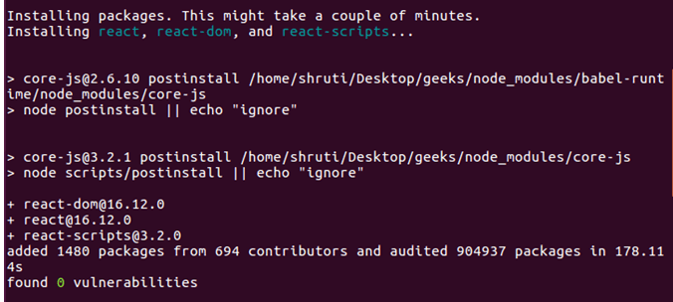

Your development environment is ready. Let's now install React Router in our application.

**React Router**: React Router can be installed in your React application via npm. Follow the steps below to set up the Router in your React application:

Play Video[](https://campaign.adpushup.com/get-started/?utm_source=banner&utm_campaign=growth_hack)

Step 1: CD in your project directory, i.e**., java.**

Step 2: Use the following command to install React Router:

**npm install - -save react-router-dom**

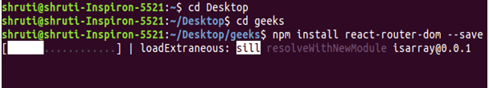

After installing react-router-dom, add its components to your React application.

### **Adding React Router Components:**

The main components of React Router are:

* **BrowserRouter:** BrowserRouter is a router implementation that uses the HTML5 history API (pushstate, replacestate, and popstate events) to keep your UI in sync with the URL. It is the parent component used to store all other components.
* **Route:** This is a new component introduced in v6 and an upgrade of the component. The main advantages of Switch Over Routes are:

Instead of traversing in sequence, routes are selected based on the best match.

* **Route**: A route is a conditionally shown component that provides UI when its path matches the current URL.
* **Links**: The Links component creates links for different routes and implements navigation around the application. It works as an HTML anchor tag.

To add React Router components to your application, open your project directory in the editor you use and go to the app.js file. Now, add the below code to app.js.

1. **import** {
2. BrowserRouter as Router,
3. Routes,
4. Route,
5. Link
6. }
7. from 'react-router-dom';

#### **Note: BrowserRouter is aliased as Router.**

**Using React Router:** To use React Router, Let's first create some components in the React application. In your project directory, create a folder named components inside the src folder and now add 3 files named home.js, about.js, and contact.js in the components folder.

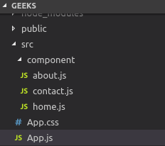

Let us add some code to our 3 components:

### **Home.js:**

1. **import** React from 'react';
3. function Home (){
4. **return** <h1>Welcome to the world of jAVAtPOINT!</h1>
5. }
7. export **default** Home;

### **About.js:**

1. **import** React from 'react';
2. function About () {
3. **return** <div>
4. <h2> jAVAtPOINT is a computer science portal **for** TUTORIALS!</h2>
5. Read more about us at :
6. <a href="https://www.javatpoint.in/about/">
7. https://www.javatpoint.in/about/
8. </a>
9. </div>
10. }
11. export **default** About;

### **Contact.js:**

1. **import** React from 'react';
2. function Contact (){
3. **return** <address>
4. You can find us here:<br />
5. Javatpoint<br />
6. G-13, second floor, Sector -3 Noida<br />
7. Noida, Uttar Pradesh (201305)
8. </address>
9. }
10. export **default** Contact;

Now, let's include the React Router components in the application:

**BrowserRouter**: Add an aliased BrowserRouter as a router to your app.js file to wrap all other components. BrowserRouter is a parent component and can have only one child.

1. **class** App **extends** Component {
2. render() {
3. **return** (
4. <Router>
5. <div className="App">
6. </div>
7. </Router>
8. );
9. }
10. }

**Links:** Let us now create the links of our components. The Link component uses props to describe the location to which the link should navigate.

1. <div className="App">
2. <ul>
3. <li>
4. <Link to="/">Home</Link>
5. </li>
6. <li>
7. <Link to="/about">About Us</Link>
8. </li>
9. <li>
10. <Link to="/contact">Contact Us</Link>
11. </li>
12. </ul>
13. </div>

Now, run your application on the local host and click on the link created. You will notice that the URLs change according to the value of the link component.

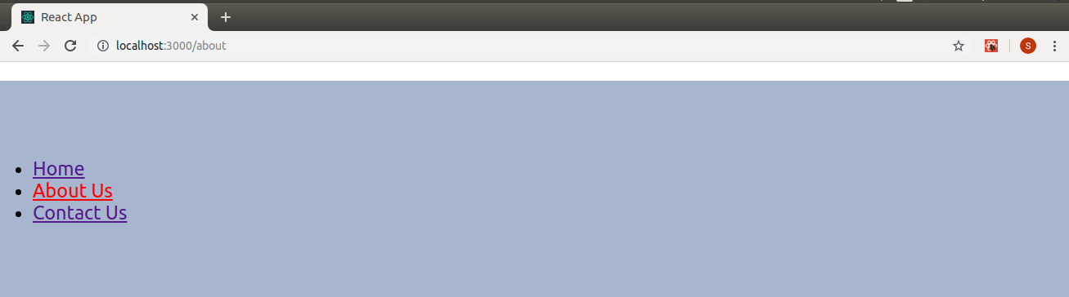

**Route**: The route component will help us establish the link between the component's UI and the URL. To include the route in the application, add the below code to your app.js.

1. <Route exact path='/' element={< Home />}></Route>
2. <Route exact path='/about' element={< About />}></Route>
3. <Route exact path='/contact' element={< Contact />}></Route>

The components are now connected, and clicking any link will render the corresponding component. Let us now try to understand the props associated with the root component.

1. **Exact**: This matches the exact value with the URL. For example, exact path='/about' will only render the component if it exactly matches the path, but if we remove it from the syntax, the UI will still be rendered, even if the structure is /about /10.
2. **Path**: Path specifies a pathname that we assign to our component.
3. Element refers to the component that will render if the path matches.

#### **Note: By default, routes are inclusive, which means that more than one route component can match a URL path and render simultaneously. If we want to render a single component, we need to use routes here.**

**Routes**: To read a single component, wrap all routes inside the Routes component.

1. <Routes>
2. <Route exact path='/' element={< Home />}></Route>
3. <Route exact path='/about' element={< About />}></Route>
4. <Route exact path='/contact' element={< Contact />}></Route>
5. </Routes>

Switch groups across multiple routes, iterate over them and find the first one that matches the path. Thus, the corresponding component of the path is rendered.

Here is our full source code after adding all the components:

1. **import** React, { Component } from 'react';
2. **import** { BrowserRouter as Router,Routes, Route, Link } from 'react-router-dom';
3. **import** Home from './component/home';
4. **import** Contact from './component/contact';
5. **import** About from './component/about';
6. **import** './App.css';
8. **class** App **extends** Component {
9. render() {
10. **return** (
11. <Router>
12. <div className="App">
13. <ul className="App-header">
14. <li>
15. <Link to="/">Home</Link>
16. </li>
17. <li>
18. <Link to="/about">About Us</Link>
19. </li>
20. <li>
21. <Link to="/contact">Contact Us</Link>
22. </li>
23. </ul>
24. <Routes>
25. <Route exact path='/' element={< Home />}></Route>
26. <Route exact path='/about' element={< About />}></Route>
27. <Route exact path='/contact' element={< Contact />}></Route>
28. </Routes>
29. </div>
30. </Router>
31. );
32. }
33. }
34. export **default** App;

Now, you can click on the link and navigate the different components. React Router keeps your application UI in sync with the URL.

Finally, we have successfully implemented navigation in our React application using React Router.

A <router> that uses the HTML5 history API (pushstate, replacestate, and popstate events) to keep your UI in sync with the URL.

1. <BrowserRouter
2. basename={optionalString}
3. forceRefresh={optionalBool}
4. getUserConfirmation={optionalFunc}
5. keyLength={optionalNumber}
6. >
7. <App />
8. </BrowserRouter>

### **basename: string**

Base URL for all locations. If your app is served from a sub-directory on your server, you will want to set it to that sub-directory. A properly formatted basename must contain a leading slash, but no trailing slash.

1. <BrowserRouter basename="/calendar">
2. <Link to="/today"/> // renders <a href="/calendar/today">
3. <Link to="/tomorrow"/> // renders <a href="/calendar/tomorrow">
4. ...
5. </BrowserRouter>

### **getUserConfirmation: func**

A function to use to confirm navigation. Defaults to using window.confirm.

1. <BrowserRouter
2. getUserConfirmation={(message, callback) => {
3. // this is the default behavior
4. **const** allowTransition = window.confirm(message);
5. callback(allowTransition);
6. }}
7. />

**forceRefresh: bool**

If true, the Router will use full-page refreshes on-page navigation. You may want to use this to imitate how a traditional server-rendered app would work with full-page refreshes between page navigation.

1. <BrowserRouter forceRefresh={**true**} />

**keyLength: number**

The length of location. Key. Defaults to 6.

1. <BrowserRouter keyLength={12} />

**children: node-** child element to render.

Note: On React, you must use a single child element because the render method cannot return more than one element. If you need more than one element, you can try wrapping them in an additional <div> or <React.Fragment>.

### **<hash router>**

A <router> that uses the hash part of the URL (i.e., window.location.hash) to keep your UI in sync with the URL.

#### **Note: the hash does not support history location. Key or location. State. In previous versions, we tried to reduce the behavior, but there were edge cases that we could not resolve. Any code or plugin that requires this behavior will not work.**

Since this technology is intended to support only older browsers, we encourage you to configure your server to work with <BrowserHistory> instead.

1. <HashRouter
2. basename={optionalString}
3. getUserConfirmation={optionalFunc}
4. hashType={optionalString}
5. >
6. <App />
7. </HashRouter>

**basename: string**

The base URL for all locations. A properly formatted basename should have a leading slash, but no trailing slash.

1. <HashRouter basename="/calendar"/>
2. <Link to="/today"/> // renders <a href="#/calendar/today">

**getUserConfirmation: func**

A function to use to confirm navigation. Defaults to using window.confirm.

1. <HashRouter
2. getUserConfirmation={(message, callback) => {
3. // this is the default behavior
4. **const** allowTransition = window.confirm(message);
5. callback(allowTransition);
6. }}
7. />

**hashType: string**

The encoding used for **window.location.hash**. Available values are:

* "slash" - creates hashes like #/ and #/sunshine/lollipops
* "noslash" - # and #sunshine/lollipops . as hash creates
* "hashbang" - creates "ajax crawlable" (deprecated by google) hashes like #!/ and #!/sunshine/lollipops

**Defaults to "slash".**

### **children: node**

A single child element to render.

**< Link>**

Provides declarative, accessible navigation around your application.

1. <Link to="/about">About</Link>

**to: string**

A string representation of a link location is created by combining the location's pathname, search, and hash properties.

1. <link to="/course?sort=name" />

An object that can have any of the following properties:

* **pathname**: A string representing the path to be linked.
* **find**: A string representation of the query parameter.
* **hash:** The hash to put in the URL, e.g., #A-hash.
* **state**: The state to remain in place.

1. <Link
2. to={{
3. pathname: "/courses",
4. search: "?sort=name",
5. hash: "#the-hash",
6. state: { fromDashboard: **true** }
7. }}
8. />

### **to: func**

A function in which the current location is passed as an argument and which must return the location representation as a string or object.

1. <Link to={location => ({ ...location, pathname: "/courses" })} />
2. <Link to={location => `${location.pathname}?sort=name`} />

### **replace: bool**

When true, clicking the Link will replace the current entry instead of adding a new

1. entry to the history stack.
2. <replace="/course" from link />

### **internal ref: func**

As of React Router 5.1, if you are using React 16, you should not need this prop as we forward the ref to the underlying <a>. Use a normal ref instead.

**Allows access to the component's built-in ref.**

1. <Link
2. to="/"
3. innerRef={node => {
4. // `node` refers to the mounted DOM element
5. // or null when unmounted
6. }}
7. />

**innerRef: RefObject**

As of React Router 5.1, if you are using React 16, you should not need this prop because we forward the ref to the underlying <a>. Use a normal ref instead.

Get the underlying ref of the component using React.createRef.

1. let anchorRef = React.createRef()
2. <Link to="/" innerRef={anchorRef} />

### **component: React.Component**

If you would like utilize your own navigation component, you can do so by passing it through the component prop.

1. **const** FancyLink = React.forwardRef(({ navigate, ...props }, ref) => {
2. **return** (
3. <a ref={ref} {...props} onClick={handleClick}>💅 {props.children}</a>
4. )
5. })
6. <Link to="/" component={FancyLink} />

You can also pass props you'd like to be on the <a> such as a title, id, className, etc.

### **<NavLink>**

A special version of <link> that will add styling attributes to the rendered element if it matches an existing URL.

1. <NavLink to="/about">About</NavLink>

### **className: string | func**

className can either be a string or a function that returns a string. If the function className is used, the link's active state is passed as a parameter. This is helpful if you want to exclusively apply a className to an inactive link.

1. <NavLink
2. to="/faq"
3. className={isActive =>
4. "nav-link" + (!isActive ? " unselected" : "")
5. }
6. >

### **FAQs**

**</NavLink>**

In React Router v6, activeClassName will be removed and you should use the function className to apply the classname to active or inactive NavLink components.

### **ActiveClassName: String**

class to give the element when it is active. The default given class is active. It will be combined with the classname prop.

1. <NavLink to="/faq" activeClassName="selected">
2. </NavLink>

### **style: object | func**

style can either be a React.CSSProperties object or a function that returns a style object. If the function style is used, the link's active state is passed as a parameter.

1. <NavLink
2. to="/faq"
3. style={isActive => ({
4. color: isActive ? "green" : "blue"
5. })}
6. >
7. </NavLink>

In React Router v6, the active styling will be removed, and you must use the function style to apply inline styles to active or inactive NavLink components.

### **Active Style: Object**

The styles applied to the element when it is active.

1. <NavLink
2. to="/faq"
3. activeStyle={{
4. fontWeight: "bold",
5. color: "red"
6. }}

### **exact: bool**

When true, the active class/style will only apply if the location is an exact match.

1. <NavLink exact to="/profile">
2. Profile
3. </NavLink>

### **strict: bool**

If true, the trailing slash on a location's pathname will be considered when determining whether the location matches the current URL. See the <route hardening> documentation for more details.

1. <NavLink strict to="/events/">
2. Events
3. </NavLink>

### **isActive: func**

A function to add additional logic to determine if the Link is active. This should be used when you want to do more than verify that the pathname of the Link matches the pathname of the current URL.

1. <NavLink
2. to="/events/123"
3. isActive={(match, location) => {
4. **if** (!match) {
5. **return** **false**;
6. }
7. // only consider an event active if its event id is an odd number
8. **const** eventID = parseInt(match.params.eventID);
9. **return** !isNaN(eventID) && eventID % 2 === 1;
10. }}
11. >
12. Event 123
13. </NavLink>

### **location: object**

isActive Compares to the current history location (usually the current browser URL).

### **aria-current: string**

**The value of the area-current attribute used on the active Link. Available values are:**

* "page" - used to indicate a link within a set of pagination links
* "Steps" - used to indicate a link within the step indicator for a step-based process
* "location" - used to indicate an image that is visually highlighted as the current component of the flow chart
* "date" - used to indicate the current date within the calendar
* "time" - used to indicate the current time within a timetable
* "true" - used to indicate whether NavLink is active
* "false" - used to prevent assistive technologies from reacting to the current Link (one use case would be to prevent multiple area-current tags on a page)

# **React vs. Svelte**

Both Svelt and React are tough competitors when discussing JavaScript frameworks. While React is an old player, Svelt is a new joiner.

It is said that React will shape the future, but it seems that Svelte is the future. So, to end this debate, let's look at the basics of both the frameworks and decide which one is best for your needs, React or Svelte?

## What is Svelte?

Svelte is an open-source, front-end JavaScript framework used to develop interactive web pages and apps. Rich Harris broadened with an initial release in November 2016. Svelte resembles React, Vue, and more when it comes to framework and web app development, but it is more.

### **Svelte features**

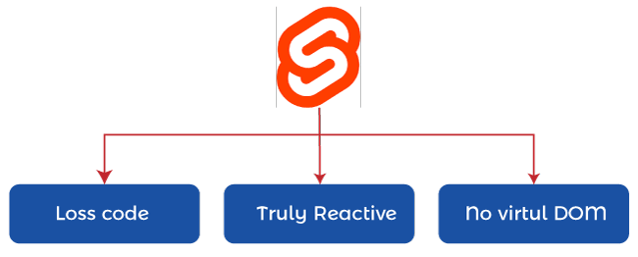

Svelte is a young and growing framework that is slowly rushing to become one of the most popular. Now that you know what Svelte means, here are some of the main features that make Svelte so efficient.

[](https://campaign.adpushup.com/get-started/?utm_source=banner&utm_campaign=growth_hack)

**Less code**

The Svelte framework is known for fewer lines of code and simpler syntax. Since there are relatively few lines of code, developers can save time, avoid errors, bugs, etc., and increase ease of reliability. In addition, Svelte allows users to create multiple top-level elements and easily update the local state of variables. And this feature shapes Svelte's future in the market.

**Truly Reactive**

Users can build applications according to the Svelte framework requirements without worrying about any unnecessary overhead. The DOM is updated only at the time of creation in Svelte. Svelte components have effectively incorporated React into the language to achieve greater ease of coding. Svelte minimize the lines of code as compared to React or Vue.

**No virtual domain**

As Svelte is a compiler, the .js file is loaded directly on the page to render the app, and Svelte's code does not need to load the entire library on the browser. Also, the overhead generated by the virtual DOM is reduced in Svelte because all objects are updated only at compile time.

### **Svelte pros and cons**

With the growing popularity of Svelte and the rapid increase in the number of developers adopting it, it is time to look at the various broad pros and cons of its choice.

### **Pros of Svelte**

Some of the important features that have prompted various giants to choose Svelte for the development of their business solutions are,

**Easily usable**

Svelte is relatively easy to use as it has easy syntax and code for development. Code can be written in .html or .svelte file without using "this" in the code block. Hence, it becomes easy for developers to use Svelte for web application development.

**Reduces overhead**

Svelte minimizes the overhead of the JavaScript framework you are using. Code readability and reusability are improved by compiling Svelte to vanilla JavaScript. All this is responsible for the rapid development of web applications.

**Compile without virtual Dom**

In Svelte, the number of digital layers between the application and the browser is reduced, resulting in faster work and is highly optimized. This fact is a major selling point and is reflected in the performance of the Svelte as well.

**Automatic updates**

Svelte automatically updates your data with the help of declared variables. To improve the user experience, you no longer need to wait for changes reflected in the application.

### **Cons of Svelte**

With so many features making Svelte the choice of various businesses, a few factors hold it back in certain areas. Let's have a look at them,

**Small Community**

Any framework takes time to grow and expand its community. The same is the case with Svelte, and building a strong and huge community will take time. Open-source contributors are essential to building a community, and Svelte needs them.

**No Cross-Platform Development**

When using Svelte, you have to completely forget about cross-platform applications. If you are developing an app with Svelte, you will need to completely rewrite the code for the mobile app or opt for Hardwired NativeScript instead.

**Less Comprehensive Development Tools**

As Svelte is relatively young, you may not find many development tools of Svelte in the market. It is a rapidly growing ecosystem and demands contributions from the community for support in terms of the availability of development tools.

**Limited Support for IDE Compatibility**

IDE support is not as good as contemporary frameworks. It is the demand of every little problem in today's world, and the internet cannot be surfed. Of course, you can find good online resources to address some issues. Still, a strong IDE is required.

### **Top Companies Using Svelte**

A young and powerful player in the race for development infrastructure, Svelte already has some big names in its kitty. Let's look at some successful companies that have used Svelte to grow their business solutions. So the Svelte examples are,

**Avast**

The antivirus giant, which has gained popularity among thousands of users, has adopted Svelte to develop its mobile app. Avast chose Svelt for the availability of several simple and convenient solutions that clearly defined its idea of the mobile application it wanted to develop.

**Philips**

Philips chose the Svelte for its stability and variety of features that can elevate the mobile experience to another level. Many developers believe that Svelte is comparatively faster than other frameworks. This belief has prompted Philips to choose Svelte for its mobile application development.

**Decathlon**

One of the most well-known sports equipment stores, Decathlon, also believed that Svelte was an ideal choice for developing their smart mobile application. The Decathlon's Svelte app allows you to buy, return or exchange products and even collect points. Decathlon chose Svelt for code segmentation, optimization, etc.

**The New York Times**

An application was created for The New York Times using Svelte. This small and efficient framework was used to develop complex applications and provide easy context and an interactive experience and connection.

**Chess.com**

Svelte was used to develop the Chess.com application, an online chess platform, and millions of chess guides, lessons, etc. Chess.com chose svelte for its complete compatibility with IoT devices, quick implementation, and code reusability.

## What Is React?

React is a JavaScript-based UI development library powered and developed by a vast community of developers on Meta (formerly known as Facebook) in May 2013. React is currently the most widely used front-end library for web development and provides various extensions. Application architecture, such as React Native, Flux, etc.

### **React features**

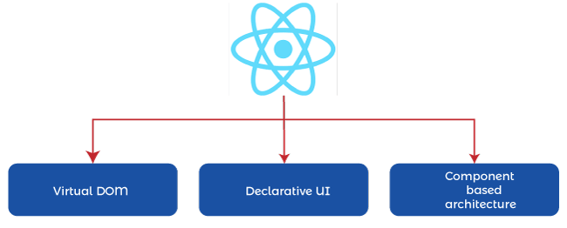

React is the first choice of many giants, and there are many reasons for this. So, here are some reasons to choose React for your next project.

**Virtual Dom**

A virtual DOM is simply a representation of the original DOM. You can say that it is similar to one-way data binding. Thus, whenever a change is made to the app, the entire UI is first rendered in the virtual DOM, speeding up the process without wasting any money.

**Declarative UI**

With a declarative user interface, React's code is simple, easily readable, and allows for quick and easy bug resolution. Thus, React has become the first and best choice for developing intuitive, interactive, engaging web and mobile applications.

**Component-Based Architecture**

React has a component-based architecture, which means that the application's user interface consists of multiple components. Each component has a separate logic which is written in JavaScript. Due to this architecture, developers can move data across the app without changing the DOM.

### **React pros and cons**

No technology or framework is perfect, and the same goes for React. So, let's have a look at some of the major pros and cons of React to get to know this framework better,

### **React's Pros**

React is widely used by many big names in the market, and apparently, many factors prove it. So, here are some reasons to choose React,

**Virtual Dom**

The Virtual Document Object Model is primarily intended to enhance the user experience. The main advantage of Virtual DOM is its ability to update even minimal changes in real-time without causing any interruption to the interface. With DOM, React can speed up the entire web development process.

**One Way Data Flow**

React has a one-way data flow to eliminate the possibility of unstable code due to changes in child data affecting parent data. In React, any change to the child data does not affect the parent data. It gives developers the upper hand in giving them complete control over the data in case of complex projects.

**Component Reusable**

Since changes in one component do not affect other components in React, code components can be reused effectively in the case of large projects. In React, all components are isolated, allowing developers to save time by reusing code.

**SEO friendly**

Search engine rankings play a vital role in taking your business to the next level or knocking it down. With React, you get a lightweight JavaScript that all search engines like Google can easily read.

### **React Cons**

Apart from the amazing features and benefits of React, you may also like to look at some of the drawbacks that can help you in your decision making,

**Pace Of Development**

Due to the fast pace of development of React, there are mixed views among developers. Some people find it easier with the rapid development of React, while others find it a pain to keep running it repeatedly.

**Documentation**

React is a rapidly evolving technology, and because of this, a lot of new tools, patterns, etc., are being added. It makes it difficult for the community to keep the documentation up to date with the latest resources and needed support.

**jsx**

Since JSX is a combined form of JavaScript and HTML, it becomes confusing for developers to understand the syntax. To create JavaScript objects with HTML syntax, React extensively uses JSX syntax extensions. But, JSX extensions can be complicated, and it can take time for developers to understand them.

**Toolset is incomplete**

When you choose React, you should be familiar with the fact that it can only be used to develop the UI of the application. Therefore, when you choose React to develop your business solution, you must choose a few other technologies to complete the development.

### **Top companies using react**

Being one of the most preferred web development frameworks, React is loved, preferred, and used by many giants to develop complete business solutions with all the desired features. So, here are the top companies that are using React for their developed apps,

**Facebook**

Facebook needs no introduction. Who doesn't know Facebook, and who isn't on Facebook? Facebook is a pioneer of React, so it is obvious that it uses React for web page development. Using React's features in the best possible way, Facebook enhances the user experience with each passing day.

**WhatsApp**

The most used app on everyone's phone, WhatsApp has demanded React for its stable performance and security. The user interface of WhatsApp has been designed using React. Furthermore, the web versions of WhatsApp use React to enhance the user experience and take advantage of its best features.

**Salesforce**

The world's largest CRM organization, Salesforce, is considered the best among its contemporaries. To quickly but efficiently render highly complex Visualforce pages, Salesforce decided to leverage the power of React. With React, Salesforce can render pages faster and create pages inside Visualforce.

**Dropbox**

Dropbox is an on-demand file hosting service that uses a cloud computing model. It allows users to store, share and manage files. Dropbox has adopted React to develop its applications due to its small file size, virtual DOM, community support, etc.

**GitHub**

GitHub is one of the largest software development platforms with a huge community of developers to help them with software design and development. GitHub chose React to develop its development framework because they believed in its capability and goodness.

## Svelte is a Compiler, while React uses Virtual DOM.

Both React and Svelte offer a similar component-based architecture - meaning that both enable a CDD bottom-up development. Both enable their components to be shared between apps through tools and platforms like Bit.



The key difference between them is that Svelte is a compiler that ideally converts your application to JavaScript during build time instead of React, which uses virtual DOM to interpret the application code during runtime. Yes, that was quite the jargon.

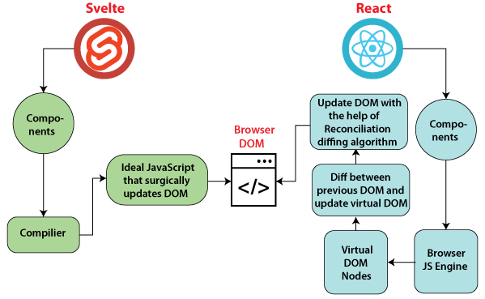

### **React Virtual DOM**

React uses a virtual DOM (VDOM) concept, where a virtual representation of the UI is kept in memory and synced with the real DOM through cohesion.

The reconciliation process will find the difference between the Virtual DOM (an object in memory where we push the latest updates to the UI) and the real DOM (the DOM that holds the previously rendered UI). Using specific heuristic algorithms, it decides how to update the UI. This process is fast, reliable, and highly responsive for the most part.

React bundles a certain amount of overhead code to achieve this, which will run in the browser's JS engine to monitor and update the DOM based on various user interactions.

### **Svelte Compiler**

Svelte is purely a compiler that turns your application into ideal JavaScript code as you build the application for production. This means that it will not inject any overhead code into the browser while your application is running to update the DOM.

This approach is relatively new compared to React, which generally takes advantage of virtual DOM.

### **Where Svelte is Strong**

**Let's find out what key benefits we can gain by using Svelte.**

* The build time is blazing fast as compared to React or other frameworks. Using the rollup plugin as a bundler might be the secret here.
* The bundle size is smaller and smaller than React, which is a huge plus point. Even with the shopping cart application, I've built, the initial load time and the time it takes to render the UI is extremely short. Only the chunky pictures I've added take some time.
* Binding classes and variables are relatively easy, and custom logic is unnecessary when binding classes.
* Scoping allows flexible styling within the CSS <style> component itself.
* Easier to understand and get started with than other frameworks as the key part of Svelte is plain JavaScript, HTML, and CSS.
* More simple store implementation than React's context API, the provided context API provides more features, and svelte can be quite simple for common scenarios.

### **Where Svelte Falls Behind**

**Let's find out where Svelte has its downsides.**

* Svelte won't listen for reference updates and array mutations, which are a huge hassle, and developers need to actively seek out and ensure that arrays are reassigned so that the UI is updated.
* The usage style for DOM events can also be annoying, as we need to follow Svelte's specific syntax instead of using the predefined JS syntax. Can't use onclick directly like in React, but instead have to use special syntax like onclick.
* Svelte is a new and young framework with minimal community support, making support for a wide range of plugins and integrations unnecessary for heavy production applications. React is a powerful contender here.
* No additional improvements. Ex-React Suspense actively controls your code and how it runs and tries to optimize when the DOM is updated, and sometimes even provides an automatic loading spinner while waiting for data. These additional features and continuous improvements are relatively few in Svelte.
* Some developers may prefer not to use special syntax like #if and #each in their templates and would instead prefer to use plain JavaScript, which React allows. It may come down to personal preferences.

## Is Svelte better than react or vice versa?

Svelte provides notable improvements in some features as compared to React. But it still may not be important or big enough to replace React completely. The response is still strong and broadly adopted. Svelte has a lot to do. But concept-wise, the compilation approach taken by Svelte has proven that virtual DOM dereferencing isn't the only way to build fast, responsive applications and a good enough compiler can do as good a job as it gets.

## Which framework should we use for your next application?

While weighing the pros and cons, in my opinion, if you are building a small application like a simple e-commerce application for your startup, I would recommend Svelte. Svelte is easy to master if you have a good knowledge of JS, HTML, and CSS. With Svelte, you can build some powerful, fast, and lightweight applications.

For huge production applications requiring many integrations and specialized plugins, React may still be the way to go. Again, as React provides Next.js, Svelt also provides its own production-ready single-page application framework called Sapper, which may be worth looking at.

As I mentioned above, declaring a winner is challenging as they put on beautiful performances to achieve their primary goals. Both contenders are practical and efficient tools for creating great user interfaces. Choosing between the two is mostly based on your scenario and preferences.

## Comparison Between Svelte Vs. React

After looking at React and Svelte, let us dive deep and understand Svelte Vs. React thoroughly.

### **1. Performance**

Reactjs increases performance as it allows building with reusable components. Furthermore, its platform employs optimized coding practices that enhance the user experience and performance of the app.

Thus, it is easier to achieve consistency throughout the app development cycle with less code clutter.

On the other hand, Svelte minimizes runtime overload, leading to faster interface navigation. It also provides flexibility so that developers can produce high-quality code. Plus, as an IT business owner, you don't have to worry about the complexities surrounding virtual DOM overhead. Thus, the apps developed through Svelte are powerful and sophisticated.

### **2. User experience**

Comparison of Svelte for User Experience. React is an ultra-fast application, and it enhances the loading speed. As web pages load faster, it enhances the user experience. With an enhanced user experience, there is a higher chance of increasing your customers' loyalty to the brands. Thus, it will create a win-win situation for you as a CTO.

Svelte supports component-based UI design and thus is exceptional at building lightweight apps. Along with a better user experience, the platform also enhances the response time. Page speed also increases as Svelte removes the middle-stage loading of the virtual DOM.

### **3. Code maintainability**

React is a component-based architecture it focuses on customizing the UI and developing functional and individual code snippets. These code snippets can then be used in other apps of different modules.

As the codes can be used elsewhere, this app breakdown enhances the team's productivity and efficiency. Moreover, as an IT business owner, you don't have to worry about orienting a new developer.

The React platform itself has organized coding patterns and components that make the code easy to learn. Since the developers can feel at home with React, it increases the code maintainability.

The components of Svelte have a readable structure that helps define different app components. With Svelte, different pieces of a web application like buttons, forms, etc., work together easily. So along with acting in **performance comparison,** the platform helps the developers to maintain the code as well.

### **4. App size**

As an IT business owner, you need to understand that Reactjs is a fully-featured front-end framework. Thus, it is easy to build larger and more complex applications using React. Also, with the latest development, it is easy to reduce app size by 30% using React JS.

Svelte is widely used in making small-size applications. Thus, it is the most accessible JavaScript component library, and it drives the development process in a better way.

### **5. Faster development**

React has a reputation for being the fastest framework. Thus in the race for Svelt Vs. React, React has some edge. All you need is a team of developers familiar with basic JavaScript concepts. Once you know this, development speeds up, with configuration warnings, etc.

With Svelte, developers can easily develop more advanced features. Furthermore, they can separate the app structure and the design HTML markup. The framework here also has an excellent data structure and design functionality. Furthermore, it is easier for developers to develop rapidly with a clear separation of front-end controls and methodologies.

### **6. Testing**

To facilitate the testing process, Reactjs provides test runners. Thus, it helps the QA team to trace the problem to the actual browser settings. In addition, it reduces app time-to-market, thereby increasing overall app productivity.

Developers can do unit testing with the Svelte testing library. The library is smaller in size and has less complex computations. Also, if in Svelte vs. React, you are looking for a 'lean web', then Svelte should be your choice.

## Conclusion

There's no doubt that the Svelt vs. React debate will continue with such loud perks.

Now it is up to the CTO to understand their business requirements and choose the platform. React and Svelte both have their share of perks, but it all depends on the nature of the app. Both the frameworks are component-based and are known to enhance the user experience. Thus, be sure of your options before opting for a framework.

# **Button in React**

Buttons allows users to take actions and make choices with a single tap.

They (buttons) communicate the actions that users can perform. It is placed by your UI in places like below:

* Modal windows
* Forms
* Cards
* Toolbars
* Basic Button

The Button comes in 3 variants: **text (default), contained,** and **outlined.**

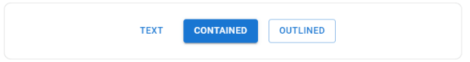

1. **import** * as React from 'react';
2. **import** Stack from '@mui/material/Stack';
3. **import** Button from '@mui/material/Button';
4. export **default** function BasicButtons() {
5. **return** (
6. <Stack spacing={2} direction="row">
7. <Button variant="text">Text</Button>
8. <Button variant="contained">Contained</Button>
9. <Button variant="outlined">Outlined</Button>
10. </Stack>
11. );
12. }

### **Text button**

Text buttons are used for less-pronounced actions, including those in card dialogs. In cards, the text buttons will help us to maintain an emphasis on card content.

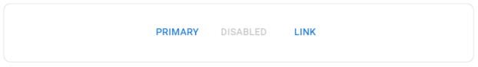

1. **import** * as React from 'react';
2. **import** Button from '@mui/material/Button';
3. **import** Stack from '@mui/material/Stack';
4. export **default** function TextButtons() {
5. **return** (
6. <Stack direction="row" spacing={2}>
7. <Button>Primary</Button>
8. <Button disabled>Disabled</Button>
9. <Button href="#text-buttons">Link</Button>
10. </Stack>
11. );
12. }

### **Contained Button**

Contained buttons are high-emphasis, distinguished by the use of elevation and fill. It contains actions which are primary used in our App.

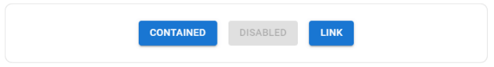

1. **import** * as React from 'react';
2. **import** Button from '@mui/material/Button';
3. **import** Stack from '@mui/material/Stack';
4. export **default** function ContainedButtons() {
5. **return** (
6. <Stack direction="row" spacing={2}>
7. <Button variant="contained">Contained</Button>
8. <Button variant="contained" disabled>
9. Disabled
10. </Button>
11. <Button variant="contained" href="#contained-buttons">
12. Link
13. </Button>
14. </Stack>
15. );
16. }

You can remove the elevation with the disable Elevation prop.

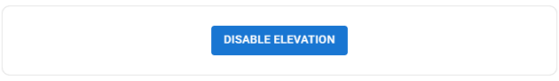

1. **import** * as React from 'react';
2. **import** Button from '@mui/material/Button';
3. export **default** function DisableElevation() {
4. **return** (
5. <Button variant="contained" disableElevation>
6. Disable elevation
7. </Button>
8. );
9. }

### **Outlined Button**

Outlined buttons are medium-emphasis buttons. They contain essential actions but not the main action in the app.

Outlined buttons are the lower alternative to contain the buttons or a higher emphasis alternative to the text buttons.

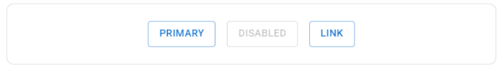

1. **import** * as React from 'react';
2. **import** Button from '@mui/material/Button';
3. **import** Stack from '@mui/material/Stack';
4. export **default** function OutlinedButtons() {
5. **return** (
6. <Stack direction="row" spacing={2}>
7. <Button variant="outlined">Primary</Button>
8. <Button variant="outlined" disabled>
9. Disabled
10. </Button>
11. <Button variant="outlined" href="#outlined-buttons">
12. Link
13. </Button>
14. </Stack>
15. );
16. }

### **Handling clicks**

All components accept an **onClick** handler which is applied to the root **DOM** element.

1. **<Button**
2. onClick={() =**>** {
3. alert('clicked');
4. }}
5. **>**
6. Click me
7. **</Button>**

#### **Note: The documentation avoid mentioning the native props in our API section of the components.**

### **Color**

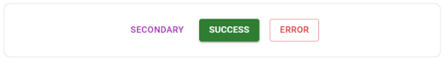

1. **import** * as React from 'react';
2. **import** Stack from '@mui/material/Stack';
3. **import** Button from '@mui/material/Button';
4. export **default** function ColorButtons() {
5. **return** (
6. <Stack direction="row" spacing={2}>
7. <Button color="secondary">Secondary</Button>
8. <Button variant="contained" color="success">
9. Success
10. </Button>
11. <Button variant="outlined" color="error">
12. Error
13. </Button>
14. </Stack>
15. );
16. }

In addition, by using the default button colors, you can add custom or disable any you don't need.

### **Size**

Use this propertty for larger or smaller buttons.

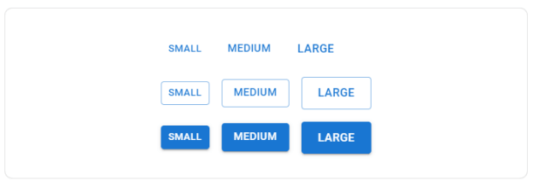

### **Upload button**

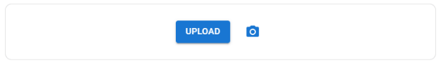

1. **import** * as React from 'react';
2. **import** { styled } from '@mui/material/styles';
3. **import** Button from '@mui/material/Button';
4. **import** IconButton from '@mui/material/IconButton';
5. **import** PhotoCamera from '@mui/icons-material/PhotoCamera';
6. **import** Stack from '@mui/material/Stack';
8. **const** Input = styled('input')({
9. display: 'none',
10. });
11. export **default** function UploadButtons() {
12. **return** (
13. <Stack direction="row" alignItems="center" spacing={2}>
14. <label htmlFor="contained-button-file">
15. <Input accept="image/*" id="contained-button-file" multiple type="file" />
16. <Button variant="contained" component="span">
17. Upload
18. </Button>
19. </label>
20. <label htmlFor="icon-button-file">
21. <Input accept="image/*" id="icon-button-file" type="file" />
22. <IconButton color="primary" aria-label="upload picture" component="span">
23. <PhotoCamera />
24. </IconButton>
25. </label>
26. </Stack>
27. );
28. }

### **Buttons with label and icon**

Sometimes you may want to have icons for certain buttons to enhance the UX of the application, as we acknowledge logos easier than plain text.

**For example,** If we want to delete button than you should label it with a dustbin icon.

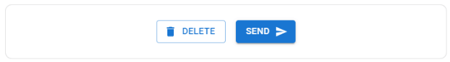

1. **import** * as React from 'react';
2. **import** Button from '@mui/material/Button';
3. **import** DeleteIcon from '@mui/icons-material/Delete';
4. **import** SendIcon from '@mui/icons-material/Send';
5. **import** Stack from '@mui/material/Stack';
7. export **default** function IconLabelButtons() {
8. **return** (
9. <Stack direction="row" spacing={2}>
10. <Button variant="outlined" startIcon={<DeleteIcon />}>
11. Delete
12. </Button>
13. <Button variant="contained" endIcon={<SendIcon />}>
14. Send
15. </Button>
16. </Stack>
17. );
18. }

### **Icon button**

Icon buttons are found in toolbars and app bars. Icons are appropriate for toggle buttons which allow the choices to be selected or deselected. Like, adding or removing any item from the label.

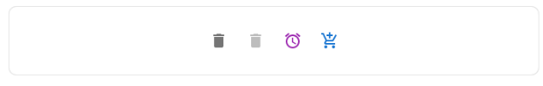

1. **import** * as React from 'react';
2. **import** IconButton from '@mui/material/IconButton';
3. **import** Stack from '@mui/material/Stack';
4. **import** DeleteIcon from '@mui/icons-material/Delete';
5. **import** AlarmIcon from '@mui/icons-material/Alarm';
6. **import** AddShoppingCartIcon from '@mui/icons-material/AddShoppingCart';
7. export **default** function IconButtons() {
8. **return** (
9. <Stack direction="row" spacing={1}>
10. <IconButton aria-label="delete">
11. <DeleteIcon />
12. </IconButton>
13. <IconButton aria-label="delete" disabled color="primary">
14. <DeleteIcon />
15. </IconButton>
16. <IconButton color="secondary" aria-label="add an alarm">
17. <AlarmIcon />
18. </IconButton>
19. <IconButton color="primary" aria-label="add to shopping cart">
20. <AddShoppingCartIcon />
21. </IconButton>
22. </Stack>
23. );
24. }

### **Sizes**

Use the size prop for larger or smaller icon in button.

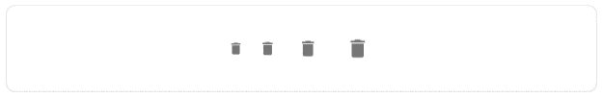

1. **import** * as React from 'react';
2. **import** Stack from '@mui/material/Stack';
3. **import** IconButton from '@mui/material/IconButton';
4. **import** DeleteIcon from '@mui/icons-material/Delete';
5. export **default** function IconButtonSizes() {
6. **return** (
7. <Stack direction="row" alignItems="center" spacing={1}>
8. <IconButton aria-label="delete" size="small">
9. <DeleteIcon fontSize="inherit" />
10. </IconButton>
11. <IconButton aria-label="delete" size="small">
12. <DeleteIcon fontSize="small" />
13. </IconButton>
14. <IconButton aria-label="delete" size="large">
15. <DeleteIcon />
16. </IconButton>
17. <IconButton aria-label="delete" size="large">
18. <DeleteIcon fontSize="inherit" />
19. </IconButton>
20. </Stack>
21. );
22. }

### **Colors**

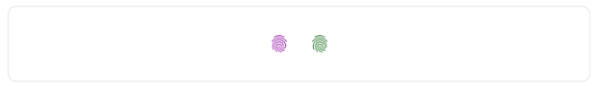

Use color prop to apply the theme color palette to the component.

1. **import** * as React from 'react';
2. **import** Stack from '@mui/material/Stack';
3. **import** IconButton from '@mui/material/IconButton';
4. **import** Fingerprint from '@mui/icons-material/Fingerprint';
6. export **default** function IconButtonColors() {
7. **return** (
8. <Stack direction="row" spacing={1}>
9. <IconButton aria-label="fingerprint" color="secondary">
10. <Fingerprint />
11. </IconButton>
12. <IconButton aria-label="fingerprint" color="success">
13. <Fingerprint />
14. </IconButton>
15. </Stack>
16. );
17. }

### **Customization**

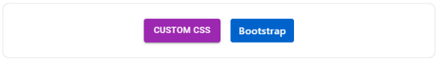

Below are the examples of customizing our component.

### **Loading button**

The loading buttons can show the loading state and disable interactions of the button.

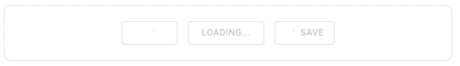

1. **import** * as React from 'react';
2. **import** LoadingButton from '@mui/lab/LoadingButton';
3. **import** SaveIcon from '@mui/icons-material/Save';
4. **import** Stack from '@mui/material/Stack';
6. export **default** function LoadingButtons() {
7. **return** (
8. <Stack direction="row" spacing={2}>
9. <LoadingButton loading variant="outlined">
10. Submit
11. </LoadingButton>
12. <LoadingButton loading loadingIndicator="Loading..." variant="outlined">
13. Fetch data
14. </LoadingButton>
15. <LoadingButton
16. loading
17. loadingPosition="start"
18. startIcon={<SaveIcon />}
19. variant="outlined"
20. >
21. Save
22. </LoadingButton>
23. </Stack>
24. );
25. }

Toggle the loading button to see the transition between unrelated positions.

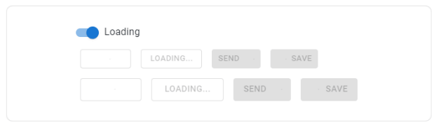

### **Complex button**

Icon button, Text button, contained buttons, and floating action buttons are built into a single component which is called as ButtonBase.



You can take lower level component to create custom interactions.

### **Third-party Routing libraries**

Navigating the client without an exact HTTP trip to the server is a unique use case. The ButtonBase component provides component properties to handle the use case.

### **Borders**

ButtonBase sets the component pointer-events: none; on the disable Button, which prevents the appearance of the disabled cursor.

If you want to use "not allowed", you have two options:

**CSS only:** You can remove the pointer-event style on the disabled state of **< Button>** element:

1. .uibuttonbase-root:disabled {
2. cursor: not allowed;
3. pointer-events: auto;
4. ,

**Although,**

You should add pointer-events: none; when you needed to display tooltips on disabled elements.

If you render anything other than the button element, then the cursor will not change. For example, a link **<a>** element.

DOM change. You can wrap the button:

1. **<span** style={{ cursor: 'not allowed' }}**>**
2. **<button** component={link} disabled**>**
3. disabled
4. **</button>**
5. **</span>**

It can support any element, for example, a link <a> element.

**unstyled**

The component will comes with the unstyled version. It is ideal for doing heavy optimizations and reducing bundle size.

### **API**

* **<button >**
* **<buttonbase >**
* **<iconbutton >**
* **<loadingButton >**

### **How to use the button component in ReactJS?**

Buttons allow users to take their actions and make choices at a single tap. This component is available to us for React UI content, and it is very easy to integrate. We can use button component in ReactJS by using following approach.

**Creating react app and installing modules:**

**Step 1:** Build a React application by using the given below command:

1. npx create-react-app foldername

**Step 2:** After creating the project folder, and name of the folder to navigate it by using the given command:

1. cd foldername

**Step 3:** Install the **Material-UI** module using the following command, after creating the ReactJS application:

1. npm install @material-ui/core

**Project Structure:** It will look as the following.

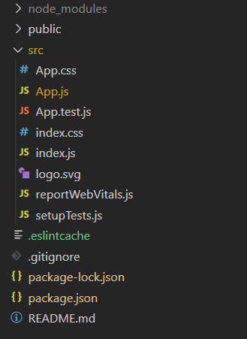

**project structure**

**App.js:** Now, you have to write the below code in the **App.js** file.

Here, the App is the default component where we have written in our code.

**JavaScript**

1. **import** React from 'react';
2. **import** Button from '@material-ui/core/Button';
4. **const** App = () => {
6. **return** (
7. <div style={{
8. display: 'flex',
9. margin: 'auto',
10. width: 400,
11. flexWrap: 'wrap',
12. }}>
13. <div style={{ width: '100%', **float**: 'left' }}>
14. <h3>How to use Button Component in ReactJS?</h3> <br />
15. </div>
16. <Button variant="contained">Default Button</Button>
17. <Button variant="contained" color="primary">
18. Primary Button
19. </Button>
20. <Button variant="contained" color="secondary">
21. Secondary Button
22. </Button>
23. <Button variant="contained" disabled>
24. Disabled Button
25. </Button>
26. <Button variant="contained" color="primary"
27. href="#">
28. Link Button
29. </Button>
30. </div>
31. );
32. }
33. export **default** App;

### **Steps to run the application:**

Run the application by using the command from the root directory of the project:

1. npm start

**Output:** Now open your browser and go to **http://localhost:3000/.** You can see the below output:

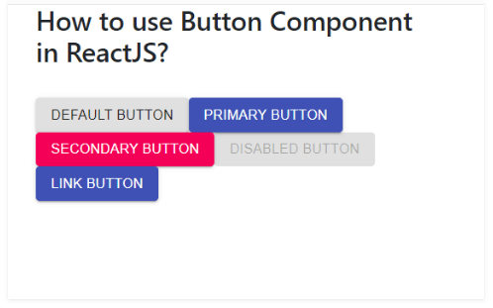

# **What is Dom in React?**

### **Real/Browser DOM:**

DOM stands for **'Document Object Model'.** It is a structured representation of HTML in the webpage or application. It represents the entire UI**(User Interface)** of the web application as the tree data structure.

It is a structural representation of HTML elements of a web application in simple words.

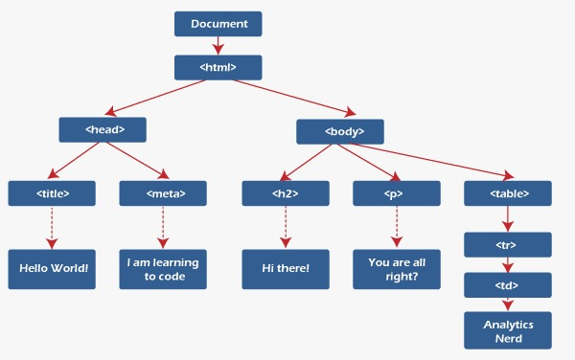

Whenever there is any change in the state of the application UI, DOM is updated and represents the change. The DOM is rendered and manipulated with every change for updating the application User Interface, which affects the performance and slows it down.

Therefore, with many UI components and the complex structure of **DOM,** It will update in more expensive as it needs to be re-rendered with each change.

Play Video

The DOM is constituted as a tree data structure. It consists of the node for each **UI element** present in the web document.

### **Updating the DOM:**

If we know some about JavaScript you may see people using the **'getElementById()'** or **'getElementByClass()'** method to modify the contents of DOM.

Whenever there is any change that occurs in the state of your application, the DOM is updated to reflect the change in the UI.

### **How Virtual DOM speeds things up:**

When any new things are added to the application, the virtual DOM is created, represented as a tree. Every element in the application is a node in the tree.

Therefore, whenever there is a change in the position of an element, a new virtual DOM is created. The newer virtual DOM tree is compared with the latest, where the changes are noted.

It finds the possible way to make these changes by the actual DOM. Then the updated elements would re-render on the page.

### **How Virtual DOM Helps in React:**

Everything in React is observed as a component, a functional component, and a class component. A component has a state. Whenever we change something in the JSX file, to put it simply, whenever the state of the component is changed, the react updates its virtual DOM tree.

React maintains two virtual DOMs every time. The first one contains the updated virtual DOM, and the other is a pre-updated version of the updated virtual DOM. It compares the pre-updated version of the updated virtual DOM and finds what was changed in the DOM, like which components will be changed.

Although it may seem ineffective, the cost is no more, as updating the virtual DOM cannot take much time.

When comparing the current virtual DOM tree with the previous one is known as **'defying'.** Once React knows what has changed, it updates the objects in the actual DOM. React uses batch updates to update the actual DOM. It changes to the actual DOM are sent in batches rather than sending any updates for the single change into the component's state.

Re-rendering the UI is the most expensive part, and React manages to do most efficiently by ensuring the Real DOM that receives the batch updates to re-render the UI. The process of converting the changes to the actual DOM is called reconciliation.

It improves performance and is the main reason developers love react and its Virtual DOM.

### **What is React's Virtual DOM?**

The concept of Virtual DOM comes to make the performance of Real DOM better and faster. Virtual DOM is a virtual symbol of the DOM.

But the main difference is that every time, with each change, the virtual DOM gets updated instead of the actual DOM.

For example, the **real** and **virtual DOM** is represented as a tree structure. Every element in the tree is a node. A node is added to the tree when a new item is added to the application UI.

If the position of any elements changes, a new virtual DOM tree is created. The virtual DOM computes the minimum number of operations on the real DOM to make changes to the real DOM. It is efficient and performs better by reducing the cost and operation of re-rendering the whole real DOM.

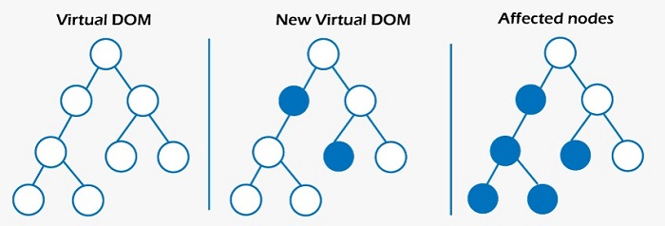

Now we have a normal understanding of Real and Virtual DOM.

Let's look at how React works by using Virtual DOM.

* Each UI is an individual component, and every component has its state.
* React follows observable patterns and observes the changes in states.
* Whenever any change is made to the component's state, React updates the virtual DOM tree but does not change the actual DOM tree.
* React compares the current version of the virtual DOM with the previous version after updating.
* React knows which objects are changed in the virtual DOM. It replaces the objects in the actual DOM, leading to minimal manipulation operations.
* This process is known as **"differentiation".** This picture will make the concept clear.

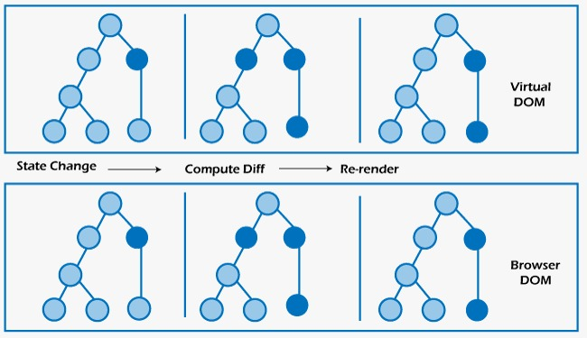

In the image, the **dark blue** circles are the nodes that have been changed. The state of these components has changed. React computes the difference between the previous and current version of the virtual DOM tree, and the entire parent sub-tree is re-rendered to show the UI which is changed.

The updated tree is batch updated (that updates to the real DOM are sent in batches instead of sending updates for each state change.) to the real DOM.

To get deeper into this, we need to know about the **React render ()** function.

Then, we need to know about some of the important features of React.

### **JSX**

JSX stands for JavaScript XML. It is a syntax extension of JS. Using JSX, we can write HTML structures in the file which contain JavaScript code.

### **Components**

Components are independent and reusable of code. Every user interface in the React app is a component. A single application has many components.

Components are of two types, class components and functional components.

Class components are stateful because they use their "state" to change the user interface. Functional components are stateless components. They act like a JavaScript function that takes an arbitrary parameter called "props".

React Hooks have been introduced to access states with functional components.

### **Lifecycle Methods**

Lifecycle methods are important methods built-in to react, which operate on components through their duration in the DOM. Each component of React went by a lifecycle of events.

**The render() method is the maximum used lifecycle method.**

It is the only method within React class components. So, in each class, component render() is called.

The render () method handles the component's render by the UI. The render () contains all the logic displayed on the screen. It can also have a null value if we don't want to show anything on display.

**Example is shown below:**

1. **class** Header **extends** React.Component{
2. render(){
3. **return** <div> React Introduction </div>
4. }
5. }

The example will show the **JSX** written in the render().

When a state or prop is updated within the component, render() will return a different tree of React elements.

When writing the code in the console or the JavaScript file, these will happen:

* The browser parses the HTML to find the node with the ID.
* It removes the child element of the element.
* It updates the element **(DOM)** with the **'updated value'.**
* It recalculates **CSS** for parent and child nodes.
* Then, Update the layout.

Finally, traverse the tree on the screen display.

So as we know that updating the **DOM** involves changing the content. It is more attached to it.

Complex algorithms are involved in recalculating CSS and changing the layouts, which affect the performance.

So, React has many ways of dealing with it, as it uses something known as virtual DOM.

### **reactdome**

The react-dom package provides DOM-specific methods at the top level of the application to escape route out of the React model if needed.

1. import * as ReactDOM from 'react-dom';

If you use ES5 with npm, you should also write:

1. var ReactDOM = require('react-dom');

The **react-dom** package also provides modules specific to the client and server apps:

* react-dom/client
* react-dom/server

The react-dom package exports of these methods:

* createPortal()
* flushSync()

The react-dom methods are also exported:

* render ()
* hydrate ()
* findDOMNode()
* unmountComponentAtNode ()

#### **Note: Both hydrate and render have been replaced with newer client methods.**

### **Browser Support**

React supports all modern browsers, and some polyfills are required for older versions.

#### **Note: We cannot support older browsers that do not support ES5 methods, Like, Internet Explorer. You can find that apps work in the latest browsers if polyfills like es5-shim and es5-sham that included in the page, but you're on your own if you take the path.**

### **Reference**

**createPortal()**

Creates Portal () Portal provides the way to read children into the DOM node, which exists outside the ranking of the DOM component.

**flushSync()**

Force React updates in the provided callback simultaneously. It ensures the DOM is updated immediately.

1. // Force this state update to be synchronous.
2. flushSync(() =**>** {
3. setCount(count + 1);
4. });
5. // By this point, DOM is updated.

**Note:**

* Use sparingly. Flush Sync significantly hurt performance.
* FlushSync will force pending boundaries to show the fallback state.
* It runs pending effects and simultaneously applies the updates before returning it.
* flushSync flush updates outside the callback to flush the updates the callback. **For example,** if there are any pending updates from a click, React may flush it before flushing the updates at the callback.

### **Legacy Reference**

**render()**

1. render(element, container[, callback])

#### **Note: Render is replaced with creating Root in React. Render a React element into the DOM at the supplied container and repay a reference to the component.**

If a React element were previously rendered into any container, it would perform an update on it, and it is necessary to reflect the latest React element.

It is executed when the component is rendered if the optional callback is provided.

**Note:**

Render () method controls the content of the container node when it passes by. Any existing DOM element is replaced.

Render () does not alter the container's node (it can only modify the container's children). It might be possible to insert a component into an existing DOM node without overwriting the child elements.

Render () currently back reference to the root instance of ReactComponent.

However, its return value is inherited and can be avoided as, in some cases, future versions of React may generate components asynchronously.

If you need a reference to the ReactComponent prototype, the best solution is to attach a recall reference to the element.

Render () is used to hydrate a rendered container to the server is obsolete. Use hydrateRoot() in place of it.

### **hydrate()**

hydrate is replaced with the hydrate Root.

It is exactly as render() but is used for a container whose HTML content is rendered by ReactDOMServer. React will try to connect event listeners to the current markup.

1. hydrate(element, container[, callback])

**Note:**

React expects rendered content to be identical between the server and client. We can correct the content of the text, but we must treat the inconsistencies as errors and right them. In development mode, React warns of the inconsistency during hydration.

There is no assurance that specific differences are corrected for discrepancies.

It is important for performance reasons in most applications, and it will be too expensive to validate all flags.

Suppose an element's attribute or text content inevitably differs between the server and the client (for example, **the timestamp**). In this case, we can silence the alert by adding **suppressHydrationWarning = {true}** to the element.

If it's not a text element, it cannot try to patch it so that it may remain inconsistent until future updates.

You can perform a two-pass render if we need to provide different on the server and client deliberately. Components left on the client can read state variables like this.state.isClient, where it will set to true in **componentDidMount().**

The initial render pass will do the same as the server, avoiding inconsistencies, but the additional pass will be made synchronously after hydration.

#### **Note: This approach will make the components slower since they do it twice, so use it carefully.**

1. unmountComponentAtNode()
2. unmountComponentAtNode(container)

### **Note:**

**unmountComponentAtNode** has been replaced with **root.unmount()** in React. It erases the mounted React component from the DOM and cleans its event handlers and state.

If no component was mounted to the container, it can't do anything. Returns true if no component is mounted and false if there is no component to unmount.

## findDOMNode()

#### **Note: findDOMNode is an escape hatch used to access the underlying DOM node. This escape hatch is discouraged in most cases because it pierces the component abstraction. It has been deprecated in StrictMode.**

### **findDOMNode(component)**

If this component has been mounted to the DOM, this returns the corresponding native browser DOM element. This method is useful for reading values from the DOM, such as form field values, and performing DOM measurements. In most cases, you can attach a reference to the DOM node and avoid using findDOMNode.

When a component returns null or false, findDOMNode returns null. When a component is rendered to a string, findDOMNode returns a text DOM node containing that value. The component can return a fragment with multiple children in case findDOMNode has returned the DOM node corresponding to the first non-empty child.

**Note:**

findDOMNode only works on mounted components (that is, components that have been placed in the DOM). If you try to call this on a component that hasn't been mounted yet (such as calling findDOMNode() on render() on a component that hasn't been created yet), an exception will be thrown.

findDOMNode cannot be used in function components.

### **DOM elements**

React implements a browser-independent DOM system for the performance and with cross-browser compatibility. We take this opportunity to clean up some of the rough edges in the browser's DOM implementation.

In React, all the DOM properties and attributes (including event handlers) must be camelcase. For example, the HTML tabindex attribute corresponds to the tab Index attribute in React.

The exceptions are the aria-* and data-* attributes, which must be lowercase. For example, you can have an area tag as an area tag.

### **Differences in Attributes**

Several attributes will work differently between React and HTML:

### **checked**

The checked attribute is supported by components of a checkbox or radio of type <input>. It is useful for manufacturing controlled components. You can use this to determine whether the component is checked or not.

DefaultChecked is the unchecked counterpart that determines the component is checked the first time it is mounted.

### **className**

To specify the CSS class, use the className attribute. It applies to all regular DOM and SVG elements like <div>, <a>, etc.

If you use React with Web Components (uncommon), use the class attribute instead.

### **dangerouslySetInnerHTML**

Dangerously SetInnerHTML is React's replacement for using innerHTML in the DOM browser. Configuring HTML code is risky because it is easy to expose the users to a cross-site scripting (XSS) attack.

So we can set HTML directly from React, but you have to dangerously type SetInnerHTML and pass an object with the __html key to remember that it's dangerous.

### **For example:**

1. function createMarkup() {
2. return {__html: 'First · Second'};
3. }
4. function MyComponent() {
5. return **<div** dangerouslySetInnerHTML={createMarkup()} **/>**;
6. }
7. htmlFor

React elements use htmlFor instead, Since for is a reserved word in JavaScript.

### **onChange**

The onChange event behaves as expected; the event fires every time a form field is changed.

We intentionally don't use the existing browser behavior because change is grand for its behavior and React relies on the event to handle user input in real-time.

### **selected**

If you want to mark the <option> as selected, refer to that option's value in the <select>'s value instead. See "Select Tag" for detailed instructions.

**Note:**

In maximum cases, class names refer to classes defined in an external CSS style sheet. Styles are used in React apps to add calculated styles at render time. The style attribute accepts the JavaScript object with camel properties instead of a CSS string.

It conforms **DOM-style** JavaScript properties, is more efficient, and avoids **XSS** security holes.

**For example:**

1. const divStyle = {
2. color: 'blue',
3. backgroundImage: 'url(' + imgUrl + ')',
4. };
6. function HelloWorldComponent() {
7. return **<div** style={divStyle}**>**Hello World!**</div>**;
8. }

#### **Note that: styles are not autoprefixed. To support older browsers, we need to supply style properties:**

1. const divStyle = {
2. WebkitTransition: 'all', // note capital 'W' here
3. msTransition: 'all' // 'ms' is the lowercase vendor prefix
4. };
6. function ComponentWithTransition() {
7. return **<div** style={divStyle}**>**This should work cross-browser**</div>**;
8. }

Style keys are camel to correspond to accessing properties on DOM nodes from within JS. Provider prefixes MS begin with an uppercase letter.

React will automatically add a "px" suffix to some inline number style properties. If we want to use units other than "px", specify the value as a string with the desired unit.

**for example:**

1. // Result style: '10px'
2. **<div** style={{ height: 10 }}**>**
3. Hello World!
4. **</div>**
6. // Result style: '10%'
7. **<div** style={{ height: '10%' }}**>**
8. Hello World!
9. **</div>**

However, not all the style properties are converted to pixel strings.

### **Suppress Editable Content Alert**

There is a warning if an element to children is marked as content editable, as it will not work. The attribute suppresses the warning.

### **Suppression Warning**

If we use server-side React rendering, it is a warning when the server and client render with different content. However, it is hard to guarantee an exact match in rare cases. For example, timestamps are expected to differ at the server or the client.

If you set the suppression warning to true, it will not warn about mismatches between attributes and content of the element.

It only worked at one level depth and was meant to be used as an escape.

### **value**

The value attribute is designed by the <input>, <select> and <textarea> components. You can use it to setting the value of the component.

It is useful for manufacturing controlled components. defaultValue and equal to unchecked set the component's value when mounted serially.

### **All supported HTML attributes**

Any custom and standard DOM attribute are supported.

React has provided a JavaScript-centric API in the DOM. And React components often contain custom and DOM-related props, and then React uses the same CamelCase conventions as the DOM API:

1. **<div** tabIndex={-1} **/>**      // Just like node.tabIndex DOM API
2. **<div** className="Button" **/>** // Just like node.className DOM API
3. **<input** readOnly={true} **/>**  // Just like node.readOnly DOM API

# **Unit Testing in React**

Unit testing is a method of testing that tests the individual software unit in theprocess of isolation. Check the output of a function for any given input.

It means verifying that the component renders for any specific accessory to react components.

In other words, to writing a unit tests is also alike writing code that verifies the code works as expected.

### **What is the Distinction between Unit Testing, Integration Testing, and End-to-end Testing?**

A unit test tests the smallest code unit, which is possible, and any dependencies the component may have.

Play Video[](https://campaign.adpushup.com/get-started/?utm_source=banner&utm_campaign=growth_hack)

Integration tests test the work of multiple components that work together. The tests give the best understanding of user experiences with the application.

The downside of testing is that finding the component that caused the test to break is more complicated. While we failed in unit tests that indicate a problem in a particular component, a broken integration test can be caused by many components, and it's not an explicit component that caused it.

End-to-end testing is called user interface testing, which takes integration testing by testing the entire system from the user's point of view.

The tests cannot know the system, and it focuses on the system from the point ofview of users.

The tests click by the application and verify the user interface matches the expected results, and it is the result of manual and automation testing.

The straightforward thing is to look at the pyramid oftests to explain the tests which will work together:



Unit test is the base of the pyramidbecause it is supposed to lay the foundation of tests. Itis easier to write and is the best written for writing code and fixingbugs.

### **What is the purpose of unit tests?**

There are many reasons why unit tests will be helpful. Some of them are below:

* It exercises your code
* It prevents the regressions
* Faster feedback in the development

These are valid points, but the main advantages of writing unit tests are to **improving the coding style.**

Writing the tests during or before implementing the feature gives us a better idea of the requirements. Write the code that is loosely coupled and easier to test. It was with refactoring a code snippet to make it easier to test in the first place.

For example, we extract the functions into the separate file to make the code easier to test. After that, the result is less coupled.

### **The primary intent of unit tests:**

It has prevented us from sending bugs to production on a few occasions.

Unit tests help us with all points. They form the foundation of any solid test suite for a good reason.

### **When should you write a unit test?**

There are so many opinions about when to write the unit tests. We can write by Test-Driven Development (TDD) which tells us to write test cases before writing the code, and prefer to write the unit tests when the code has been written.

The most significant advantage of unit testing is when you write tests during the actual deployment, that doesn't mean we have to follow the advice.

It is the best idea to write test cases in the following situations:

* During or before the implementation of new functionality
* Before and during refactoring
* Before correcting a mistake

### **What tools do we need to get started with unit testing in React?**

So now we know that unit tests are, used to start writing the first test. Let's see at the tools that will use to write automated tests.

To start writing unit tests in React, you only need the below two types of tools.

* Test runner
* Testing utilities

### **Choosing a test runner for React**

### **What is a test runner?**

The test runner is a program that runs the tests (in the case of unit testing) and allows us to recognize when the tests pass or fail.

* It is an essential tool to remove friction by automating the execution of unit tests. It allows doing the unit tests as apart of CI pipeline (continuous integration).
* It removed friction which will lead the developers to run tests more easily.

### **Testing a component involving state**

Note that there are two sets of testing where we can testour class component.

* **Behavioral.** We can simulate a click on the button and see the button's text has changed. We are seeing the behavior of user and testing the expected change.
* **Component-based.** It tests the toggle method of the component and looks if it does then what we expect it to do. Itis helpful when the toggle function is more complicated, and wants to test different scenarios of unit testing.

The combination of two gives us higher confidence.

### **Prerequisites for React unit testing**

We use two viral libraries named **Jest** and **Enzyme** to do the unit testing. Jest is a very popular librarywhich is written by Facebook and itbecamepopular in the sometimes (You could use other libraries such as mocha or chai in place of Jest).

Jest helps us do all the assertions, and Enzyme helps usrender React components in testing mode. We will see both in detail below.

Let's take a look at the widely used tools for testing React apps:

### **Jest**

In React, the most often used test runner is Jest. We can run Jest in watch mode, which can run our tests every time we save the file.

Jest is a test runner that runs all our test suites and test cases. Jest is previously introduced in testing JavaScript and React applications. We have to call Jest from the command line to run the test cases. We can have additional configurations for Jest custom setup.

### **Installation**

1. npm install --save-dev Jest

Jest provides the configuration file to mention the additional configurations. We provide the file path in the package, and the JSON file is below:

1. --config **<path**/to/file.js/mjs/cjs/json**>**

Let us create a jest.config.json file in the root folder and sum the script in the package.json file to run our tests:

1. {
2. ...
3. "scripts": {
4. "test": "jest",
5. }
6. ...
7. }

Let us create a jest.config.json file in the root folder and sum the script in the package.json file to run our tests:

### **Enzyme**

The Enzyme came into the field in December 2015. It is an addition to react, simplifying the output testing in React components.

The Enzyme is a library used with the Jest in so many test libraries, and it is used to render components and traverse the DOM.

If we build a React app, Jest and Enzyme are the best combinations for testing React apps.

Jest is a test runner which is mainly used to execute the test cases with assertions. And, at the same, Enzyme is a library that is used with Jest library, that provides the rendering techniques like (shallow, mount, etc.) for React components and traverses the rendered output of the DOM.

### **Let's look at the enzyme setup:**

### **Installation**

1. npm install --save-dev Enzyme

Enzymes provide the adapters to work with many versions of React.So, install the adapter in theReact. Next, we are installing React16below.

1. npm install --save-dev enzyme-adapter-react-16

Now, youhave to configure the Enzyme in the adapterto install in prank test environment.

Let's create **jest.setup.js** and add the below code at the file:

1. **import** React from 'react';
2. **import** { configure } from 'enzyme';
3. **import** Adapter from 'enzyme-adapter-react-16';
4. configure({ adapter: **new** Adapter() });
5. Now,you have to add the setup path to jest.config.json file:
6. {
7. "setupFilesAfterEnv": [
8. "<rootDir>/jest.setup.js"
9. ]
10. }

You have to installed an enzyme in your environment.

It is essential to decide what is required for the test and what should be left out of it.

So that, considering the next person after you to manage those test cases, there aren't a lot of unnecessary test and snapshot files left behind.

For each component for unit testing, start with small and stateless components and then move on to rigid components. So that if any complex reacts component includes another minor component already tested, that will make the process easier.

However, in the**test-driven development (TDD)** process, you should first decide and write test cases that initially fail and eventually develop the functionality of the test cases that will pass.

### **Consider a small example to understand:**

**1.**

1. **import** React from 'react';
2. **const** DisplayName = ({name}) => {
3. **return** (
4. <div>
5. Welcome {name}!
6. </div>
7. );
8. };
9. export **default** DisplayName;

**2.**

1. **import** React, { useState } from 'react';
2. **import** DisplayName from './displayName';
3. export **const** validateName = (name) => {
4. **if**((name && isNaN(name)) || !name)
5. **return** **false**
6. **return** **true**
7. }
8. **const** User = () => {
9. **const** [name,setName] = useState(**null**);
10. **const** [error,setError] = useState(**false**);
11. **const** setUserName = (event) =>{
12. **const** {value} = event.target;
13. var isOk = validateName(value);
14. setError(isOk);
15. setName(value);
16. }
17. **return** (
18. <div>
19. <DisplayName name={name} />
20. <input type="text" value={name} onChange={setUserName}/>
21. {error &&<div>Error</div>}
22. </div>
23. );
24. };
25. export **default** User;

A Display Name component that receives a Name property as props and renders it.

The User component in the text input as the Name property validates the username for setting the error if an error is found.

We have exported two components and the validation function use in our further tests.

### **Unit testing the above example:**

There aretwo main approaches to test the React components:

* Snapshot testing
* Logical/functional testing

**1. Snapshot Testing**

Snapshot Test generates a snapshot of the component in the current state and stores it in a folder named "**__snapshots__**."when you run the test.

So, next time we change the component or modify it to rerun the test;

A new snapshot is taken If it fails, which is clearly shows the difference between snapshots provided by the output of the component. If a test fails, we can either accept or reject the change and modify the component accordingly.

### **How is Snapshot Testing done?**

Previously, we need to install the **react-test-rendererutility** to render the component atthe test.

1. npm install --save-dev react-test-renderer

Let's implement first snapshot by writing the below test case in file named UserName.spec.js:

1. **import** React from 'react';
2. **import** renderer from 'react-test-renderer';
3. **import** DisplayName from './displayName';
4. describe('DisplayName', () => {
5. test('should render Vrushali', () => {
6. **const** component = renderer.create(<DisplayName name={"Vrushali"} />);
7. let tree = component.toJSON();
8. expect(tree).toMatchSnapshot();
9. });
10. });

Previously, we rendered the component **displayName,**converted it to JSON, and checked if it matched the previous snapshot. Let's run the test by the **"npm run test"** command on cmd and see.

For the first time, if you run the test, it generates a snapshot of the components' output and store it in a**"__snapshots__"** folder. Wesee what kind of structure it stores.

Now, Replace Display Name component and run the test again:

1. **import** React from 'react';
2. **const** DisplayName = ({name}) => {
3. **return** (
4. <div>
5. <p>Welcome {name}!</p>
6. </div>
7. );
8. };
9. export **default** DisplayName;

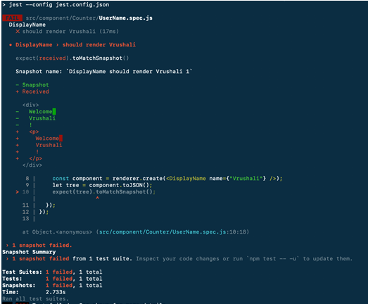

We can see that it shows the changes in the component, and the test fails because it cannot match the last snapshot.

Here is an implementation changeto fix it.You need to update the snapshot it represents a bug is found in the component to fix it. We can update the snapshot by using the "-u" option.

Similarly, we add a snapshot test for the parent component.

**2. Logical/Functional Testing**

We can add some test cases and more tests in our code for testing the validation function.

1. **import** React from 'react';
2. **import** renderer from 'react-test-renderer';
3. **import** DisplayName from './displayName';
4. **import** { validateName }  from './index';
5. describe('DisplayName', () => {
6. test('should render Vrushali', () => {
7. **const** component = renderer.create(<DisplayName name={"Vrushali"} />);
8. let tree = component.toJSON();
9. expect(tree).toMatchSnapshot();
10. });
11. });
12. describe('Validation',()=>{
13. test('can set the error if input is number',()=>{
14. **const** name = 123;
15. **const** error = validateName(name);
16. expect(error).toBeTruthy();
17. });
18. test('Could reset  error if input is empty',()=>{
19. **const** name = **null**;
20. **const** error = validateName(name);
21. expect(error).toEqual(**false**);
22. });
23. })

**We have added two test cases here:**

* It checks if any error message will send if the user passes any number of inputsofthe name.
* It checks the error message if it reactswith false where input box is empty at the name property.

So,it covers the possible outcomes where the application has crashed in logic that we have forgotten to handle at the development time.

Now, we can see the below-given output if we run the tests.

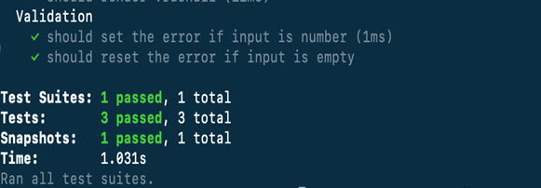

If the validation fails, the running tests will inform you; all tests will pass. Keeping the logic separate helps a lot in complex code to be tested in possible cases and seems like cleaner way to understand the code.

### **Reaction test library**

Unlike Enzyme, react-testing-library focuses on the user behavior rather than the implementation.

The focus is on checking for correct output for a set of props, by using the react test library which is writing end-to-end tests for the components in Enzyme:

1. render(**<Login** **/>**)
3. // fill the form
4. fireEvent.change(screen.getByLabelText(/username/i), {
5. target: {value: 'chuck'},
6. })
7. fireEvent.change(screen.getByLabelText(/password/i), {
8. target: {value: 'norris'},
9. })
11. fireEvent.click(screen.getByText(/submit/i))
13. const alert = await screen.findByRole('alert')
15. expect(alert).toHaveTextContent(/congrats/i)
16. expect(window.localStorage.getItem('token')).toEqual(fakeUserResponse.token)
17. });

If you're not sure what you have to test,test what you expect the component to render.

Test all the different states of this component(s). If you expect different things to be rendered based on the props passed in, render the external component with different props and make the appropriate assertions.

For example, when you click or hover a button test, you have something to happen.

If you are providing a custom button component and pass a color prop with a value of red, then you can test it, and it give you the confidence that the component meets the design requirements.

## Conclusion

It is very important to write unit tests, which is the simplest type of tests, and project to increase confidence and the code correctness. We have to aim for a higher percentage of code coverage to make it the part of workflow to write the unit test cases.

# **Carousel in React**

React Carousel is a slideshow component for cycling by elements ? slides of pictures or text ? like a carousel.

## How does it work?

React Carousel is a slideshow inside a bunch of content. It launches many images, text, or HTML elements and supports previous/next buttons.

The Page Visibility API is cross-browser compatible and prevents carousel scrolling when the user is not viewing a webpage (such as when the browser tab is inactive, the browser window is minimized, etc.).

It is a powerful, lightweight and fully customizable carousel component for React applications.

Play Video[](https://campaign.adpushup.com/get-started/?utm_source=banner&utm_campaign=growth_hack)

## Installing as a package

1. yarn add react-responsive-carousel

### **Usage**

1. **import** React, { Component } from 'react';
2. **import** ReactDOM from 'react-dom';
3. **import** "react-responsive-carousel/lib/styles/carousel.min.css"; // requires a loader
4. **import** { Carousel } from 'react-responsive-carousel';
6. **class** DemoCarousel **extends** Component {
7. render() {
8. **return** (
9. <Carousel>
10. <div>
11. <img src="assets/1.jpeg" />
12. <p className="legend">Legend 1</p>
13. </div>
14. <div>
15. <img src="assets/2.jpeg" />
16. <p className="legend">Legend 2</p>
17. </div>
18. <div>
19. <img src="assets/3.jpeg" />
20. <p className="legend">Legend 3</p>
21. </div>
22. </Carousel>
23. );
24. }
25. });
27. ReactDOM.render(<DemoCarousel />, document.querySelector('.demo-carousel'));
28. // Don't forget to include css in your page
29. // Using webpack or parcel a style loader
30. // import styles from 'react-responsive-carousel/lib/styles/carousel.min.css';
31. // Using html tag:
32. // <link rel="stylesheet" href="<NODE_MODULES_FOLDER>/react-responsive-carousel/lib/styles/carousel.min.css"/>

## Props:

|  |  |  |
| --- | --- | --- |
| **Name** | **Value** | **Description** |
| **ariaLabel** | string | Defines the area-label attribute for the root carousel element. By excluding the attribute from the markup, the default is undefined. |
| **axis** | 'horizontal', 'vertical' | Set the direction of the slider, 'Horizontal,' by default. |
| **autoFocus** | boolean | Focus on the Carousel while rendering. |
| **autoPlay** | boolean | Automatically change slide based on interval prop. |
| **centerMode** | boolean | Center the current item and set the width of the slide based on centerSlidePercentage. |
| **centerSlidePercentage** | number | Set the width percentage relative to the carousel width when centerMode is true. |
| **dynamicHeight** | boolean | The height of the objects will not be fixed. |
| **emulateTouch** | boolean | Enables swipe right on non-touch screens when swipeable. |
| **infiniteLoop** | boolean | Going after the last item will go back to the first slide. |
| **interval** | number | To skip to the next item automatically, the interval in milliseconds when autoplay is true is 3000 by default. |
| **labels** | object | Apply region labels to a carousel with an object with LeftArrow, RightArrow, and Item properties. |
| **onClickItem** | function | The default is {left arrow: 'previous slide/item', right arrow: 'next slide/item', item: 'slide item'}. |
| **onClickThumb** | function | A callback to handle a click event on the thumb receives the current index and item as arguments. |
| **onChange** | function | The callback gets the current index and item as arguments each time the selected item changes to handle. |
| **onSwipeStart** | function | The callback is handled when a touch event initiates the swipe as an argument. |
| **onSwipeEnd** | function | To handle when the swipe is finished, the callback receives a touch event as an argument. |
| **onSwipeMove** | function | The callback is triggered on every movement while swiping, receiving a touch event as an argument. |
| **preventMovementUntilSwipeScrollTolerance** | boolean | Do not let the carousel scroll until the user swipes to the value specified on SwipeScrollTolerance. |
| **renderArrowPrev** | function | Render custom back arrow. Receives a click handler, a boolean indicating whether there is a previous item, and an accessibility label as an argument. |
| **renderArrowNext** | function | Render custom back arrow. Receives a click handler, a boolean indicating where the following item is, and an accessibility label as an argument. |
| **renderIndicator** | function | Current custom indicator. Receives a click handler, a boolean indicating whether the item is selected, the item index, and an accessibility label as arguments. |
| **renderItem** | function | Submit a custom item. Get an item from the Carousel and an object with the selected property as an argument. |
| **renderThumbs** | function | Render prop to show thumb, receives carousel item as argument. Get the image tag of each item of the slider, and render it by default. |
| **selectedItem** | number | Set the selected item, default to 0. |
| **showArrows** | boolean | Enable Previous and Next arrows, True by default. |
| **showStatus** | boolean | Enable the current item's absolute position, which is confirmed by default |
| **showIndicators** | boolean | Enable the indicator to select an item, which defaults to true. |
| **showThumbs** | boolean | Enable thumbs, defaults to true. |
| **statusFormatter** | function | Formatter that returns the position as a string gets the current item and takes the total count as an argument. Defaults to {currentItem} of the format {total}. |
| **stopOnHover** | boolean | The slide cannot change by autoplay on hover. Default to true. |
| **swipeable** | boolean | Enable the user to swipe the Carousel, which defaults to true. |
| **swipeScrollTolerance** | number | The number of pixels needed to slide a slide is five by default when swiping. |
| **thumbWidth** | number | Thumb width, 80 by default. |
| **transitionTime** | number | The duration of the slide change animation. |
| **useKeyboardArrows** | boolean | Enable arrows to move the slider when focused. |
| **verticalSwipe** | 'natural', 'standard' | Set swipe mode when the axis is 'vertical.' The default is 'Standard.' |
| **width** | number or string | The width of the Carousel is 100% by default. |

### **Customizing**

**Items (Slides)**

By default, each slide is rendered as passed as children. If we need to customize it, use the prop renderItem.

1. renderItem: (item: React.ReactNode, options?: { isSelected: **boolean** }) => React.ReactNode;

### **Thumbs**

By default, thumbs are generated by extracting images in each slide. If you don't have pictures on your slides or prefer a different thumbnail, use the renderThumb method to return a new list of images to be used as thumbnails.

1. renderThumbs: (children: React.ReactChild[]) => React.ReactChild[]

### **Arrows**

By default, simple arrows are provided on each side. If you need to customize them and css isn't enough, use renderArrowPrev and renderArrowNext. The click handler is passed as an argument to the prop and must be added to the custom arrow as the click handler.

1. renderArrowPrev: (clickHandler: () => **void**, hasPrev: **boolean**, label: string) => React.ReactNode;
2. renderArrowNext: (clickHandler: () => **void**, hasNext: **boolean**, label: string) => React.ReactNode;

### **Indicators**

By default, the indicators will be presented as those tiny little dots at the bottom of the carousel. To customize them, use the RenderIndicator prop.

1. renderIndicator: (
2. clickHandler: (e: React.MouseEvent | React.KeyboardEvent) => **void**,
3. isSelected: **boolean**,
4. index: number,
5. label: string
6. ) => React.ReactNode;

### **Take full control of the carousel**

If none of the previous options suffice, you can create your controls for the Carousel.

### **Custom Animations**

By default, Carousel uses traditional 'slide' style animations. There is also a built-in fade animation, which is used by passing 'fade' to the AnimationHandler prop.

#### **\*Note: The 'fade' animation may not support swiping animations, so you may want to set swipeable to false.**

If you want something completely custom, you can pass custom animation handler functions to AnimationHandler, SwipeAnimationHandler, and StopSwipingHandler. Animation handler functions accept props and positions and return the styles for the list, the default slide style, the selected slide style, and the previous slide style. Take a look at the fade animation handlers to get an idea of how they work:

1. **const** fadeAnimationHandler: AnimationHandler = (props, state): AnimationHandlerResponse => {
2. **const** transitionTime = props.transitionTime + 'ms';
3. **const** transitionTimingFunction = 'ease-in-out';
5. let slideStyle: React.CSSProperties = {
6. position: 'absolute',
7. display: 'block',
8. zIndex: -2,
9. minHeight: '100%',
10. opacity: 0,
11. top: 0,
12. right: 0,
13. left: 0,
14. bottom: 0,
15. transitionTimingFunction: transitionTimingFunction,
16. msTransitionTimingFunction: transitionTimingFunction,
17. MozTransitionTimingFunction: transitionTimingFunction,
18. WebkitTransitionTimingFunction: transitionTimingFunction,
19. OTransitionTimingFunction: transitionTimingFunction,
20. };
22. **if** (!state.swiping) {
23. slideStyle = {
24. ...slideStyle,
25. WebkitTransitionDuration: transitionTime,
26. MozTransitionDuration: transitionTime,
27. OTransitionDuration: transitionTime,
28. transitionDuration: transitionTime,
29. msTransitionDuration: transitionTime,
30. };
31. }
33. **return** {
34. slideStyle,
35. selectedStyle: { ...slideStyle, opacity: 1, position: 'relative' },
36. prevStyle: { ...slideStyle },
37. };
38. };

### **Videos**

If your Carousel is about videos, keep in mind that it's up to you to decide which videos are playing. Using the RenderItem prop, you will get information saying whether the slide is selected or not and can use this to change the position of the video.

### **React Carousel component**

Carousel doesn't automatically normalize slide dimensions, and you may want to use additional utilities or custom methods to size content properly. While Carousel supports previous/following controls and indicators, they are not expected. Add and customize as you see fit.

### **Slides only**

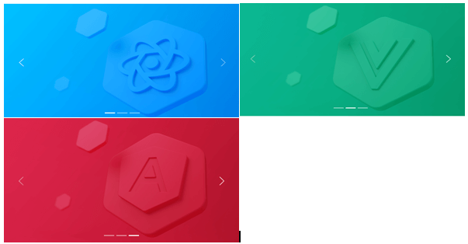

1. <CCarousel>
2. <CCarouselItem>
3. <CImage className="d-block w-100" src="/images/react.jpg" alt="slide 1" />
4. </CCarouselItem>
5. <CCarouselItem>
6. <CImage className="d-block w-100" src="/images/vue.jpg" alt="slide 2" />
7. </CCarouselItem>
8. <CCarouselItem>
9. <CImage className="d-block w-100" src="/images/angular.jpg" alt="slide 3" />
10. </CCarouselItem>
11. </CCarousel>

### **With controls**

It will add in the previous and next controls by controls property.



1. <CCarousel controls>
2. <CCarouselItem>
3. <CImage className="d-block w-100" src="/images/react.jpg" alt="slide 1" />
4. </CCarouselItem>
5. <CCarouselItem>
6. <CImage className="d-block w-100" src="/images/vue.jpg" alt="slide 2" />
7. </CCarouselItem>
8. <CCarouselItem>
9. <CImage className="d-block w-100" src="/images/angular.jpg" alt="slide 3" />
10. </CCarouselItem>
11. </CCarousel>

### **With indicators**

You can also attach the indicators to the Carousel lengthwise and the controls.



1. <CCarousel controls indicators>
2. <CCarouselItem>
3. <CImage className="d-block w-100" src="/images/react.jpg" alt="slide 1" />
4. </CCarouselItem>
5. <CCarouselItem>
6. <CImage className="d-block w-100" src="/images/vue.jpg" alt="slide 2" />
7. </CCarouselItem>
8. <CCarouselItem>
9. <CImage className="d-block w-100" src="/images/angular.jpg" alt="slide 3" />
10. </CCarouselItem>
11. </CCarousel>

### **With captions**

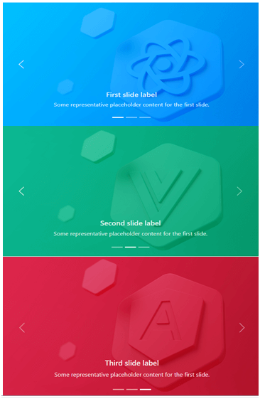

You can add captions to slides in any <CCarouselItem> with the <CCarouselCaption> element. Optional display utilities can be quickly hidden on a small viewport, as shown below. We hide them with .d-none and pull them back on medium-sized devices with .d-MD-block.

Some representative placeholder content for the first slide.

1. <CCarousel controls indicators>
2. <CCarouselItem>
3. <CImage className="d-block w-100" src="/images/react.jpg" alt="slide 1" />
4. <CCarouselCaption className="d-none d-md-block">
5. <h5>First slide label</h5>
6. </CCarouselCaption>
7. </CCarouselCaption>
8. </CCarouselItem>
9. <CCarouselItem>
10. <CImage className="d-block w-100" src="/images/vue.jpg" alt="slide 2" />
11. <CCarouselCaption className="d-none d-md-block">
12. <h5>Second slide label</h5>
13. <p>Some representative placeholder content **for** the first slide.</p>
14. </CCarouselCaption>
15. </CCarouselItem>
16. <CCarouselItem>
17. <CImage className="d-block w-100" src="/images/angular.jpg" alt="slide 3" />
18. <CCarouselCaption className="d-none d-md-block">
19. <h5>Third slide label</h5>
20. <p>Some representative placeholder content **for** the first slide.</p>
21. </CCarouselCaption>
22. </CCarouselItem>
23. </CCarousel>

### **Crossfade**

the carousel to animate slides with a fade transition instead of a slide.

1. <CCarousel controls transition="crossfade">
2. <CCarouselItem>
3. <CImage className="d-block w-100" src="/images/react.jpg" alt="slide 1" />
4. </CCarouselItem>
5. <CCarouselItem>
6. <CImage className="d-block w-100" src="/images/vue.jpg" alt="slide 2" />
7. </CCarouselItem>
8. <CCarouselItem>
9. <CImage className="d-block w-100" src="/images/angular.jpg" alt="slide 3" />
10. </CCarouselItem>
11. </CCarousel>

### **Dark variant**

Add a dark property to the CCrocell for dark color controls, indicators, and captions. Controls with the Filter CSS property are reversed from their default white fill, and captions and controls have additional Sass variables that customize the color and background color.

Some representative placeholder content for the first slide.

1. <CCarousel controls indicators dark>
2. <CCarouselItem>
3. <CImage className="d-block w-100" src="/images/react.jpg" alt="slide 1" />
4. <CCarouselCaption className="d-none d-md-block">
5. <h5>First slide label</h5>
6. <p>Some representative placeholder content **for** the first slide.</p>
7. </CCarouselCaption>
8. </CCarouselItem>
9. <CCarouselItem>
10. <CImage className="d-block w-100" src="/images/vue.jpg" alt="slide 2" />
11. <CCarouselCaption className="d-none d-md-block">
12. <h5>Second slide label</h5>
13. <p>Some representative placeholder content **for** the first slide.</p>
14. </CCarouselCaption>
15. </CCarouselItem>
16. <CCarouselItem>
17. <CImage className="d-block w-100" src="/images/angular.jpg" alt="slide 3" />
18. <CCarouselCaption className="d-none d-md-block">
19. <h5>Third slide label</h5>
20. <p>Some representative placeholder content **for** the first slide.</p>
21. </CCarouselCaption>
22. </CCarouselItem>
23. </CCarousel>

### **API**

**CCarousel**

1. **import** { CCarousel } from '@coreui/react'
3. // or
5. **import** CCarousel from '@coreui/react/src/components/carousel/CCarousel'

|  |  |  |  |
| --- | --- | --- | --- |
| **Property** | **Description** | **Type** | **Default** |
| **activeIndex** | Index of the active object. | number | 0 |
| **className** | A string of all the classnames you want to apply to the parent component. | string | - |
| **controls** | Adding to previous and next controls. | boolean | - |
| **dark** | Add darker controls, indicators, and captions. | boolean | - |
| **indicators** | Adding indicators at the bottom of the Carousel for each item. | boolean | - |
| **interval** | The amount of time for the delay between automatically cycling an item. If false, the Carousel will not cycle automatically. | number | boolean | 5000 |
| **onSlid** | The callback is fired when a slide transition is finished. | (active: number, direction: string) => void | - |
| **onSlide** | The callback is fired when a slide transition is initiated. | (active: number, direction: string) => void | - |
| **pause** | If set to 'hover,' pauses cycling of the Carousel on mouseenter and resumes cycling of the Carousel on mouseleave. If set to false, hovering over the Carousel will not stop it. | boolean | 'hover.' | hover |
| **transition** | Set the transition type. | 'slide' | 'crossfade' | - |
| **wrap** | Set whether the Carousel must be cycled continuously or have a hard stop. | boolean | true |

## CCarouselCaption

1. **import** { CCarouselCaption } from '@coreui/react'
3. // or
5. **import** CCarouselCaption from '@coreui/react/src/components/carousel/CCarouselCaption'

|  |  |  |  |
| --- | --- | --- | --- |
| **Property** | **Description** | **Type** | **Default** |
| **className** | A string of all the className we want to apply to the base component. | string | - |

### **CCarouselItem**

1. **import** { CCarouselItem } from '@coreui/react'
3. // or
5. **import** CCarouselItem from '@coreui/react/src/components/carousel/CCarouselItem'

|  |  |  |  |
| --- | --- | --- | --- |
| **Property** | **Description** | **Type** | **Default** |
| **className** | A string of all the class names you want to apply to the parent component. | string | - |
| **interval** | The amount of time for the delay between automatically cycling an item. | number | boolean | false |

### **React-Bootstrap Carousel Component**

React-Bootstrap is a front-end framework that was designed with React in mind. The Carousel component provides a way to create a slideshow for images or text slides in a cyclic manner for full rendering.

We use the following approach in ReactJS to use the react-bootstrap carousel component.

**Carousel props:**

* **Active Index:** Used to control the currently active view slide. It is used as a custom element type for the component.
* **Controls:** These display the Next/Prev buttons in the Carousel.
* **Default Active Index:** This is the default Active Index which is 0.
* **Fade:** Used to add fade animations between slides as they move.
* **Indicators:** Used to display a set of slide status indicators.
* **Interval:** Used to delay the time between cycles automatically.
* **Keyboard:** Specifies whether the Carousel should respond to keyboard events.
* **Next icon:** This is used to override the default next icon.
* **Next Label:** This can show the next element in the Carousel and is a type of label shown only to screen readers.
* **On selection:** This is a callback triggered when the active item changes.
* **onSlide:** This callback is triggered when the slide transition ends.
* **onSlide:** This callback is triggered when the slide transition begins. Pause is used to pause the slide based on different mouse events.
* **prevIcon:** This is used to override the default last icon.
* **prevLabel:** This can show the last element in the Carousel and is a type of label shown only to screen readers.
* **Ref:** It is used to provide the attribute for the element.
* **Slides:** This is used to enable animation between slides.
* **Touch:** Touchscreen devices use a touchscreen to indicate whether they should support left/proper swipe interaction.
* **Wrap:** Indicates whether the Carousel should be a continuous rigid stop or circle.
* **bsPrefix:** This is an escape hatch to work with strongly optimized Bootstrap CSS.
* **Carousel. Item props:** It will be used as the custom element type of the component.
* **Interval:** This is used to delay the time between cycling for these items automatically.
* **bsPrefix:** This is an escape hatch to work with strongly optimized Bootstrap CSS.
* **Carousel. Caption props:** It is used as a custom element type for this component.
* **bsPrefix:** This is the escape hatch for working with strongly optimized Bootstrap CSS.

### **Creating React App and installing module:**

**Step 1:** Create a React application by using the below command:

1. npx create-react-app foldername

**Step 2:**After creating the project folder, i.e., folder name, go to using the fcommand below:

1. cd foldername

**Step 3:** After creating the **ReactJS** application, install the required modules using the command below:

1. npm install react-bootstrap
2. npm install bootstrap

**Project Structure: It looks like the below.**

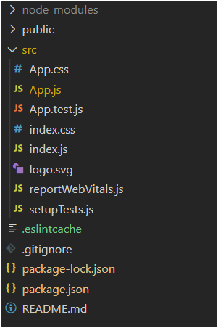

### **Project Structure**

**Example:** Now, write the below code in the **App.js** file. Here, App is the default component where we wrote our code.

**App.js**

1. **import** React from 'react';
2. **import** 'bootstrap/dist/css/bootstrap.css';
3. **import** Carousel from 'react-bootstrap/Carousel';
5. export **default** function App() {
6. **return** (
7. <div style={{ display: 'block', width: 700, padding: 30 }}>
8. <h4>React-Bootstrap Carousel Component</h4>
9. <Carousel>
10. <Carousel.Item interval={1500}>
11. <img
12. className="d-block w-100"
13. src=" https://www.javatpoint.com//wp-content/uploads/20210425122739/2-300x115.png"
14. alt="Image One"
15. />
16. <Carousel.Caption>
17. <h3>Label **for** first slide</h3>
18. <p>Sample Text **for** Image One</p>
19. </Carousel.Caption>
20. </Carousel.Item>
21. <Carousel.Item interval={500}>
22. <img
23. className="d-block w-100"
24. src="https://www.javatpoint.com//wp-content/uploads/20210425122716/1-300x115.png"
25. alt="Image Two"
26. />
27. <Carousel.Caption>
28. <h3>Label **for** second slide</h3>
29. <p>Sample Text **for** Image Two</p>
30. </Carousel.Caption>
31. </Carousel.Item>
32. </Carousel>
33. </div>
34. );
35. }

**Steps to run the application:** Run the applications by using the command from the root directory of the project:

1. npm start

**Output:** Open the browser and go to **http://localhost:3000/.** You will see the following output:

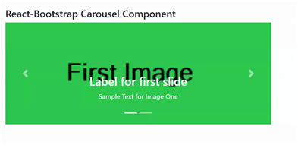

# **React-Paginate**

The Reactjs pagination library will be used directly for the pagination functionality of any list of items. The props required here are an array of list items to render and an onChange callback function, which informs the parent component about the page change.

But pagination is important by filtering and displaying only relevant data, for example, Google search engine.

Therefore, Reactjs pagination becomes crucial when users search for certain information and do not consume random information.

Some built-in libraries are used to handle pagination in web development, in the case of React. You directly use many resources to handle pagination in the application.

Play Video[](https://campaign.adpushup.com/get-started/?utm_source=banner&utm_campaign=growth_hack)

Some of the NPM and other pagination libraries available are:

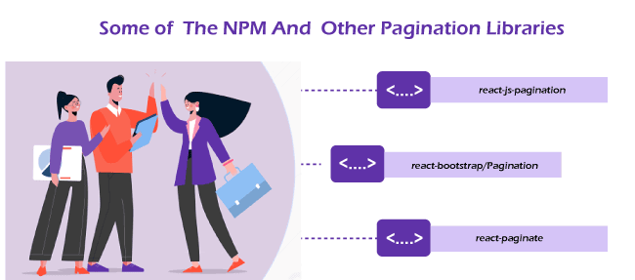

* **react-js-paginate**
* **react-paginate**
* **react-boot/paginate**

Instead of rewriting your own, it's ideal to use these existing libraries, as there's no need to reinvent the wheel; instead, you can focus on other things.

But at the same time, it is very important to know what is going on behind the scenes to build and customize the app to your needs without compromising any requirements.

There is also a possibility that different logic is used for different reactjs pagination packages. To implement react pagination in your app, read this excellent react-jw-pagination article.

**Here we talk only about react-paginate (the second one):**



A ReactJS component to render the pagination.

By installing the component and writing just a bit of CSS, you can get this: Note: You must write your CSS to get this UI. This package does not provide any CSS.



**or**



### **Installation**

1. Install the react page with npm:
2. npm install react-page --save
3. **import** React, { useEffect, useState } from 'react';
4. **import** ReactDOM from 'react-dom';
5. **import** ReactPaginate from 'react-paginate';
6. // Example to simulate obtaining the resources.
7. constant elements = [1, 2, 3, 4, 5, 6, 7, 8, 9, 10, 11, 12, 13, 14];
9. Function elements ({current elements}) {
10. **return** (
11. <>
12. {current items &&
13. currentelements.map((element) => (            <div>
14. <h3>Article #{article}</h3>
15. </div>
16. ))}
17. </>
18. );
19. }function Paginated Items ({ items per page }) {
20. // We start with an empty list of elements.
21. **const** [currentitems, setcurrentitems] = useState(**null**);
22. **const** [pageCount, setPageCount] = useState(0);
23. // element offsets; we also use as page scrolls
24. // API we are working with.
25. **const** [element offset, set Element Offset] = usestate(0);
27. useEffect(() => {    // Get the items of other resources.
28. **const** endOffset = itemOffset + itemsPerPage;
29. console.log(`Loading items from ${itemOffset} to ${endOffset}`);
30. setCurrentItems(items.slice(itemOffset, endOffset));
31. setPageCount(Math.ceil(items.length / itemsPerPage));
32. }, [element offset, elements per page]);
34. // Call user clicks to request another page.
35. **const** handlePageClick = (event) => {
36. **const** newOffset = (event.selected * itemsPerPage) % items.length;
37. console.log(
38. `User requested page number ${event.selected}, offset by ${newOffset}`
39. );
40. setItemOffset(newOffset);
41. };
42. **return** (
43. <>
44. <articles current articles={current articles} />
45. <ReactPaginate
46. breakLabel="..."
47. nextLabel="next >"
48. onPageChange={handlePageClick}
49. Displayed Page Range = {5}
50. pageCount={pageCount}
51. previousLabel="< previous"
52. renderOnZeroPageCount={**null**}
53. />
54. </>
55. );
56. }
57. // Add a <div id="container"> to HTML to see the component.
58. ReactDOM.render(
59. <Items Paginated itemsPerPage={4} />,
60. document.getElementById('container')
61. );

**Try it on Code Pen.**

You can read the code in demo/js/demo.js to understand make reactive pagination work in a list of objects.

Finally, the CodePen demo introduces getting the sample code (GitHub API) and two synchronized widgets of pagination.

### **Props**

|  |  |  |
| --- | --- | --- |
| **Name** | **Type** | **Description** |
| pageCount | Number | The total number of pages which is required. |
| PageRank displayed | Number | The range of pages which is displayed. |
| marginPagesDisplayed | Number | The number of pages has displayed in the margins. |
| previousLabel | Node | It is mainly used for Label for the previous button. |
| nextLabel | Node | It is used for Label for the next button. |
| breakLabel | Node | Mainly used for Label for ellipses. |
| breakClassName | String | The name of the class in the li tag of the ellipsis element. |
| breakLinkClassName | String | The name of the class is in the tag of the ellipsis element. |
| onPageChange | Function | It is used to call when a page is changed and exposes the page object as an argument. |
| onClick | Function | A callback for click on the component. Exposes information about the clicked (for example, is next for the next control), the expected next page, nextSelectedPage, and others. It returns prevents page changes or numbers from overriding the page again. |
| onPageActive | Function | It is used to call if any active page is clicked. It exposes the active page object as the argument. |
| initialPage | Number | The initial page is selected at uncontrolled mode. Don't use it forcePage. |
| forcePage | Number | To override the selected page with the main prop. If you want to control the page from app state then use it. |
| disableInitialCallback | boolean | It disable the onPageChange callback with the initial page. Default**: false** |
| containerClassName | String | It is the class name of paging container. |
| className | String | It is same as the containerClassName. It is use with styled-components and other CSS-in-JS. |
| pageClassName | String | The class name in the li tag of every page element. |
| pageLinkClassName | String | The name of the class is the tag of each element on the page. |
| pageLabelBuilder | Function | It is a function used to set the text links on the page. Default to (page) = **page** |
| activeClassName | String | The name of the class for the active page. |
| activeLinkClassName | String | The name of the class in the tag activates a. |
| previousClassName | String | The name of the class is in the li tag of the previous button. |
| nextClassName | String | The class name is in the li tag of the following button. |
| previousLinkClassName | String | The name of the class is in a tag on the previous button. |
| nextLinkClassName | String | The name of the class is on the tag of the next button. |
| disabledClassName | String | It is used as the disabled previous and next buttons. |
| disabledLinkClassName | String | The class name in the tag is used for disabled previous or next buttons. |
| hrefBuilder | Function | The method is used to generate the attribute value in the tag of the element on the page. |
| hrefAllControls | Bool | hrefBuilder adds hrefs as active controls by default. Set its property to true so that the hrefs will generate on all the controls. |
| extraAriaContext | String | Additional context to add the aria-label at the HTML attribute. |
| ariaLabelBuilder | Function | It is called to generate the value of the aria-label attribute. |
| eventListener | String | The event is used to listen to before changing the selected page. The default value is onClick here. |
| renderOnZeroPageCount | Function | A rendering function is called when pageCount is zero. Let the Next buttons shown by default. It does not display anything when a null value is supplied. |
| prevRel | String | The actual property in the tag is the control of the previous page. Default value prev. set is the null to disable. |
| nextRel | String | The actual property for the next page control. Next default value. |
| prevPageRel | String | The actual property in the tag is before the selected page. Default value prev. Set to null to disable. |
| selectedPageRel | String | The actual property in the selected page tag. Canonical default value. Set is null to disable. |
| nextPageRel | String | The actual property in the tag is right after the selected page-the next default value. Set is null to disable. |

### **Demo**

Clone the repository and access it easily to run the demo:

1. git clone git@github.com:AdeleD/react-paginate.git
2. cd react-page

**Install the dependencies:**

1. install npm

**Prepare the demo:**

1. npm run demo

**Run the server:**

1. npm run serve

**Open the browser and go to http://localhost:3000/**.

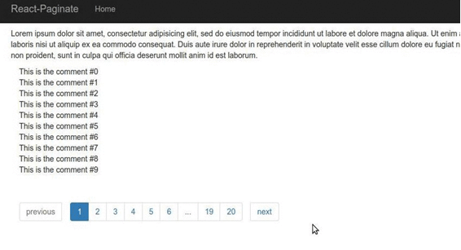

Here we implement a pagination element in React app by using the react-paginate.

**Let's start**

**Add and install react-paginate on a dependency in the app.**

1. $ npm install react-page --save

### **State Definition**

currentPage is index of the page selected by user, you may want to set it to 0, ie. the first page.

Data contains all data elements. It is empty and we fill it after we get the data.

1. **const** [CurrentPage, setCurrentPage] = useState(0);
2. **const** [data, setData] = useState([]);
3. Getting the data
4. useEffect(() => {
5. get information();
6. }, []); function fetchdata() {
7. search("https://ihsavru.me/Demo/uploads.json")
8. .then((res) => res.json())
9. .then((data) => {
10. constant {
11. course: {loads}
12. } = data;
13. setData(loads);
14. });
15. }

Here, we create a useEffect hook by an empty dependency array that functions as the DidMount component's lifecycle method and is responsible for getting the data and updating the data state.

Calculation of data to represent the current page.

**Let's first define some constants:**

1. **const** PER_PAGE = 10; **const** offset = current page * BY_PAGE; **const** current page data = data
2. .slice(offset, offset + BY_PAGE)
3. .map(({ thumburl }) => <img src={thumburl} />);**const** pageCount = Math.ceil(data.length / PER_PAGE);

The PER_PAGE constant contains the number of items to display on each page, and an offset is the number of items that is already been displayed on previous pages.

If the current page is two (**or the third page indexing starts by 0**), then the offset becomes 20. It means that the first 20 elements have been rendered, and we will start rendering the next elements after 20 (the first page yielded the first ten items, 2nd the page yielded the next 10). The third page will render items 20 to 20 + BY_PAGE, 30.

This offset is used to set the current page elements, ie the current page data, which is mapped to an array of images using the split data.

**let's render the component:**

1. **return** (
2. <div className="Application">
3. <h1>React pagination example</h1>
4. <ReactPaginate
5. previousLabel={"? Previous"}
6. nextLabel={"Next ?"}
7. pageCount={pageCount}
8. onPageChange={handlePageClick}
9. containerClassName={"paging"}
10. previouslinkClassName={"paging__link"}
11. nextLinkClassName={"paging__link"}
12. disabledClassName={"paging__link--disabled"}
13. activeClassName={"paging__link--active"}
14. />
15. {current page data}
16. </div>
17. );

You can refer to this to see the different types of props passed to ReactPaginate.

When a new page is clicked here, a handlePageClick event handler function sets the current page.

1. function handlePageClick ({selected: selectedpage}) {
2. setCurrentPage(selectedpage);
3. }

### **Styling the pagination element:**



It would be best to classify props like nextLinkClassName, previousLinkClassName, disabledClassName, and activeClassName to add classes of the pagination links for custom styling of the page.

# **What is the useState in React?**

**useState() hook** in React is a hook that allows us to state variables in our functional components.

React has two types of components. The first one is class components which are ES6 classes that extend from the React, and the second one is functional components. Class-to-components will have state and lifecycle methods: the message class extends React. useState Hook is a special function which takes the initial state as the arguments and returns it as an input array.

**Syntax:** The first element is the initial state, and the second one is a function used to update the state.

1. **const** [state, setState] = useState(initialState)

We pass a function as an argument if the initial state is computed. And the return value of the function is used as the initial state.

Play Video[](https://campaign.adpushup.com/get-started/?utm_source=banner&utm_campaign=growth_hack)

1. **const** [sum, setsum] = useState(function generateRandomInteger(){5=8+7);})

The above function is the line function which calculates the sum of numbers and it set as the initial state of it.

**To use useState, we need to import useState from the react as given below:**

1. **import** React, { useState } from "react"

useState() is a built-in function which comes by the React library.

1. **import** { useState } from "react";

useState() is only used inside a functional component.

1. Application constant = () => {
2. **const** [counter, setCounter] = useState(0);
3. // ... JSX elements
4. };

**useState()** cannot work on class component.

useState() returns a tuple. The parameter of the array is the current state of value. The second parameter is the function that allows updating the value of the state.

1. setCounter(counter + 1); // Incrementing the state value by 1

### **React useState() example**

1. Application constant = () => {
2. **const** [counter, setCounter] = React.useState(0);
3. **const** handleClick = () => setCounter(counter + 1);
4. **return** (
5. <>
6. <h1>Counter: {counter}</h1>
7. <button onClick={handleClick}>Increase</button>
8. </>
9. );
10. };

### **Creating the React app:**

**Step 1**: Create a React app by using the command below:

1. npx create-react-app (folder name)

**Step 2** After creating the project, i.e., folder name, access it by the command or syntax below:

1. cd folder name

The implementation of the use State () function

**Application.js:**

1. **import** React, { useState } of "react";
2. function app (props) {
3. **const** [count, setRandomCount] =
4. useState(function generate RandomInteger() { **return** Math.floor(Math.random() * 200);
5. });
6. function clickHandler(e) {
7. setRandomCount(Math.floor(Math.random() * 200));
8. }
9. **return** (
10. <div style={{margin: 'auto', width: 100, screen: 'lock'}}>
11. <h1> {account} </h1>
13. <p>
14. <button onClick={clickHandler}> Click </button>
15. </p>
17. </div>
18. );
19. };
21. export **default** App;

**Step to run the application**: Run the application by using the command from the root directory of the project:

1. npm start

A random number initializes the first count variable to use a random function and setRandomCount to update the count state.

Whenever we click the onClick button, it calls the click Handler function, which resets the count variable by a random number.

React's UseState Hook allows tracking the state in a function component.

State refers to data that needs to be tracked in the application.

1. **import** useState

We first import it into our component to use useState Hook.

1. **import** { useState } from "react";

### **Initialize useState**

We initialize our state by calling the use State on the function component.

useState accepts the initial state and returns the two values which are given below:

* The current status of useCase.
* And a function that updates the state.

### **Example 1:**

Initialize the state at the top of the function component.

1. **import** { useState } from "react";
2. function Favorite Color() {
3. **const** [color, setColor] = useState("");
4. };

Notice that we are destructuring the return values of useState.

* The 1st value is color, which is the current state.
* The second value is the setColor, which is used to update the useState.
* These names of variables can have the name we like.
* We set a initial state to the empty string: useState(").

Now we can include state anywhere in the component.

### **Example 2:**

Use the state variable in rendered component.

1. **import** { useState } from "react";
2. **import** ReactDOM from "react-dom/client";
3. function Favorite Color() {
4. **const** [color, setColor] = useState("red");
5. back <h1>My favourite color is {color}!</h1>
6. }
7. **const** root = ReactDOM.createRoot(document.getElementById('root'));
8. root.render(<FavoriteColor />
9. );

**Output:**

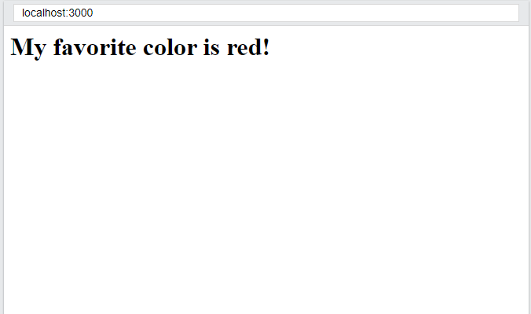

### **Update Status**

We use our updated status feature to update status.

We can never directly update the state. E.g., color = "red" is not allowed here.

### **Example 3:**

1. Use a button to update the state:
2. **import** { useState } from "react";
3. **import** ReactDOM from "react-dom/client";
4. function Favorite Color() {
5. **const** [color, setColor] = useState("red");
6. **return** (
7. <>
8. <h1>My favorite color is {color}!</h1>
9. <button
10. type = "button"
11. onClick={() => setColor("blue")}
12. >Blue</button>
13. </>
14. )
15. }
16. **const** root = ReactDOM.createRoot(document.getElementById('root'));
17. root.render(<Favorite Color />);

**Output:**

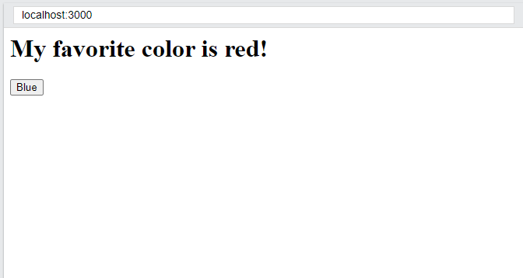

After clicking on the blue button, it turns blue like the below:

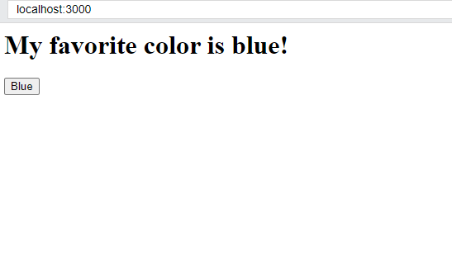

### **What Can State Hold?**

UseState Hook is used to keep track of Strings, Like **Numbers, Booleans, Arrays, Object**s, and other combinations of these.

We create multi-state Hooks to track individual values.

### **Example 4:**

1. Create multi-state hooks:
2. **import** { useState } from "react";
3. **import** ReactDOM from "react-dom/client";
4. function Car() {
5. **const** [brand, setBrand] = useState("Ford");
6. **const** [model, setModel] = useState("Mustang");
7. **const** [year, setYear] = useState("1964");
8. **const** [color, setColor] = useState("red");
9. **return** (
10. <>
11. <h1>My {brand</h1>
12. <p>
13. It is a {color} {model} of {year}.
14. </p>
15. </>
16. )
17. }
18. **const** root = ReactDOM.createRoot(document.getElementById('root'));
19. root.render(<Car />);

**Output:**

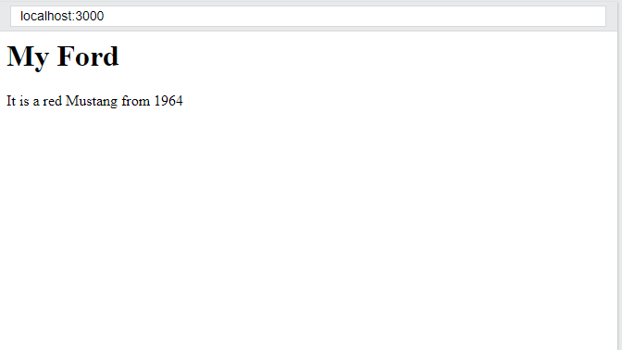

You can use a state and include an object instead!

### **Example 5:**

Create a single Hook that will holds an object:

1. **import** { useState } from "react";
2. **import** ReactDOM from "react-dom/client";
4. function Car() {
5. **const** [car, setCar] = useStatus({
6. Brand: "Ford",
7. model: Mustang,
8. year: "1964",
9. Red color"
10. });
12. **return** (
13. <>
14. <h1>My {car.brand</h1>
15. <p>
16. It is a {car.color} {car.model} of {car.year}.
17. </p>
18. </>
19. )
20. }
21. **const** root = ReactDOM.createRoot(document.getElementById('root'));
22. root.render(<Car />);

**Output:**

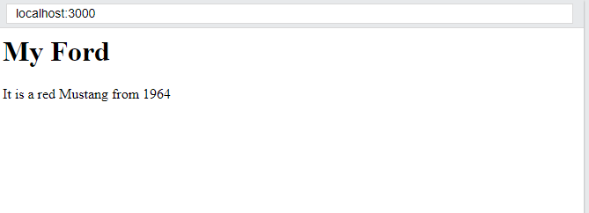

Since we are tracking a single object, we need to reference the object and the object's property rendering the component. When the state is updated, then the entire state is overwritten.

### **What if we update the color of the car?**

If we called setCar({color: "blue"}),

it removes the model and year from the state.

We use the JavaScript spread operator for this.

### **Example 6:**

Here, we are using the JavaScript spread operator to update the color of the car:

1. **import** { useState } from "react";
2. **import** ReactDOM from "react-dom/client";
4. function Car() {
5. **const** [car, setCar] = useStat
6. U.S({
7. Brand: "Ford",
8. model: mustang,
9. year: "1964",
10. Red color"
11. });
13. **const** updateColor = () => {
14. setCar(prevState => {
15. **return** {...previous state, color: "blue"}
16. });
17. }
18. **return** (
19. <>
20. <h1>My {car.brand</h1>
21. <p>
22. It is a {car.color} {car.model} of {car.year}.
23. </p>
24. <button
25. type = "button"
26. onClick={updateColor}
27. >Blue</button>
28. </>
29. )
30. }
31. **const** root = ReactDOM.createRoot(document.getElementById('root'));
32. root.render(<Car />);

**Output:**

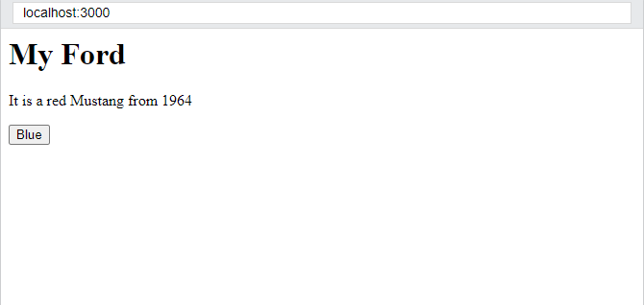

Here, we need the current value of the state, where we pass a function to the setCar function. The function receives the previous value.

We return an object, extending the state and overwriting only the car's color.

React provides many hooks that allow to addition functionality of the components. These hooks are JavaScript functions that can import from the React package. However, hooks are available for function-based components, so they cannot be used inside a class component.

### **What is useState, and when do we use it?**

React provides many hooks that we can use in our application. useState and useEffect are the two important hooks that we use a lot.

**UseState** is a function that takes only one argument at a time, the initial state, and it returns two values: the current state and a state case.

If we print the useState() function in the React dev tools (console.log(useState)), we notice that it returns an array containing the argument that you have put in the useState function.

UseState Hook is used when you want to change the text after clicking a button, like creating a counter.

### **Simple examples of useState**

You first must import it from the React package to use the useState Hooks.

**Here is an example:**

1. **import** React, {useState} of 'react'

Now, you can start using the Hook in the code without any problem. See the following example:

1. **import** React, { useState } from 'react'
2. function component () {
3. **const** [name, setName] = useState('Mehdi')
4. }

Note that we are using here the unstructured ES6 array in the component. So, the variable's name inside the array refers to the argument of the function useState.

On the other hand, the setName variable refers to the function you add to update the state. We have a state name and call the setName() function.

Let's use it by the return statement:

1. **import** React, { useState } from 'react'
2. function component () {
4. **const** [name, setName] = useState('Brad')
5. **return** <h1> My name is {name} </h1>
6. }
7. //Returns: My name is Brad

Since function components do not have a setState() function, you must use the setName() function to update it. It is how he changes the name from "Brad" to "John":

1. **import** React, { useState } from 'react'
2. function component () {
3. **const** [name, setName] = useState('Brad')
4. **if**(name === "Brad"){
5. setName("John")
6. }
7. **return** <h1> My name is {name} </h1>
8. }
9. //Returns: My name is John

### **Multiple-use state**

You can call useState Hook as much as you need when you have many states.

**Example:**

1. **import** React, {useState} of 'react'
2. function component () {
3. **const** [name, setName] = useState('Alex')
4. **const** [age, setAge] = usageStatus(15)
5. **const** [friends, setFriends] = useStatus(["Brad", "Mehdi"])
6. **return** <h1> My name is {name} and I am {age} </h1>
7. //My name is Alex and I am 15 years old
8. }

The hook receives all javaScript **boolean, data types, such as string, number array, and object.**

1. useState() concept
2. **const** [counter, setCounter] = React.useState(0);

Here we will cover the basics of **React.useState()**.

### **What is UseState Hook?**

In React, functional components are stateless as we cannot manage their state. If we write a component when we need to add some state to it, you can use useState Hook with React **16.8**.

useState allows to add of the React state of the running components.



1. **const** [count, setCount] = useStatus()

* count: It is used as the current state
* setCount: It is a function that updates the state

It's similar to **this.state.count** and **this.setState** in a class, except we see them in a pair.

The useState() Hook is the initial state of Hook. The state does not have to be an object.

1. **const** [count, countSet] = useStatus(0)

Below is the code snippet for a counter that uses a class component.

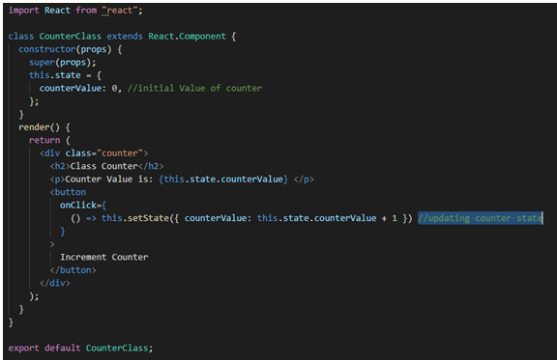

We want to implement a similar counter into the functional component.

### **Import the useState Hook from the React App**

Declare a new state variable by calling the useState Hook. Returns a value pair, counterValue, with the number of clicks and setCounter, that updates the counter value.

Initialize counterValue to zero by passing zero as the useState argument.

When the user clicks on setCounter with a new value, react will re-render the component and pass in the new value of the counterValue.

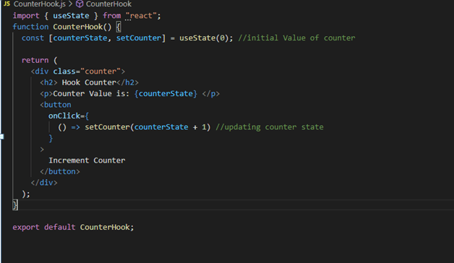

### **Conclusion**

The useState Hook is one of the necessary and useful hooks we should know about. Also, it allows function components to do their internal state and features.

# **React Time-Picker**

Time picker allows users to select any one time.

Time Picker allows the users to select a single time (in an hour or a minute format). The filled circle is indicating the selected time at the end of the clock.

**Time picker for the React application.**

* It supports any language virtually.
* Just install **npm** to execute the **add react-time-picker**or **yarn add react-time-picker operator.**
* Then, Import it by adding the TimePicker from 'react-time-picker'.
* We can use it by adding <Time Picker />

#### **Note: React-time-picker will use better with react-date-picker or react-date time-picker.**

### **Getting Started**

The project uses the React 16.3 or later version. If we use an older version of React, then refer to the below given table to find the appropriate react-time-picker version.

Play Video[](https://campaign.adpushup.com/get-started/?utm_source=banner&utm_campaign=growth_hack)

|  |  |
| --- | --- |
| **React Version** | **Latest compatible react-time-picker version** |
| 16.3 | latest |
| 16.0 | 3. x |

### **Legacy browser**

If we want to support older browsers which are Internet Explorer 10, then we will need to use Intl.js or Intl polyfill with React-Date-Picker.

### **Installation Process:**

Firstly, Add the react-time-picker to the project by executing the **npm install react-time-picke** and **yarn add react-time-picker**.

### **Example 1:**

1. **import** react from 'react'; {useState};
2. **import** timepicker from 'react-time-picker';
3. function MyApp() {
4. **const** [value, onChange] = useState('10:00');
5. **return** (
6. <div>
7. <timepicker onchange={onchange} value={value} />
8. </div>
9. );
10. };

### **Custom Style**

We import the react time picker without importing the Time Picker from the **'react-time-picker/dist/entry.nostyle**' if we use the default react time picker then it will not work.

The styles loaded by the default input file are **React-time-picker/dist/TimePicker.css** and **React-clock/dist/Clock.css**.

You need to copy it into the project to build it.

### **User guide**

It displays the input field with the custom input, native input, and a clock.

**Property:**

|  |  |  |  |
| --- | --- | --- | --- |
| **Prop name** | **Description** | **Default value** | **Example values** |
| amPmAriaLabel | aria-label is mainly used in AM/PM selection in amPmAriaLabel. | N/A | "Select AM/PM" |
| className | Class name(s) is added with "react-time-picker" to the parent React-Time-Picker <div> element. | N/A | String: "class1 class2" Array of strings: ["class4", "class5 class6"] |
| autoFocus | autoFocus focuses at the input part. | n/a | true |
| clearAriaLabel | cleararia-label is used for the delete button. | n/a | "Clear value" |
| clockAriaLabel | aria-label is used for the clock button. | n/a | "Toggle clock" |
| clearIcon | It is the Delete button content. which will setting the value of null will hide the icon. | (default icon) | String: "Clear" React element: <ClearIcon /> |
| clockClassName | Class name is used to added with "react-clock" to the parent React-Clock <time> with the element. | n/a | String: "class1 class2" Array of strings: ["classA", "classB classc"] |
| clockIcon | It is used in Clock content button. The value to null can hide the icon. | (default icon) | String: "Clock" React element: <ClockIcon /> |
| disabled | The time selector will be disabled. | false | true |
| closeClock | It will close the watch on the value selection. | true | false |
| disableClock | When set to true, it removes the clock and button by toggling the visibility. | false | true |
| hourAriaLabel | It is the area-label for the input time. | n/a | "Hour" |
| format | It supports the Input format based on the Unicode Technical Standard. The values which are supported is: hh, m, mm, s, ss, a, H, HH, h. | n/a | "h:m:s a" |
| hourPlaceholder | The placeholder for the time entry. | "--" | "hh" |
| isOpen | Used to open the watch features. | false | true |
| locale | It is the IETF language tag. | User's browser settings | "hu-HU" |
| minuteAriaLabel | minuteAria-label is used for minutes input. | n/a | "Minute" |
| maxDetail | It can be "hour", "minute" or "second". The detailed selection will be used here. | "minute" | "second" |
| maxTime | The user can select the maximum time here. | n/a | Date: new Date() String: "23:11:00" |
| minTime | The user can select the minimum time here. | n/a | Date: new Date() String: "12:18:00" |
| nativeInputAriaLabel | nativeAria-label is a native time input. | n/a | "Time" |
| onChange | It is called where the user choosing a valid time. | n/a | (value) => alert('New time is: ', value) |
| onClockOpen | When the watch is opened, onClockOpen is used. | n/a | () => alert('Clock opened') |
| onClockClose | When the clock closes it works. | n/a | () => alert('Clock closed') |
| required | If the entry of the date is req. | false | true |
| secondAriaLabel | secondAria-label is used in the second input. | n/a | "Second" |
| openClockOnFocus | Used to open the clock in input focus. | true | false |
| secondPlaceholder | Second placeholder is mainly used in the second entry. | "--" | "ss" |
| value | It is just Input value what we used. | n/a | Date: new Date() String: "20:11:00" |

### **Clock:**

The time picker component will passes the props of react-clock, except the classname which is used in the clockClassName.

### **Types of Time Pickers**

Various types of time selectors which are dropdown, scroll, and wheel. The UI design of the time picker helps us determine the type you use in React.

**1. Dropdown**

The dropdown time picker is the easiest time pickers and generallyused to select the hour and minute at the dropdown format. It is not as inherent as other time pickers, but it is better than a traditional text box because it let us select options instead of letting the user text on own own. It helps clear the confusion at the needed format.

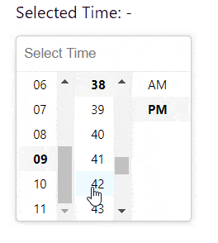

***Image courtesy of Clue Mediator***

**2. Displacement**

When we use the scroll selector as the name suggests,, the user will scrolls to select the needed date or time infor.



***Image courtesy of Hossein***

### **Wheel**

The wheel time selector simulates a real clock and makes it easier for the customer to select the exact time.

It asking about the time or intuitively changes where the numbers at the wheel immediately selects the next minutes. We can change the minute value in many ways depending at the implementation.

Some wheel time selectors display the numeric digits (as, hours or minutes) after selecting them, and have some buttons we can select. The buttons are simple arrows that allow s to toggle between the hours and minutes clock arrow.

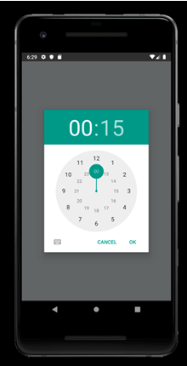

***Image courtesy of Vonovak***

## Implementation of the time picker

Now that we know that how useful time pickers is, you will learn that how to create it with the help of React. This tutorial focuses on a time picker with a Material-UI, as it is the most popular React library on the GitHub.

We have to download and install Node.js and npm in the system before we start.

### **Create the app**

We need to build your React app in the same place where we eventually build our time picker to get started. Run the below command in the CMD:

1. npx create-react-app time picker

This command generates React app with the below files:

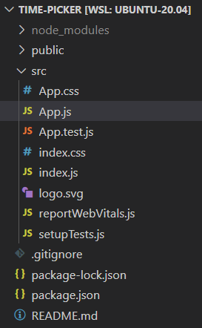

### **Installing Libraries**

We need to install two libraries before using the time picker in our Material-U: First is the Material-UI library and second is the library that will handle our dates.

Many developers use Moment.js because it is easy to use; however, the package size of date-fns is four times smaller (19.5 kB) than that of Moment.js (71.9 kB), making **date-fns** a faster option.

To install the libraries, we have to use **npm**, which is the default package for the React app.

Start to change the directory of the current project (which is installed previously) with the command **cd time-picker**.

Lastly, install the Material-UI and **date-fns** libraries here:

**cd time selector**

1. npm install @date-io/date-fns date-fns @mui/material @mui/lab @emotion/react @emotion/styled

### **Create Time Picker**

Now, we are going to build a time picker. You have many options to choose in the Material-UI library:

* **Desktop date:** It selects dates with the suitable user interface for our desktop
* **Date mobile:** It selects dates with the suitable user interface of mobile devices
* **Time:** It is a selector used mainly for time
* **Date and time:** It is the selector which has built-in date and time capabilities here.

**Now take a look at every option in action:**

1. **import** * as React from 'react';
2. **import** stack from '@mui/material/Stack';
3. **import** AdapterDateFns from '@mui/lab/AdapterDateFns';
4. **import** LocalizationProvider from '@mui/lab/LocalizationProvider';
5. **import** DateTimePicker from '@mui/lab/DateTimePicker';
6. **import** TimePicker from '@mui/lab/TimePicker';
7. **import** DesktopDatePicker from '@mui/lab/DesktopDatePicker';
8. **import** TextField from '@mui/material/TextField';
9. **import** MobileDatePicker from '@mui/lab/MobileDatePicker';

In this code, we import the required libraries. It includes React and many time pickers Like: (**DateTimePicker, DesktopDatePicker, TimePicker, and MobileDatePicker**) from the Material-UI library.

The code will include the adapter for the date-fns (AdapterDateFns) which handles dates and import format which help structure the page.

1. export **default** function App() {
2. **const** [value, setValue] = React.useState (newDate('2014-08-18T21:11:54'));
3. **const** handleChange = (newValue)
4. =>
5. {
6. setValue(newValue);
7. };

Here, we define the app component and export it by using the app's default export function. You can define it without export default and export it by using the export default apps; however, the solution is the simplest option.

We need to keep track of the date and store a new value every time it is changed after exporting the component. If you don't track the changes, the date and time will not update when you select a new time. In the above code, the useState () hook initializes the date (2014-08-18T21:11:54), and handleChange function will handle the changes.

Now we want JSX, the React extension to the JavaScript language syntax, to create a realtime selector here:

1. return (
2. **<div** style={{margin: "5% 40%"}}**>**
3. **<LocalizationProvider** dateAdapter={AdapterDateFns}**>**
4. **<**Stackspace**Stackspace**={3}**>**
5. **<DesktopDatePicker**
6. label="Desk Date"
7. inputFormat="MM/dd/yyyy"
8. value={value}
9. onChange={handleChange}
10. renderInput={(parameters) =**>** **<TextField** {...parameters} **/>**}
11. **/>**
12. **<MobileDatePicker**
13. label="Movable Date"
14. inputFormat="mm/dd/yyyy"
15. value={value}
16. onChange={handleChange}
17. renderInput={(parameters) =**>** **<TextField** {...parameters} **/>**}
18. **/>**
19. **<time** picker
20. label = "Time"
21. value={value}
22. onChange={handleChange}
23. renderInput={(parameters) =**>** **<TextField** {...parameters} **/>**}
24. **/>**
25. **<Date** and time picker
26. label="Date and time picker"
27. value={value}
28. onChange={handleChange}
29. renderInput={(parameters) =**>** **<TextField** {...parameters} **/>**}
30. **/>**
31. **</Stack>**
32. **</Location** Provider**>**
33. **</div>**
34. );
35. }

JSX provides a structural component that is rendered by using the syntax familiar to the developers. It is the same as the appearance of HTML.

Above, we also create the selectors by using the selector modules in Material-UI, with appropriate props for label, value, onChange, and inputFormat, that indicate the format where the dates are displayed.

After that, we use LocalizationProvider to combine individual modules into single-parent elements. It indicates that you are using the date-fns library to handle the dates.

Finally, we have to apply a margin so that the time pickers line up in the middle of the web page. It is done by enclosing the code in the div element and applying the margin to it by using the inline style.

Below is the code snippet that needs to be placed in src/App.js for the App component to be exported in the index.js and displayed at the screen:

1. **import** * as React from 'react';
2. **import** TextField from '@mui/material/TextField';
3. **import** stack from '@mui/material/Stack';
4. **import** AdapterDateFns from '@mui/lab/AdapterDateFns';
5. **import** TimePicker from '@mui/lab/TimePicker';
6. **import** LocalizationProvider from '@mui/lab/LocalizationProvider';
7. **import** DateTimePicker from '@mui/lab/DateTimePicker';
8. **import** MobileDatePicker from '@mui/lab/MobileDatePicker';
9. **import** DesktopDatePicker from '@mui/lab/DesktopDatePicker';
10. export **default** function App()
11. {
12. **const**[value, setValue] = React.useState(**new** Date('2014-08-18T21:11:54'));
14. **const** handleChange = (newValue) => {
15. setValue(newValue);
16. };
17. come back (
18. <div style={{margin: "5% 40%"}}>
19. <LocalizationProvider dateAdapter={AdapterDateFns}>
20. <Stack Spacing={3}>
21. <DesktopDatePicker
22. label="Office date"
23. inputFormat="MM/dd/yyyy"
24. value={value}
25. onChange={handleChange}
26. renderInput={(params) => <TextField {...params} />}
27. />
28. <MobileDatePicker
29. label="Rolling date"
30. inputFormat="MM/dd/yyyy"
31. value={value}
32. onChange={handleChange}
33. renderInput={(params) => <TextField {...params} />}
34. />
35. <TimePicker
36. label="Time"
37. value={value}
38. onChange={handleChange}
39. renderInput={(params) => <TextField {...params} />}
40. />
41. <DateTimePicker
42. label="Date and time picker"
43. value={value}
44. onChange={handleChange}
45. renderInput={(params) => <TextField {...params} />}
46. />
47. </stack>
48. </LocalizationProvider>
49. </div>
50. );
51. }

Start the application by using the **npm start** command and navigate the URL **http://localhost:3000/** on the browser.

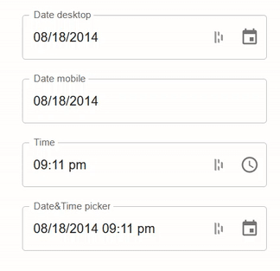

### **Style the Time Picker**

Most organizations have their brand that they want to add at time picker, so Material-UI lets you add two imports to add any theme to the page. One import lets us create and apply themes, and the other will let us add any specific color.

To start styling time picker, add the below imports at the top of the src/App.js file:

1. **import** { ThemeProvider, createTheme } from '@mui/material/styles';
2. **import** { purple } from '@mui/material/colors';

Next, we must create a theme for your component (by createTheme function). In the example, we will focus on typography and color, but we can customize the time picker as much as we want.

We need to add the following code between imports and app component in our src/App.js file to create a theme:

1. **const** theme = createTheme({
2. typography: {
3. fontSize: 12,
4. fontFamily: "Segoe, Helvetica, Arial, Sans Serif UI",
5. },
6. palette: {
7. primary: {
8. main: purple[500],
9. },
10. secondary: {
11. main: '#f44336',
12. },
13. },
14. });

The last step in the styling process is we have to apply the theme to component. For that, we need to wrap the div element with the ThemeProvider element and pass the theme:

1. **<ThemeProvider** theme={theme}**>**
2. **<div** style={{margin: "5% 40%"}}**>**
3. **<LocalizationProvider** dateAdapter={AdapterDateFns}**>**
4. **<Stack** Spacing={3}**>**
5. **<DesktopDatePicker**
6. label="Office date"
7. inputFormat="MM/dd/yyyy"
8. value={value}
9. onChange={handleChange}
10. renderInput={(params) =**>** **<TextField** {...params} **/>**}
11. **/>**
12. **<MobileDatePicker**
13. label="Rolling date"
14. inputFormat="MM/dd/yyyy"
15. value={value}
16. onChange={handleChange}
17. renderInput={(params) =**>** **<TextField** {...params} **/>**}
18. **/>**
19. **<TimePicker**
20. label="Time"
21. value={value}
22. onChange={handleChange}
23. renderInput={(params) =**>** **<TextField** {...params} **/>**}
24. **/>**
25. **<DateTimePicker**
26. label="Date and time picker"
27. value={value}
28. onChange={handleChange}
29. renderInput={(params) =**>** **<TextField** {...params} **/>**}
30. **/>**
31. **</stack>**
32. **</LocalizationProvider>**
33. **</div>**
34. **</ThemeProvider>**

The code applies the theme with the parameters we choose in the createTheme() function to the website.

## Basic Usage of Time-picker

The time picker is rendered as a modal dialog in the mobile, and a textbox is also used with the popup on the desktop.

1. **import** * as React from 'react';
2. **import** TextField from '@mui/material/TextField';
3. **import** { LocalizationProvider } from '@mui/x-date-pickers/LocalizationProvider';
4. **import** {AdapterDateFns} from '@mui/x-date-pickers/AdapterDateFns';
5. **import** { TimePicker } from '@mui/x-date-pickers/TimePicker';
6. **default** export function BasicTimePicker() {
7. **const** [value, setValue] = React.useState(**null**);
8. **return** (
9. <LocalizationProvider dateAdapter={AdapterDateFns}>
10. <time picker
11. label="Basic example"
12. value={value}
13. onChange={(newValue) => {
14. setValue(newValue);
15. };
16. }
17. renderInput={(parameters) => <TextField {...parameters} />}
18. />
19. </Location Provider>
20. );
21. }

**Output:**

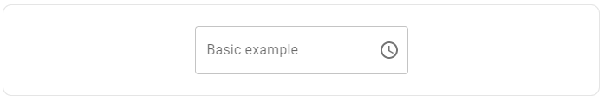

When we click here and put the time with AM/PM then, it will come like this:

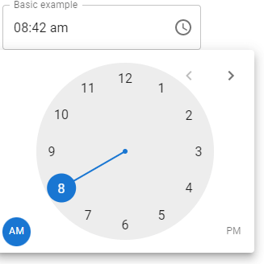

### **Static mode**

It's possible to read any time picker inline. It will enable building custom popover/modal containers.

1. **import** * as React from 'react';
2. **import** TextField from '@mui/material/TextField';
3. **import** { AdapterDateFns } from '@mui/x-date-pickers/AdapterDateFns';
4. **import** { LocalizationProvider } from '@mui/x-date-pickers/LocalizationProvider';
5. **import** { StaticTimePicker } from '@mui/x-date-pickers/StaticTimePicker';
7. export **default** function StaticTimePickerDemo() {
8. **const** [value, setValue] = React.useState(**new** Date());
10. **return** (
11. <LocalizationProvider dateAdapter={AdapterDateFns}>
12. <StaticTimePicker
13. displayStaticWrapperAs="mobile"
14. value={value}
15. onChange={(newValue) => {
16. setValue(newValue);
17. }}
18. renderInput={(params) => <TextField {...params} />}
19. />
20. </LocalizationProvider>
21. );
22. }

**Output:**

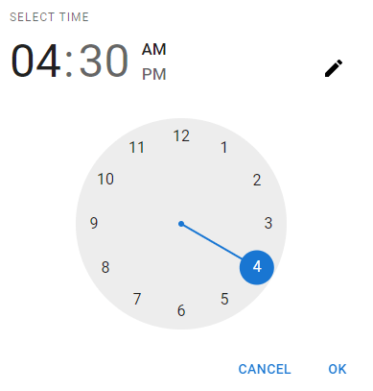

### **Responsiveness**

The time picker component is increased by the device which will runs.

* The MobileTimePicker component works for small screens and touch devices.
* The DesktopTimePicker component works for big and large devices and mouse devices like, Laptop and Pcs.
* By default, The timePicker component will read the desktop version if the @media(pointer:good) query matches the timepicker. It can be customized with the desktopModeMediaQuery properties.

1. **import** * as React from 'react';
2. **import** TextField from '@mui/material/TextField';
3. **import** { AdapterDateFns } from '@mui/x-date-pickers/AdapterDateFns';
4. **import** Stack from '@mui/material/Stack';
5. **import** { LocalizationProvider } from '@mui/x-date-pickers/LocalizationProvider';
6. **import** { TimePicker } from '@mui/x-date-pickers/TimePicker';
7. **import** { MobileTimePicker } from '@mui/x-date-pickers/MobileTimePicker';
8. **import** { DesktopTimePicker } from '@mui/x-date-pickers/DesktopTimePicker';
9. export **default** function ResponsiveTimePickers()
10. {
11. **const** [value, setValue] = React.useState(newDate('2018-01-01T00:00:00.000Z'));
12. **return** (
13. <LocalizationProvider dateAdapter={AdapterDateFns}>
14. <Stackspace={3}>
15. <MobileTimePicker
16. label="For mobile"
17. value={value}
18. onChange={(newValue) => {
19. setValue(newValue);
20. }
21. }
22. renderInput={(params) => <TextField {...params} />}
23. />
24. <DesktopTimePicker
25. label="For desktop"
26. value={value}
27. onChange={(newValue) => {
28. setValue(newValue);
29. }
30. }
31. renderInput={(params) => <TextField {...params} />}
32. />
33. <TimePicker
34. value={value}
35. onChange={setValue}
36. renderInput={(params) => <TextField {...params} />}
37. />
38. </Stack>
39. </LocalizationProvider>
40. );
41. }

**Output:**

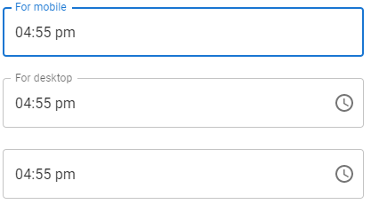

When we click for mobile apps:

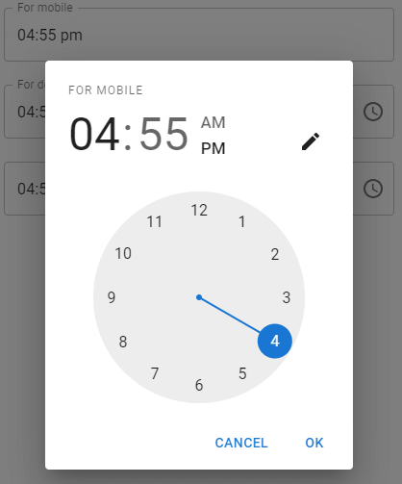

When we click for desktop:

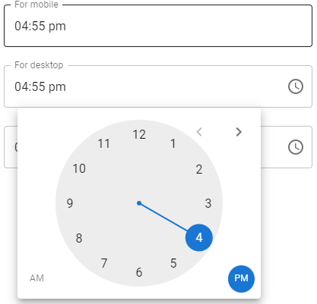

### **Form props**

The time picker will disable or read-only.

1. **import** * as React from 'react';
2. **import** TextField from '@mui/material/TextField';
3. **import** stack from '@mui/material/Stack';
4. **import** {AdapterDateFns} from '@mui/x-date-pickers/AdapterDateFns';
5. **import** { LocalizationProvider } from '@mui/x-date-pickers/LocalizationProvider';
6. **import** { TimePicker } from '@mui/x-date-pickers/TimePicker';
7. **default** export function FormPropsTimePickers() {
8. **const** [value, setValue] = React.useState(**null**);
9. **return** (
10. <LocalizationProvider dateAdapter={AdapterDateFns}>
11. <Stackspace={3}>
12. <time picker
13. tag="disabled"
14. disabled
15. value={value}
16. onChange={(newValue) => {
17. setValue(newValue);
18. }
19. }
20. renderInput={(parameters) => <TextField {...parameters} />}
21. />
22. <time picker
23. label="read-only"
24. read only
25. value={value}
26. onChange={(newValue) => {
27. setValue(newValue);
28. }
29. }
30. renderInput={(parameters) => <TextField {...parameters} />}
31. />
32. </Stack>
33. </LocalizationProvider>
34. );
35. }

**Output:**

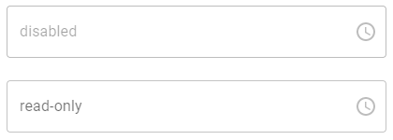

### **Time validation**

1. **import** * as React from 'react';
2. **import** TextField from '@mui/material/TextField';
3. **import** Stack from '@mui/material/Stack';
4. **import** { AdapterDateFns } from '@mui/x-date-pickers/AdapterDateFns';
5. **import** { LocalizationProvider } from '@mui/x-date-pickers/LocalizationProvider';
6. **import** { TimePicker } from '@mui/x-date-pickers/TimePicker';
8. export **default** function TimeValidationTimePicker() {
9. **const** [value, setValue] = React.useState(**new** Date('2020-01-01 12:00'));
11. **return** (
12. <LocalizationProvider dateAdapter={AdapterDateFns}>
13. <Stack spacing={3}>
14. <TimePicker
15. renderInput={(parameters) => <TextField {...parameters} />}
16. value={value}
17. label="miximum/minimum time"
18. onChange={(newValue) => {
19. setValue(newValue);
20. }}
21. minTime={**new** date (0, 0, 0, 8)}
22. maxTime={**new** date (0, 0, 0, 18, 45)}
23. />
24. <time picker
25. renderInput={(parameters) => <TextField {...parameters} />}
26. label="Disable odd hours"
27. value={value}
28. onChange={(newValue) => {
29. setValue(newValue);
30. }
31. }
32. shouldDisableTime={(timeValue, clockType) => {
33. **if** (clockType === 'hours' && timeValue % 2) {
34. **return** **true**;
35. }
36. **return** **false**;
37. }
38. }
39. />
40. </Stack>
41. </LocalizationProvider>
42. );
43. }

**Output:**

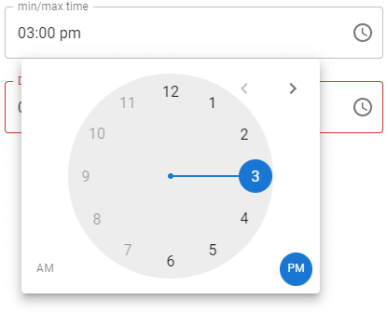  
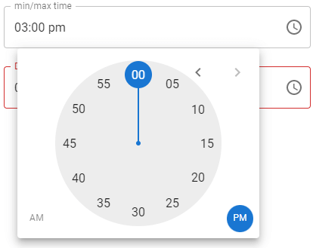

### **Landscape**

1. **import** * as React from 'react';
2. **import** TextField from '@mui/material/TextField';
3. **import** {AdapterDateFns} from '@mui/x-date-pickers/AdapterDateFns';
4. **import** { LocalizationProvider } from '@mui/x-date-pickers/LocalizationProvider';
5. **import** { StaticTimePicker } from '@mui/x-date-pickers/StaticTimePicker';
6. **default** export function StaticTimePickerLandscape() {
7. **const** [value, setValue] = React.useState(newDate());
8. **return** (
9. <LocalizationProvider dateAdapter={AdapterDateFns}>
10. <Static time picker AM PM
11. orientation="landscape"
12. openTo="minutes"
13. value={value}
14. onChange={(newValue) => {
15. setValue(newValue);
16. }
17. }
18. renderInput={(parameters) => <TextField {...parameters} />}
19. />
20. </Location Provider>
21. );
22. }

**Output:**

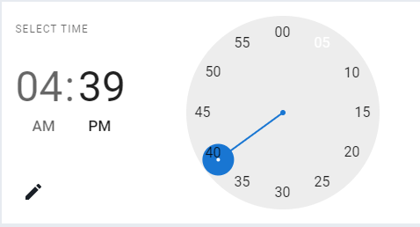

### **Sub-components**

Some lower-level sub-components (ClockPicker) are exported. It is being read without any wrapper and outer logic that are **masked input, date values parsing** and **validation**, etc.

1. **import** * as React from 'react';
2. **import** {AdapterDateFns} from '@mui/x-date-pickers/AdapterDateFns';
3. **import** { LocalizationProvider } from '@mui/x-date-pickers/LocalizationProvider';
4. **import** { ClockPicker } from '@mui/x-date-pickers/ClockPicker';
5. **default** export function SubComponentsTimePickers() {
6. **const** [date, setDate] = React.useState(newDate());
7. **return** (
8. <LocalizationProvider dateAdapter={AdapterDateFns}>
9. <ClockPicker date={date} onChange={(newDate) => setDate(newDate)} />
10. </Location Provider>
11. );
12. }

**Output:**

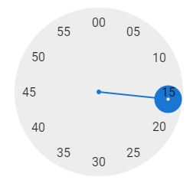  
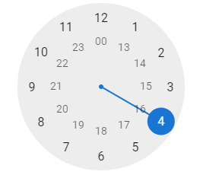

### **Second:**

The input second is used as a selection of the accurate time point.

1. **import** * as React from 'react';
2. **import** {AdapterDateFns} from '@mui/x-date-pickers/AdapterDateFns';
3. **import** TextField from '@mui/material/TextField';
4. **import** { LocalizationProvider } from '@mui/x-date-pickers/LocalizationProvider';
5. **import** stack from '@mui/material/Stack';
6. **import** { TimePicker } from '@mui/x-date-pickers/TimePicker';
7. **default** export function SecondsTimePicker() {
8. **const** [value, setValue] = React.useState(newDate());
9. **return** (
10. <LocalizationProvider dateAdapter={AdapterDateFns}>
11. <Stackspace={3}>
12. <time picker
13. ampm={**false**}
14. openTo="hours"
15. views = {['hours', 'minutes', 'seconds']}
16. input format="HH:mm:ss"
17. mask="__:__:__"
18. label="With seconds"
19. value={value}
20. onChange={(newValue) => {
21. setValue(newValue);
22. }
23. }
24. renderInput={(parameters) => <TextField {...parameters} />}
25. />
26. <time picker
27. ampmInClock
28. views={['minutes', 'seconds']}
29. input format="mm:ss"
30. mask="__:__"
31. label="Minutes and seconds"
32. value={value}
33. onChange={(newValue) => {
34. setValue(newValue);
35. }
36. }
37. renderInput={(parameters) => <TextField {...parameters} />}
38. />
39. </Stack>
40. </Location Provider>
41. );
42. }

**Output:**

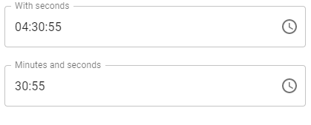

When we need with the second:

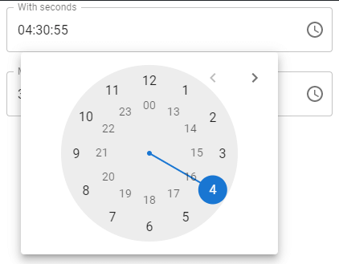

When we want the minutes and second both:

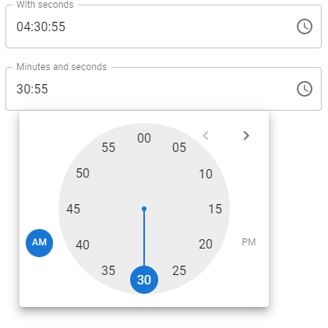

# **React.js Vs. Node.js**

Node.js and React.js are both JavaScript technologies, but they are different things. The primary difference between Node.js and React.js is that Node.js is a back-end framework, and React is used to develop user interfaces. But, they both have advantages and disadvantages with special use cases.

Read if you want to know which one we have to use for our next JavaScript project. Below we see the features of Node.js and React.js and the pros and cons of both Node and React. We can decide which will suits our project best and according to the need after reading this article.

**Let's start.**



### **What is Node.js?**

Node.js is a multiplayer cross-platform runtime environment and an open-source platform that can be used to execute the JavaScript driver code of the browser.

Play Video

Most people are respected and understand that it is a brand or a programming language. Almost person Node.js for creating back-end services like API, web applications, or mobile applications.

Node.js is a technology that can be used to build a back-end, which is used to use JavaScript.

Google Chrome's **V8** JavaScript engine powers Node.js.

Node.js is an efficient and light-weighted technology because it is used as an event-driven and non-blocking I/O model. Developers use this framework for hosting the APIs, which serve the HTTP requests and access the database equally.

**Code:** Below is an example which includes the **HTTP module** to building the servers.

**File name: App.js**

**JavaScript**

1. var HTTP = requires('http');
3. // it creates the server object:
4. http.createServer(function (req, res)
5. {
7. // it will write the response to the client
8. res.write('JavaTpoint');
10. // End the response
11. res.end();
13. // The server object listens at port 8080
14. }).listen(8080);

**Output:** Go to terminal and write the command to compile the nodejs file:

**node folder_name.js**

Now, open the localhost:8080 in the browser for output.

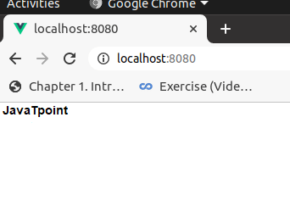

### **Who uses Node.js?**

Node.js is used by famous clients and companies like **Netflix, Trello,** and **Uber.** Below, we explain why Node.js has become their framework of choice.

The online video streaming leader, **Netflix,** conducts **A/B testing** to provide **93 million< users** with a rich experience.

The platform faces some issues with application stability and conditional dependencies. The company chose Node.js for its speed and lightness in solving these problems. In this way, Netflix reduced the start-up time by 70% more.



Trello is an application of project management and uses server-side Node.js. The Trello team has found the Node good and useful for system updates that require many connections.

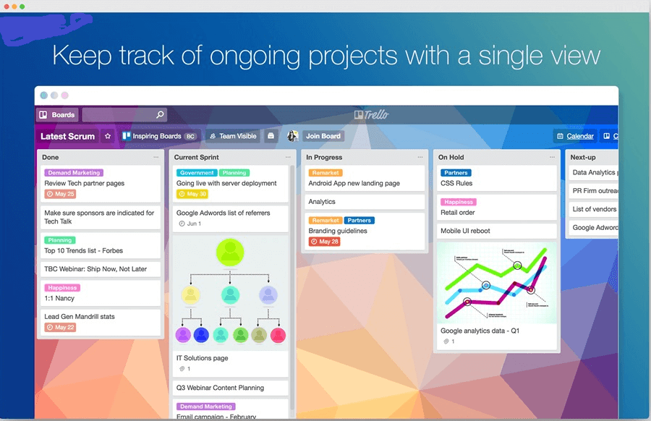

**Uber** is a two-way carpooling service and said Node.js is the most crucial technological solution. The framework enables up scaling in line with the growing service demand.



### **Node JS Key Features**

**Now let's find out the main Node.js features.**

* **Open-source.** Node.js is a completely free and open-source framework.
* **Improved performance.** Here, developers perform non-blocking operations that improve the web app's performance.
* **Server development.** Node.js has built-in APIs. It allows developers to create servers like DNS servers, TCP servers, HTTP servers, and many more.
* **Unit test.** Node.js has a device testing called Jasmine, which allows you to test clear code quickly.
* **Scalability.** The apps built by Node.js are scaled vertically and horizontally to improve their performance.

### **What Is React.js?**

React.js is an open-source Javascript library used to develop user interfaces for websites and web apps in a structured way. React.js allows the development of a **dynamic, high-performance** library.

For example, the technology displays news feeds while people chat. The alternatives to React js is Angular and Vue.js.

It is efficient, declarative, and flexible and allows the creation of reusable UI components. It is mainly used in hard, interactive one-page web projects and responsive sites which are difficult to reuse.

The virtual DOM algorithm from React is a time-consuming and inaccurate write code. A React application consists of components, each responsible for reproducing the small and reusable piece of HTML.

Components are embedded in the components, allowing complex applications to be built of simple building blocks.

Create a react project and edit the **App.js** file in the src folder like below:

**FilePath:- src/App.js:**

**Javascript**

1. **import** React, { Component } from 'react';
2. **class** App **extends** Component {
3. render() {
4. **return** (
5. <div className="App">
6. <>
7. <h1>JavaTpoint</h1>
8. </>
9. </div>
10. );
11. }
12. }
13. export **default** App;

**Output**

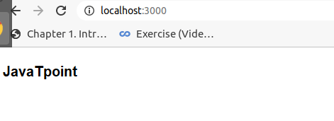

### **Who uses React.js?**

Facebook itself develops the react.js framework. React.js is used for content-based websites like **"The New York Times"** to apps like **Twitter.** Now let's check the apps that use this directory.

Facebook is heavily dependent on user interaction with the website elements. Almost all the dynamic elements of any Facebook web app are built with React.js.



Instagram is a good example of successful React use. The app will use React for Google Maps geolocation, APIs, and other features.



Netflix uses React.js for its Gibbon platform. The platform uses **low-performance TVs** instead of **DOMs** used in web browsers.

The React.js library is used for doing the Netflix team to improve the **runtime performance, modularity,** and **speed** of the site.



React.js was handy for adding a dynamic online multicurrency calculator to a two-way marketplace.



### **React.js main features**

* **Easy Maintenance.** This library reuses the system components and resolves the issues with the updates.
* **Performance.** React uses the Virtual DOM (Document Object Model) that improves the performance of applications.
* **Stable code.** React guarantees the code stability and best performance of apps using the downward data flow.
* **Developer Toolkit.** React js provides the developers with troubleshooting and designing the tools, which ensures high performance.
* **Mobile App Development.** You can build a rich user interface for native apps supported by iOS and Android platforms by following the same design patterns.

Now compare **React** and **Node.js.**

### **Comparison between both the Node js and React js.**

Both React.js and Node.js are different technologies which will be used to develop different parts of any web app.

Below, we compare React with Node js and the advantages and disadvantages.

|  |  |  |
| --- | --- | --- |
|  | **Node.js** | **React.js** |
| **It is Developed by** | Ryan Dahl Developed node js | Jordan Walke, an employee of Facebook |
| **Type** | It is an open-source framework for writing codes and generating dynamic web pages. | ReactJS is open-source and a client-side library used for delivering high-performance dynamic applications. |
| **Latest version** | 12.9.0 / 20 August 2019; | 16.8.6 / 6 May 2019 |
| **Advantage** | It is very stretchable It and Used for web development. It is used for caching individual modules. Apps could be scaled horizontally or vertically both. We can convert the JavaScript code into Machine code by **Google's V8** JavaScript engine. | It is an easy UI test case. It supports both Android and iOS as well. It provides server-side and front-end support. Code components would be reused. It is faster for debugging. It has a faster virtual DOM. |
| **Disadvantages** | It follows asynchronous programming in place of linear and blocking I/O **(input/output)** programming. The absence of a rich library. | It is complex to learn JSX and JavaScript. Keeping up with the regular release of newer tools and technology is difficult for developers. |
| **Use cases** | **Data streaming.** It handles data streaming in real time. It is used to stream media, data from so many sources, uploading the files, and it is excellent for the **Websockets server; API server.** Node.js will handle many connections at a time. Therefore, it is suitable for API service.**Microservices.** Node.js is fast and easy. Thus, it is used to write microservices, such as an API gateway. | **Dynamic apps.** It is perfect for projects with so many components, Like, such as changing mode frequently, the user logs in and accessing the permissions. **Complex architecture.** We choose React.js for building websites with a complex structure which is not easy to keep track of the traditional approach. As the application scales, React allows keeping track of every interaction. |
| **Popularity in the developer community** | 63,976 stars on the Github site. | Here, 135,401 stars are on the Github site. |
| **Developer price per hour** | It is based on the Upwork information. The hourly rate for Node.js may vary: Basic back-end: $ 15-50 + Full Stack Developer: $ 30-150 + | According to Upwork, hourly rates will vary as follows: Front-End: basic $ 15- $ 50, between $ 35- $ 100; Back-End: Basic $ 15- $ 50, Advanced $ 35- $ 100; Full-Stack Developer: $ 30 - $ 150. |

### **The difference between Node.js and React.js are below:**



|  |  |  |
| --- | --- | --- |
| **Difference point** | **Node.Js** | **React.Js** |
| **Frame** | It's a back-end frame. | It is mainly used to develop user interfaces |
| **Model View Framework Support** | It is used to support the Model-View Framework | It does not support Model-View Framework. |
| **Development process** | It uses an event-driven, non-blocking I / O paradigm developed in C ++ and works at Chrome's v8 engine. | It compiles or optimizes the JavaScript code using Node.js, and it's easy to develop UI test cases. |
| **Features** | Node.js handles the browser requests and authentication of database calls. | It makes API calls and also handles data. |
| **Data tracking** | Real-time data streaming is handled here. | Its sophisticated design makes the old technology difficult to keep track of in React. |
| **Library** | The most comprehensive ecosystem of open source libraries for JavaScript execution. | Facebook supports Open Source JS library. |
| **Programming languages used** | Only JavaScript is used as a programming language. | JSX and JavaScript are the languages used in React js. |
| **Document object model concept** | There is no use of the Document Object Model (DOM) here in Node js. | Virtual Document Object Model using here to make the working faster. |
| **Adaptability of users** | Node.js is very simple to understand. | React.js is so tough to learn. |
| **Scalability** | Highly scalable. | Scalability is a challenge. |
| **Architecture** | The architecture is quite simple. | React.js has a complex architecture. |
| **Microservices** | Since it's easy - it's easy to write microservices. | It's hard to write microservices in React.Js |
| **Dynamics** | It can handle single operations efficiently. | The large USP for React.js handles dynamic events. |
| **Support** | The code is written in Java and easily converted into machine code. | Both iOS and Android support it. |
| **Caching** | It caches the individual modules for efficient driving time. | Here, the code reusability and DOM are focused. |

### **Which is the better option (Node js Vs React js)?**

Both Node.js vs React.js is modern technologies used by many successful companies.

But what do you choose for our suggested application? Let us give you a clue.

If you want to create a scalable yet sophisticated server-side web application as an online streaming platform, then you can choose **Node JS.**

React.js is better for creating the project with changing modes such as dynamic inputs, buttons and many other options.

We can use both technologies for our web apps at the same time. You can create the web app's front end with the help of React and make the back end with the Node js, as Netflix did.

### **Conclusion:**

When we create a server-side web application, like an online streaming platform, then Node.js will be an excellent framework.

When you want to do a project with dynamic inputs and buttons, React.js is a better option.

You can use both frameworks for a single project as well. The Node.js framework can be used to create the backend, while React.js will be used to create the front-end part.

Netflix is an example of framework integration. Both frameworks have a significant and committed community. We hope that this article can clarify the differences between Node.js and React.js.

### **Frequently Asked Questions (FAQs)**

**Which is better: Node.js or React.js?**

**As above discussed:**

Both Node.js and React.js have their use cases. They should be used together in a project. So it is not just making a comparison.

**Does React.js need Node.js?**

No, react.js does not need Node.js.

**React.js is frontend or backend?**

React.js is a front-end development application.

**Is Node.js easier than Java?**

It is similar to comparing apples to oranges. But it would be highlighted that Java is a comprehensive language and can justly be described as the tougher of the two.